DDOS ATTACK DETECTION USING CLASSIFICATION TECHNIQUES IN SDN
P.Varalakshmi, A.R.Shajina, B. Mithra Sangavi
Department of Information Technology
Madras Institute of Technology, Anna University, Chennai, India
'varanip@gmail.com, 'shajina.ar@gmail.com, 'bmithra26@gmail.com

Abstract— Software Defined Networking (SDN) is the modern paradigm which separates the control plane from the data plane. SDN is trending as any changes to the data plane can be done from the controller itself. The switch-to-controller communication happens through OpenFlow protocol. Distributed Denial of Service (DDoS) attack is done by attackers from different locations with the intent to destroy a machine by flooding it with enormous amount of requests than the machine can handle. This results in a situation where the machine is no longer capable to provide resources to the legitimate requests. If DDoS attack is launched in an SDN environment, it poses more threat in regard to the performance of the controller and consequently, the entire network is vulnerable to attack. Hence, an Intrusion Detection System (IDS) is necessary to maintain network security. The paper aims to propose a novel Convolution Neural Network (CNN)-based IDS for DDoS scenario in SDN. CNN is used to improve the attack detection rate and to decrease the false positive alarms. The performance results when compared with Support Vector Machine (SVM) shows that it is a promising approach to detect attacks in SDN.

Index Terms— Software Defined Networking, OpenFlow, SDN controller, CNN, SVM

INTRODUCTION
Cloud computing offers easy access to high performance computing, storage infrastructure through web services. It provides considerable scalability, reliability and configurability along with high performance. Given the recent popularity of cloud computing, and the applicability of cloud computing to the scenario of data and computation intensive scientific workflow applications, there is an increasing demand to investigate scientific cloud workflow systems. Scientific cloud workflow systems support complex e-science applications such as disaster recovery simulation, earthquake modelling, weather forecast, astrophysics and high energy physics and climate modelling.

Workflows are defined as a set of computational tasks and a set of data or control dependencies between them. The workflows are represented as a Directed Acyclic Graph (DAG) in EXtended Markup Language (XML) based formats. Each node of the DAG represents an independent task or an application. The directed edge in the DAG represents an execution dependency among the tasks present in them. These are widely used by the scientific community to analyse and process large amounts of scientific data efficiently.

Workflow technology has been successfully used in business and scientific applications for many years.
• Business Workflows - Business workflows aim to automate and optimize an organization's processes administered by human or computer agents in an administrative context. The main purpose of building a workflow for companies is to enable customers to make better use of its services and gain profits from them. The main concerns are the workflow integrity and security.

• Scientific Workflows – Scientific workflows usually help scientists in streamlining knowledge-intensive activities in their experiments that are domain specific, especially in proving scientific goals or hypotheses. Such scientific processes are exploratory in nature and have new analysis methods that are rapidly evolved from initial ideas and preliminary workflow designs.

A DAG can be used to represent a set of programs where the input, output or execution of one or more programs is dependent on one or more other programs. In DAGMan nodes in the graph represent the programs and the dependencies between the programs are given as edges of the graph. The Fig. 3.2 gives the simple scientific workflow for weather forecasting.

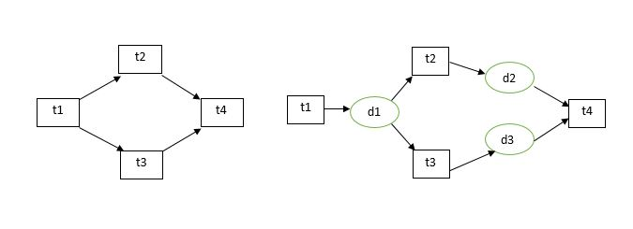

- SDN Architecture
The paper is organized as follows. In Section II the related work to our method is stated. Section III presents the summary of problem identified in the existing scheduling mechanisms. Our novel approach based on local search heuristic is presented in Section IV and V. The results of our experimental study are discussed in Section VII. The conclusion is drawn in Section VIII.

RELATED WORKS
Weiwei Chen et al (2016 a) proposed the dynamic estimation of parameters where the runtime data are collected during execution of workflow and updating the values for determining the clustering factor. These paper includes machine leaning technique namely maximum likelihood estimation for the prior knowledge to adjust parameter estimation. They consider the overhead-aware DAG (O-DAG) model for task clustering. Task clustering is mainly considered to reduce the system overhead during the execution of workflow. Retry is the fault tolerant technique used in clustering.
Weiwei Chen et al (2012 a) proposed the work for increasing the computational granularity for the execution of scientific workflows. They propose two failure modeling frameworks namely task failure model and job failure model. The overhead, runtime and failure parameters are analysed to improve the makespan of the workflow execution.
Weiwei Chen et al (2013 a) proposed balancing methods for addressing the load balance problem for the execution of workflows. Three imbalance metrics namely task runtime variation, task impact factor and task distance variance are measured. The balance factors are mainly to provide a trade-off between runtime and data dependency balancing, such that these factors does not affect each other during the execution of workflow.
Jyoti Sahni et al (2016 b) focused more about the degree of parallelism among the tasks at the level of a workflow while also reducing the system overheads and resource wastage. They mainly consider two imbalance factors namely Runtime imbalance and dependency imbalance. Clustering algorithms are performed with imbalance factors and they aim to improve the runtime and load consolidation abilities of different approaches.
Anju Bala et al (2015 a) proposed a model that predicts the task failures using machine learning methodologies. They also provide the model for locating the actual failures after executing workflow in Cloud environment. They make a focus on designing intelligent task failure prediction model for proposing proactive fault tolerance, which is done by predicting task failures for scientific applications. The models have been implemented by using machine learning methods with the help of evaluated performance metrics. It also presents Naive Bayes approach with maximum prediction accuracy.

Maria Alejandra Rodriguez et al (2014 a) presents an algorithm,Particle Swarm Optimization (PSO) which is based on the meta-heuristic optimization technique. The main aim was to minimize the overall workflow execution cost where the deadline constraints are given more importance. This work focuses on finding a schedule to execute a workflow on Infrastructure as a Service (IaaS) computing resources based on two factors as mentioned earlier namely, the total execution cost and deadline. IaaS cloud principles such as a pay-as-you-go model, dynamicity, elasticity, and heterogeneity of the resources are considered. The fitness function complexity is based on the schedule generation algorithm and depends on the number of resources being used R and the number of tasks T in PSO.
Xiaolong Xu et al (2016 c) deals with energy consumption in dynamic deployment of VM for scientific workflow executions. Here, an energy-aware resource allocation algorithm is proposed for VM scheduling for scientific workflow executions along with an energy consumption model. Migration-Based Resource Allocation policy for task requests in a time partition was designed.
Chase Qishi Wu et al (2015 b) developed a prototype generic workflow system with existing technologies and proposed a model to quantify the network performance of scientific workflows and formulated a task scheduling problem to minimize the workflow end-to-end delay under a user-specified financial constraint by using a heuristic solution named Critical-Greedy algorithm.
Gideon Juve et al (2013 b) considered different scientific workflows for assessing their performance. Six workflows are considered like astronomy, bioinformatics and earthquake science and gravitational-wave physics. The tasks that are available for computation are analysed. The I/O intensive, memory intensive and computational intensive characteristics are observed for every workflow considered. It also includes the analysis of inefficiency caused during execution by different factors. The profiling of such workflows can be useful for selecting algorithms for scheduling and resource provisioning and further analysis of workflow performance in different environments.
Kefeng Deng et al (2015 c) proposed a new multi-level K-cut graph partitioning algorithm for minimizing the volume of data transfer across datacenters. In distributed environment where the datacenters are geographically distributed, the movement of input and intermediate datasets causes latency that affects the efficient execution of data-intensive workflows. The method also upholds load balancing and fixed data constraints of the workflow execution with a consideration that the resources are homogeneous and unlimited so that the input data is always available for the tasks to be executed.
Rodrigo N. Calheiros et al (2014 b) offered an algorithm which uses unused time of provisioned resources and budget excess to replicate tasks. The proposed algorithm increases the possibility of meeting deadlines and reduces the total execution time of applications. It uses cloud infrastructures where the applications are workflows with deadline constrained and resources are of dynamically allocated. They propose strategies for correcting the delays which are caused by undervaluing the execution time of the tasks or performance of the resources used.
Sucha Smanchat et al (2015 d) discussed the taxonomy of scheduling problem and techniques which are proposed based on systematic analysis. The scheduling classifications that are unique to workflow namely, scheduling of the process, task and resource are given. The resources considered are virtual machine instances. The structure of the workflow is given more importance because of dependencies between them and also considers the difficulties in processing them in parallel instances. In order to estimate workflow makespan, cost and for finding the critical path of the workflow, the structure of the workflow plays an important role.
Yong Zhao et al (2015 e) proposed a reference service framework using various cloud platforms for integrating scientific workflow management systems. The cloud services considered has components that include Cloud Workflow Management Service, Cloud Resource Manager and six interfaces between them. The Resource manager is accountable for resource provisioning and virtual resources management used during computation using cloud. The framework is implemented by integrating them with Swift with Open Nebula and Eucalyptus cloud platforms.
Marta Mattoso et al (2015 f) proposed a taxonomy wherethe issues in dynamic steering of high performance computing are identified for scientific workflows. The main notions are workflow lifecycle, user support for real-time monitoring, interference, analysis and notification by adjusting the workflow execution at runtime. They also explained the challenges and the potential of dynamically exploring workflows to improve the execution, maintaining the provenance data of the workflows. Dynamic workflow features namely adaptive and user-steered workflows are helpful in Large-scale experiments. It also studiedfine-tuning adjustments made during the execution of HPC workflows.
Yang Wang et al (2016 d) proposed Workflow-Aware File System (WaFS) that automatically detect and gather the explicit and implicit data dependencies between workflows and also a workflow scheduler to make effective cost performance trade-offs or improve storage utilization. They achieve the above proposed work by maximizing the job concurrency with acceptable performance overheads.
Ketan Maheshwari et al (2016 e) proposed a multi-site workflow scheduling technique to predict the execution time on resources using performance models. The scheduling of tasks requires mapping of tasks in workflows to the resources to maintain the balanced distribution of the workflow. The scheduling was also used to reduce the overhead caused due to data transfer. It also proposed the idea of using dynamic probes to recognize the feasible network throughput between the considered sites.
Weiwei Chen et al (2012 b) proposed a simulator named WorkflowSim, which extended the existing CloudSim simulator by providing a higher layer of workflow management. The simulator assists in workflow optimization techniques by considering system overheads and failures in simulating scientific workflows.
Rodrigo N. Calheiros et al (2010) proposed a simulation tool called Cloudsim that supports workflow execution and was the predecessor of the workflowsim tool. It simulates and models cloud computing systems for different application providing environments. The CloudSim toolkit supports both system modelling and behaviour modeling of cloud system components such as data centres, VMs and resource provisioning policies. It is a suitable research tool that can handle the system overheads and complexities arising from simulated environments.
Ewa Deelman et al (2015 g) described about the design, development and evolution of the Pegasus Workflow Management System where workflows from different scientific domains like astronomy, seismology and bioinformatics are considered. It mainly focuses to achieve scalable and reliable execution of workflows across different computing infrastructures. It supports large-scale applications with I/O intensive, data intensive, computation intensive workflows. It also supports platforms such as Grid and cloud.
Yi Gu et al(2016 f) proposed analytical cost models and formulated workflow mapping as optimization problems for minimum end-to-end delay and maximum frame rate. A mapping algorithm was offered to minimize the latency based on a recursive critical path optimization procedure. Simulation based comparisons with existing algorithms are performed with large-scale experiments. It also used real time scientific workflows through active system implementation and deployment in real networks.

PROBLEM DESCRIPTION
Convolutional Neural Network (CNN) is widely used in image classification but not in DDoS. This work uses CNN in DDoS scenario in the SDN environment. Proposed work includes classification of incoming packets into attack or normal packets with the help of Support Vector Machine (SVM) and CNN. Various types of DDoS attacks are launched in the SDN environment on the fly which are classified and are mitigated from the system in case of an attack.

PROPOSED WORK
The incoming packets from the internet arrive at the SDN switches as in fig. 2. Each SDN switch will have a flow table or a group of flow tables associated to it. The flow table provides the necessary actions such as forwarding of the packets to next hop or drop. Each incoming packet will have a key which is checked among the flow table entries. If there is an entry, actions are taken respectively as suggested in the flow table. If not, a special message called packet-in message is generated and sent to the controller.
Through fair sharing technique implemented in a SDN controller, part of the incoming traffic can be redirected to another controller such that the load is shared among them efficiently. IDS application in the respective controllers collects the packet-in messages. If there exists some abnormality in the number of packets arrived from the same host, it is detected through outlier detection and is termed as a trigger for an attack. Various features of the packets are extracted and are classified using SVM and CNN. The result detects whether the packets from the host are attack traffic or normal traffic. If it is deemed as attack traffic, then it is mitigated from the system.
Network Flow
Network flow is a sequence of packets generated by the internet and is sent to the switch.
Switch
An OpenFlow enabled switch is the vital forwarding device that forwards the incoming packets based on the flow table. It is close to legacy forwarding tables but now managed and maintained by the controller. The switch is coupled to the controller through a secure channel. OpenFlow messages are exchanged between the switch and the controller using this channel. Switch maintains flow table or a group of flow tables.
Flow Table
The flow table, which OpenFlow reads from and writes to in switches consists of entries. A table entry consists of three parts; Header Fields, Counters and Actions. The Header Fields act as the key for the entry, i.e. when a packet is received from the network, the switch will try to match the header fields of the received packet to one of the flow table entries. When there is a match between a packet and an entry, the associated Counters for that entry is updated and the associated Action is applied to the packet.
Controller
SDN Controllers in a software-defined network (SDN) are the intelligence source of the network. It is the application that acts as a tactical control point in the SDN network, manages flow control to the switches/routers in the lower tier and the applications and business logic in the upper tier to set up intelligent networks. POX controller has been used in this work.
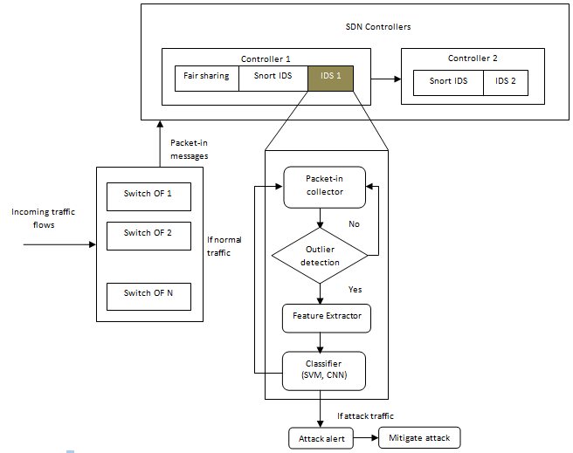Fig.2. Architecture diagram of the proposed system

V. CLASSIFICATION TECHNIQUES USED
The incoming traffic from the network is monitored with the help of Openflow_stats_reply. If there exists abnormality in the traffic, features of the packets are extracted and are classified by SVM and CNN techniques as shown in fig. 3. The training data is KDD dataset and the testing data is taken on the fly from traffic in SDN. From the testing data, features are extracted and are classified by SVM and CNN model respectively. Incase attack, the packets are dropped and the source IP address is blocked in the flow table otherwise the flow table is updated by the controller to pass the further packets directly to the next hop.
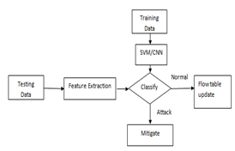

Fig 3. Classification process of packets
Support Vector Machine (SVM)
In machine learning, support vector machines are based on supervised learning models that has the capability to analyze data for classification and regression analysis.

SVM Algorithm
Input: : Wf: workflow; N: max number of tasks in a job
Output: Set of clustered tasks executed along with their execution time
Procedure HYBRID_CLUSTERING (Wf,N)
- for level <Dep(Wf) do
  - TL←TASKS_IN_LEVEL(Wf,level)
  - CL←MERGE(TL,N)
  - Wf←Wf-TL+CL
- end for
- end procedure
- Procedure Merge(TL,N)
- J_{c}←{}
- CL←{}
- While TL is not null do
  - J_{c}.add(TL.pop(N))
  - CL.add(J_{c})
  - for all t in TL do
  - J_{c}←{t}
  - while t has only 1 child tchild and tchild has only1 parent do
  - J_{c}.add (tchild)
  - TLmerged← TLmerged + tchild
  - t←{} tchild
  - end while
  - CL.add(J_{c})
  - end for
- End while
- Return (CL,TLmerged)
- end procedure

Procedure RE_CLUSTERING (J_{c})
- J_{new}←CopyOf J_{c}
- Wf←Wf+J_{new}
end procedure

Convolution Neural Network (CNN)
Convolutional Neural Network (CNN) evolved from animal visual cortex, wherein each neurons are arranged such that the regions overlap over the vision field. It is a kind of feed-forward NN and are made up of three types of layers: (1) fully-connected, (2) convolutional (3) and pooling.
Local connectivity
When the input data has more number of dimensions, it is highly improbable to connect all the neurons from the previous layer to its next layer as the spatial structure of the data is not considered. In CNN, each neuron in a layer is connected only to a few of the input neurons.
Convolutional Layer
Convolutional layers are the nucleus of a CNN. A convolutional layer is made up of kernels which have the capability to learn which when convolved on the input features produces an activation map. A kernel consists of a layer of connection weights with the input and produces output unit.
Pooling Layer
Pooling is a form of non-linear down-sampling. There are several non-linear functions to implement pooling such as the minimum, the maximum and the average but the most common is the maximum. Max pooling works by partitioning the data into a set of non-overlapping sets and for each sub-region outputs the maximum value.

CNN Algorithm
Input: training data D, testing data D’
Output: attack or normal classified data
Step 1: DDoS features given to input neurons
Step 2: Rectified Linear Unit activation function is defined as
f(x) = max(0,x)
f(x) =

Step 3: calculate hidden layer activations
f(np.dot(W,x) + b) //where w=weight, b=bias
Step 4: Define convolve with D, D’ and extract useful features F
Step 4: Define pool with F_{c}
Step 5: Return attack or normal class of data

VI. EXPERIMENTAL RESULTS
We tested our work on the open nebula tool which is a real time cloud. In our experiment, we have worked with just one datacenter. The proposed DDoS attack detection is implemented in two systems. In each system, Mininet and POX Controller is installed using Ubuntu working environment. Mininet, a virtual network simulator has been used for creating network topology. POX Controller has been used for controlling the network elements. Hping3 tool is used to provide various DDoS attacks in SDN environment.

Launching DDos attacks
Different types of attacks are launched from different hosts and SDN environment is compromised to attackers. Open xterm window of the respective hosts from which attack and normal traffic can be launched. DDoS attacks are launched with the help of hping tool. The latest version of hping tool which is hping3 is used in this work. TCP SYN attack as shown in fig. 4, ICMP flood attackas shown in fig. 5, UDP flood attack, spoof attack are launched into SDN network.

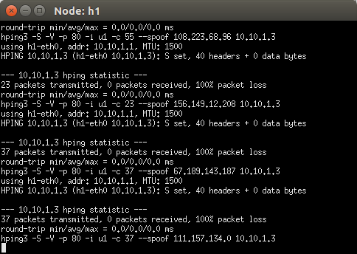
Fig 4. TCP SYN attack

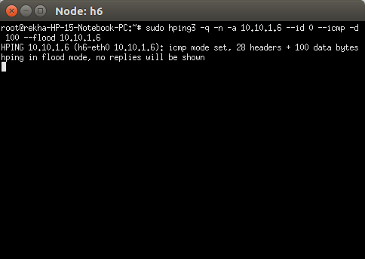
Fig.5 ICMP flood attack
CNN Result
The training model and cost of function are obtained as shown in fig 6. CNN provided an accuracy of 83% which is more than SVM. Hence, CNN is a more promising approach than SVM and can be implemented in SDN for DDoS detection scenarios. This is such a lightweight mechanism to detect DDoS attack in SDN.
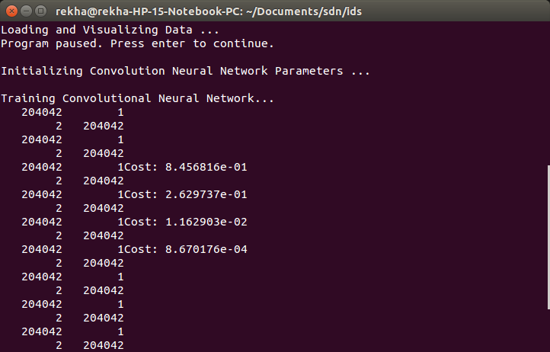
Fig 6. CNN Training result
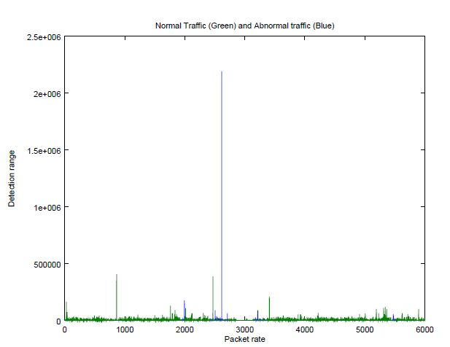

Normal traffic is shown in green colour and attack

Fig 7. CNN classification result
Normal traffic is represented in green color and attack traffic in blue color as shown in fig.7. Packet rate is termed as x-axis and detection range is termed as y-axis respectively. When the packet rate is high and the detection range is exponential, attack traffic obtained is highest than in any other range.
In the given graph as shown in fig.8, x-axis is termed as number of training data and y-axis is termed as classification accuracy rate. From the results obtained, it is clear that if the number of training data is increased, the accuracy rate also is increased. CNN provides more classification accuracy than SVM and hence it can be used in DDoS scenario to mitigate the attacks from SDN.
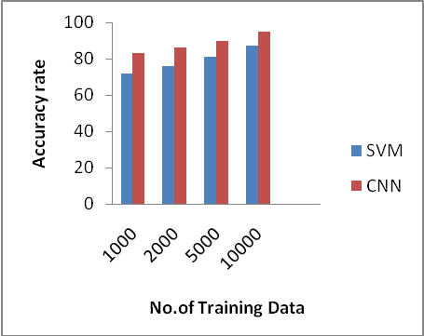
Fig.8 CNN vs SVM classification accuracy rate

VIII. Conclusion And Future Enhancement
In this work, various DDoS attacks are launched in SDN network resulting in degradation of the performance of the SDN controller. Packets are classified using two techniques namely Support Vector Machine and Convolution Neural Network into attack packets or normal packets. If it is deemed as an attack packet, then it is mitigated from the network. Both techniques are compared against each other in terms of accuracy rate. As a future work, various other complex algorithms are to be implemented to mitigate DDoS attacks from SDN environment.

REFERENCES
1.Yunhe Cui, Lianshan Yan, Saifei Li, Huanlai Xing, Wei Pan, Jian Zhu, Xiaoyang Zheng (2016),’ SD-Anti-DDoS: Fast and efficient DDoS defense in software-defined networks’, Elsevier on Journal of Network and Computer Applications, vol.68, pp.65–79.
2.Taejin Ha, Seunghyun Yoon, Aris Cahyadi Risdianto, JongWon Kim, and Hyuk Lim (2016), ‘Suspicious Flow Forwarding for Multiple Intrusion Detection Systems’, IEEE on Network Forensics and Surveillance for Emerging Topics, vo.16, pp.22-27.
3.Adrian Lara and Byrav Ramamurthy (2016),’OpenSec: Policy-Based Security Using Software-Defined Networking’, IEEE Transactions on Network and Service Management, vol.13, no.1, pp.30-42.
4.Heng Cui, Ghasson O. Karame, Felix Klaedtke, and Roberto Bifulco, ‘On the fingerprinting of Software-Defined Networks’, IEEE Transactions on Information Forensics and Security, vol.11, no.10, pp.2160-2173.
5.Silvia Fichera ,Laura Galluccio, Salvatore C. Grancagnolo, Giacomo Morabito, Sergio Palazzo (2015), ‘ OPERATTA:An OPEnflow-based Remedy to mitigate TCP SYNFLOOD attacks against web browser’, Elsevier on Computer Networks, vol.92, pp.89-100.
6. Ahmed AlEroud, Izzat Alsmadi (2016), ‘Identifying Cyber-Attacks on Software Defined Networks: An Inference-based Intrusion Detection Approach’, IEEE on Journal of Network and Computer Applications, pp.1-22.
7. He Li, Peng Li, Song Guo, and Amiya Nayak (2014), ‘Byzantine-Resilient Secure Software-Defined Networks with Multiple Controllers in cloud’, IEEE Transactions on Cloud Computing, Vol. 2, No. 4, pp.436-446.
8.Tuan A Tang, Lotfi Mhamdi, Des McLernon, Syed Ali Raza Zaidi and Mounir Ghogho (2016), ‘Deep Learning Approach for Network Intrusion Detection in Software Defined Networking’, IEEE on Computer Networks, vol.16, pp.1-6.
9.Adnan Akhunzada, Ejaz Ahmed, Abdullah Gani, Muhammad Khurram Khan, Muhammad Imran, and Sghaier Guizani (2015), ‘Securing Software Defined Networks: Taxonomy, Requirements and Open Issues’, IEEE on communications Magazine, vol.15 , pp.36-44.
10. Bing Wang, Yao Zheng, Wenjing Lou and Y.Thomas Hou (2015), ‘DDoS attack protection in the era of cloud computing and Software-Defined Networking’, Elsevier on Computer Networks, vol.81, pp.308-319.
11.Taejin Ha, Sunghwan Kim, Namwon An, Jargalsaikhan Narantuya, and Chiwook Jeong, JongWon Kim, and Hyuk Lim (2016), ‘Suspicious traffic sampling for intrusion detection in software-defined networks’, Elsevier on Computer Networks, vol.109, pp.172-182.
12.Jonghoon Kwon, Dongwon Seo, Minjin Kwon, Heejo Lee, Adrian Perrig, and Hyogon Kim (2015), ‘An incrementally deployable anti-spoofing mechanism for software-defined networks’, Elsevier on Computer Communications, vol.64, pp.1-20.
13.Qiao Yan and F. Richard Yu (2015), ‘Distributed Denial of Service Attacks in Software-Defined Networking with Cloud Computing, IEEE on Security and Privacy in Emerging Networks, pp.52-59.

V. Conclusion And Future Enhancement
In this work, various DDoS attacks are launched in SDN network resulting in degradation of the performance of the SDN controller. Packets are classified using two techniques namely Support Vector Machine and Convolution Neural Network into attack packets or normal packets. If it is deemed as an attack packet, then it is mitigated from the network. Both techniques are compared against each other in terms of accuracy rate. As a future work, various other complex algorithms are to be implemented to mitigate DDoS attacks from SDN environment.

