Shabakah Simulator
Usage Document
Version No. : 1.0
Date: 17/2/2016

APPROVALS
 | FUNCTION | NAME | DATE | *SIGNATURE
Prepared by |  | Raghu, T | 17/2/2016
Reviewed by
Approved by
* Typed names constitute approval. Actual signatures if required are maintained on Project files
Modification History
Version No. | Date  <mm/dd/yy> | Changes made | Author | Reviewers | Documents Affected
1.0 | 12/10/2015 | Initial Version | Raghu, T |  | None

Steps to use the simulator
Create Input File.
- Input File is in CSV Format
- Insert MAC id in the first column of csv as shown in the fig.1 below.
- Fig.1
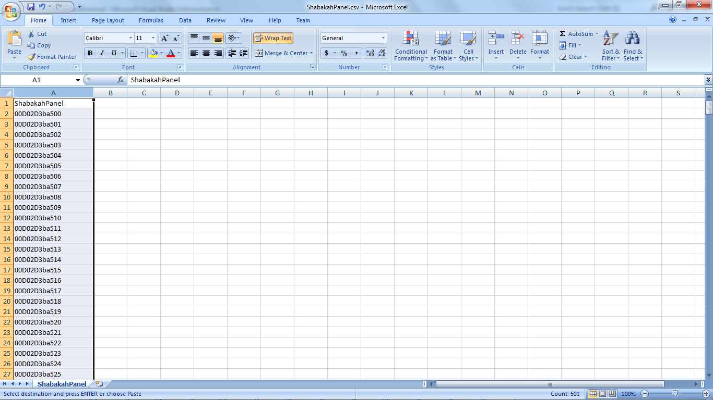

App.Config:
- Change the highlighted inputs in below as required.
<client>
<endpoint address="http://10.171.146.40:8500/TCService/" binding="basicHttpBinding"
bindingConfiguration="BasicHttpBinding_ITCService" contract="TCServiceReference.ITCService"
name="BasicHttpBinding_ITCService" />
</client>

<appSettings>

<add key="redirip" value="10.171.24.247" /> <!--Enter redirip →
<add key="redirport" value="7777" /> <!—Enter Redir Port-->

<add key="dataserverip" value="10.171.146.42"/><!—Enter dataserver IP-->
<add key="uselocalDataServer" value="1" />
<add key="uselocalDataServerPort" value="8500" />
<add key="sendtimout" value="3000000" />
<add key="receivetimeout" value="3000000" />

<add key="delayIntervalSession" value="120"/><!-- Please enter in seconds-->
<add key="DelayAfterSession" value="30"/> <!-- Please enter in seconds-->

<add key="LogFileSizeInMB" value="5"/> <!—Enter Log File Size-->
<add key="LoggerLevel" value="5"/><!—Enter Log Level-->
<add key="NumLogFilesToRetain" value="20"/> <!—Enter Number of Files to retain-->
</appSettings>

Simulator Execution:

- In Desktop, Select LynxSimulator. Right Click → Run as Administrator.
- LyncSimulator Opens as shown below.
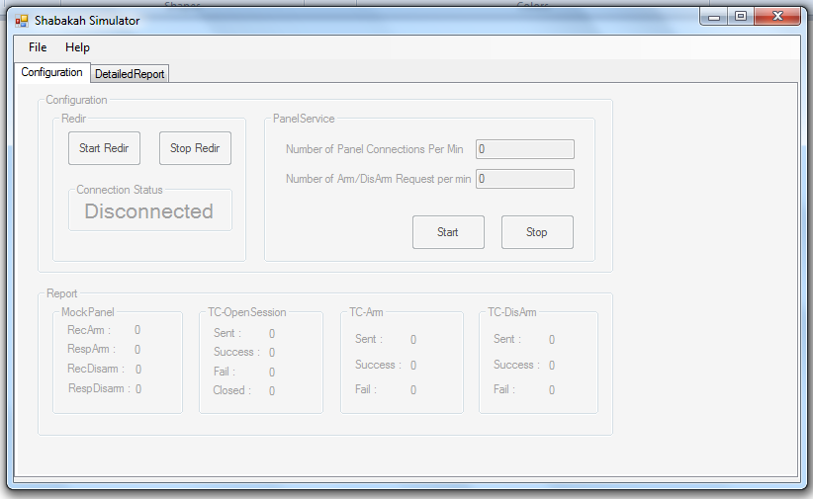
- To Upload Input data, Click File -> Configure
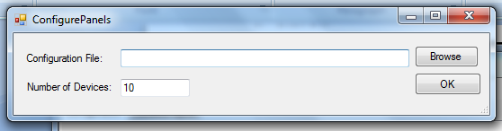
- Click Browse. Choose Required Input File.
- Enter Number of Panels required from the csv.
- Click Ok.

Start Redir:
- Click Start Redir
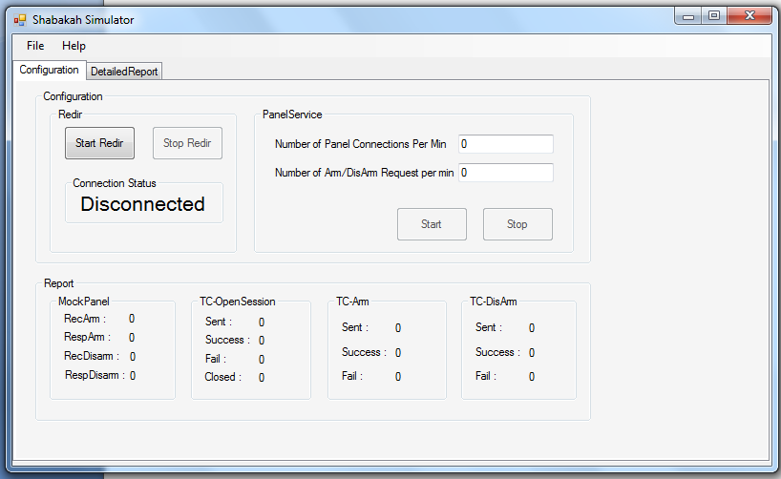
- If connection status displays Check Redir IP. Then Enter the correct Redir IP in App.Config File.
- Enter the Number of Panel Connections Per Min and Number of Arm/DisArm Request per Min.
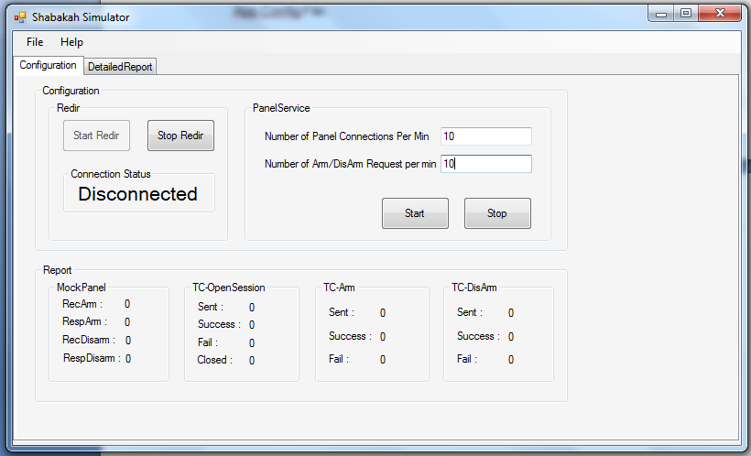
- Click Start.
- Report Group displays, Total number of Open Session, Arm and DisArm Request and Response Details.
- Mock Panel Group contains Arm and DisArm Request and Response detail from Panel Mocker.
- Can View the Reports as shown in the below fig
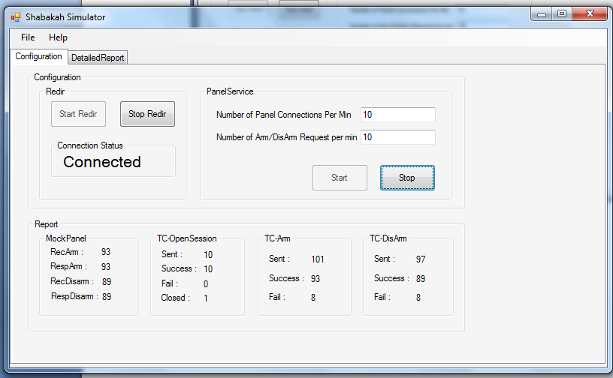
Detailed Report:
- Detailed Report contains the report for each individual panels.
- Click Detailed Report tab.
- Detailed Report displays as shown in below fig.
