WEEK3_DAY1_HOME_ASSIGNMENT

Implementing vibe coding for PlayWright with TypeScript
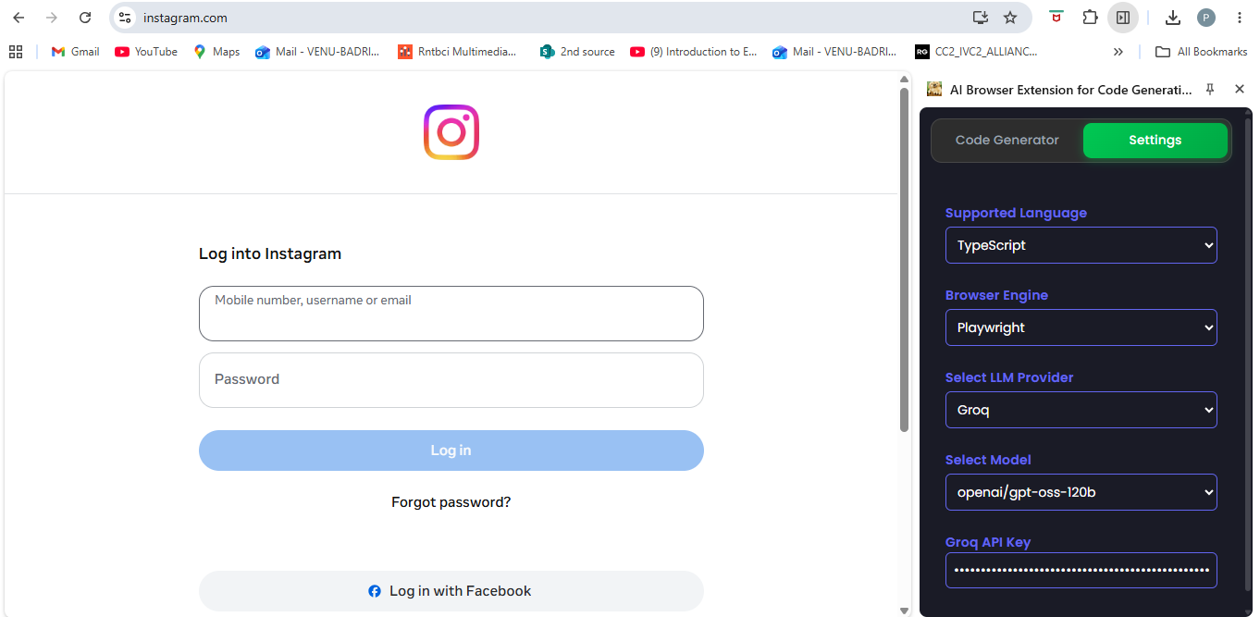

Inspect the fields and click on Generate Code.
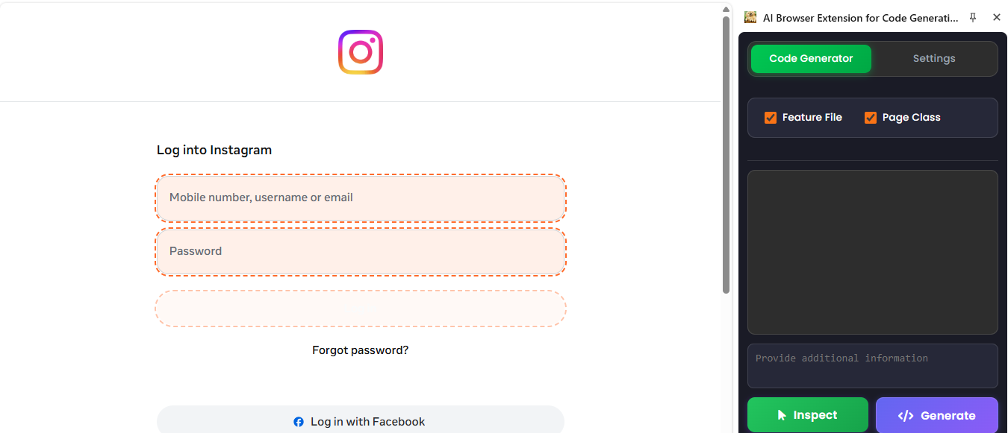

The Typescript code is generated for the selected fields.
