Task 1: System Monitoring Setup

Step 1: sudo apt install -y htop

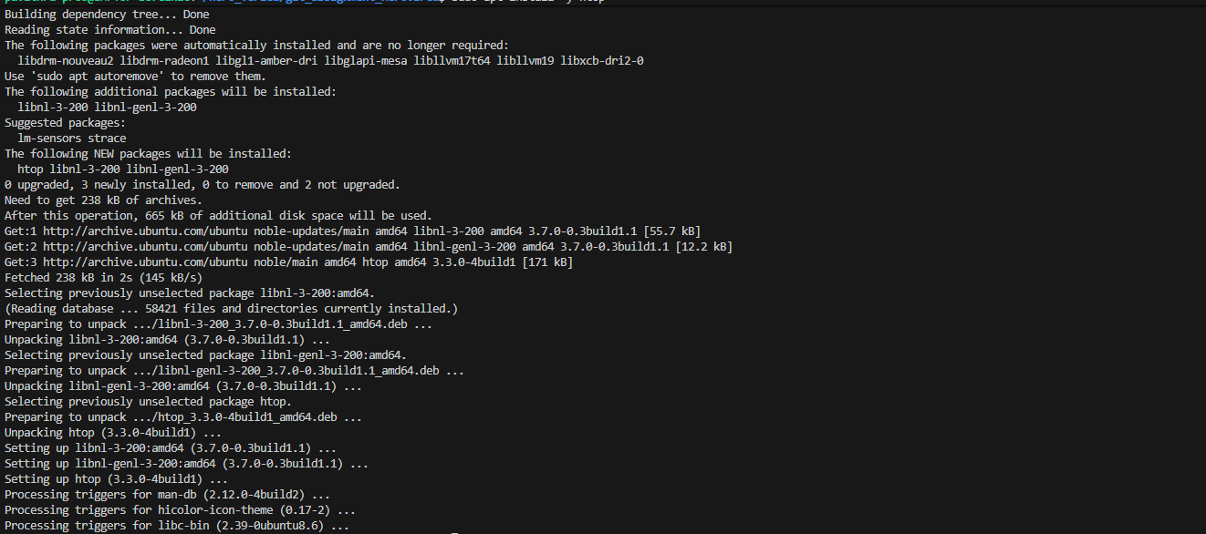

Step 2: Monitor CPU, Memory, and Processes using htop

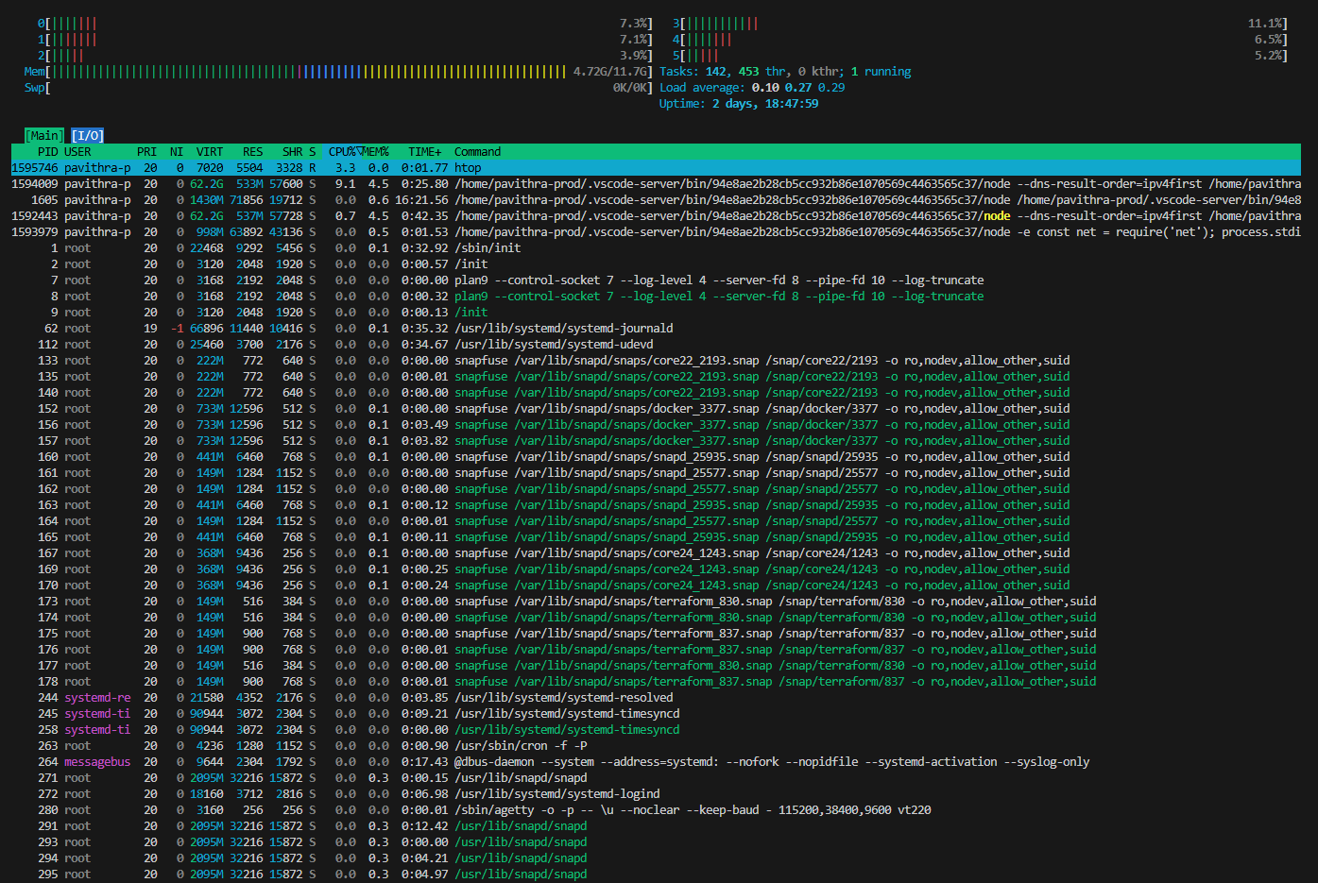

Step 3: Disk Usage Monitoring

Overall disk usage: df -h

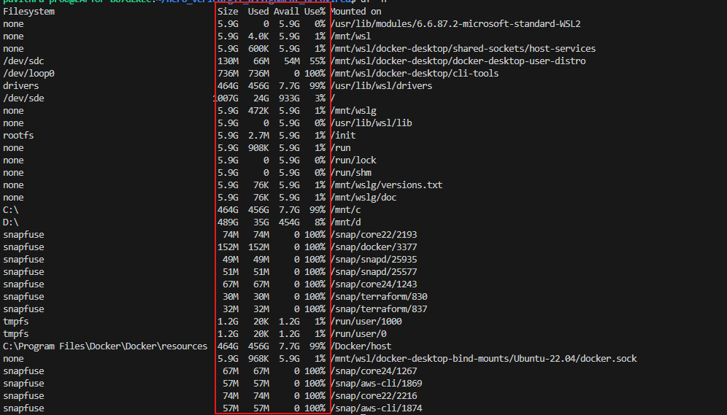

Step 4: Identify Resource-Intensive Processes

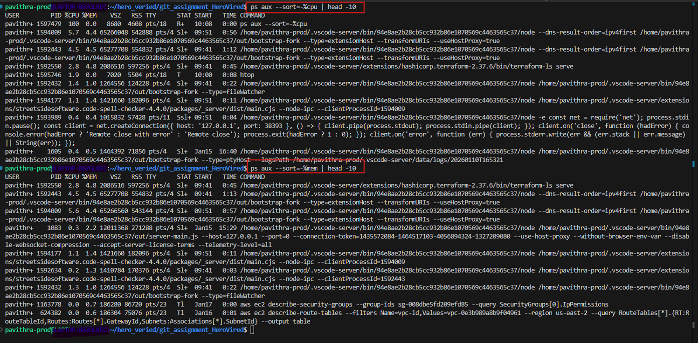

Step 5: Logging System Metrics
Option A: using script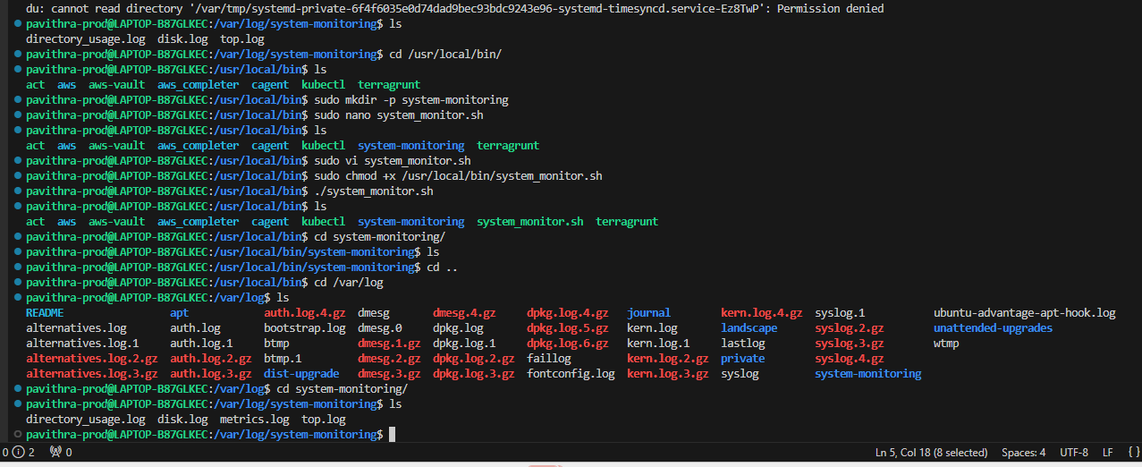

Option B: Also directly take a log:

