OCR Extracted Content

Page 1
part
1
6)a - A asrl 8blecF $
a 'Movie, cloose Seats mac an onlina
(paymont ad: Sceuuos a eleuronic Hicket Oialu 0 Usetase
pov
anxd Hs prucaus Expplaun obfed:
Sequonue diagra
linton(k'ons
and nsagq Gcuanged ,
Online
mymant Usecase
d lagraum
Onlinepaumont
(sot-
AlpplicaHion
Objeyus
Tlafo
(anlo tUOs .
Novi e
Soaks
pyymonl Mouod|
LSen
Epplicalians
Onjedls
CqunLtuens_
(ende
Hpbile Hobile , (se /
age
System Uyeg1 2
Syslem
kaate ot bivv|
Joktaot
W01 3
Inlenee
paymon (
wsot 4
amqunt
amounl @mpuni
CsT1 5
amaunk
@eevmen t
Jusen_pzdhles
nama
V'm 1 4'c11
'W agq
6
445ne
Alk)
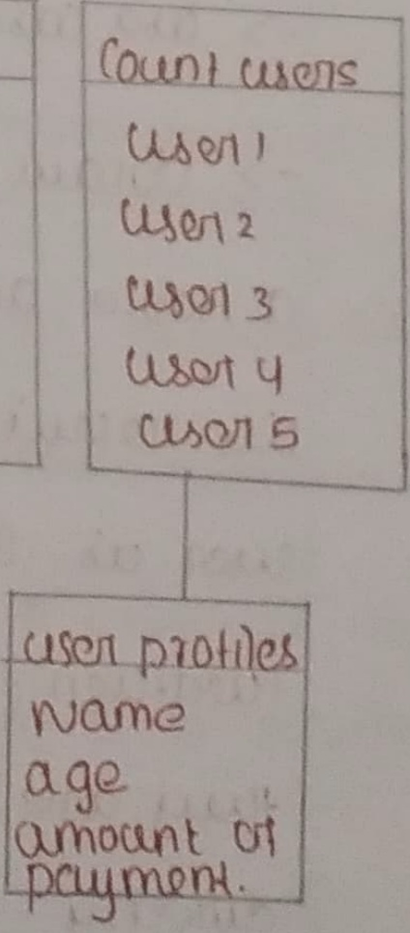
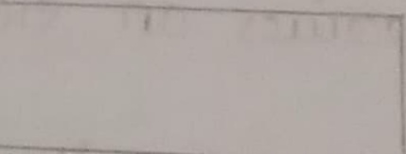
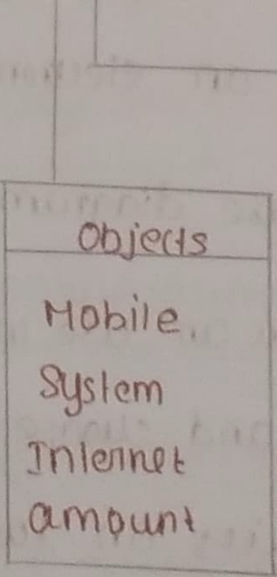
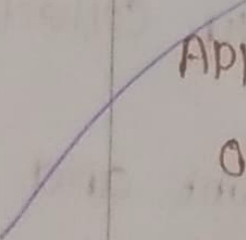
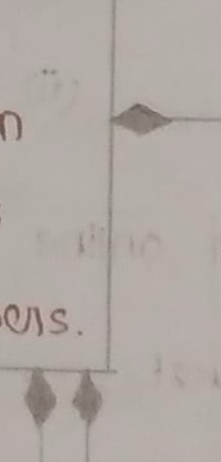
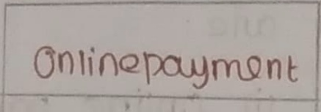
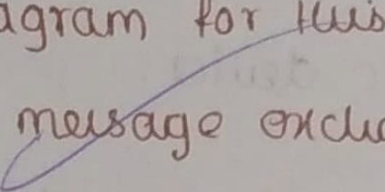
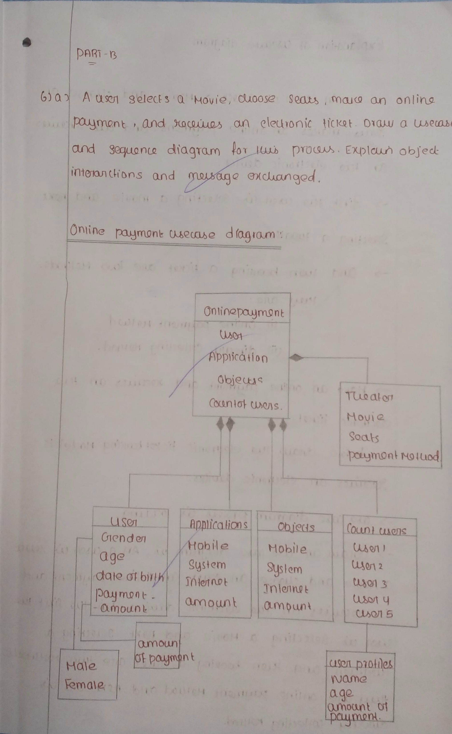

Page 2
(ausetase didgiam -
Explanalion 0]
0
@d cloose
Sect a , Novie ,
An tsel W
in onlihe paymont /Ond tis: Jcuius
Seats- mallos
elcttonic dqs ica
dn huq
td noxt
mouie
Uv slecting a
{itst HM9 Wsen
JuQa KeQ)
a 1 ,
Selacting
ae Jub AoJuads .
a ickat
boking
Cnd Huon
Fuey Mle
Ha Hlo d
(D) Online pauymont
Hoitd
Collecling
(ii) diedily_
XOCqlills an #Ua
and
online pymont
Hako @
Iiuket
declionlc
#ic kal boking Hode) is
eleatonic
dla #uo
nbeture
trwll 4716
dqvitos ,
a eleclronic
Stacoliles
Us Icadung
Prokele_
diagram
U0 Case
An A; Usorl Us getect
M
JvdUlawu a" 'ebse' tae /Aiagram
:(GEn "l I:".
kn,Sqqu4- (; dnline:' paymoni and
cucose
MoUie' @nd
Iua firs€ : Jua
bi
elatifontc dquicos.
Eeeulzyy'" Yn'
tuo
sQlding &
dd , nxt
Houie
Sekeataq 0
JLS 004f
@L 28 01
Hoiubas
@ idket ae 44ey
oeking
~)e|
Bad; Us
Qlex
Holuod and;
Tniwa
A 26
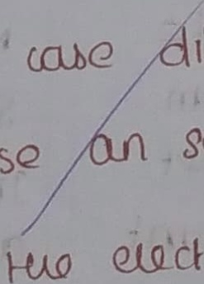
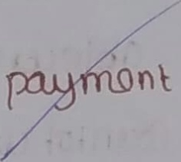
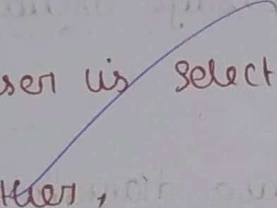
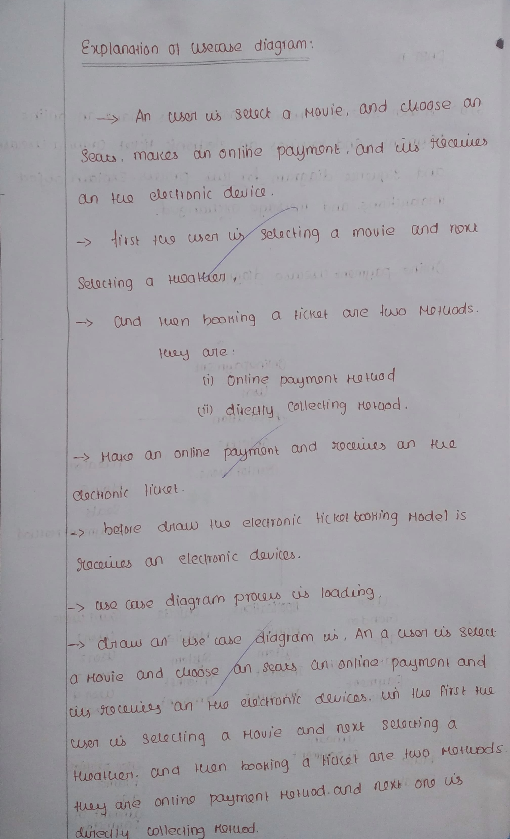

Page 3
Sequenta
Of online pymont Aoluod
LatA+?
IAIJE
Houie
(01i huaa/ler 1
Online
pys " Mon k
tludase Slqatls
Mo/uod.
Online [yymon}
tue 2
kanofuva
kalaicnangam
Min
Nis; Ahy
Online pymon t"
;i"'t
Gxplanalon 0
O: , Squanl online paymon) ; Holuod
And ' #" 'Seaunte
8' online pdymoni ' 'iuiuiod 4
'`
0 SUec a Houq and CloS
Htq
Huoahen Hi
Fanus) 0 } 1
1 T'Vik"[ 0'94'a1'
p
Qpn drttltg #D onhno In
Wiwetity AoD at
40/39 utaer
4+
tunah N6s
Q4ca
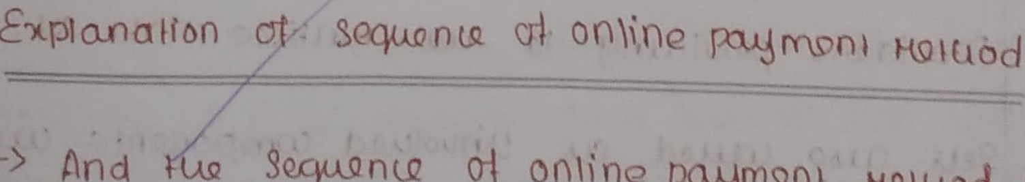
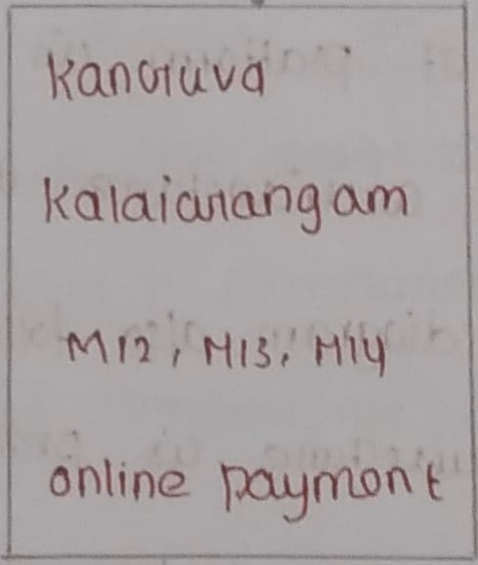
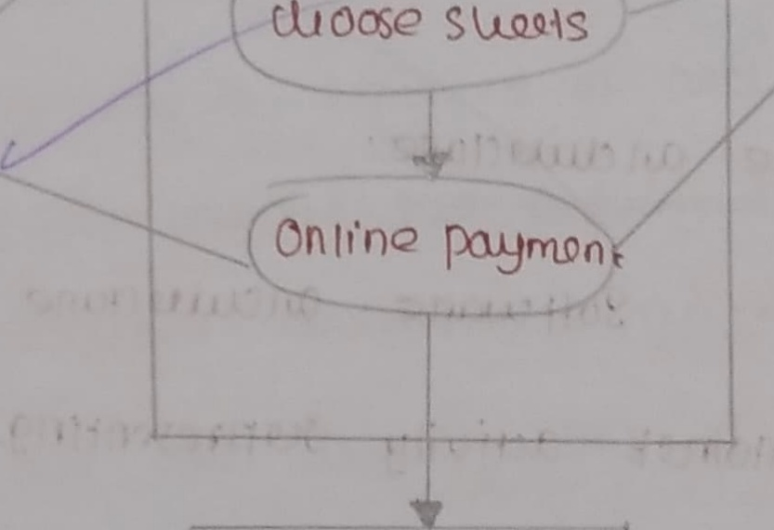
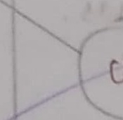
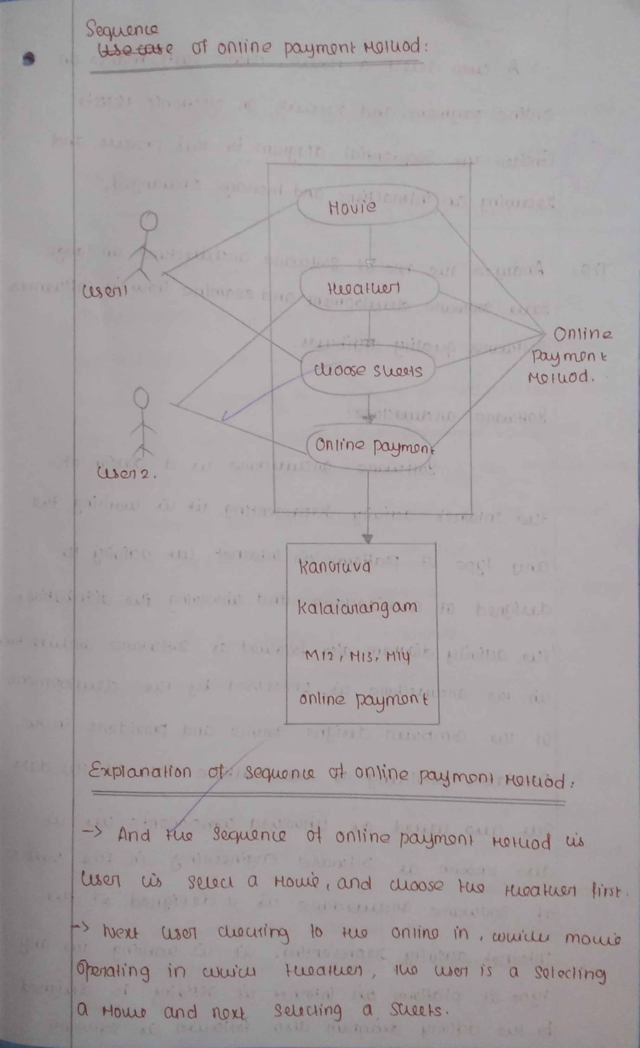

Page 4
dlcose 'sQals mako 0
5> A Houuo
(eg1 Seq& a
#fc(x-ls
clqcttoni€
SOCSULS 0
online pymont and
ad
Proclls .
br Alus
Gnsidq nia| dtagram
Ho Sequua=
and halag@ exuanged.
0n inleaclions
1Q cwing
w |a1ge _
atclue ctule
Sokwe
04
7)0) Analy ze 4uQ rdle
(ow & /lluanus
and examine
dquwlopmant
ScQ Soltuasrle
Solluxle qualily amibuss
SoHtaie @U1 clisaClule
Sol}wae Qclita Clue U a dsign 01
us worlring Ha
ti
acivily xpreseating;
#UQ Inlomok
Ul
An inlenet _ achuity H
0t plallerm
auy Iyp2
and tnvdluing tlq dislikurioo g
@Q Uditockn e
duignad 0t
Quclustacla
Yollotuad @ Sttwadle
ackiuily diggram: also
#lo
FUG ckaU lopmont
alclut{Chuule cs Procqused by
th) HuQ
in Ha
Svico and provides.
@mpatu durigns
Ct Yuq
Hua dala
Huliple 'Adka Sl
droviaers dg'' J0 Fuq
prodic
Uu Us
wpuolued _
Ju CAnd cu , compononls;
Oia9u? 1"
n +ug VCULULIE
sofkwale Enginqnin9
@Ube Icaocun CU
W Un}-
XffX'
Ha
&j 0 dsignod 0}
@lcuila cul e
IGotwa e
entf Tnc"
vj 10 " 04l- {os} 48,i
an
Hua
Xeaabla @dnuity suapres tc cls buorltng
entn
(1J}
KWae oic( 4ir
PD1@llopoe Ou inlgi,ne VtAalicy @o; deslgna
(V
Talar Knint C.
'GWhpvhe @uuo Eliewuura
g0n {OU @ #uauyc
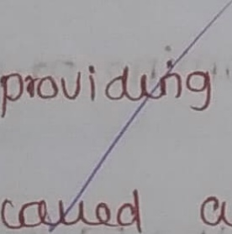
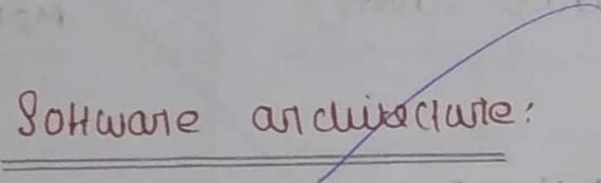
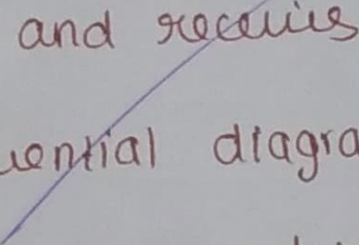
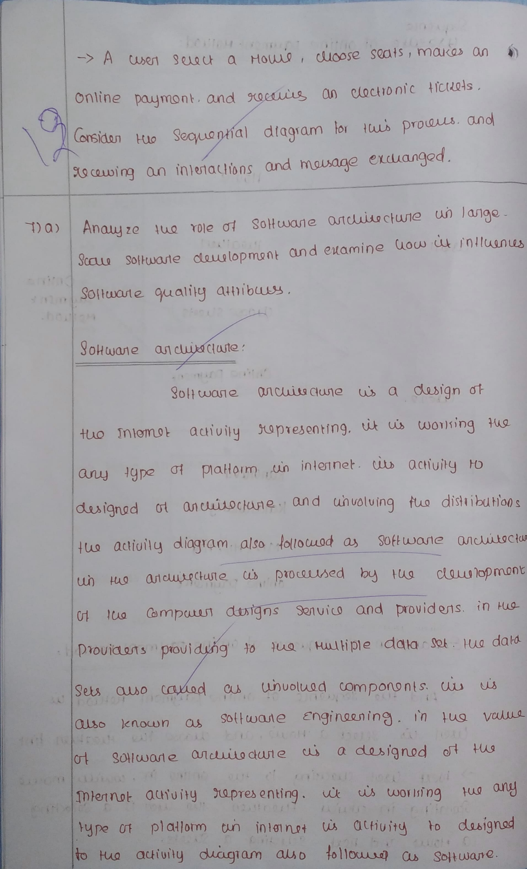

Page 5
StOUlq Sotwae dqulopmnt
Jan9e
@ Ct Iad
aquolopmont:
Huq Scaulq Sollwa1e
latge
dtlenen Fjal
Auqy @L
In OML
Sequ ncayl ciagram
0
Us Slale Ckhan / diagiam .
61 KCQ diagiam
Jeo activily
Solluap
Sllate
based on lage
Sot (kulkeul UT Cll
}wdsie
inkern } acliuity
Cf FQ
Idlulapmant, W;.4 dusignad
off plallam in
#lq cuuy Iyp
U working
t
Aepresenting,
and
QUIcluit cfuute
ho designed 0t
aelivny
snlenee Uts
als 6
acliuily dlagran
dislibaltuns FUo
June tUe'
oluing
aucluike Nule
QcuecFue, un FUQ
a Sollwae
Yollauad
Huo Computart
0k
#UQ dquglopmont
prbcused py
s
6n Jua , prouidurls
providots
Sedtuicg cnd
dSlgns
data Sels
#CQ
data Sob
fulltyple
tb suq'
Drbviauig
kb Us also
Compongnts
inuolued
CLS
puso caued
Commnenlg
cS " 'un volld
knocun
@udliiy 'Gilnibules ~
Soitwane'
ahibulo} byed
Quality
Sollcuene
dala It . In Hq qualig
Hulle
@ "@ualily o
bj Jue' : gd(uae' ' aualig' alfibees
Lu 'poittmod
'ssldarle
kua ' ~cnaintn
basox Oh
Fattriblto us
tunvolving huq dHrrbution
4odr: ta b2
So Hwale @uaL
Jollocld Q
01sb
clionko 01
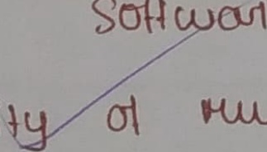
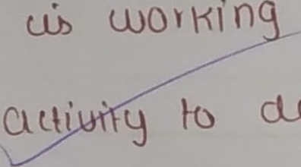
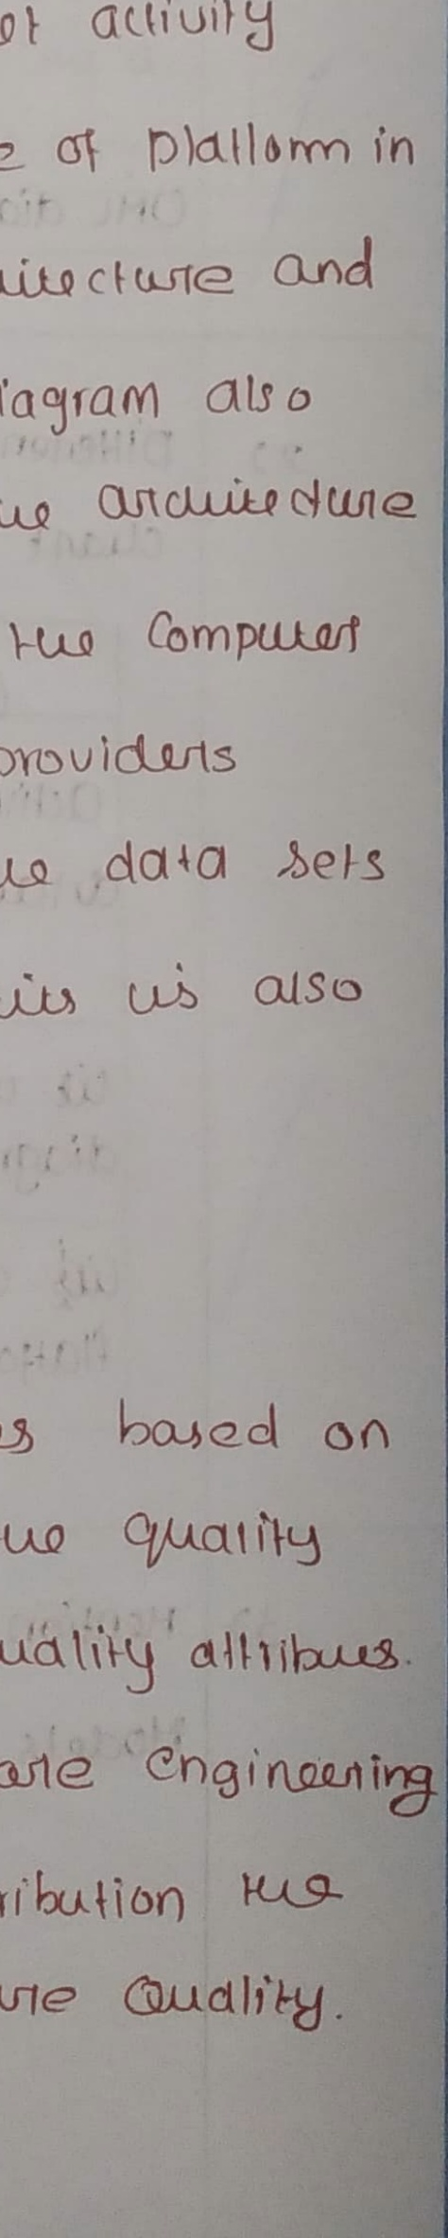
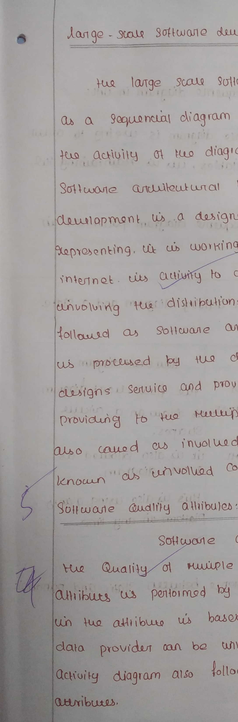

Page 6
PART - A
in UNl :
) Lise
Iuq ptpose ot 0 SqquanlQ diagram
88
@e ing to ordo
TuQ Is
Sequnt9 diagram
Haun tauing 4uI
Uis W
huq Object and yulables
by
DIocls
un
Sequenia diagtam 'ptlurmed
uh k
OHL
diagram ,
an "achlily cliagram ad a, Slate
Dileriontiale 'klulen
2 )
cat' `diagiam
Jlaucladt_diagmm iL
aliuily_dliagIam'
auliuily diagiam us" Us "Hq 'Plocu: culaut} &lgram
kiaud an cuiclll;
aihox Suapex: {ls diau ,a)
suaps
Alroud ' a8'
tie us #olloued ax MHL lit Wlso
Ja 'UHL diagtam
Idiagram
Huuts
Qso wxg a ay: d also
lu tsing,.8,%0
Hlahon In Irmo_ Iplalbi u any
any lme_
000
YGAHers,Auo_ beluean)
HGg;: dillren e
r Slan; , and
08uytatet:
Hadgk yuHla ;
42
it2
30
WSifi,
2.4} 5? Unoefiu' 7 Nd
Gr'
## Yef}
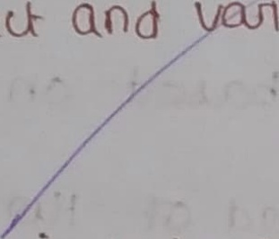
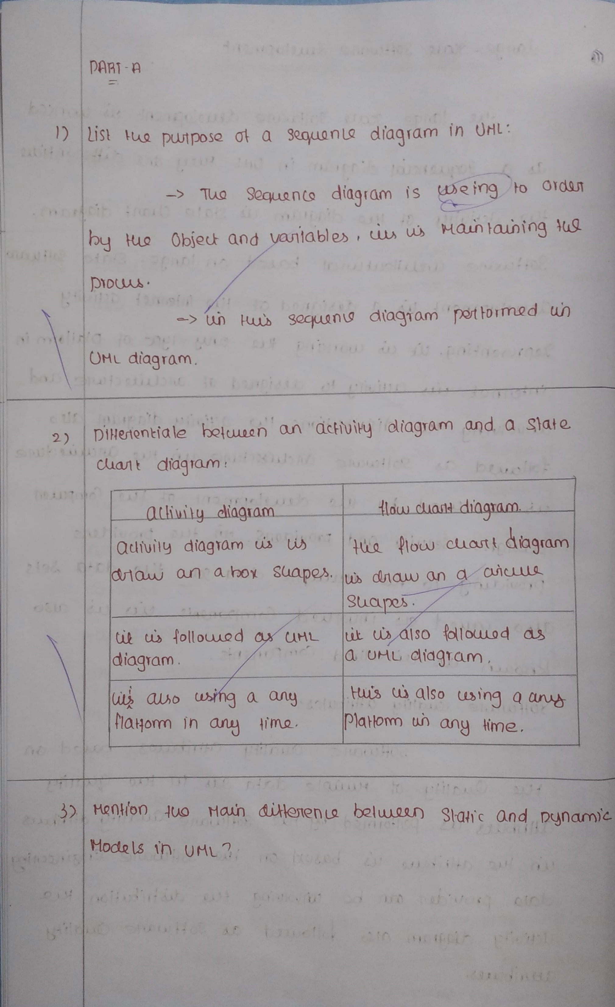

Page 7
Slauc NmeLta
NML Dynanic_todeL1o LHL_
kn +us MOclel SQcjuanla
HOda ) Is +uQ
Dynami (
pentormad in UNIL on dragram
Idiagrcm Seaulenl
Ipt bomed (n ONl dragrah ,
dlag amn
W Iu Htub moda)
#is stalic Hodal Ub dynamic
ells jus alsp dynamic
slakc .
{olloueq
ci W fellowed 0s U U als6
ClI UAL dragram
UAL dragmm
Ut aigo @ing a cny Uf also Wsimg &
hus
W ay Jima
platlorm un any ( me, auny plallor
