**FOVUS CODING CHALLENGE**

**Pavithra Moravaneni**

Front-end was added to the file_process folder.

Back-end was added to the remaining folders.

**Result 1**: Front-end web application page.

Add text input and Upload File. Select the **submit** button.

Ex: Text Input: hi new

File Input: testfile.txt.

Content in the text file is welcome.

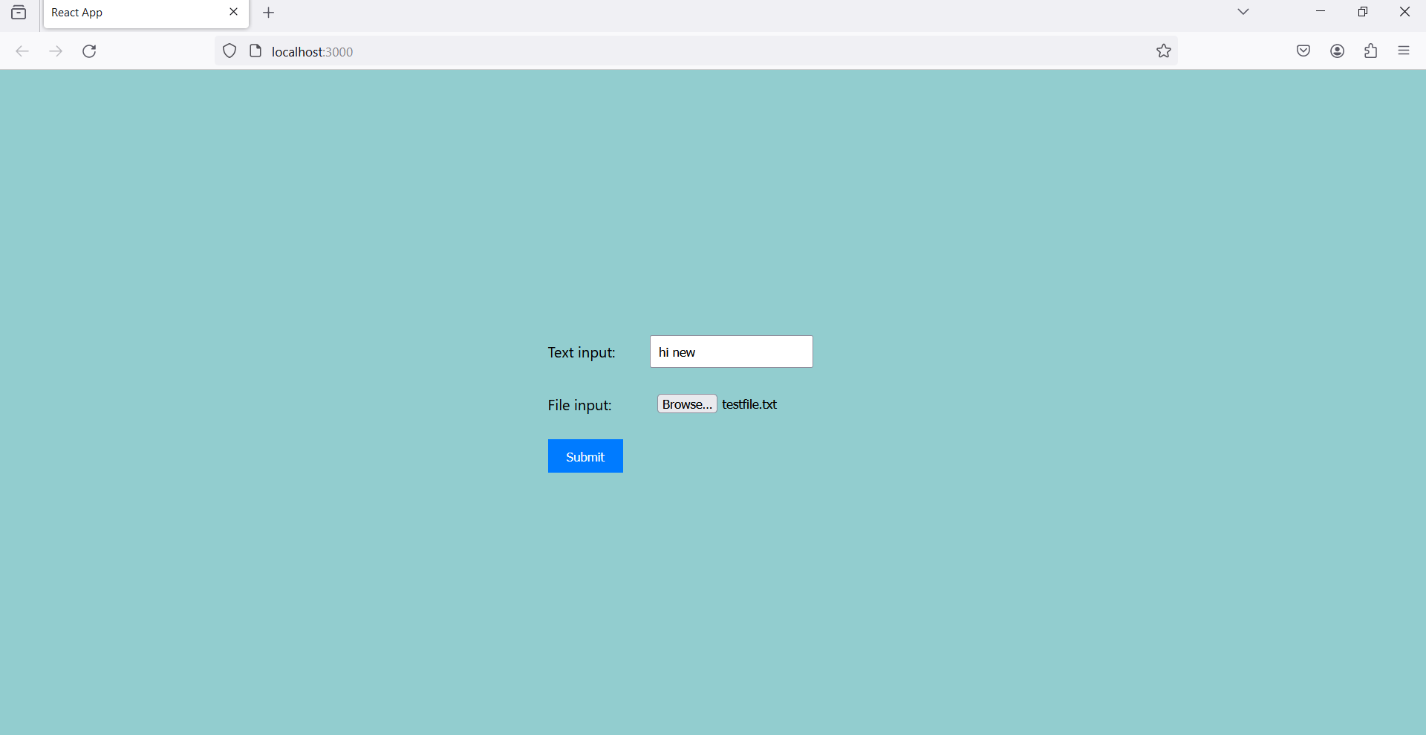

**Result 2**:

First step is to check whether the file and text uploaded successfully.

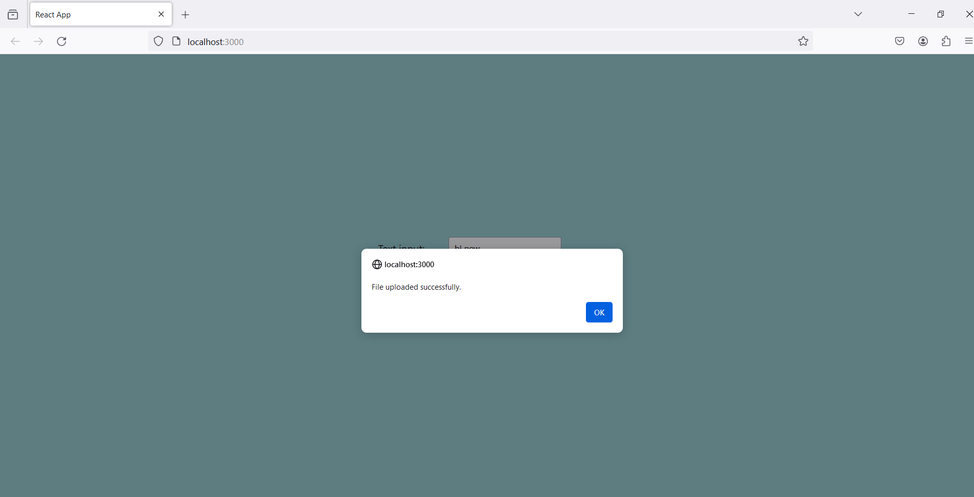

**Result 3**: This shows the confirmation of adding the data saved in Dynamo DB successfully.

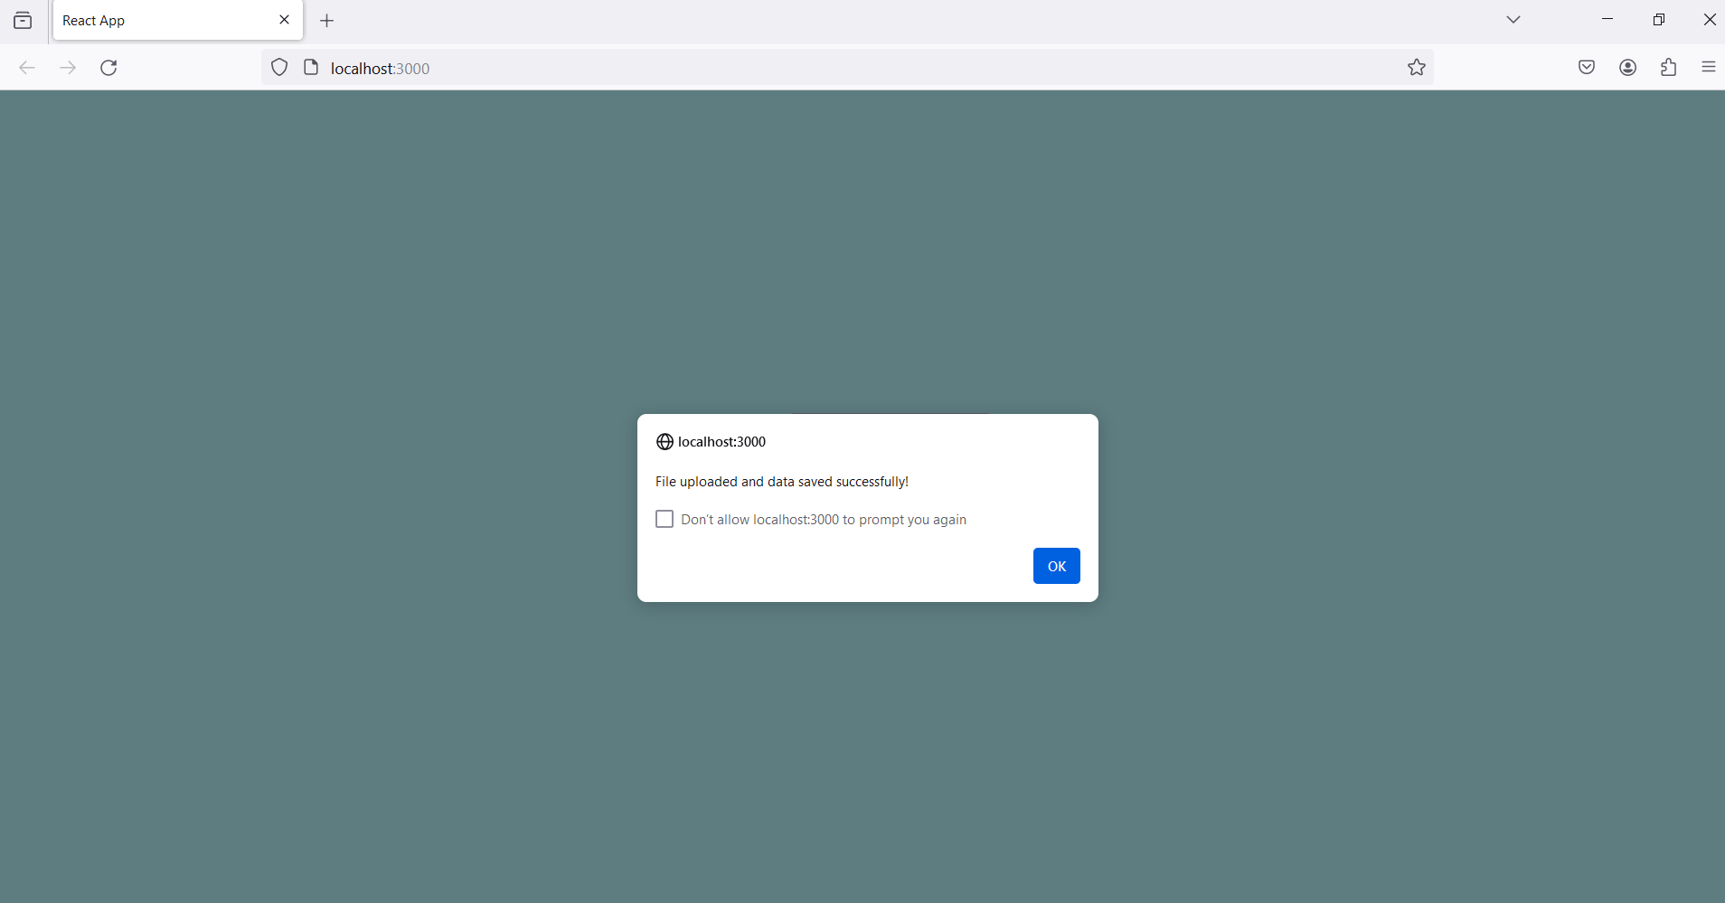

**Result 4**: Firstly, adding the python file in s3 bucket to run the Python code along with the input text file provided and get the result as shown in the last result screenshot.

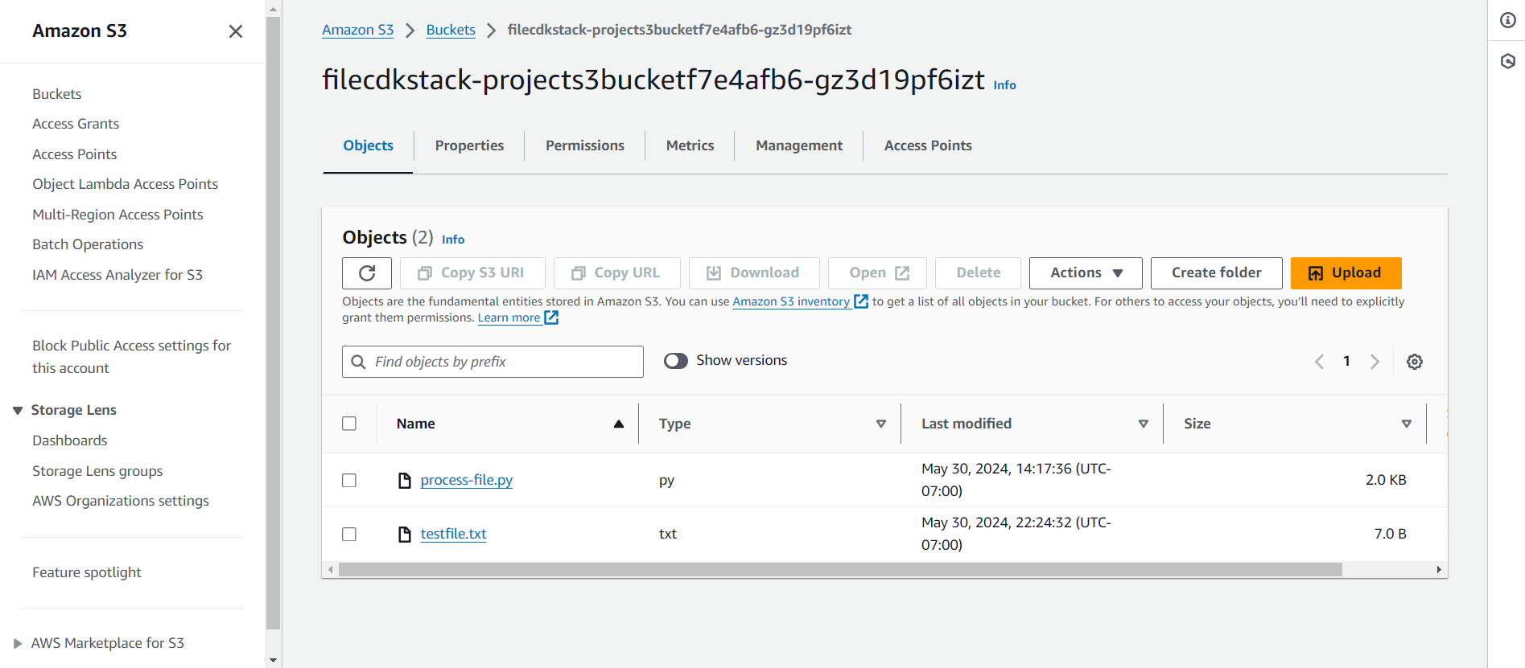

**Result 5**: This picture shows the dynamo table name and where the file input and text input “hi new” has been stored.

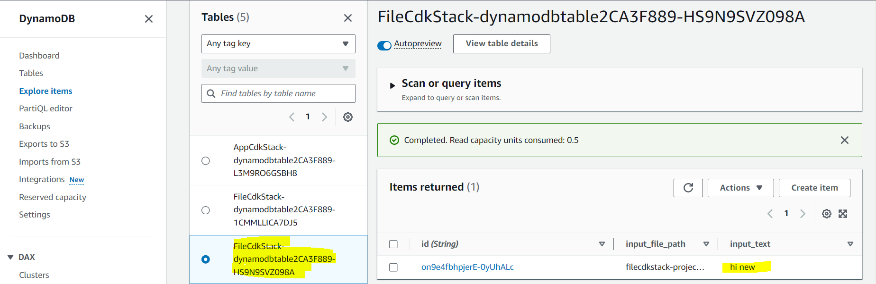

**Result 6**: This below screenshot shows the file input which has been provided along with unique ID. “testfile-UNIQUEID.txt”

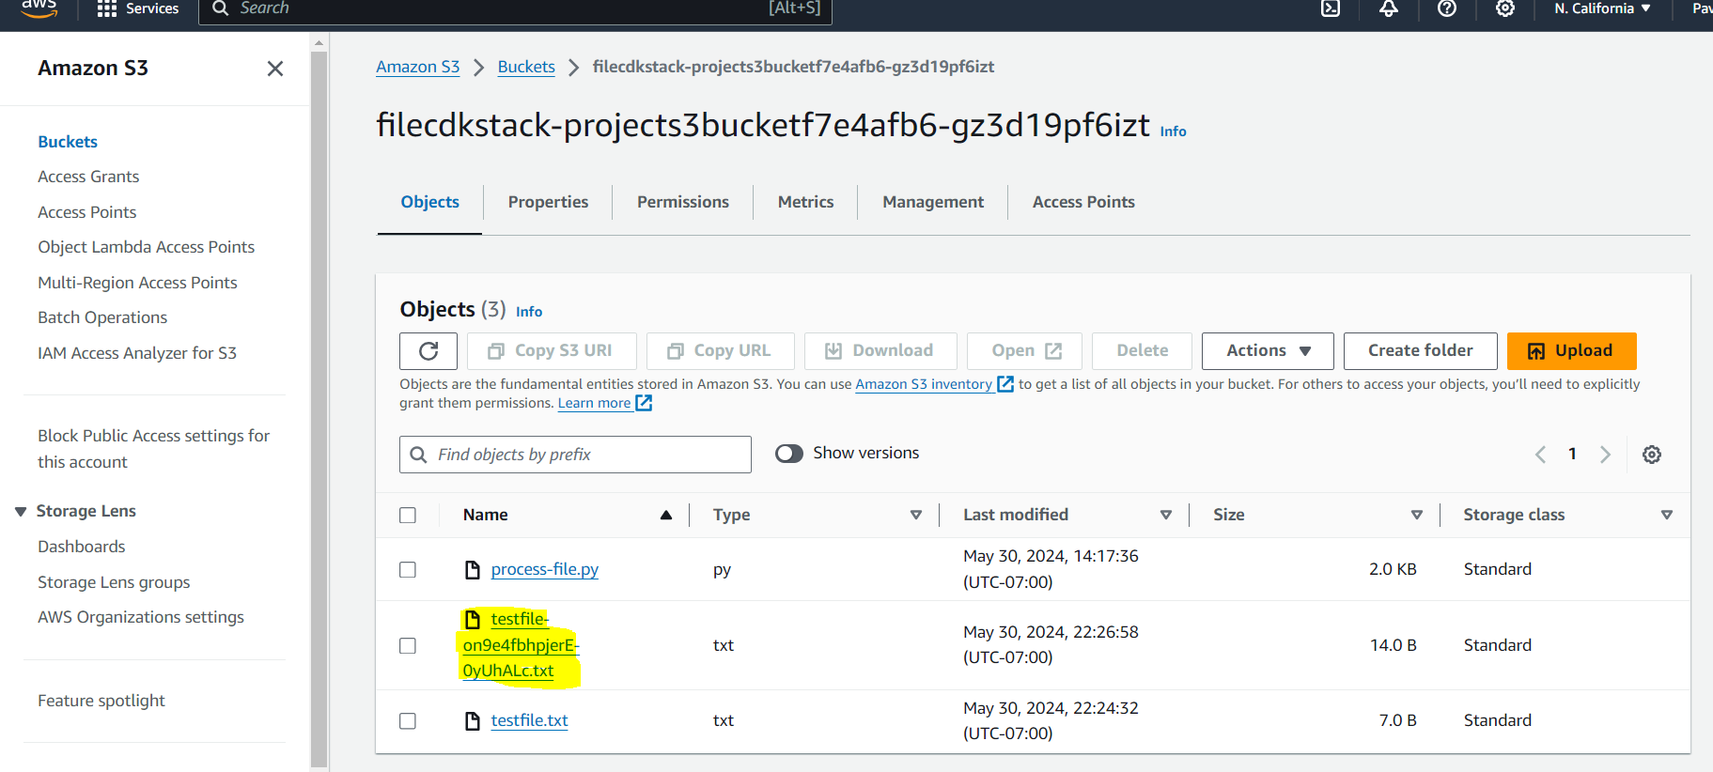

**Result 7**: EC2 instance has been terminated once the output file has been generated.

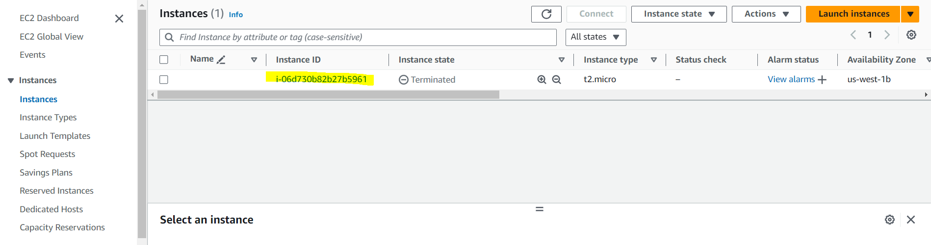

**Result 8**: This shows the output file, which has the combined text input, and the text from the file that has been uploaded. “welcome hi new”

