Give me some idea on what is a Data type. What are Primitive Data types and Non-Primitive Data types. Explain with some examples.

**Data type:**

* Data type is used to specify what kind of data is stored in the variable and the operations that can be performed on that value.
* There are two data types:
  1. Primitive Data types
  2. Non-Primitive Data types

**Primitive Data types:**

* Primitive data types are the most basic types of data.
* They are used to store only single value.
* They are available by default.
* They are immutable (their values cannot be modified after they are created).
* They directly store the value in the memory.
* There are various primitive data types:
  1. String
  2. Number
  3. Boolean
  4. Null
  5. Undefined

1. **String:**

* String represents sequence of characters (text).
* A string can be declared using single quotes(‘ ‘), double quotes(“ “), and back-tick or template literals (` `).

Ex:

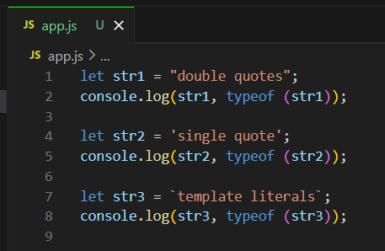

Output:

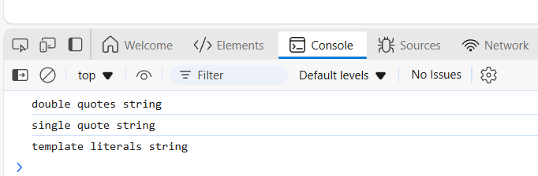

1. **Number:**

* It is used to store numerical values, including both integers and floating-point numbers (decimals).
* JavaScript does not distinguish between integers and floating-point numbers( they are both stored as “Number”).

Ex:

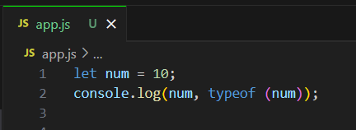

Output:

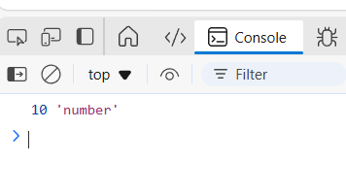

1. **Boolean:**

* It represents a logical entity with two possible values: true or false.
* They are commonly used in conditional statements (like if statements) to control the flow of the program based on certain conditions.

Ex:

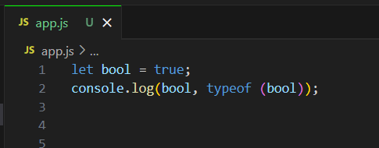

Output:

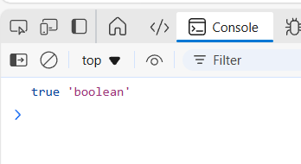

1. **Null:**

* It represents the intentional absence of any object value.
* It’s a special value that indicates that a variable has no value.

Ex:

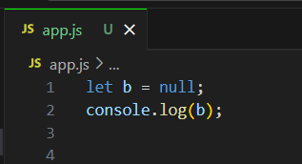

Output:

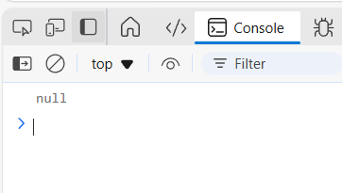

1. **Undefined:**

* It represents a variable that has been declared but not yet assigned a value.
* Automatically assigned to variables that are declared but not initialized.

Ex:

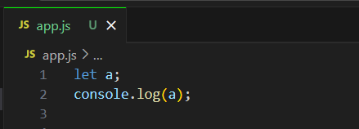

Output:

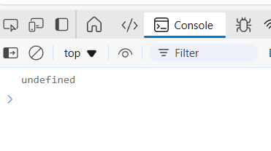

**Non-primitive data types:**

* Non-primitive data types are more complex and can store multiple values.
* They are mutable (their content can be modified after creation).
* These data types are stored as references to memory locations, not directly in the memory.
* There are various types of non-primitive data types:
  1. Object
  2. Array
  3. Function

1. **Object:**

* It represents a collection of key-value pairs (also called properties).
* Each key (property) can have a value, and that value can be a primitive or non-primitive data type.

Ex:

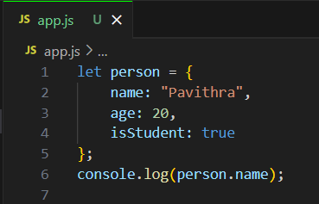

Output:

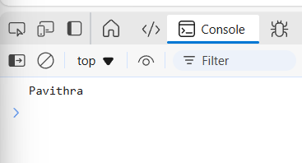

1. **Array:**

* It represents an ordered collection of values, which can be of any type, including other arrays or objects.
* Arrays are indexed, starting from 0.

Ex:

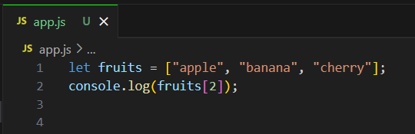

Output:

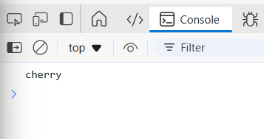

1. **Function:**

* Functions in Java Script are first-class objects, meaning they can be assigned to variables, passed as arguments to other functions, or returned from other functions.

Ex:

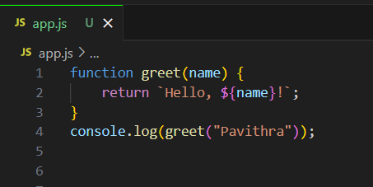

Output:

