Date: 22-03-2026
Project Title: Cricket Highlights Generator
Team Members:
- Akshitha Chirumavilla (111622104013)
- Jayashni T (111622104040)
- Hema Shree M J (111622104032)
- Pavithra V (111622104065)
College: R.M.K. College of Engineering and Technology
CASE STUDY: CRICKET HIGHLIGHTS GENERATION SYSTEM
1. PROBLEM STATEMENT
In modern cricket, matches last for several hours. Many viewers do not have enough time to watch the full match. Instead, they prefer watching highlights.
However, not every ball in a match is important. The challenge is:
- How to automatically select only the most important moments
- While still covering the entire match in a short duration
2. OBJECTIVE
The objective of this project is to:
- Automatically generate cricket highlights
- Select only important events (wickets, sixes, fours)
- Include milestones (half-centuries and centuries)
- Ensure the entire match is covered
- Limit highlights to a fixed number (20 moments)
- Present highlights in IPL-style format

3. INPUT DESIGN
In this project, the match data is taken as hardcoded input inside the program.
Reason:
- Focus on core highlight logic
- Avoid input complexity
- Simulate real match data
4. APPROACH OVERVIEW
The system follows:
- Rule-based selection
- Score-based prioritization
- Smart filtering
- Match-order reconstruction
5. CODE EXPLANATION
5.1 STRUCTURES
Ball Structure
struct Ball {
string over;
string event;
int runs;
string batsman;
};
What we did:
We created a structure to store each ball’s data.
Why:
To keep all match information organized:
- over → when event happened
- event → what happened
- runs → for milestone calculation
- batsman → to track individual performance
Highlight Structure
struct Highlight {
string over;
string event;
int score;
};
What we did:
Created a separate structure for highlights.
Why:
After processing, we only need:
- event
- over
- score
This reduces unnecessary data and improves efficiency.
5.2 PARSE FUNCTION
pair<int,int> parseOver(string s)

What we did:
Converted over from string ("18.3") → integers (18, 3)
Why:
String comparison gives wrong order:
"10.1" < "2.1" (wrong)
Using integers ensures:
- Correct match sequence sorting
5.3 RULE ENGINE
int getScore(string event, string over)
What we did:
Assigned scores to each event.
Why:
To identify importance of events.
Base Scores
- WICKET → 10
- CENTURY → 9
- HALF CENTURY → 8
- SIX → 7
- FOUR → 6
Why:
Different events have different impact on match.
Pressure Logic
if (overNum >= 16) base += 3;
What we did:
Increased score in death overs.
Why:
Late-match events are more important (match deciding).
Clutch Logic
if (event == "WICKET" && overNum >= 16)
What we did:
Extra score for critical moments.
Why:
These events change match outcome.
5.4 MATCH DATA INPUT
vector<Ball> match = {...};
What we did:
Stored match data manually.
Why:
- Simplifies testing
- Avoids input errors
- Simulates real match
5.5 MILESTONE TRACKING
map<string,int> batterRuns;
What we did:
Tracked runs for each batsman.
Why:
To detect:
- Half-century (50 runs)
- Century (100 runs)
if (runs >= 50)
Why:
Milestones are important highlights in cricket.
5.6 EVENT FILTERING
if (SIX || FOUR || WICKET)
What we did:
Selected only important events.
Why:
Ignore:
- dot balls
- low-impact moments
5.7 SORTING BY SCORE
sort(all.begin(), all.end(), ...)
What we did:
Sorted events by importance.
Why:
To select top highlights first.

5.8 SMART FILTERING
limit SIX, FOUR, WICKET
What we did:
Limited repeated events.
Why:
Avoid:
- Too many sixes or only wickets
Ensures:
- Balanced highlights
5.9 ENSURE 20 HIGHLIGHTS
while(size < 20)
What we did:
Filled remaining highlights.
Why:
Project requirement:
- Exactly 20 highlights
5.10 MATCH ORDER SORTING
sort using parseOver()
What we did:
Sorted final highlights in match order.
Why:
To maintain:
- Story flow of match
5.11 OUTPUT DESIGN

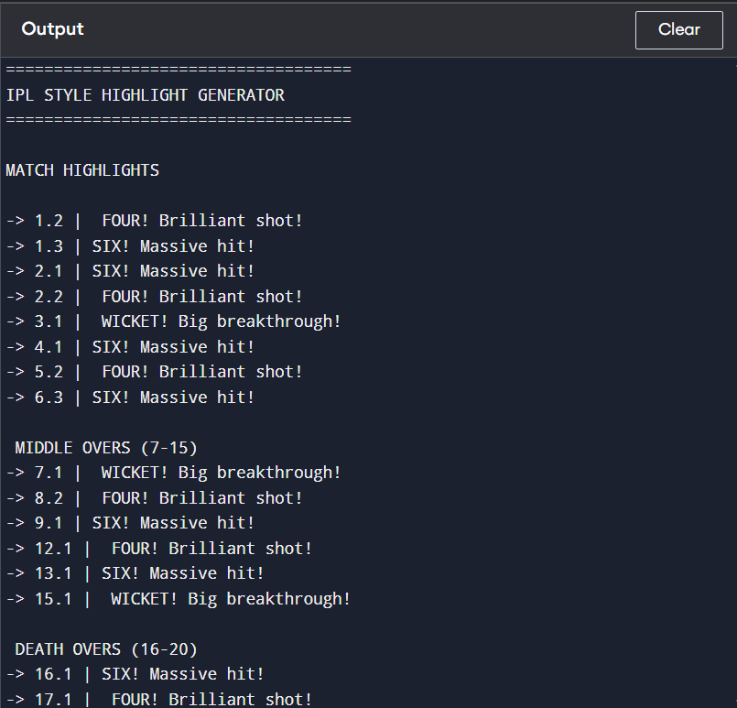
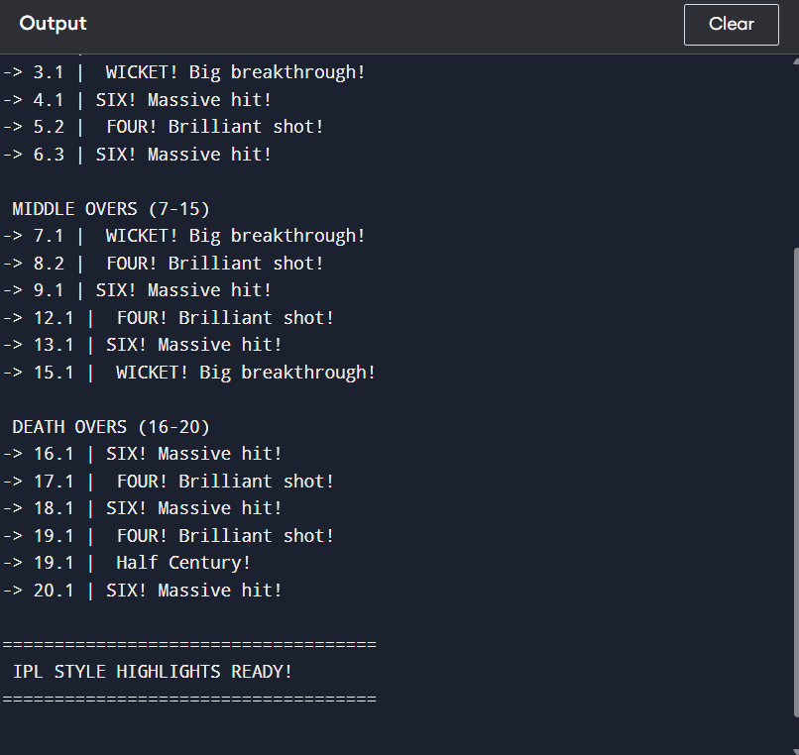
What we did:
Printed highlights in IPL format.
- Powerplay
- Middle overs
- Death overs
Why:
To make output:
- Realistic
- User-friendly
6. FINAL RESULT
The system:
- Selects 20 best highlights
- Covers entire match
- Includes milestones
- Maintains match flow
- Looks like IPL highlights
7. CONCLUSION
This project demonstrates:
- Efficient use of rule-based systems
- Importance of data structuring
- Real-world simulation of sports analytics
8. FUTURE IMPROVEMENTS
- Real-time match data input
- Video processing
- AI-based scoring
- Web UI integration

