\*\*The file where the details of users is saved is\*\*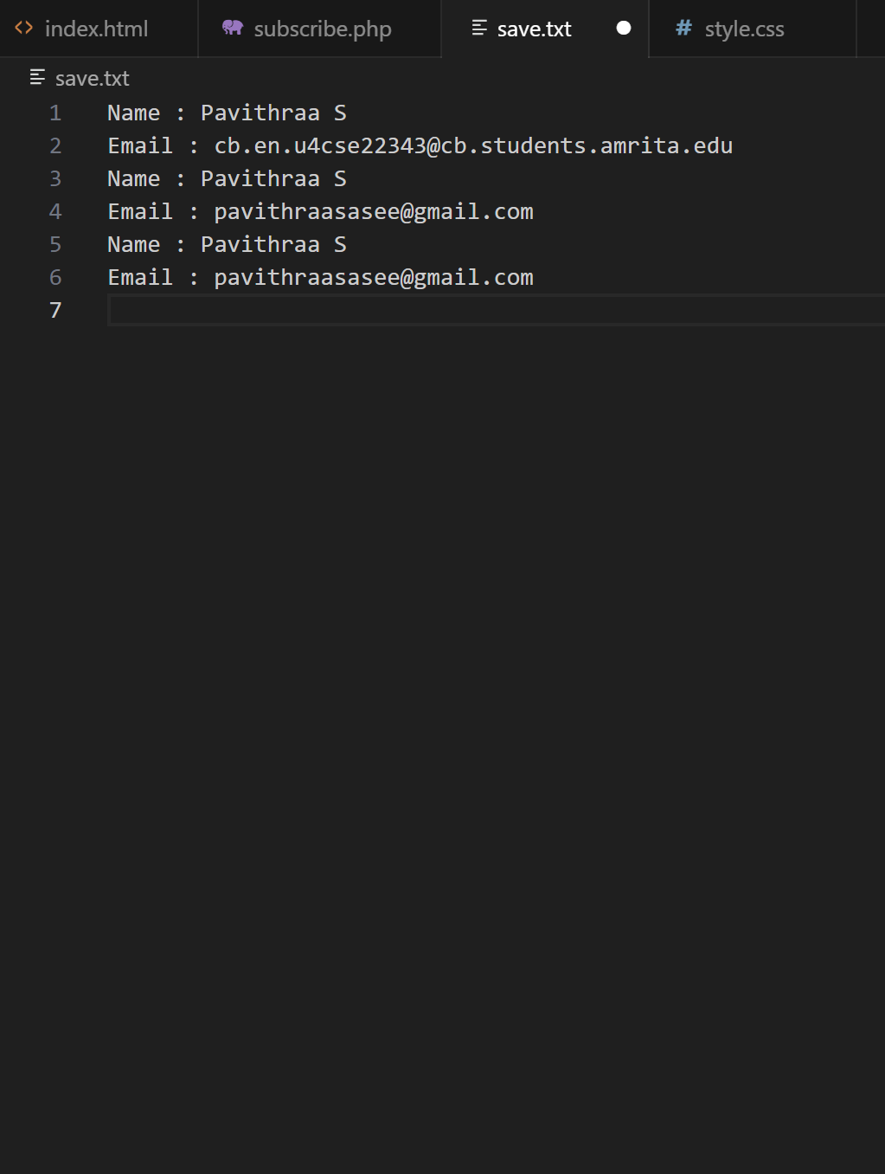

API Used: OpenWeatherMap

Why I chose OpenWeatherMap?

I used other APIs like rapid API which requires many configurations and an extension to be downloaded in vs code and the rest of them had hard limits for number of API calls per day or their availability of cities were not available and I felt this was more user friendly and simple to use and had many citty options as well.

Ideas for future modifications to this dashboard

1.Different theme options(bright colors,user input color palette,aesthetic option,movies & web series themes)

2.User should be asked for height, weight,bmi and other physical details and this should suggest type of dress,no.of layers of clothes is necessary for them etc.

3.Integrating to do list and calandar of the user with the weather dashboard. With the help of ai build a interactive interface where it suggests plans according to weather and notifies when rains are predicted on the day u are planning to go out and etc.

Leveraging ChatGPT and Google BARD for debugging tasks has significantly enriched my troubleshooting toolkit.

Thank You