**COMPUTER NETWORKS**

**HOTEL MANAGEMENT COMMUNICATION SYSTEM USING**

**CISCO PACKET TRACER**

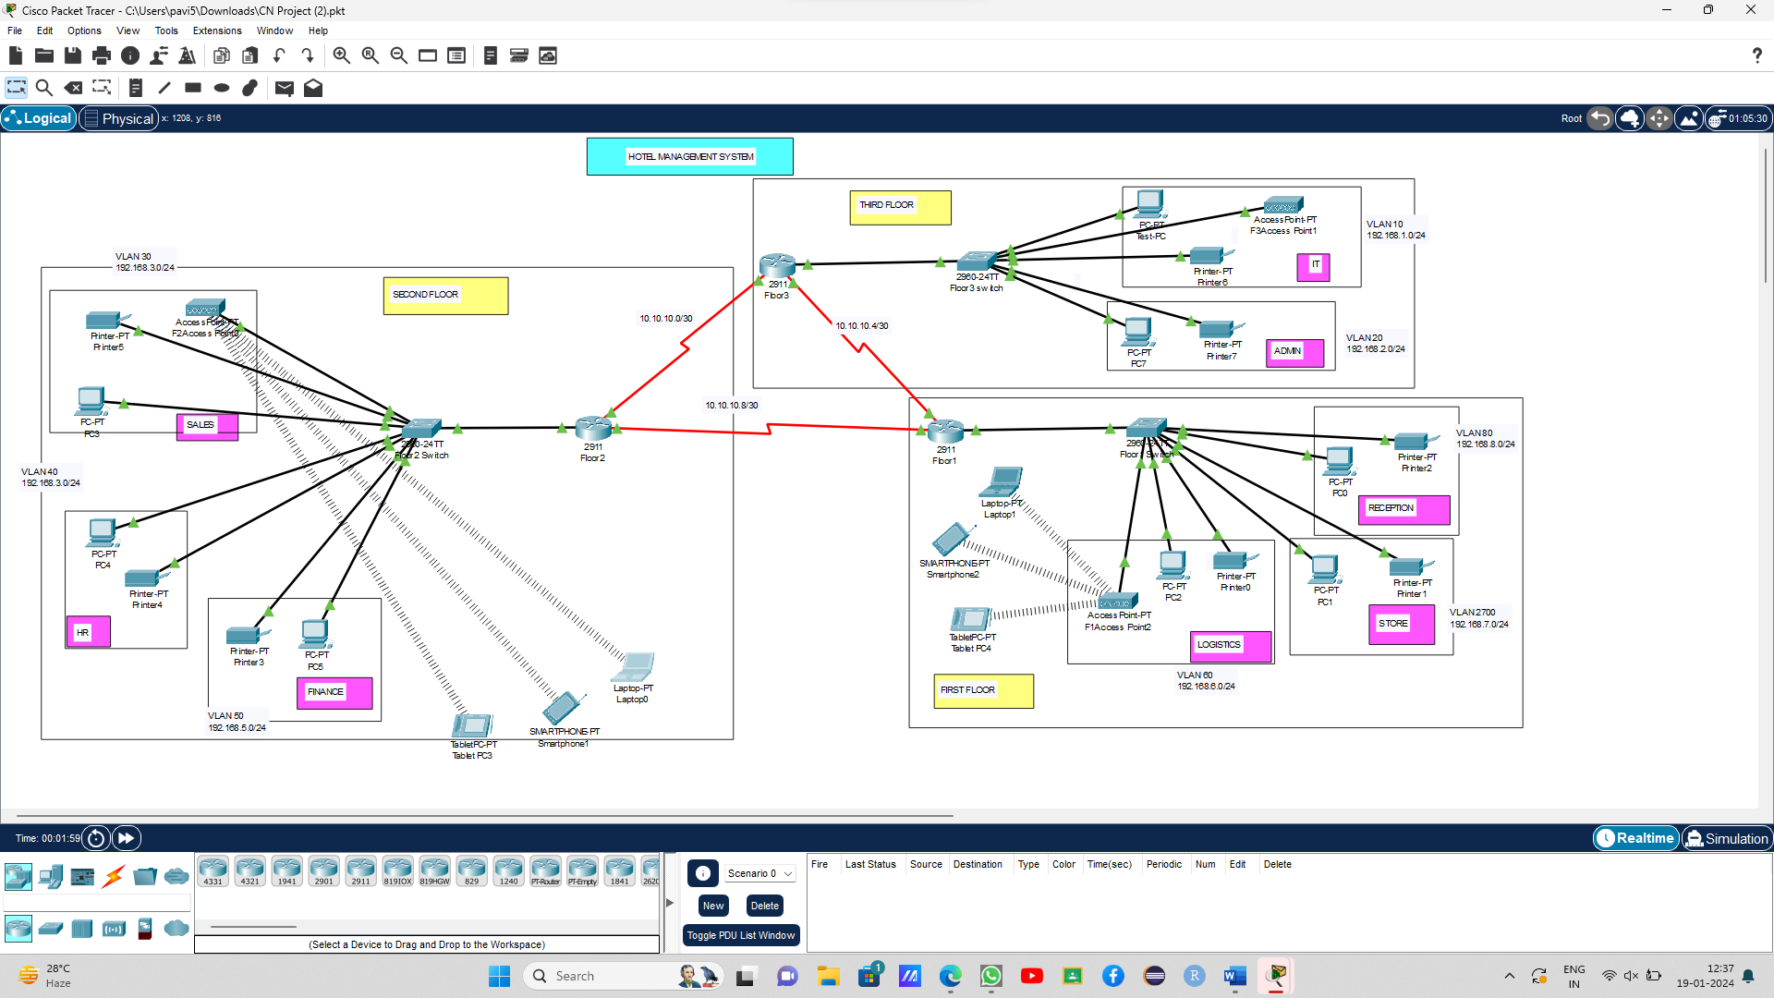

The main idea is to leverage networking technologies, simulate devices, and emulate the functionalities of a hotel's IT system. We have three routers which represents each router for each floor. Each router is connected to a switch and access point (Wifi Module). Protocols used in this project are,

* **DHCP (Dynamic Host Configuration Protocol):** DHCP is used to automatically assign IP addresses to devices on the network, including computers, printers, and other devices used in hotel management.
* **DNS (Domain Name System):** DNS is used to translate human-readable domain names into IP addresses. It plays a crucial role in allowing devices to locate and communicate with each other on the network.

**First Floor:** has three departments- reception, logistics, store. Reception has a printer and a pc. Store as a printer and a pc. Logistics has a printer, a pc and an access point common to all the departments in that floor.

**Second Floor**: has three departments – sales, HR, Finance. HR has a printer and a pc. Finance has a printer and a pc. Sales has a printer, a pc and an access point common to all the departments in that floor.

**Third Floor**: has two departments – IT, Admin. Admin has a printer and a pc. IT has a printer, a pc and an access point common to all the departments in that floor.

Each router are assigned with IP address of its own. All routers are connected with each other using serial DCE. Then each routers are connected with one switch and the departments are created where then vlan address are given. Each department is given connection to the devices in that department. The configuration is made for the each devices in the each department. The every access point in each floor is given IP address , name and password. Now wifi module is ready to pair with device. Select the device to which you want to connect, click on the device, go to config, and provide the name and password of the nearest access point.