**AWS Task-2**

Set up a VPC with an Internet gateway, create a public subnet with 256 IP addresses, a private subnet with 256 IP addresses, make a route table connecting the Internet gateway and the subnets, and launch a Linux EC2 instance by using the above VPC and public subnet.

* **VPC**

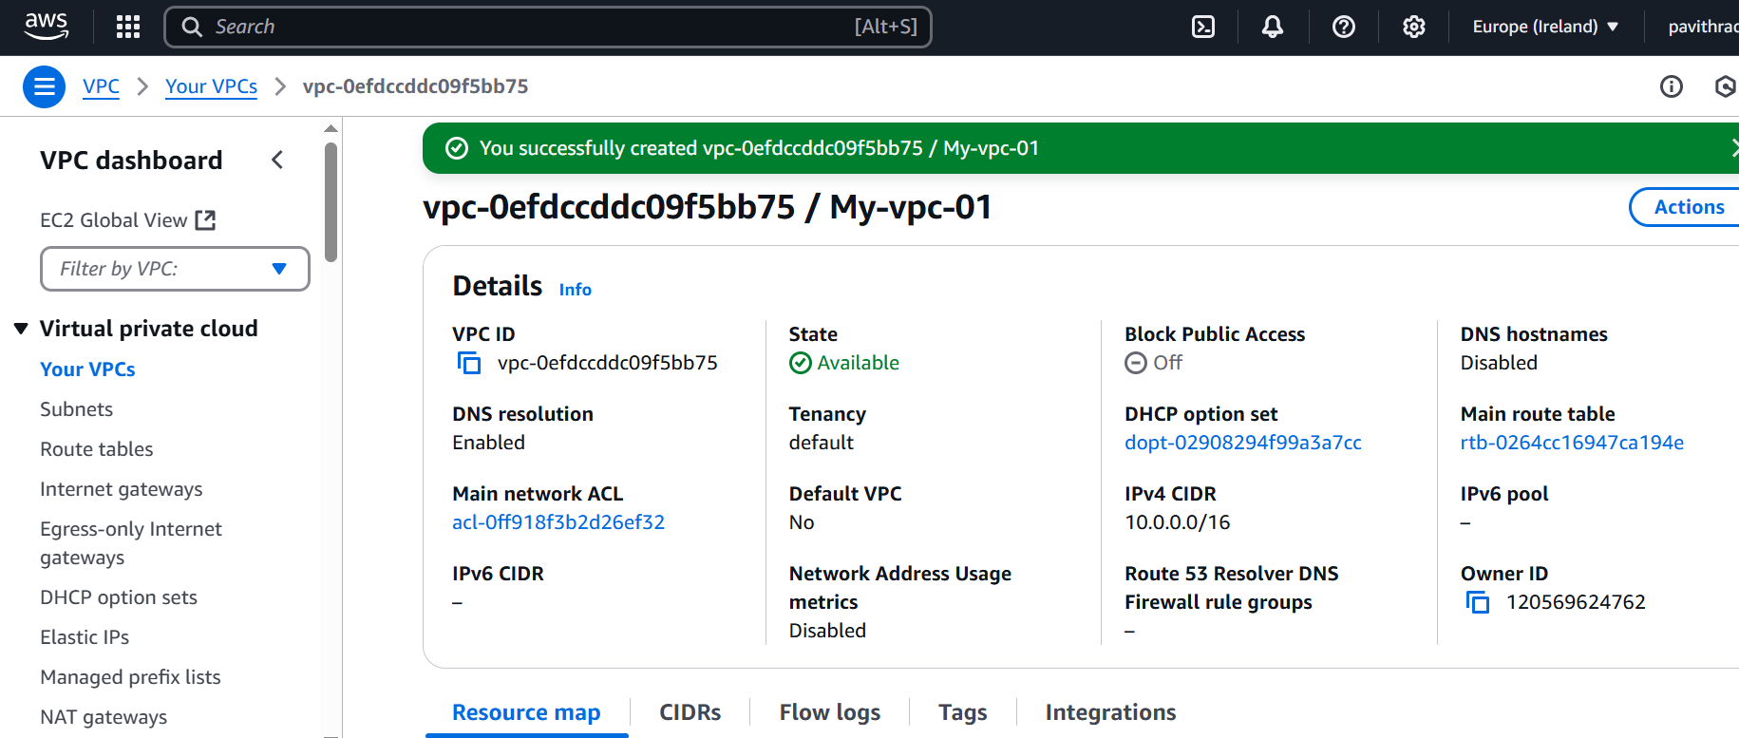

* **Internet**-**Gateway**

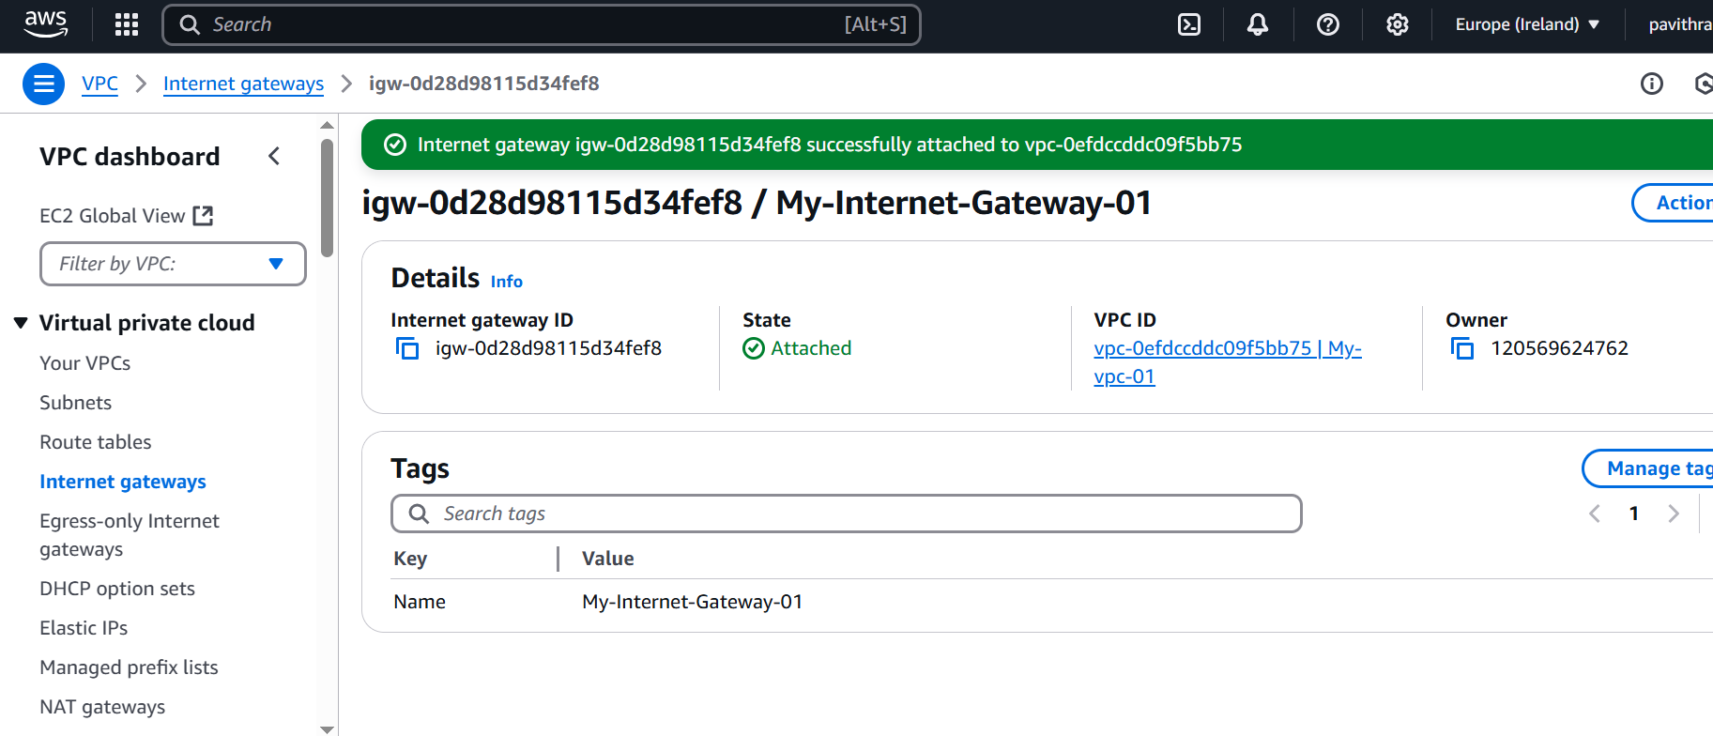

* **Subnet (public and private)**

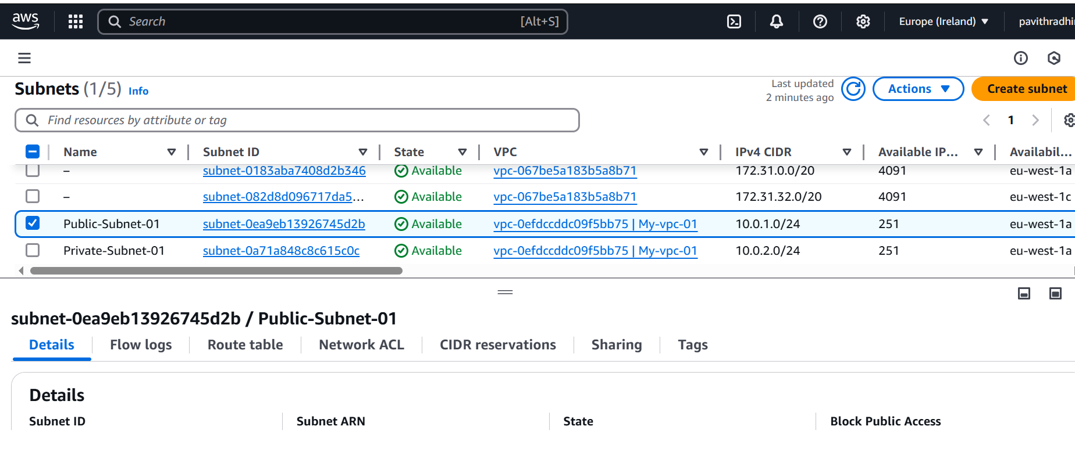

* **Route Table**

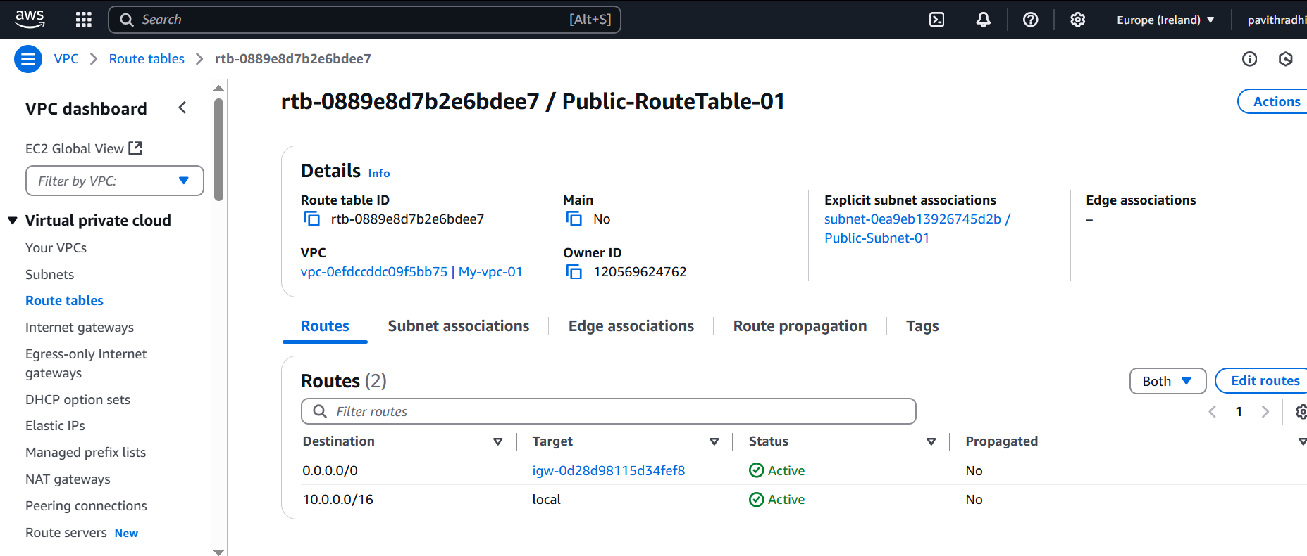

* **Ec2**

