**AWS Task-3**

**Task Description:**

1. Create a S3 bucket, with no public access and upload files to the bucket & view the logs using cloudwatch for the uploaded files.

* **S3 bucket creation**

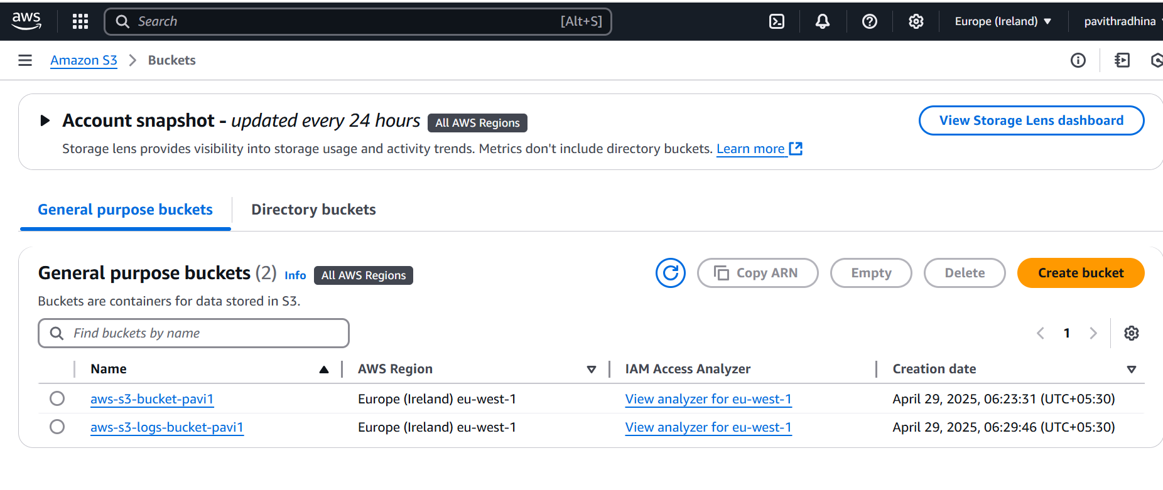

* Uploaded file to S3 bucket

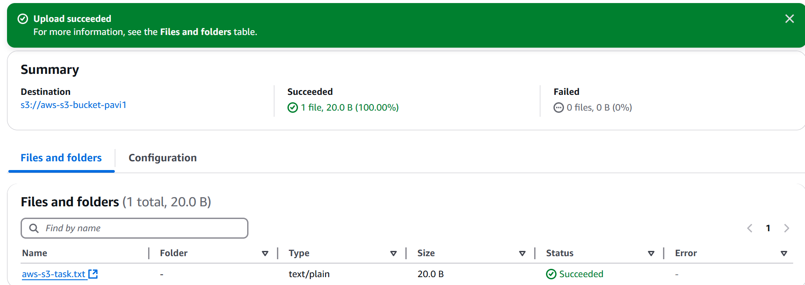

* Created cloudtrail to monitor cloud watch logs

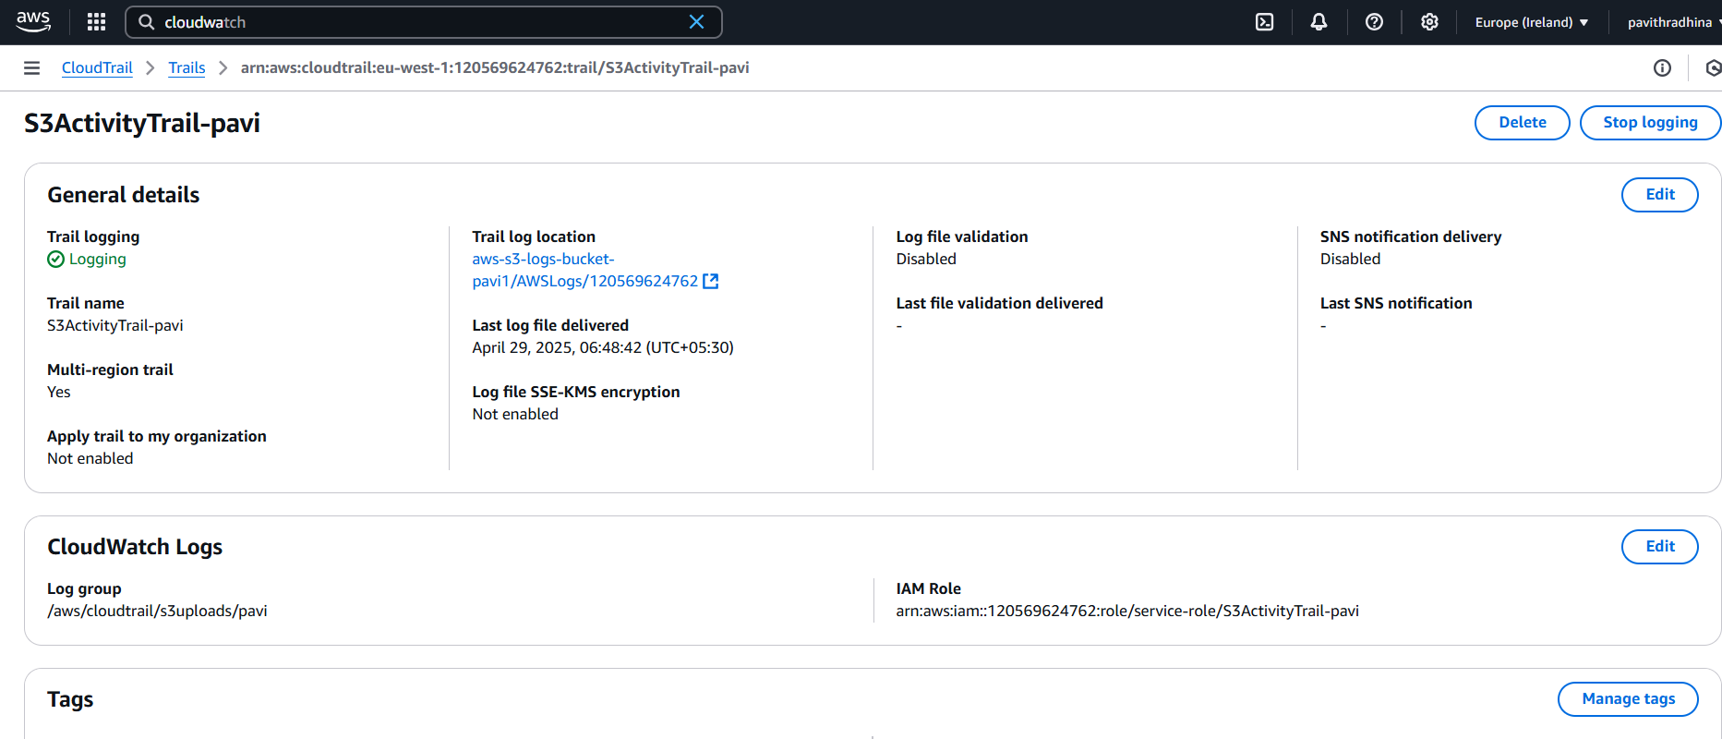

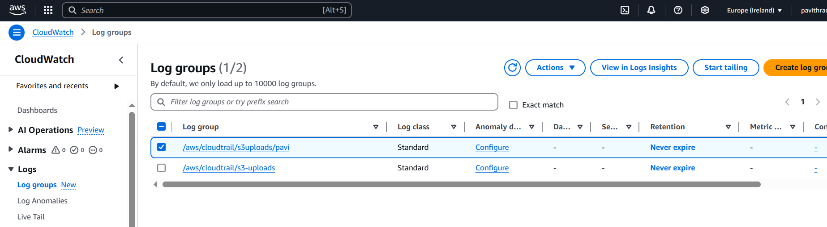

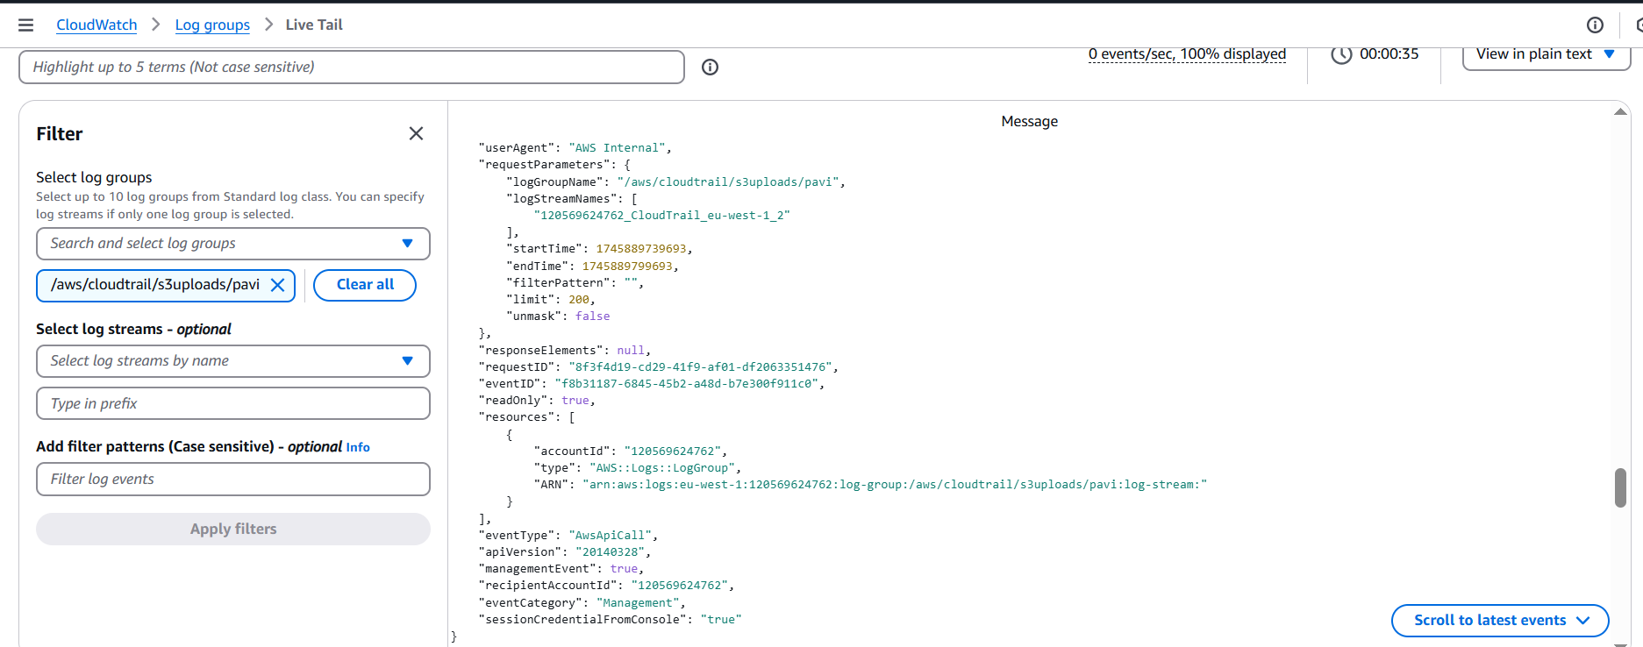

1. Launch two ec2-instances and connect it to application load balancer, where the output traffic from the server must be an load balancer IP address

* Created two ec2 Instances

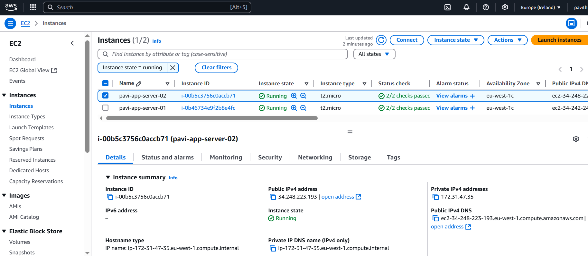

Installed Simple Web App on Each Instance

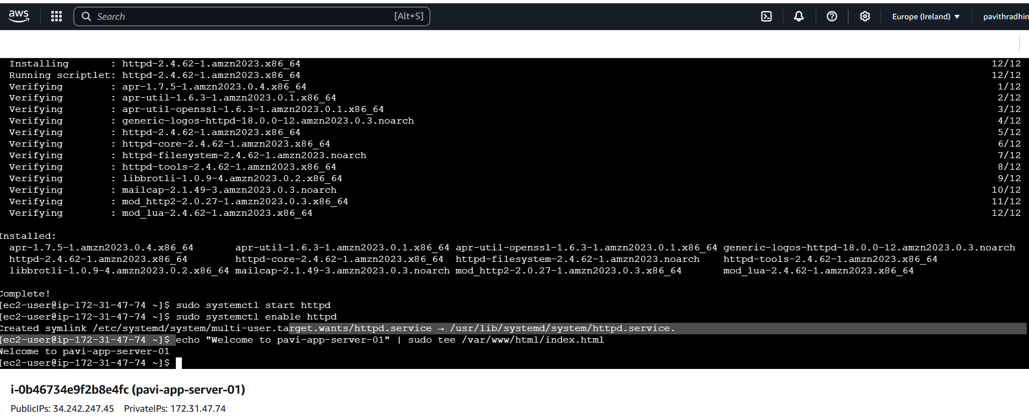

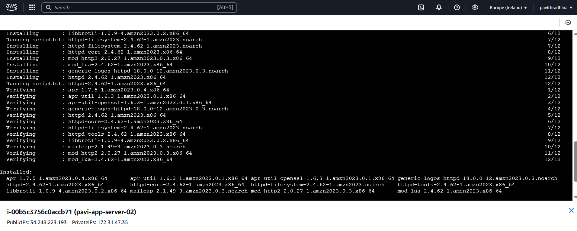

Created Loadbalancer and target group

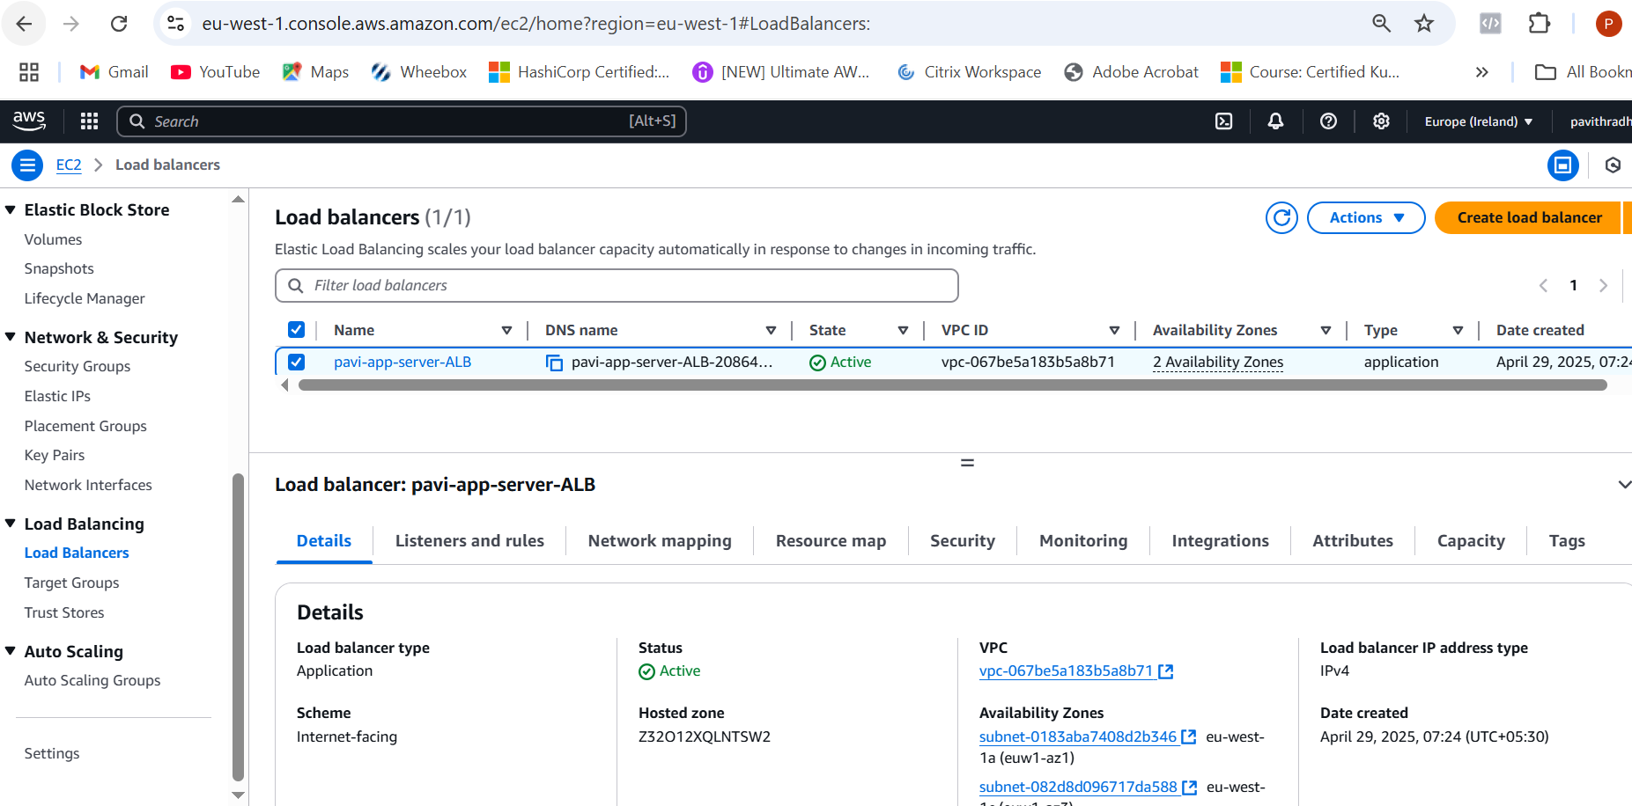

While hitting loadbalncer DNS name **"** **Welcome to pavi-app-server-01"**

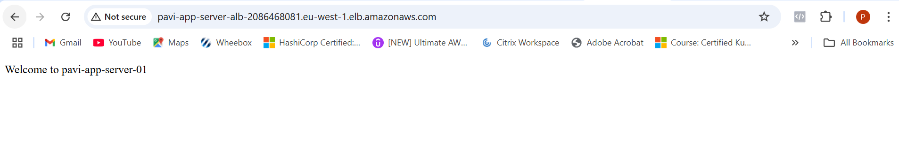

and **"Welcome to pavi-app-server-02"** randomly (load balancing).

