**AWS Task-4**

**Task Description:**

Launch an EC2 instance (Linux and Windows) along with a web server. Then, create an EBS volume of 5 GB, attach it to an EC2 machine (Linux and Windows), and take a snapshot. Finally, create an EBS volume using the taken snapshot.

Launch EC2 instance (Linux and Windows)

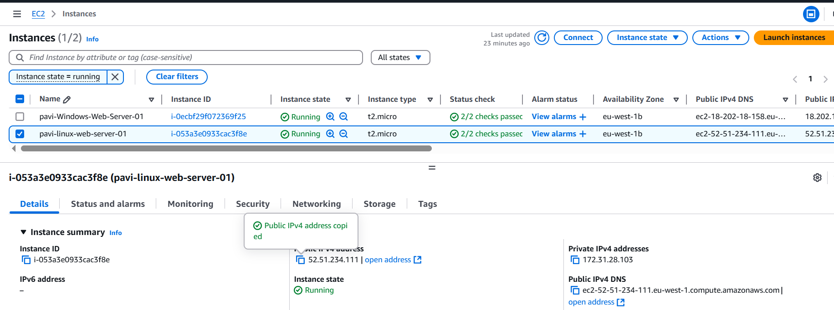

Connect via SSH

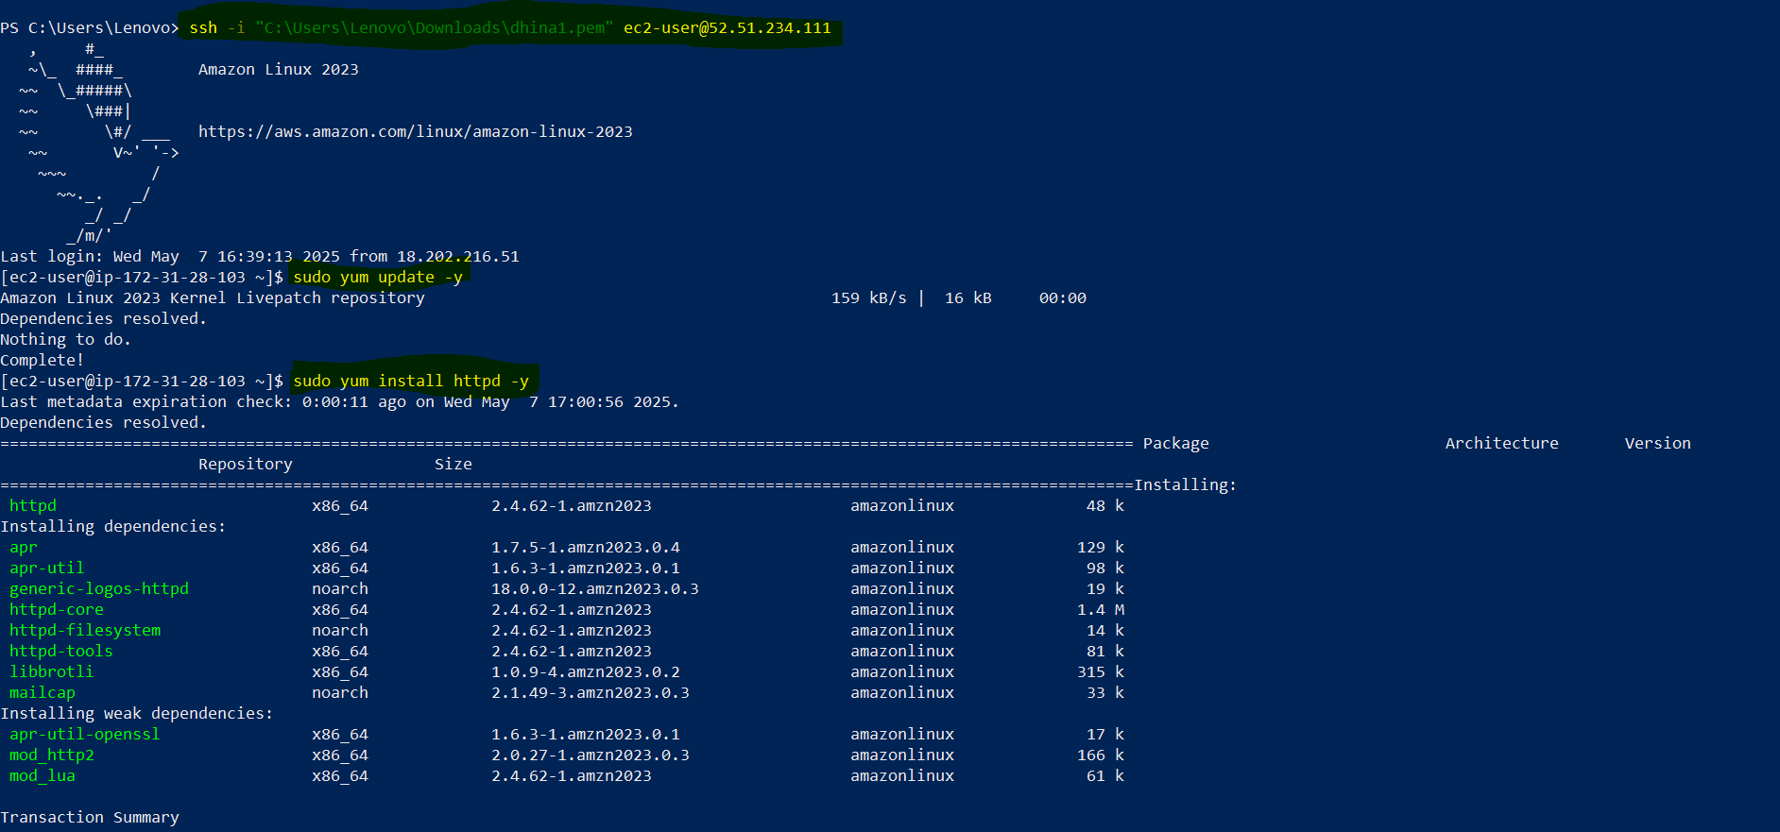

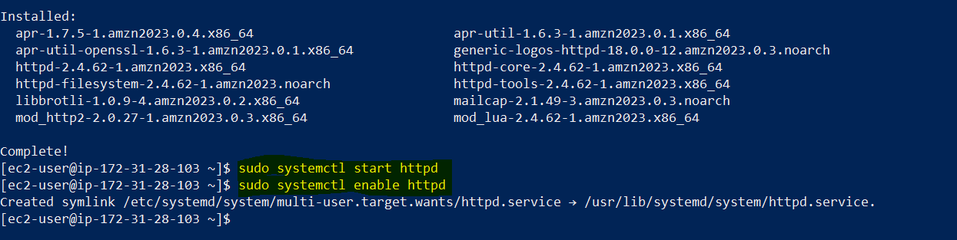

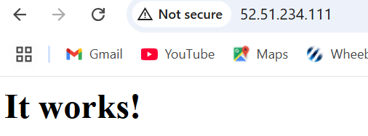

Create and Attach a 5 GB EBS Volume to the EC2 Instance

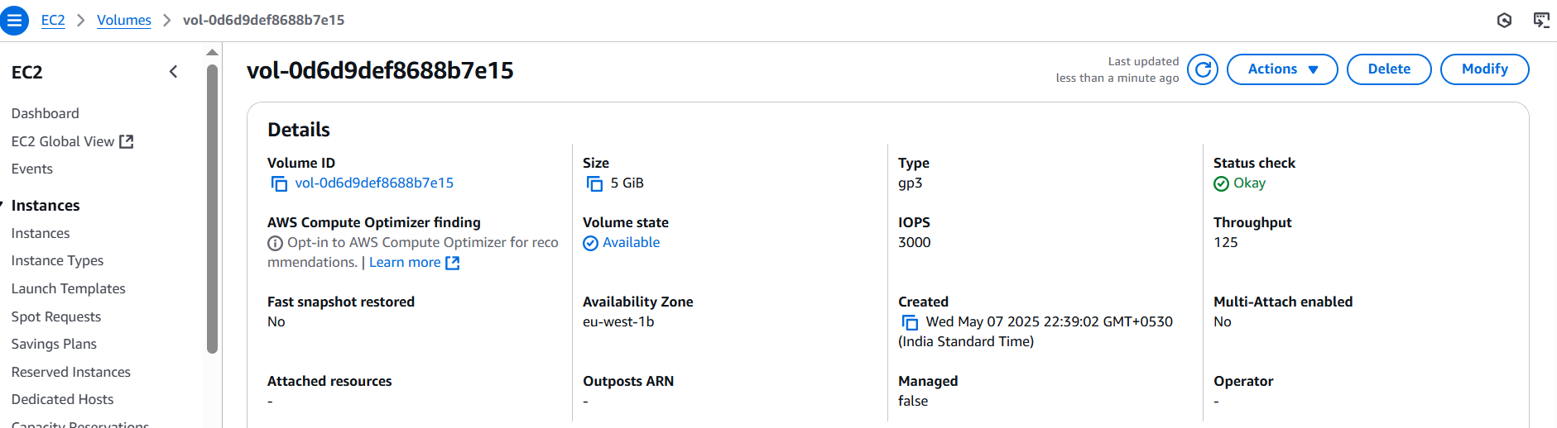

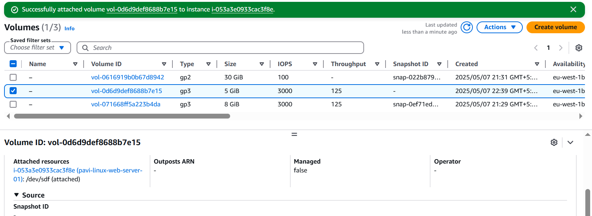

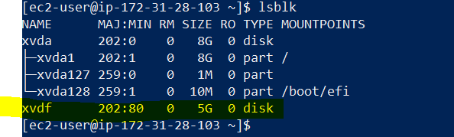

Format and Mount the EBS Volume

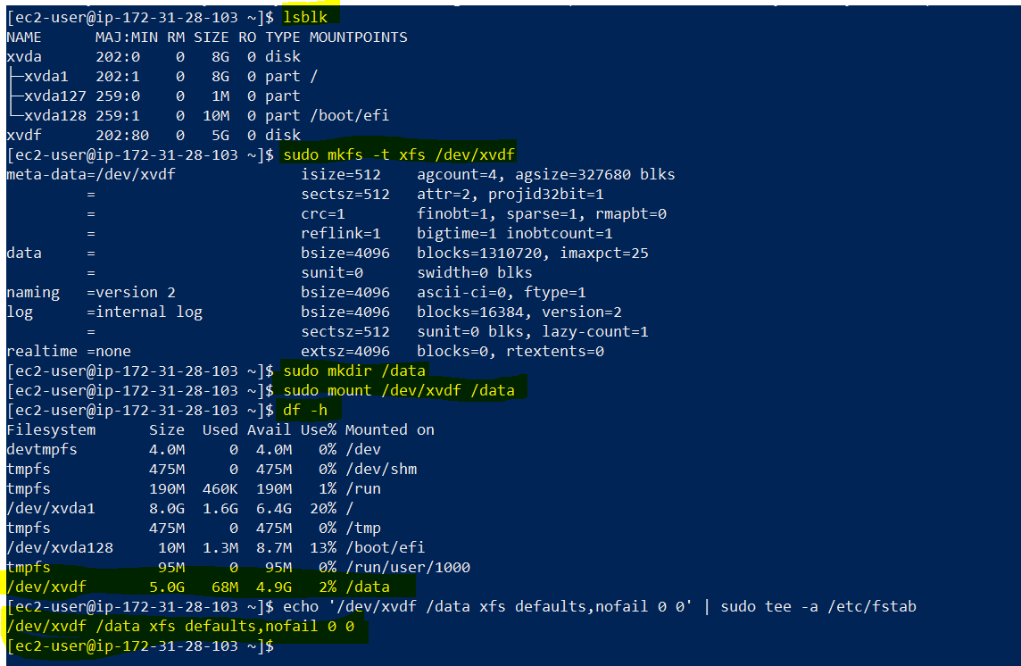

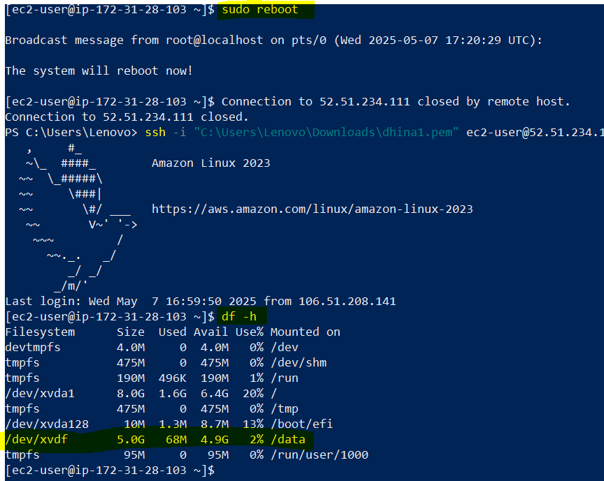After reboot it is still mounted.

Snapshot of the EBS Volume

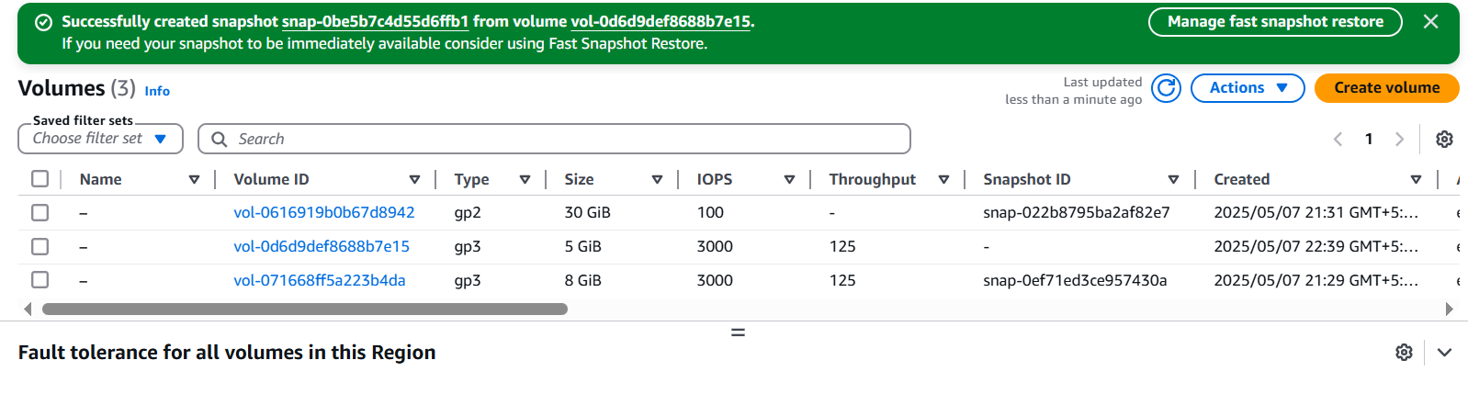

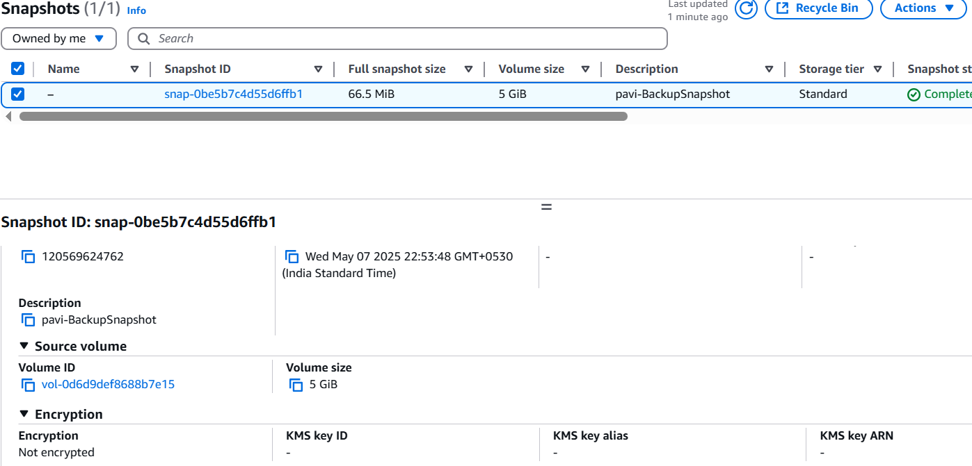

EBS Volume from the Snapshot

