**AWS Task-5**

**Task Description:**

Deploy a simple web application using AWS code commit, code build and deploy & access via browser and automate via codepipeline.

**Techstacks needs to be used :**

* AWS CI-CD (CodeCommit, CodeBuild, CodeDeploy, CodePipeline).

**How do I submit my work?**

* Push all your work files to GitHub (O/P screenshot images must).
* Submit your URLs in the portal.

**Terms and Conditions?**

* You agree to not share this confidential document with anyone.
* You agree to open-source your code (it may even look good on your profile!). Do not mention our company’s name anywhere in the code.
* We will never use your source code under any circumstances for any commercial purposes; this is just a basic assessment task.

**NOTE:** Any violation of Terms and conditions is strictly prohibited. You are bound to adhere to it.

**Solution:**

**Created a GitHub repository** named aws-task-5-web-app containing project files (index.html, buildspec.yml, appspec.yml, and workflow file).

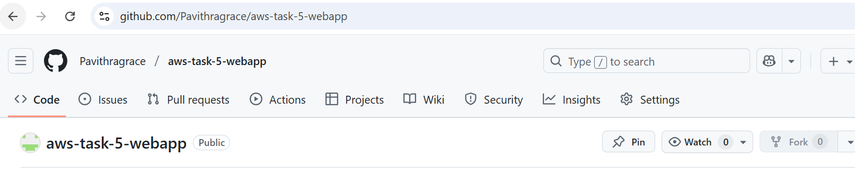

**Configured an Amazon S3 bucket named task5-pavithra-ap-south-1 with Static Website Hosting enabled to serve content publicly.**

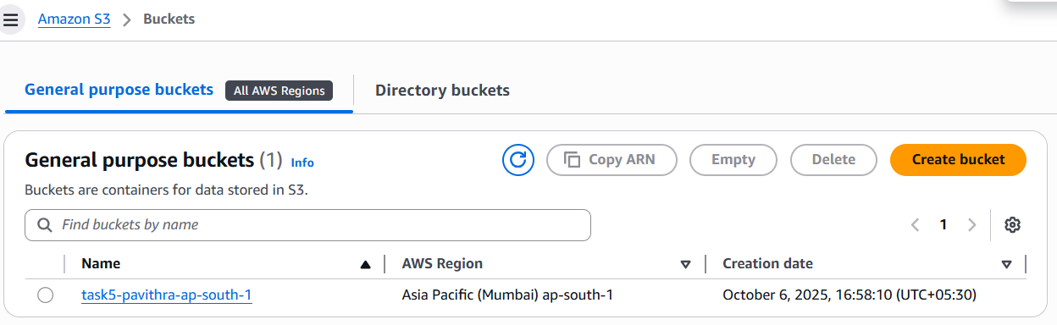

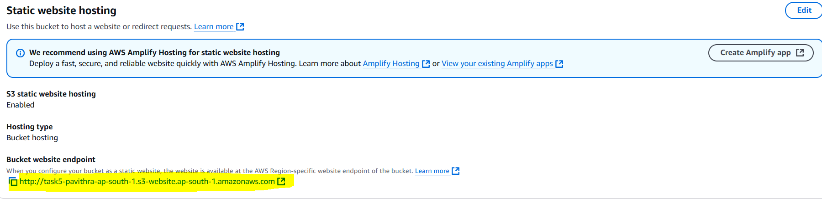

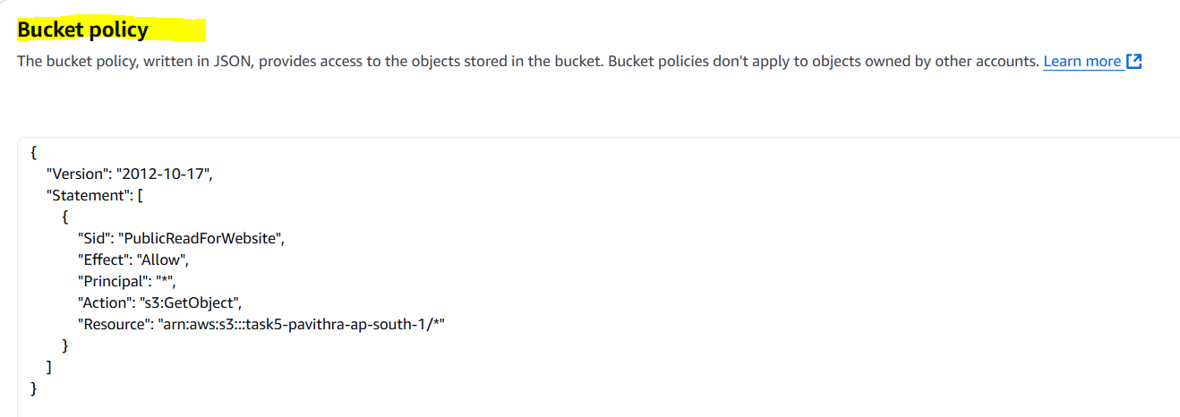

**Uploaded file manually got this result**

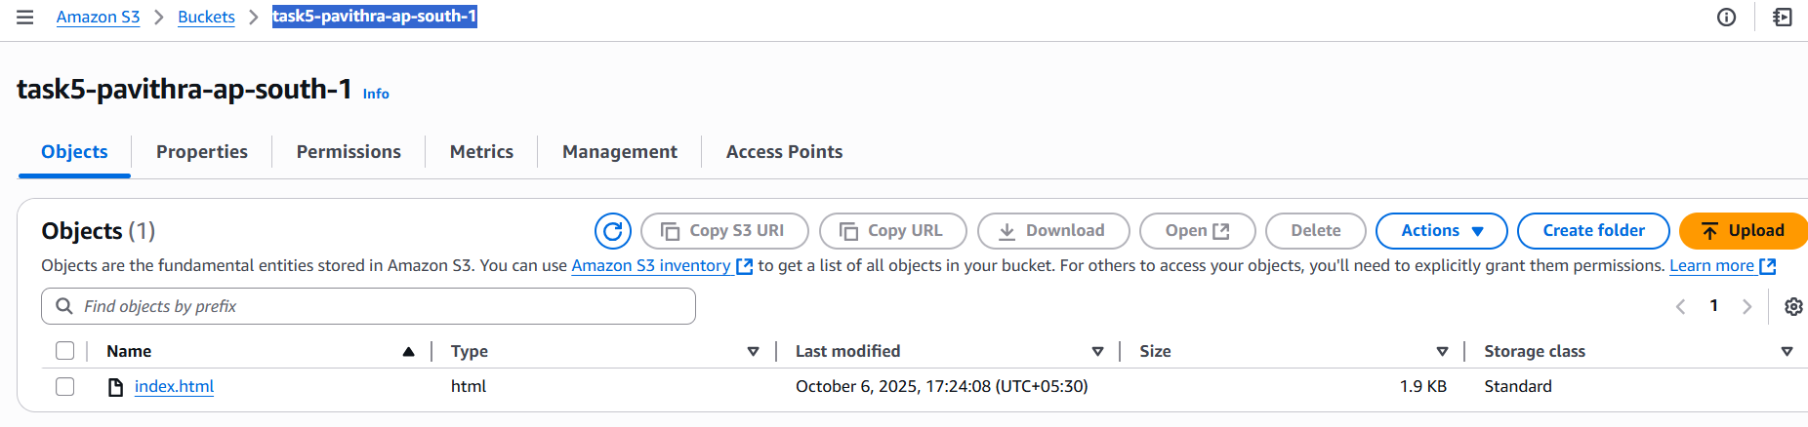

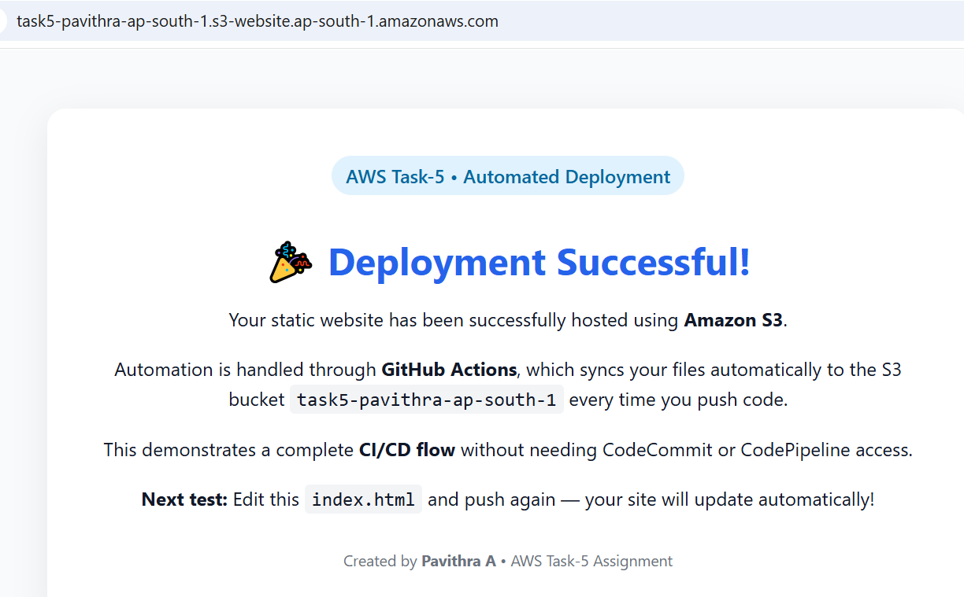

**Now l Automated**

**Added AWS Access Key ID and Secret Access Key as GitHub repository secrets for secure authentication.**

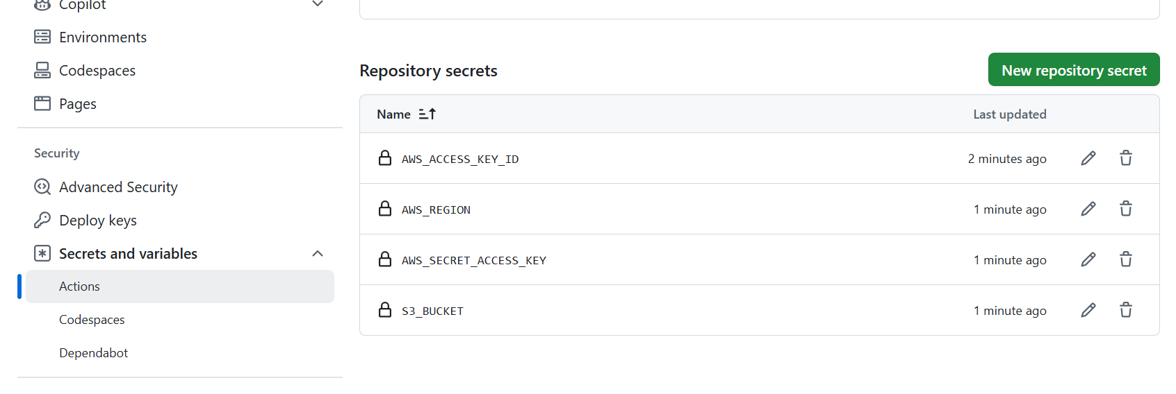

**Configured the GitHub Actions YAML** to:

* install AWS CLI,
* sync files to the S3 bucket (aws s3 sync . s3://task5-pavithra-ap-south-1 --delete)

**Committed and pushed changes** to GitHub → workflow triggered automatically → files synced to S3.

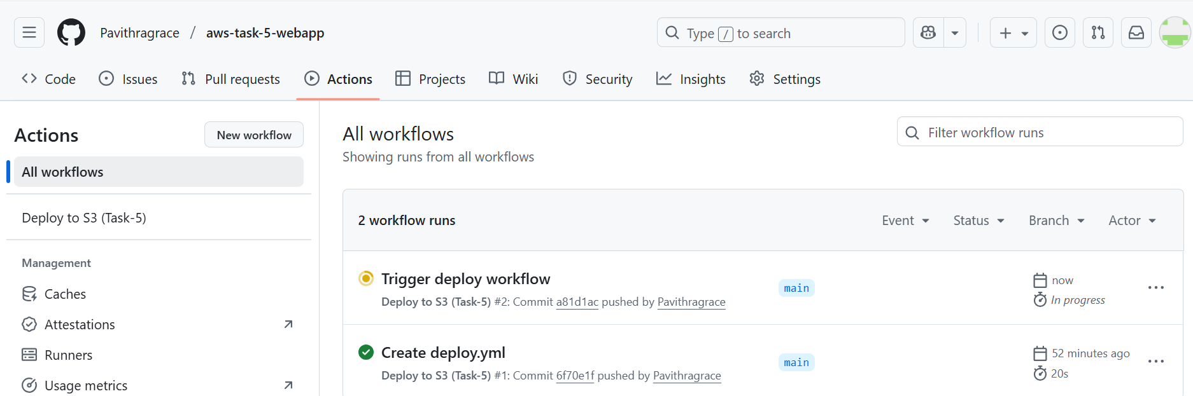

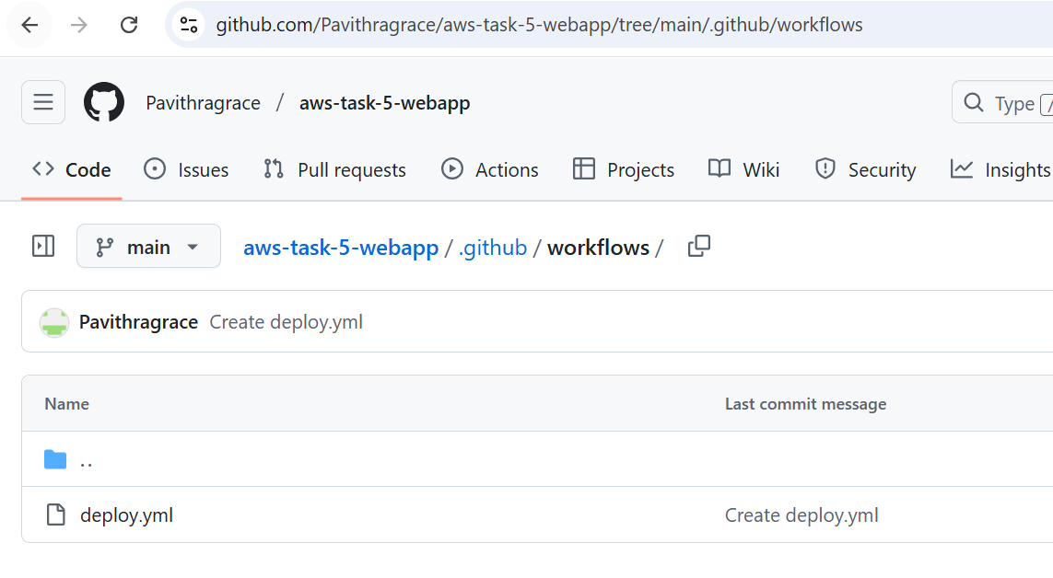

**Tested CI/CD flow** by editing index.html → pushing again → GitHub Actions automatically redeployed updated files.

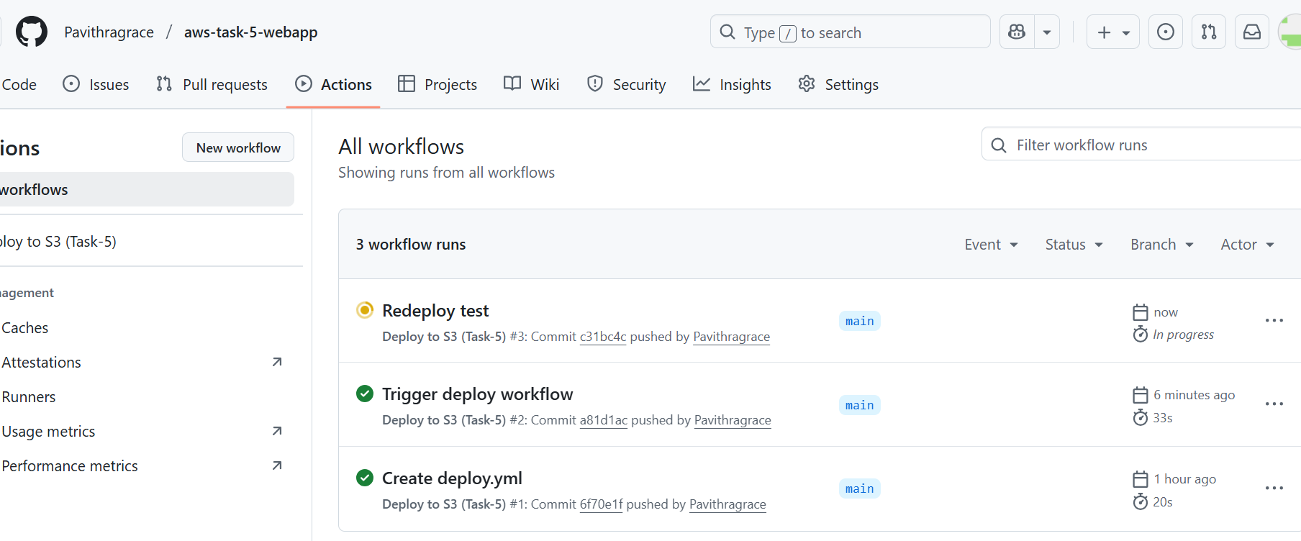

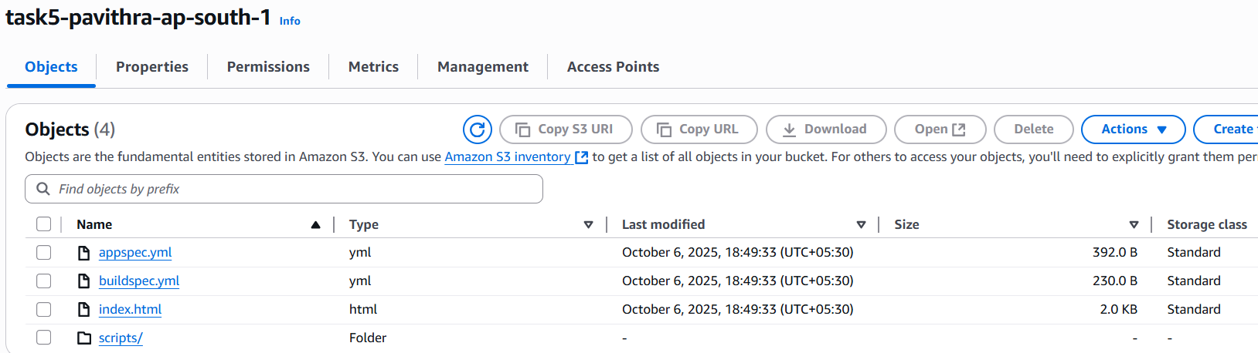

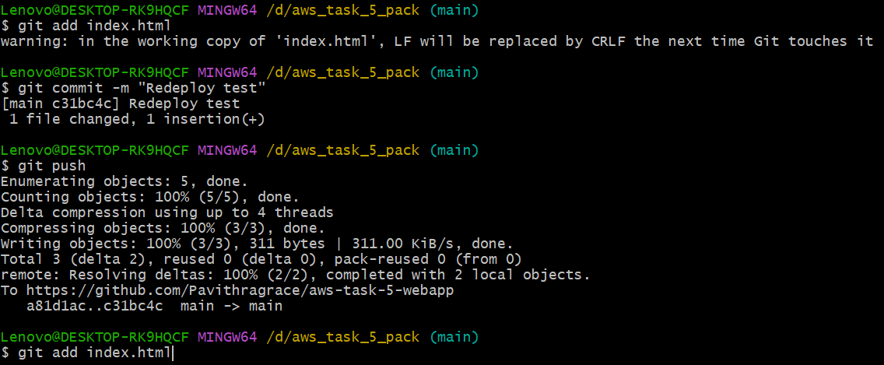

**Verified deployment** by visiting the bucket website endpoint  
 http://task5-pavithra-ap-south-1.s3-website.ap-south-1.amazonaws.com

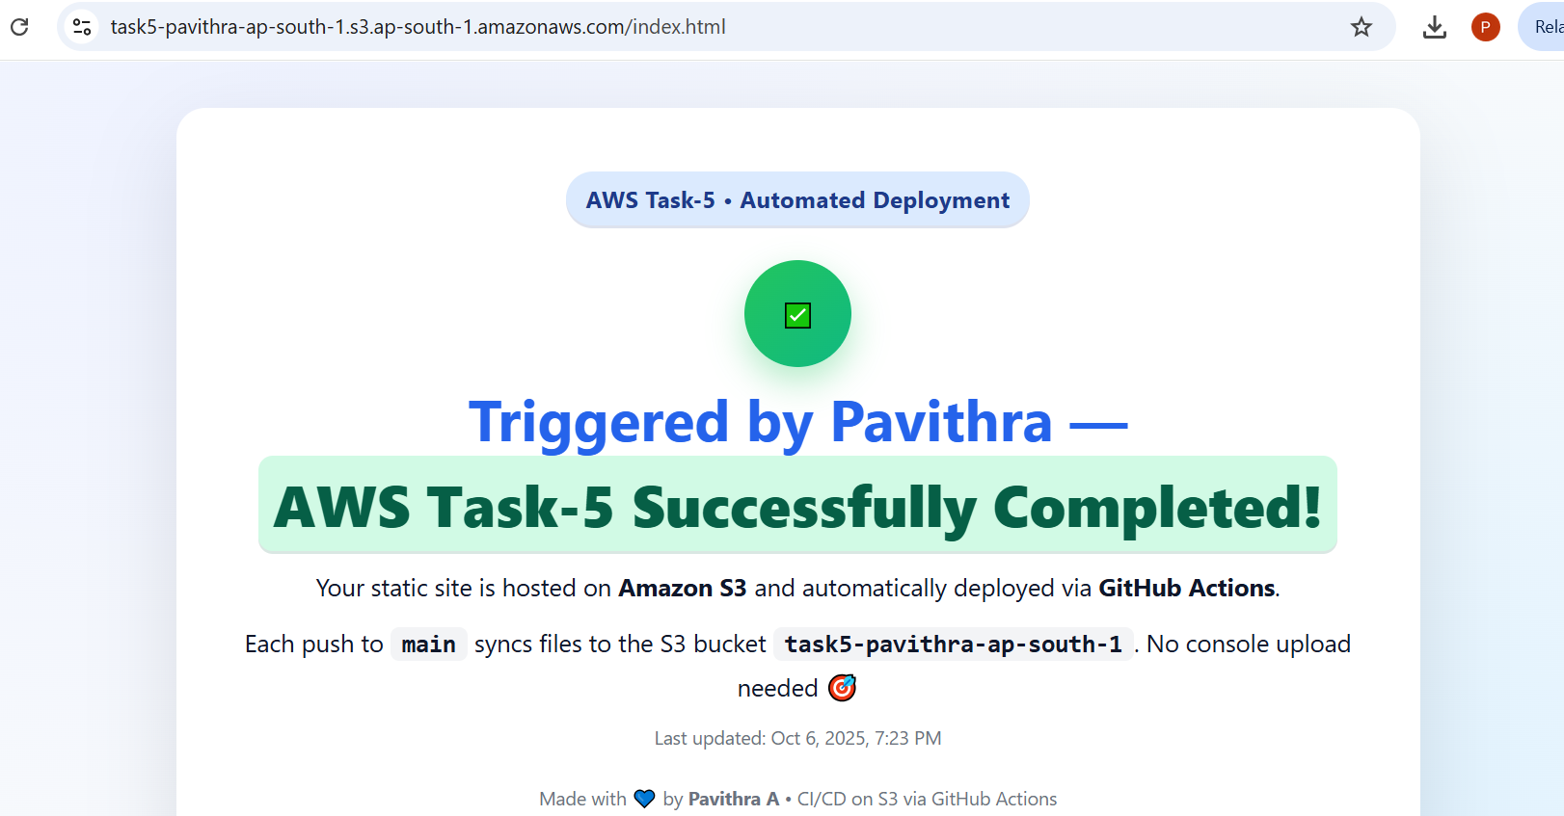

and saw **“Deployment Successful!”** message.