**Docker Task**

**Task Description:**

Install docker on EC2 and explore the docker commands (docker images, containers, volumes, network)

**Techstacks needs to be used :**

* AWS EC2
* Docker

**How do I submit my work?**

* Push all your work files to GitHub (O/P screenshot images must).
* Submit your URLs in the portal.

**Terms and Conditions?**

* You agree to not share this confidential document with anyone.
* You agree to open-source your code (it may even look good on your profile!). Do not mention our company’s name anywhere in the code.
* We will never use your source code under any circumstances for any commercial purposes; this is just a basic assessment task.

**NOTE:** Any violation of Terms and conditions is strictly prohibited. You are bound to adhere to it.

**Solution:**

**Launched an EC2 (Amazon Linux 2023 )**

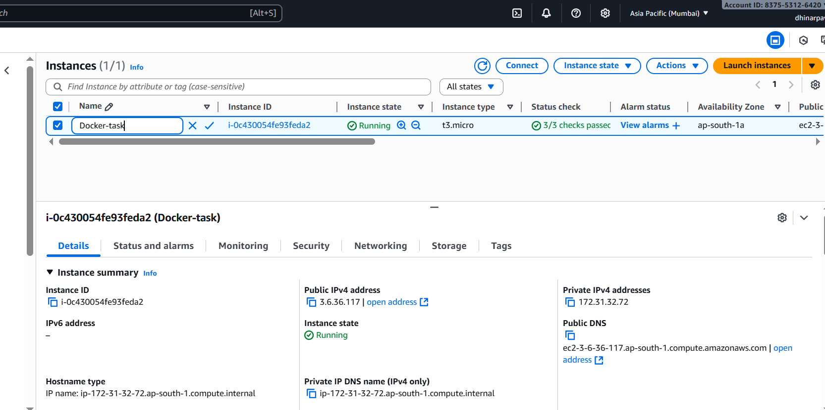

**Install Docker**

1. **Update OS packages**

**sudo yum update -y**

**➤ *Updates all existing packages to the latest version.***

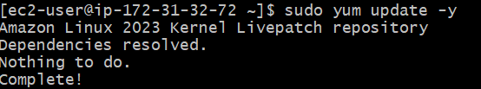

1. **Install Docker**

**sudo dnf install docker -y**

**➤ *Installs the Docker engine and CLI tools.***

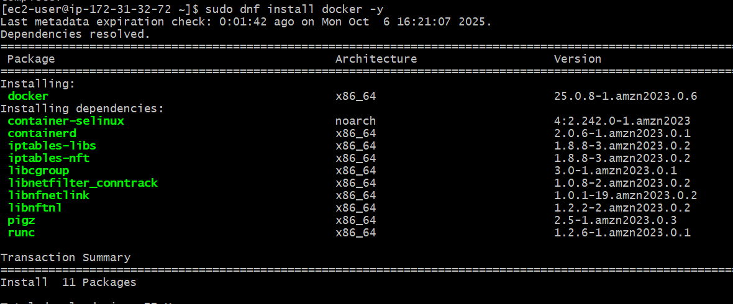

1. **Start Docker service**

**sudo systemctl start docker**

**➤ *Starts the Docker service manually.***

1. **Enable Docker service**

**sudo systemctl enable docker**

**➤ *Ensures Docker starts automatically after reboot.***





1. **Check Docker version**

**docker --version**

**➤ *Verifies Docker installation and version.***

1. **Run Hello-World container**

**sudo docker run hello-world**

**➤ *Downloads a test image from Docker Hub and runs it to confirm Docker works properly.***

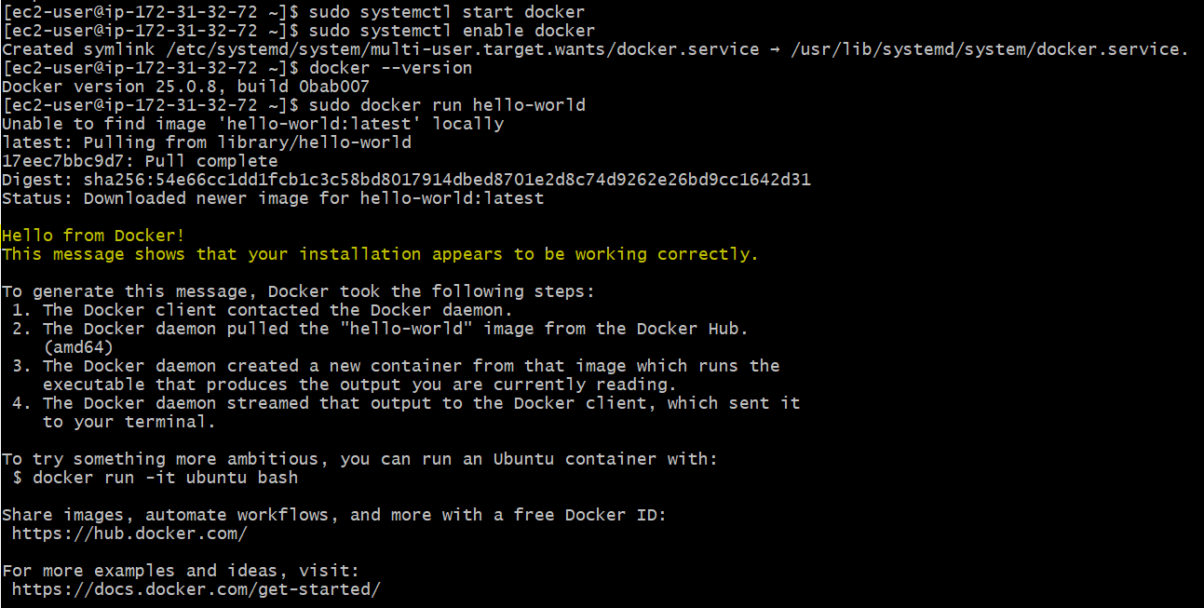

**Expected Output Explanation**

**output:**

**Hello from Docker!**

**This message shows that your installation appears to be working correctly.**

* **Docker client successfully contacted the Docker daemon.**
* **Docker pulled the “hello-world” image from Docker Hub.**
* **Docker created and ran a container successfully.**

**docker images**

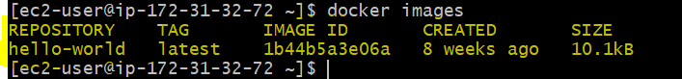

**docker ps -a**



**docker run -it ubuntu bash**

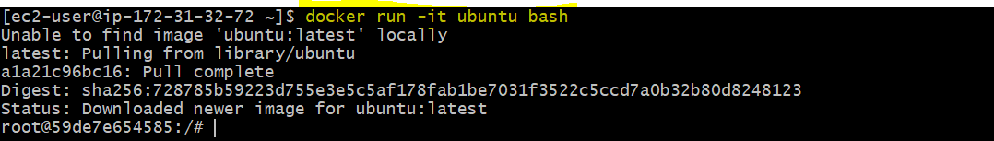

**docker network ls**

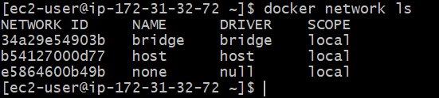

**docker network inspect bridge**

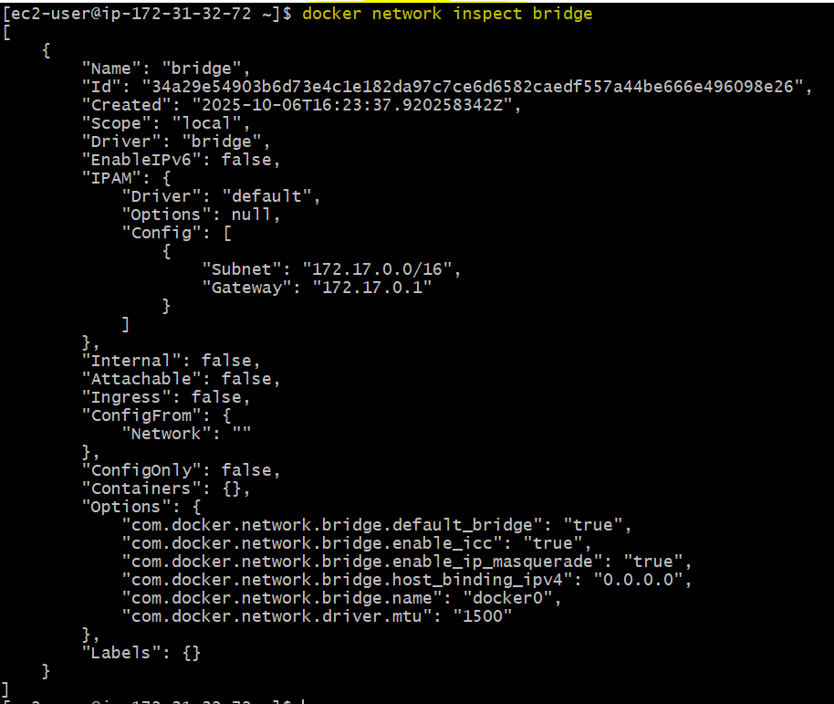

Displays detailed info about the default bridge network (connected containers, subnet, gateway, etc.).

**Clean Up Containers**

