**Jenkins Task**

**Task Description:**

Launch jenkins and explore creating projects and users.

**Techstacks needs to be used :**

* AWS EC2
* Jenkins

**Launch EC2 Instance**

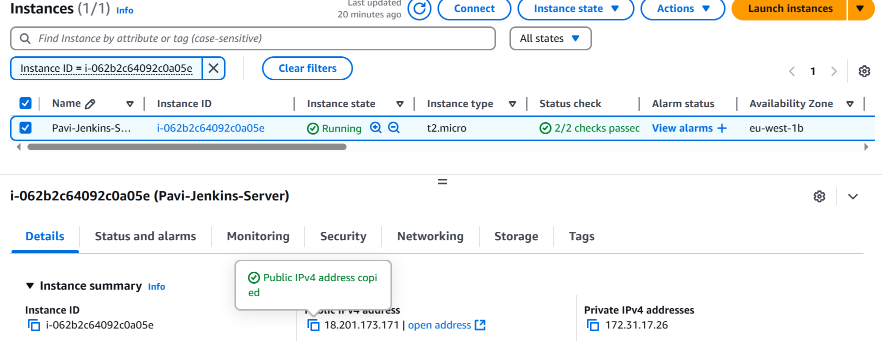

**SSH into the server**

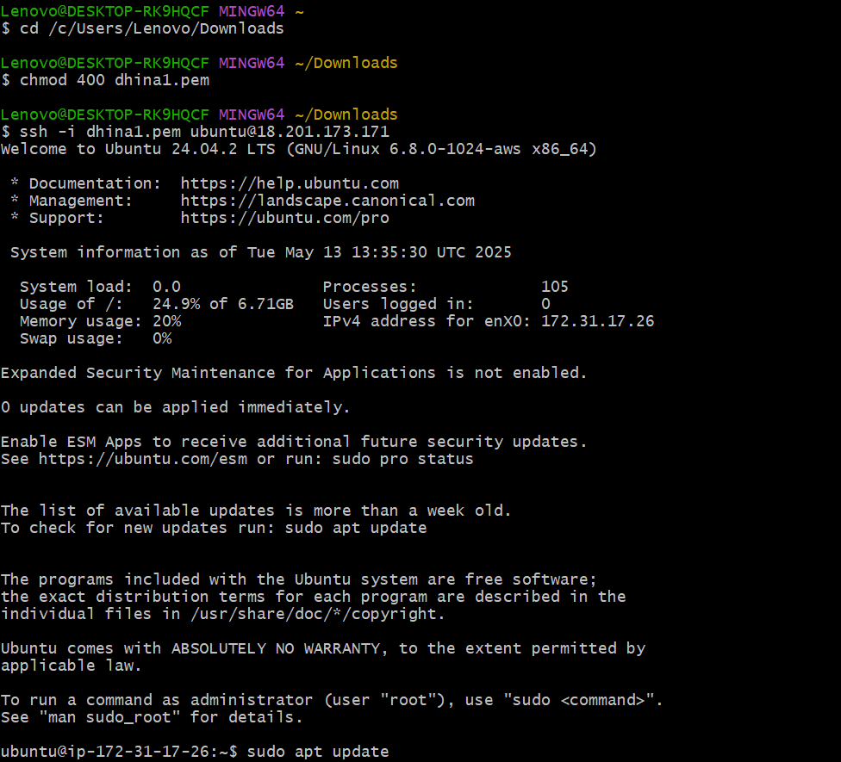

**To Update system**

**sudo apt update**

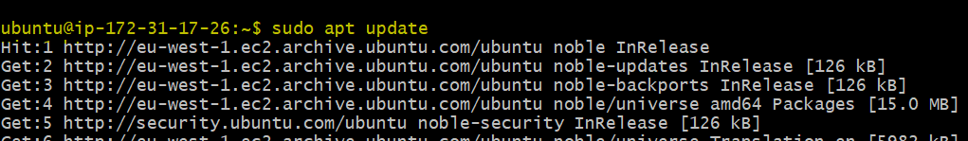

**sudo apt upgrade –y**

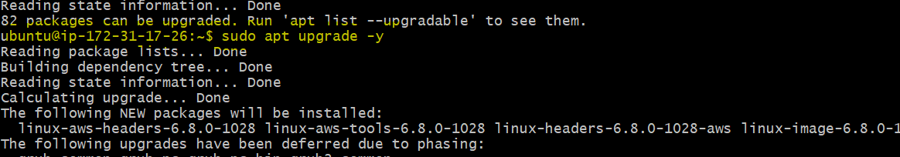

**Install Java**

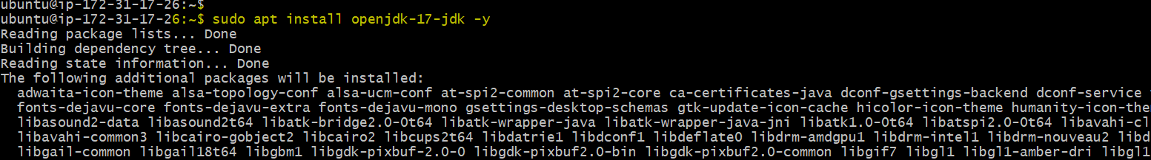

**Install Jenkins**

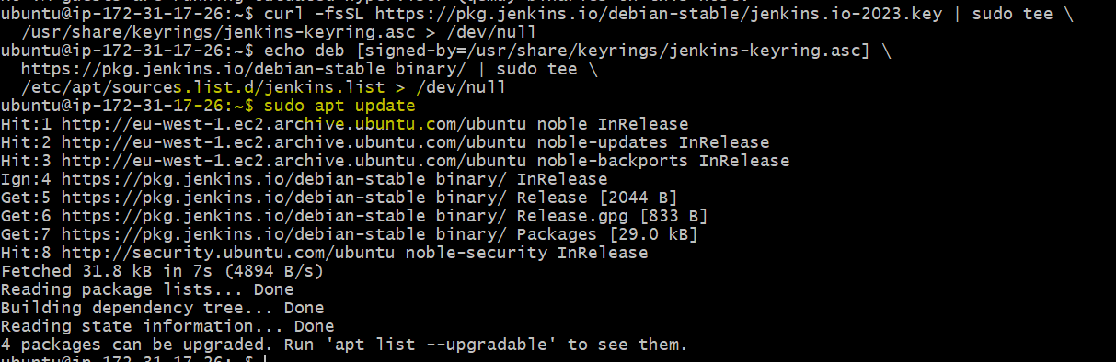

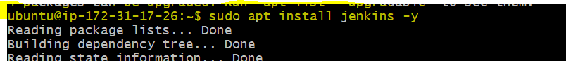

**Add this port in your security group to make work** http://18.201.173.171:8080

**Type**: Custom TCP

**Port**: 8080

**Source**: 0.0.0.0/0 (or your IP for better security)

Or check this status run below cmds

sudo systemctl status jenkins

sudo ss -tulnp | grep 8080

curl <http://localhost:8080>

**Open Jenkins in Browser**

Go to: http:// 18.201.173.171:8080

You’ll see the Jenkins unlock screen

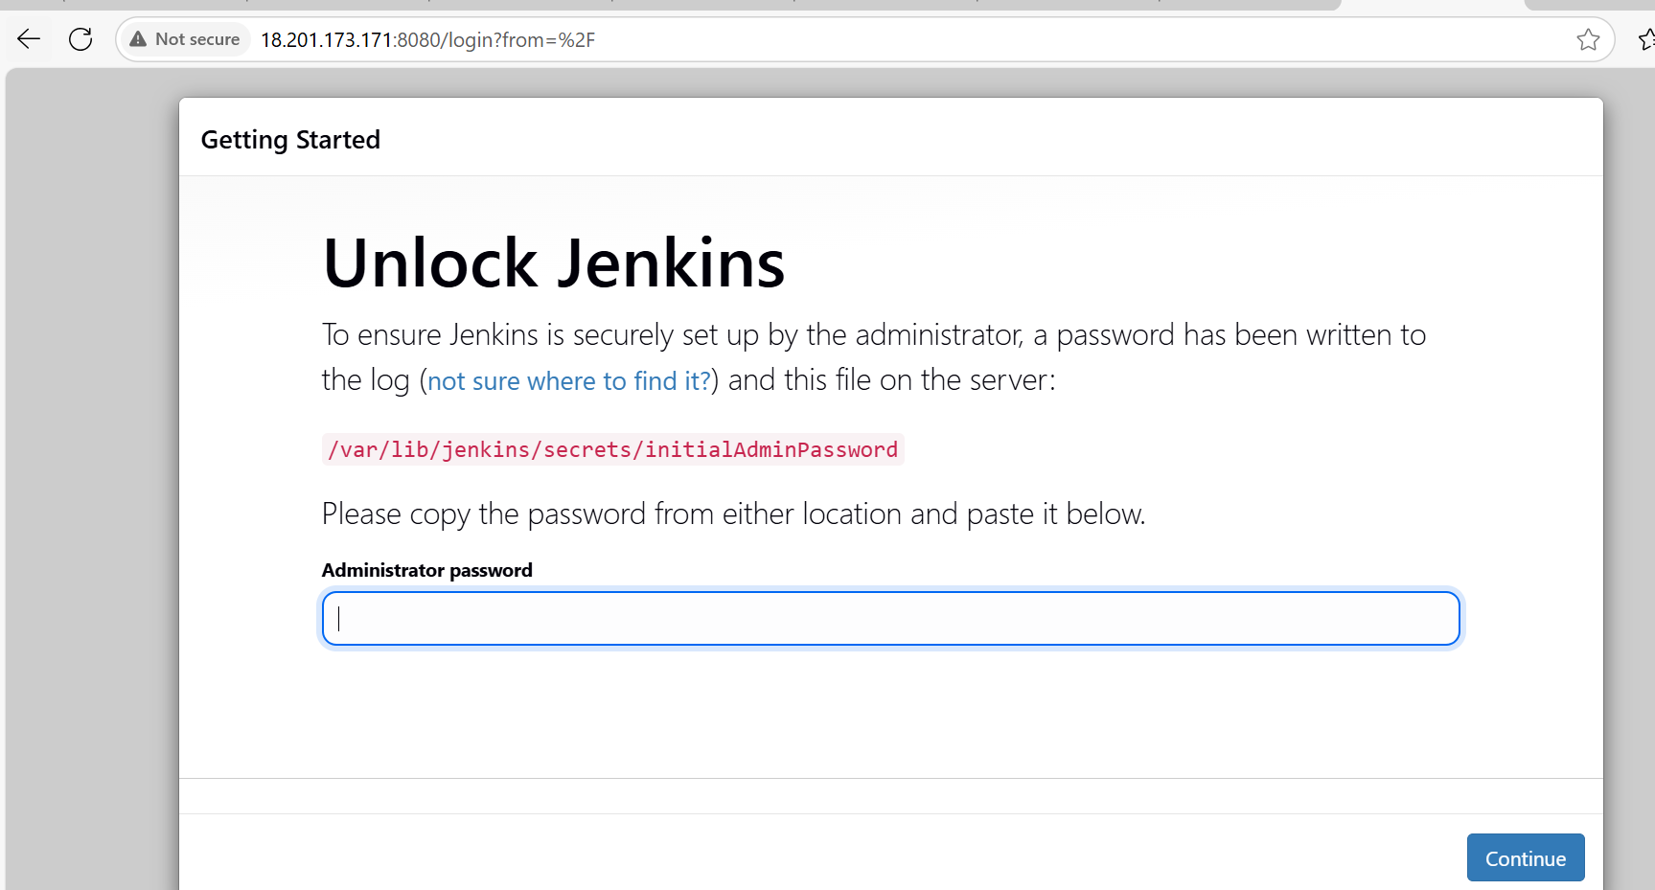

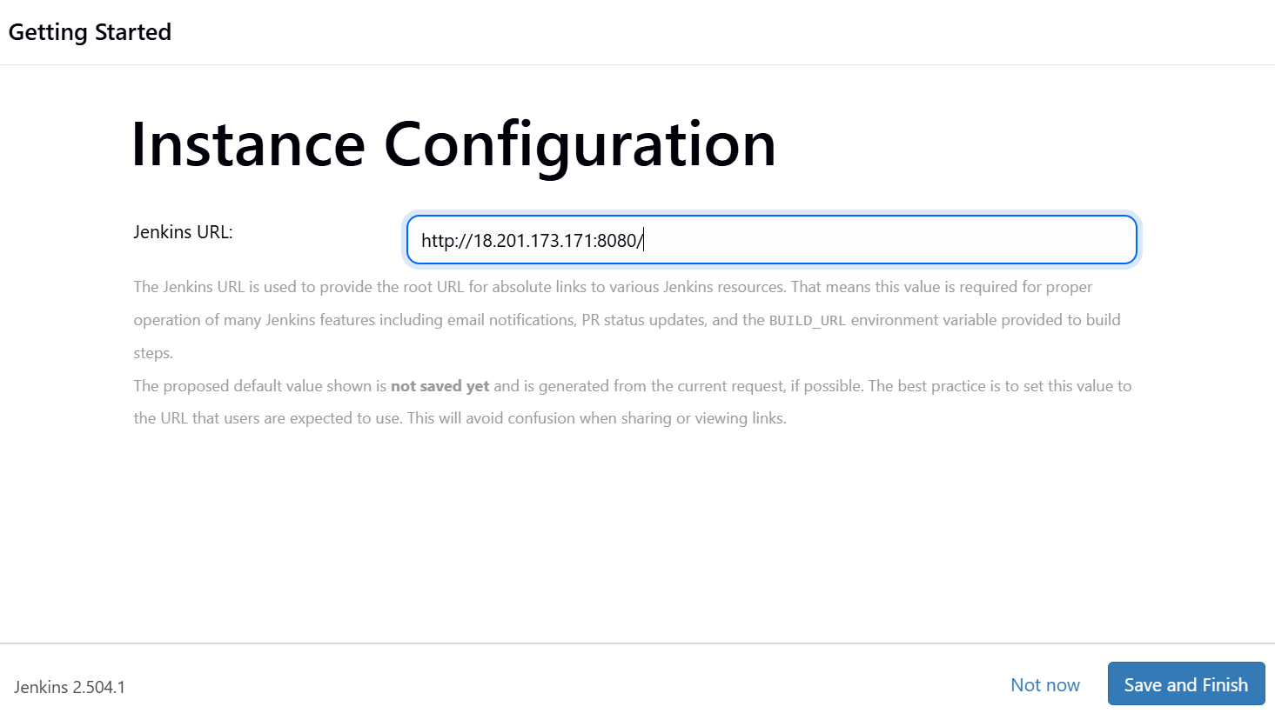

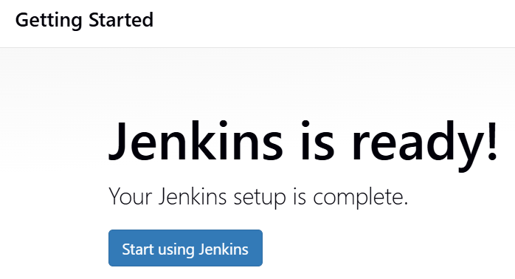

**Created a New Job**

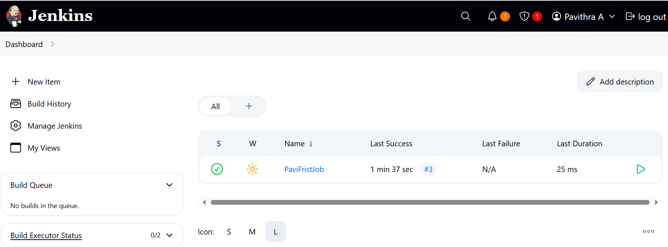

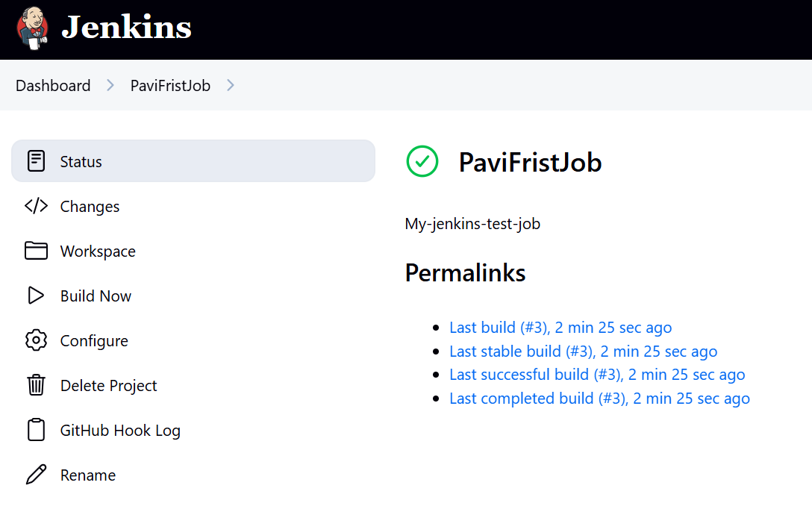

**Console Output** to verify build logs.

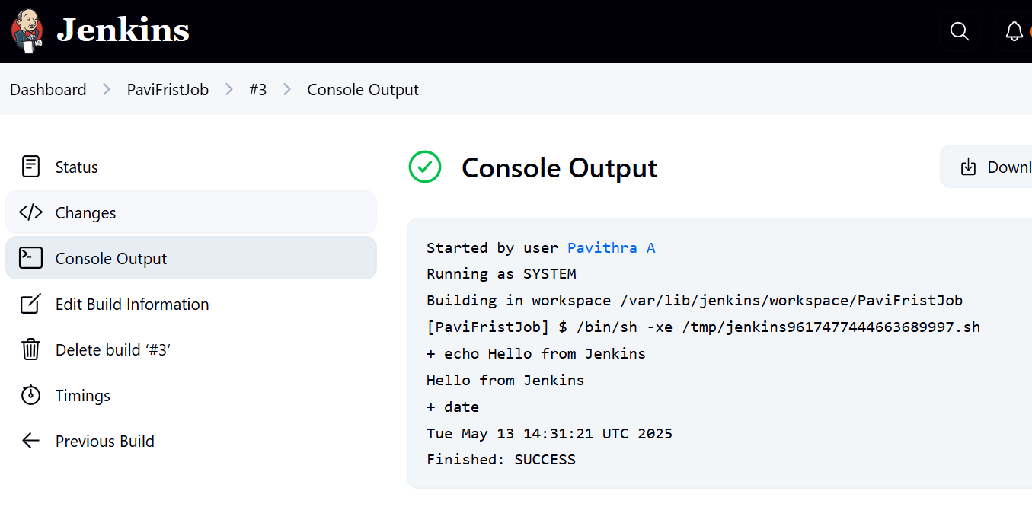

**Created on more job which is Pavi-GitHub-Clone-Build**

