**Jenkins Task-2**

**Task Description:**

Create a simple script file and push it to repo. Create a project in Jenkins connected to your GitHub repository. When a commit is made to your repo, automatically build must get triggered from Jenkins and the output must be shared to me via email.

**Techstacks needs to be used :**

* AWS EC2
* Github
* Jenkins

Solutions:

1. **Launch EC2 (Ubuntu) + open ports**

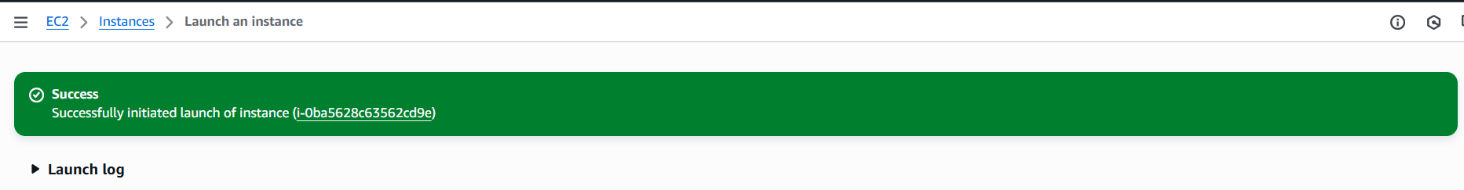

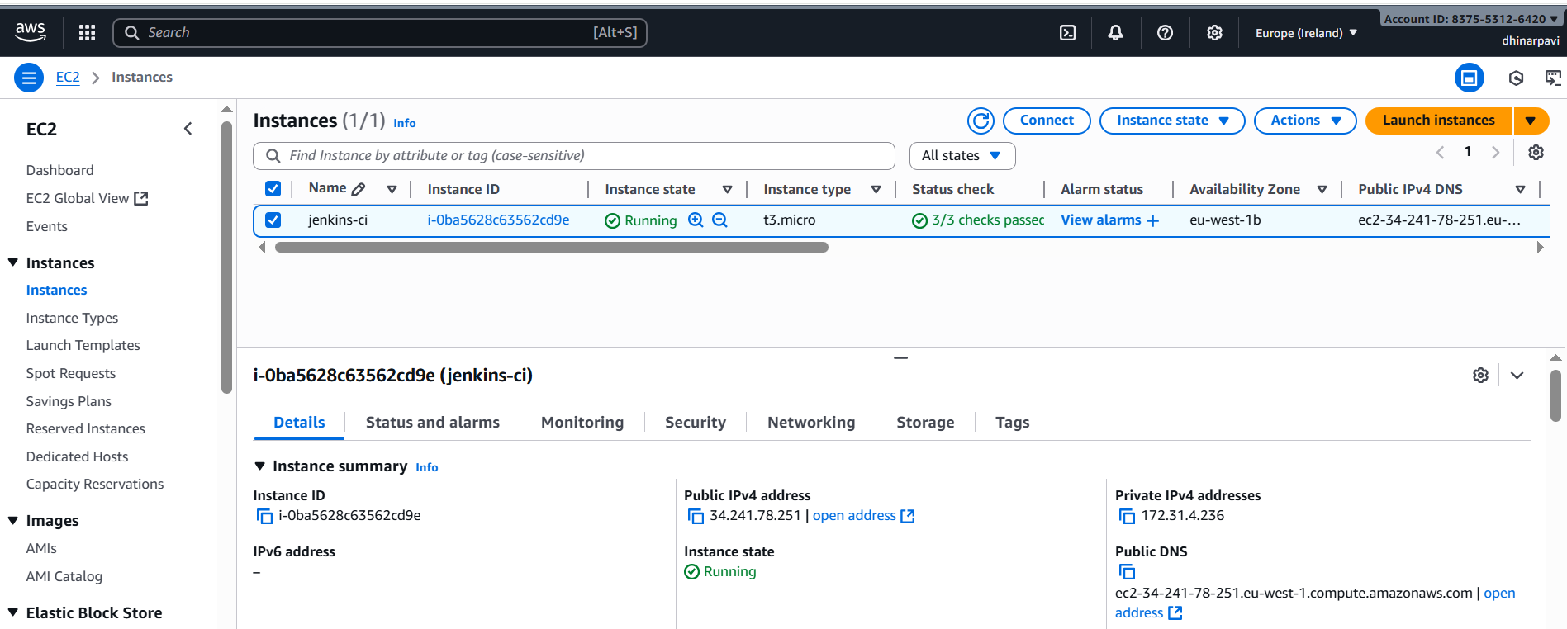

1. **SSH login to the EC2**

From Git Bash (Windows):

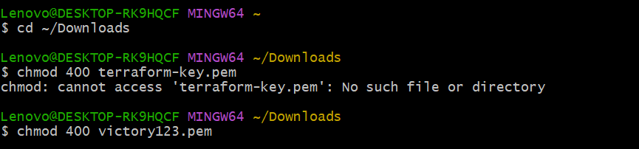

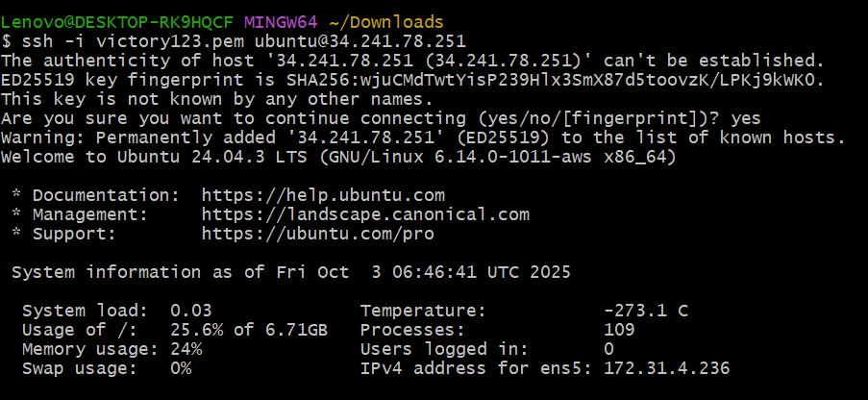

**Set timezone to IST:**



1. **Install Java + Jenkins + Git**

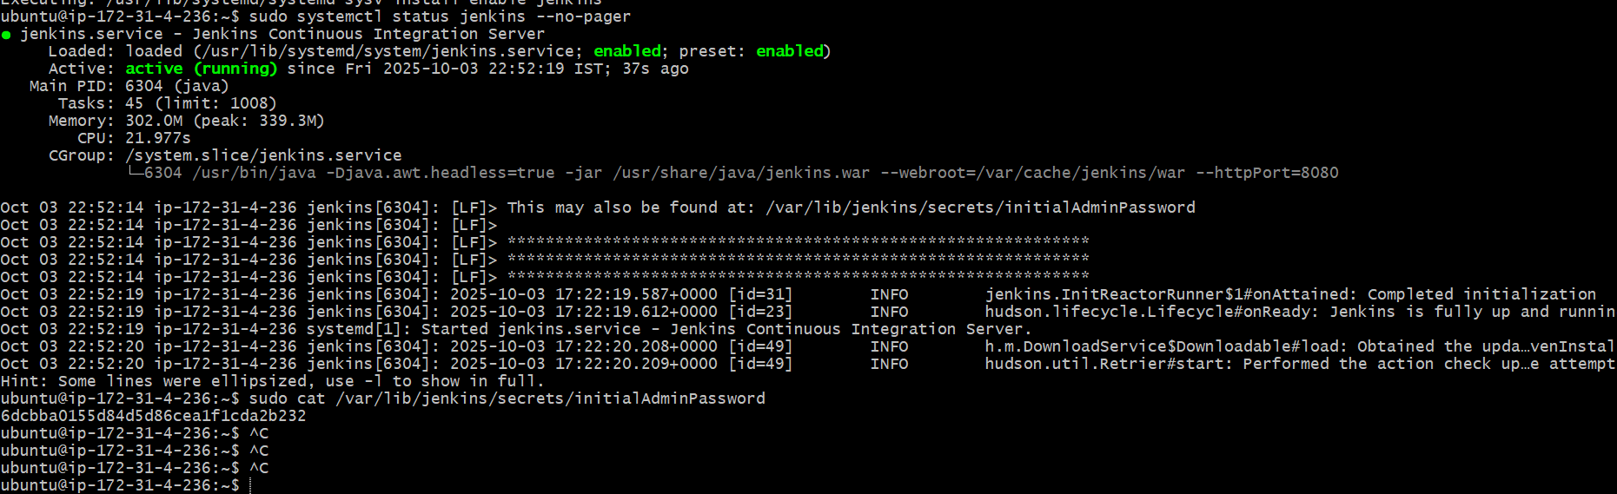

**Steps to Allow Access to Jenkins (Port 8080)**

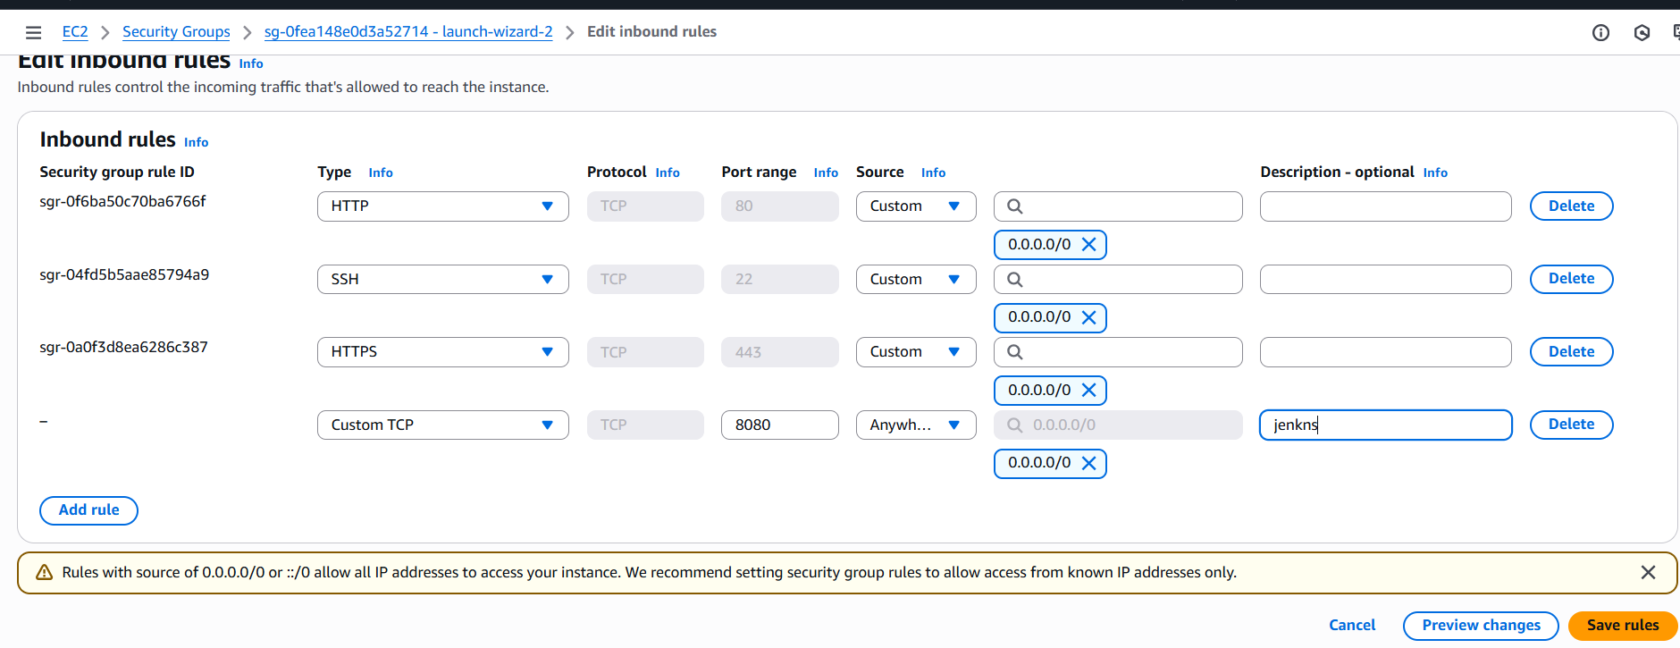

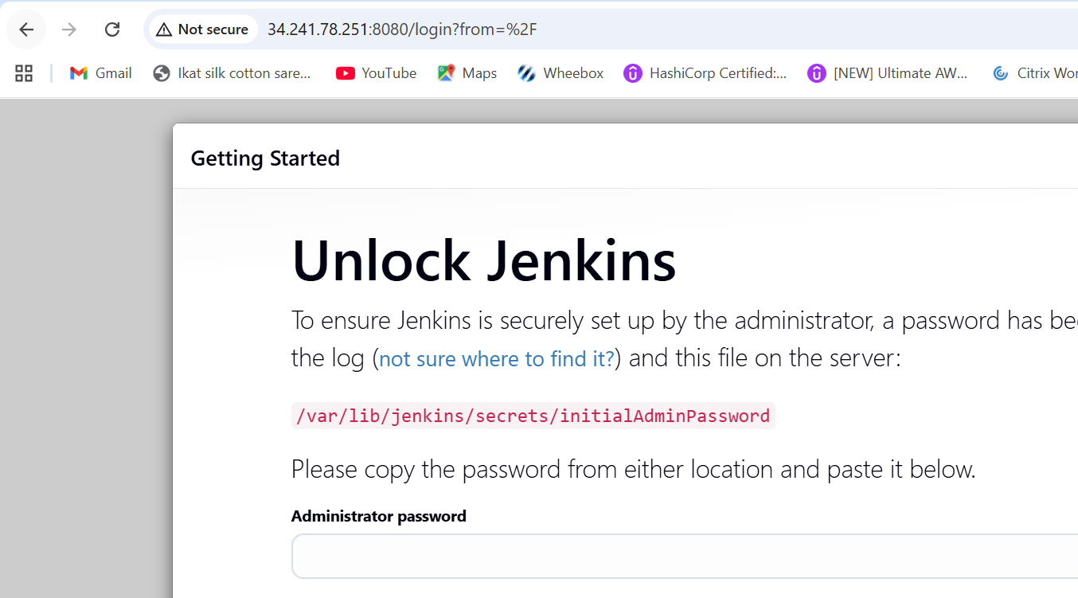

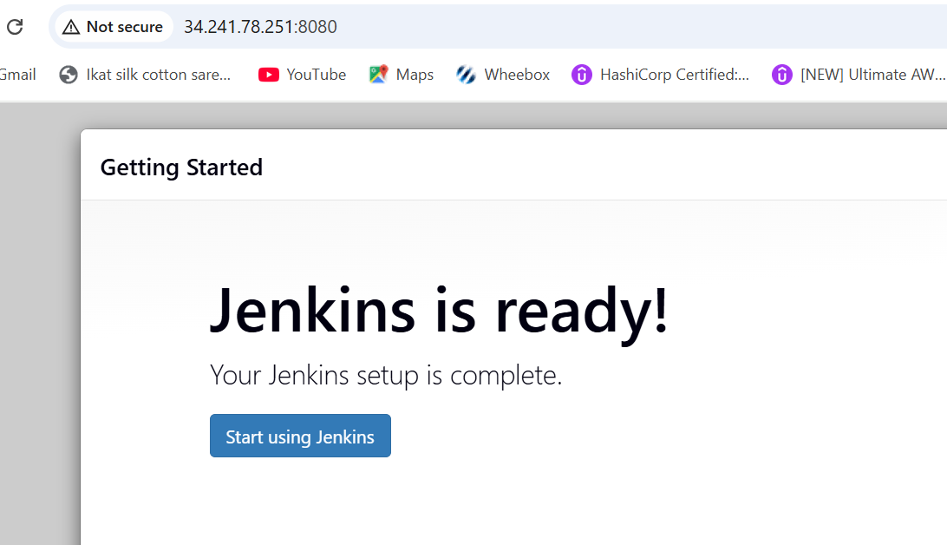

**Git**

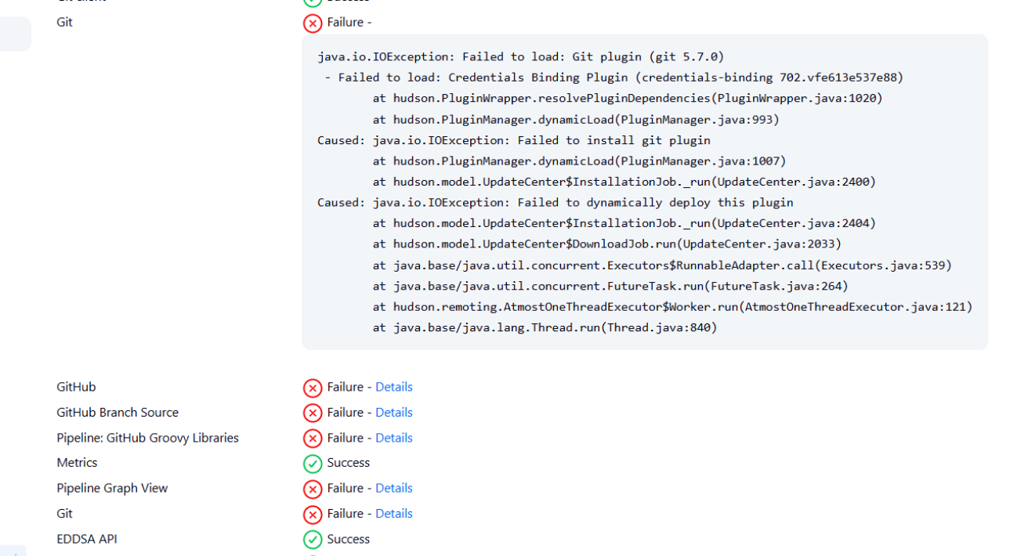

FIX for Git installation

on the EC2 shell

0) Prefer IPv4 for Jenkins networking (avoids download hiccups)

echo 'JENKINS_JAVA_OPTIONS="$JENKINS_JAVA_OPTIONS -Djava.net.preferIPv4Stack=true"' | sudo tee -a /etc/default/jenkins

1) Go to the plugins directory

cd /var/lib/jenkins/plugins

2) Fetch the MUST-HAVE credential deps

sudo wget -O plain-credentials.hpi https://updates.jenkins.io/download/plugins/plain-credentials/latest/plain-credentials.hpi

sudo wget -O credentials.hpi https://updates.jenkins.io/download/plugins/credentials/latest/credentials.hpi

sudo wget -O credentials-binding.hpi https://updates.jenkins.io/download/plugins/credentials-binding/latest/credentials-binding.hpi

3) Fetch Git stack (order matters: scm-api -> git-client -> git)

sudo wget -O scm-api.hpi https://updates.jenkins.io/download/plugins/scm-api/latest/scm-api.hpi

sudo wget -O git-client.hpi https://updates.jenkins.io/download/plugins/git-client/latest/git-client.hpi

sudo wget -O git.hpi https://updates.jenkins.io/download/plugins/git/latest/git.hpi

(Optional but useful for your task)

sudo wget -O github.hpi https://updates.jenkins.io/download/plugins/github/latest/github.hpi

sudo wget -O github-branch-source.hpi https://updates.jenkins.io/download/plugins/github-branch-source/latest/github-branch-source.hpi

sudo wget -O workflow-aggregator.hpi https://updates.jenkins.io/download/plugins/workflow-aggregator/latest/workflow-aggregator.hpi

sudo wget -O mailer.hpi https://updates.jenkins.io/download/plugins/mailer/latest/mailer.hpi

sudo wget -O email-ext.hpi https://updates.jenkins.io/download/plugins/email-ext/latest/email-ext.hpi

4) Fix ownership and restart Jenkins

sudo chown jenkins:jenkins *.hpi

sudo systemctl restart jenkins

1. **Creating Jenkins Pipeline Job**

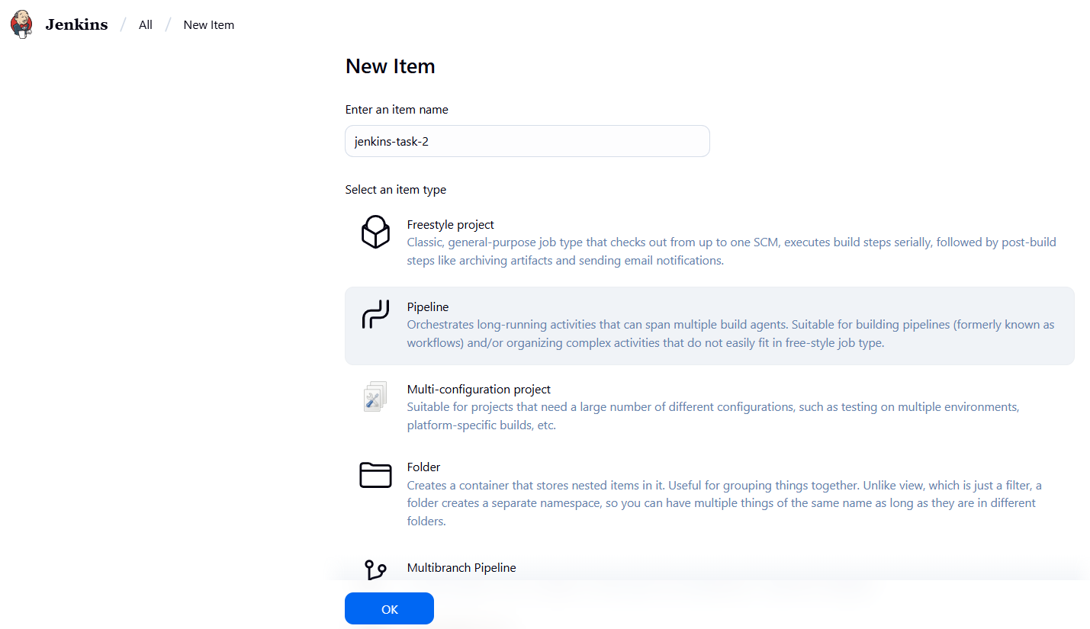

Set pat token in Jenkins for git and Jenkins integrations

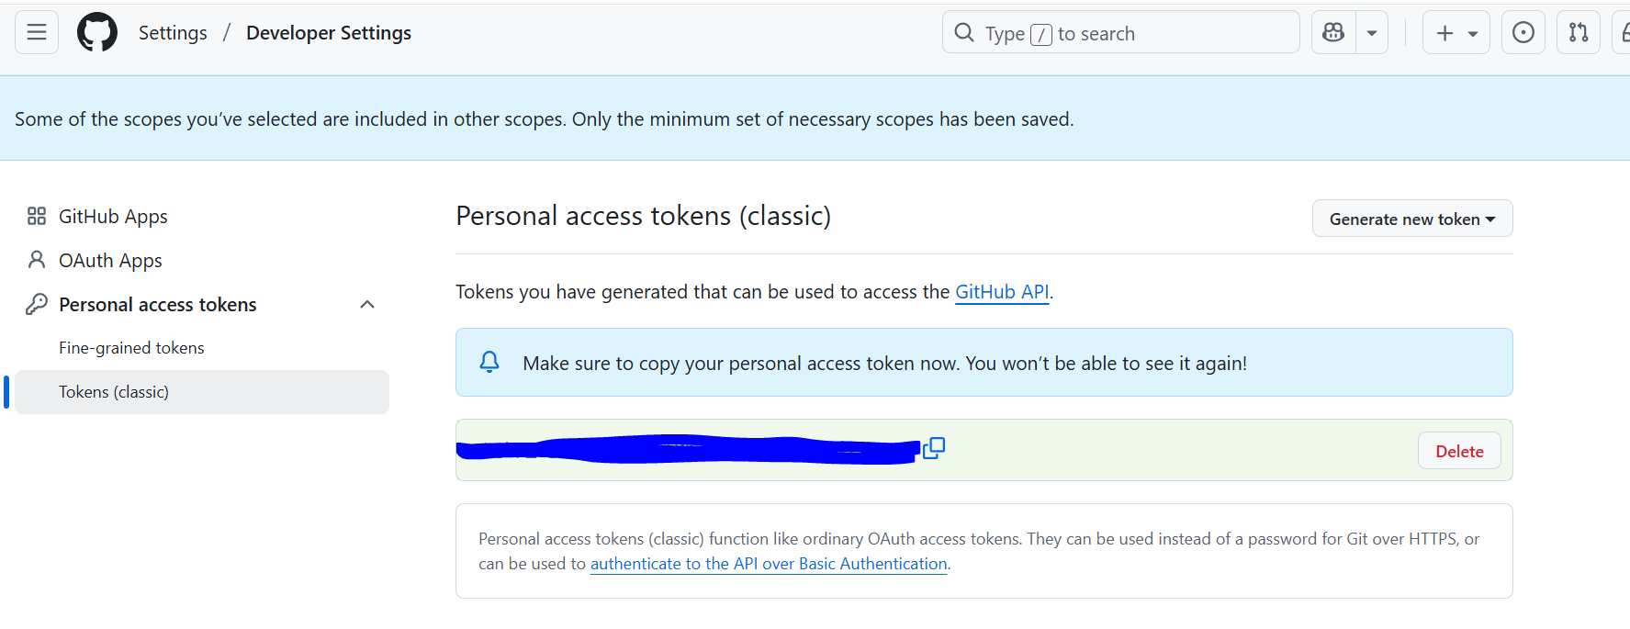

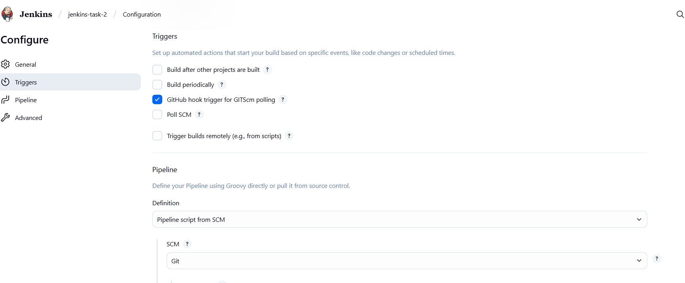

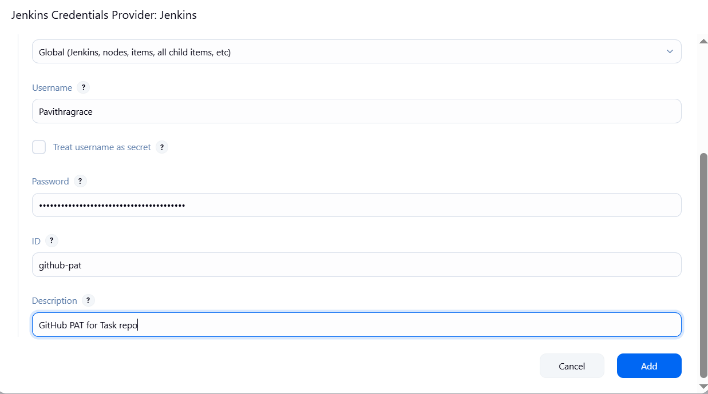

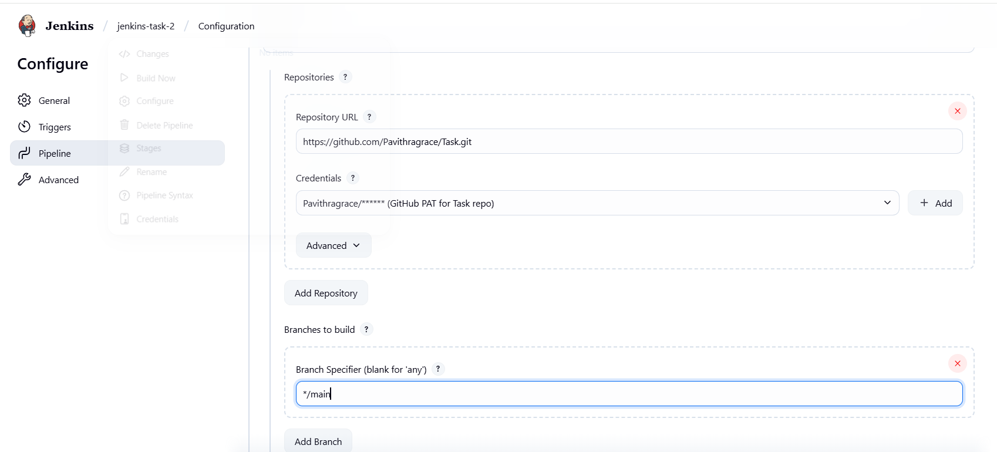

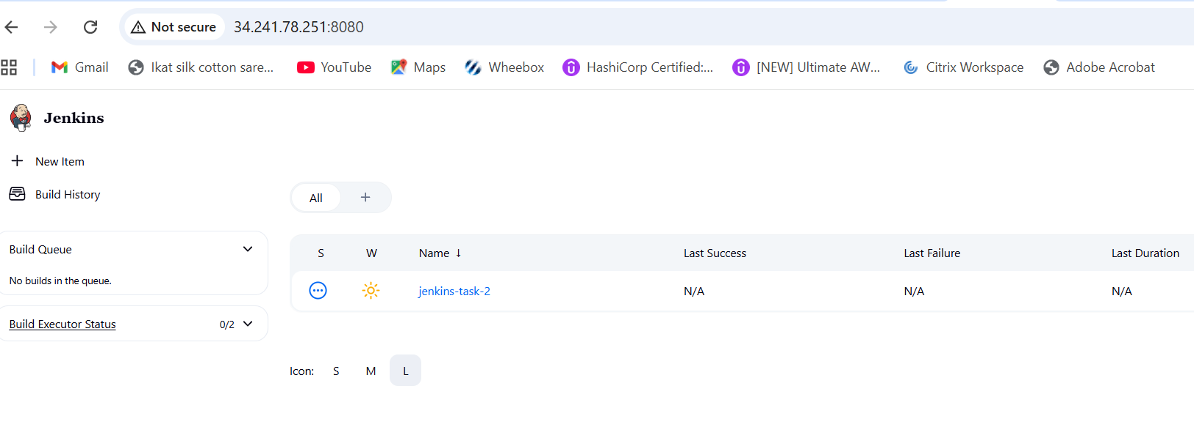

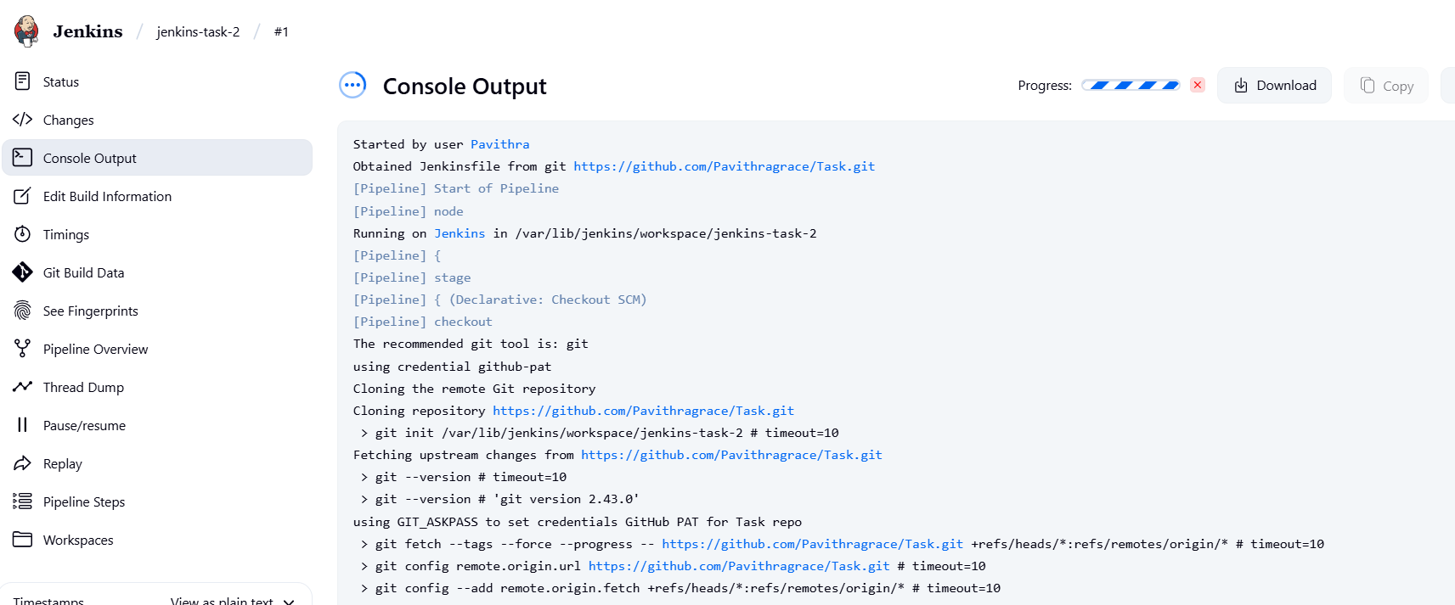

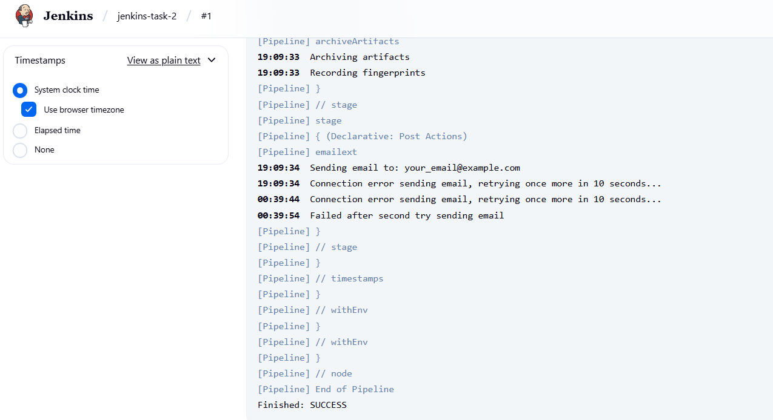

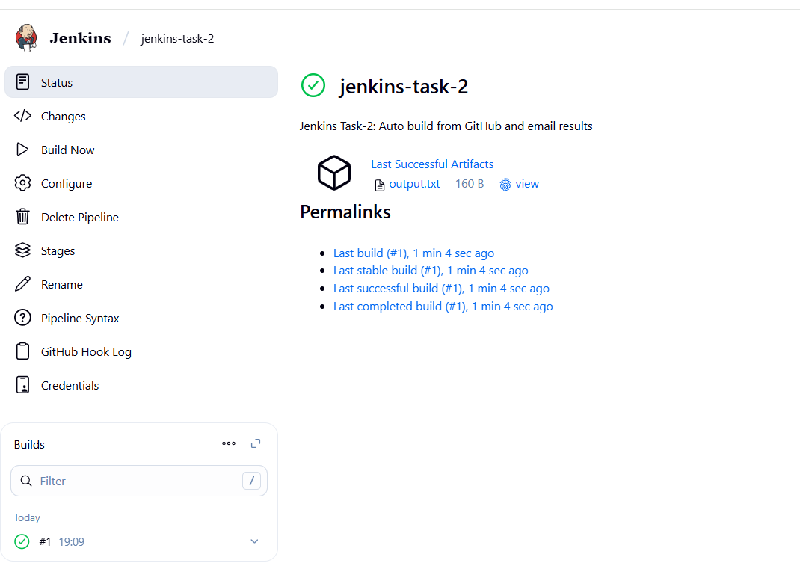

Generate Gmail App Password

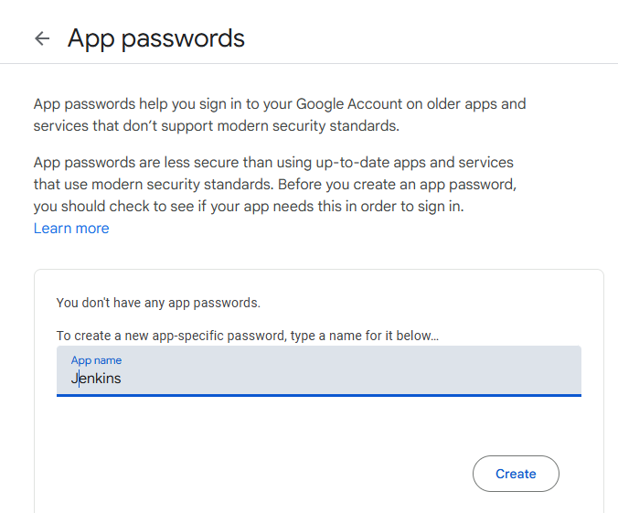

**Final Gmail Setup in Jenkins**

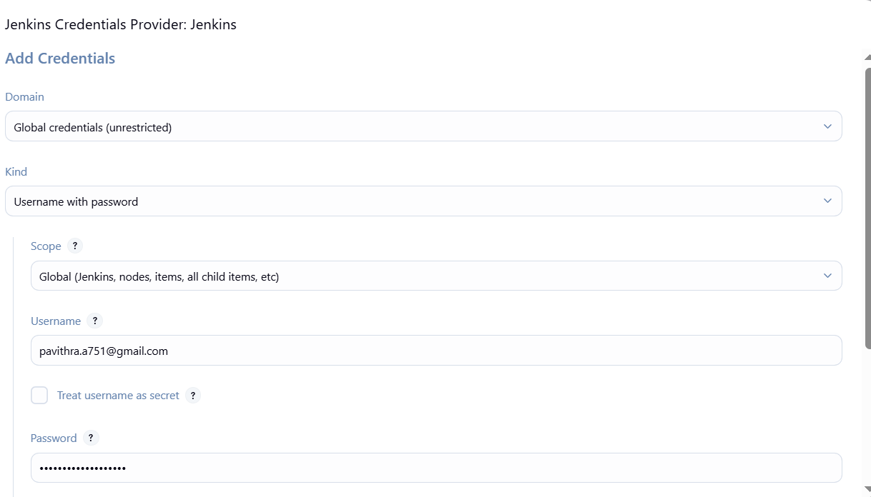

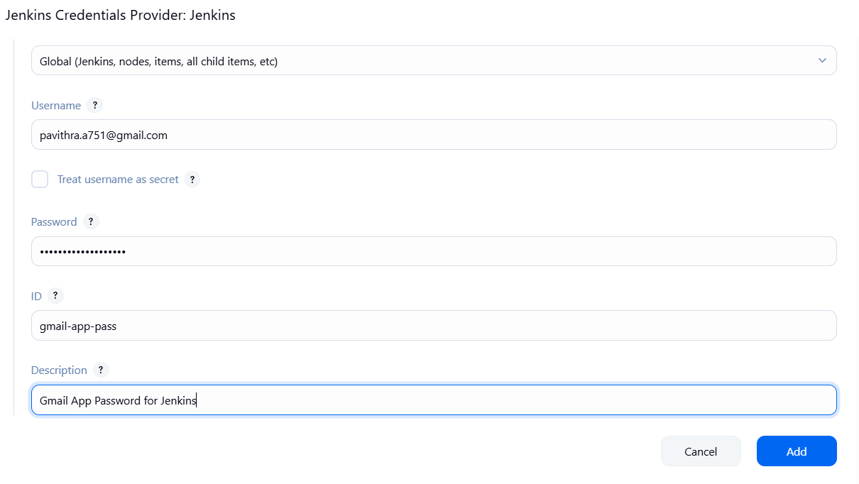

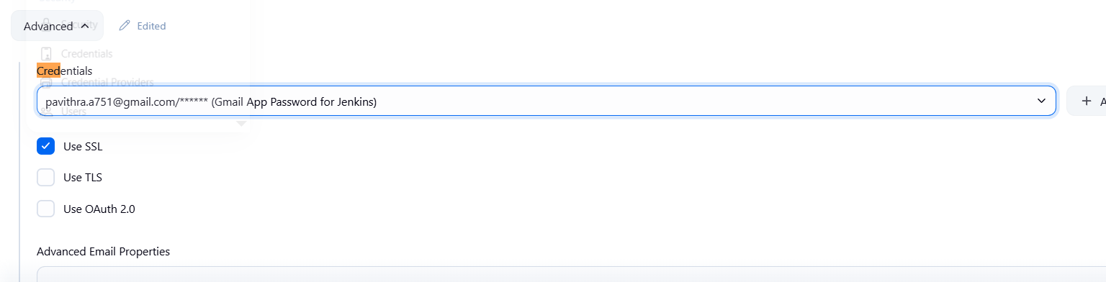

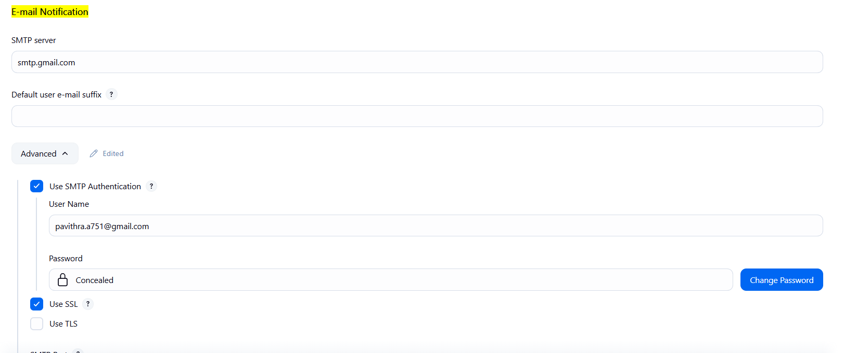

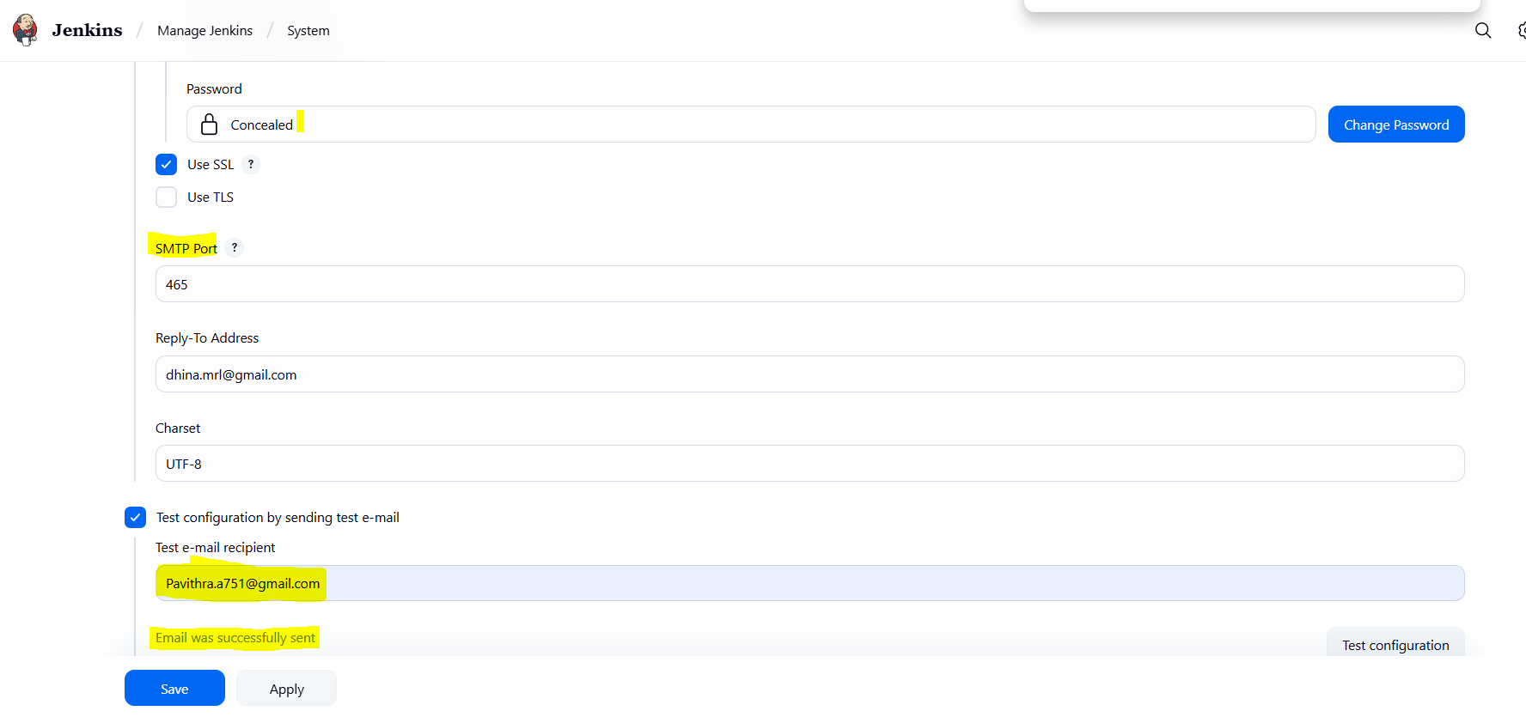

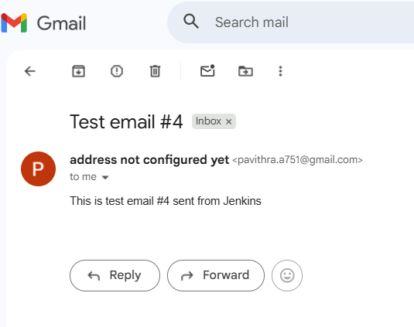

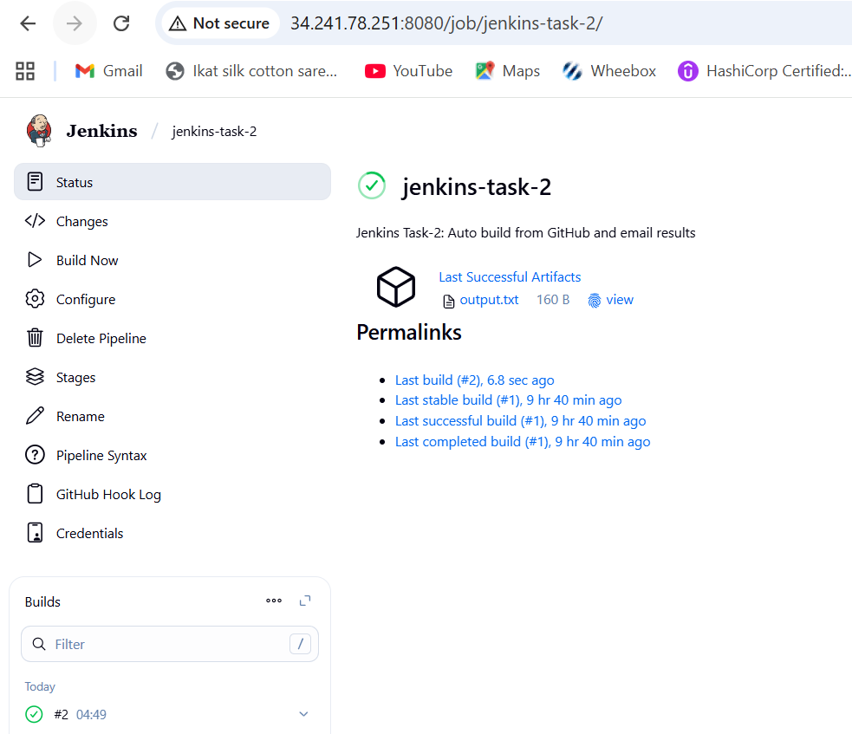

**Output**

