**Network Task**

**Task Description:**

1.Get me the IP address of a particular domain (guvi.in). How do I find my CPU/memory usage of my server?. Test the connectivity between 2 nodes?

2.I have deployed an application in guvi.com:9000, and logs show my app is running, but I’m unable to view the page. Check whether my port is open or not ?

**Techstacks needs to be used :**

* Shell (AWS, Gitbash, WSL, Vbox)

**How do I submit my work?**

* Push all your work files to GitHub (O/P screenshot images must).
* Submit your URLs in the portal.

**Terms and Conditions?**

* You agree to not share this confidential document with anyone.
* You agree to open-source your code (it may even look good on your profile!). Do not mention our company’s name anywhere in the code.
* We will never use your source code under any circumstances for any commercial purposes; this is just a basic assessment task.

**NOTE:** Any violation of Terms and conditions is strictly prohibited. You are bound to adhere to it.

**Solution:**

Launch an EC2

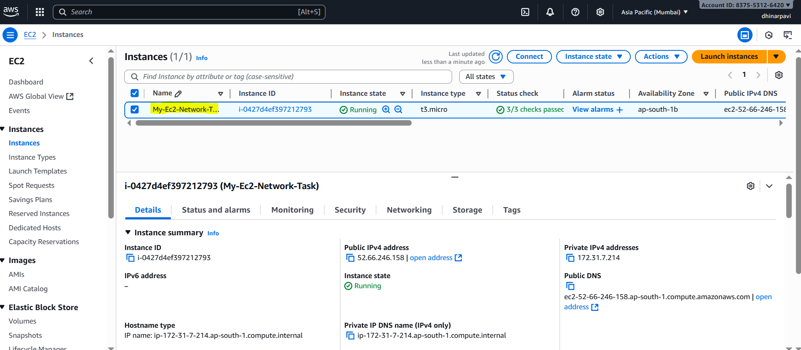

Logged into EC2

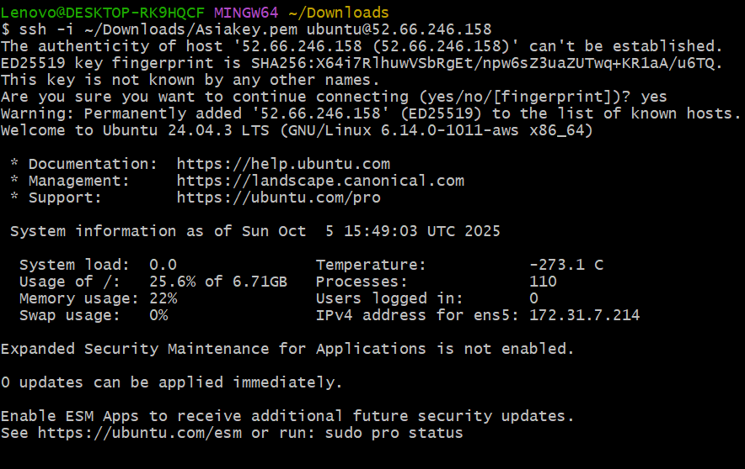

Git Bash has limited tools. You can test part 1 (IP lookup) and basic ping.

nslookup guvi.in

ping guvi.in

* the command ping guvi.in from your EC2 terminal (ubuntu@ip-172-31-7-214)
* The DNS resolved guvi.in to **IP address 104.26.4.88**
* The ping replies are successful (time=1.2 ms, ttl=54)

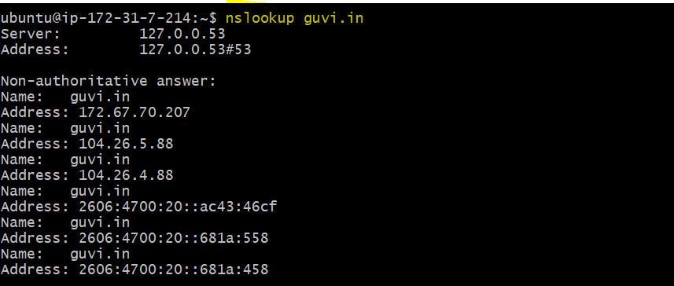

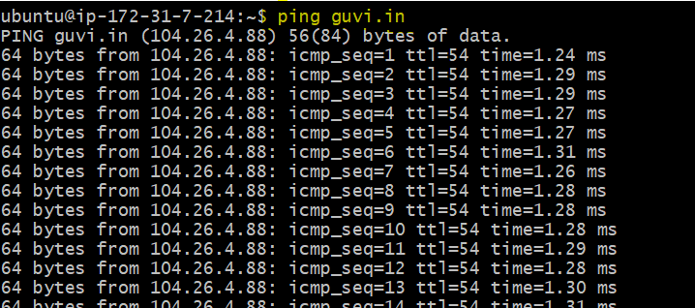

**Check CPU and Memory usage**

**top -bn1 | head -n 5**

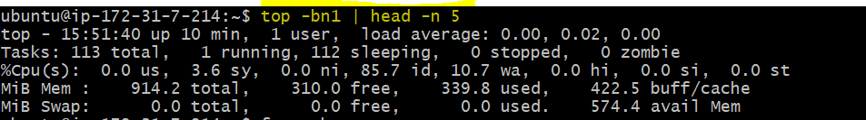

**free –h**



**Uptime**



**Test connectivity between two nodes**

ping -c 4 guvi.com

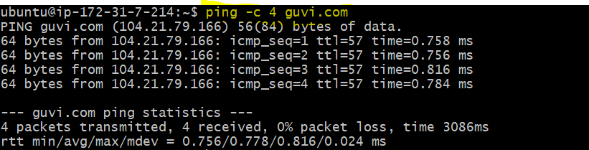

traceroute guvi.com

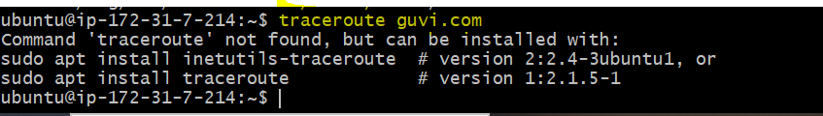

**Check whether port 9000 is open or not**



**Test Flask application in browser**

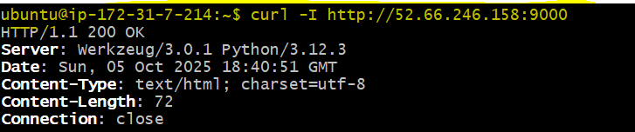



**AWS Security Group inbound rule → 9000 open**

