**Scripting Task**

**Task Description:**

1. Create a shell script to print the HTTP error code of guvi.in & print, the success/failure message based on the error code response
2. Given a file, replace all occurrence of the word "give" with "learning" from 5th line till the end in only those lines that contain the word "welcome"

**Solution**:

1. Created the Shell Script File in VS Code.

check_guvi_status.sh

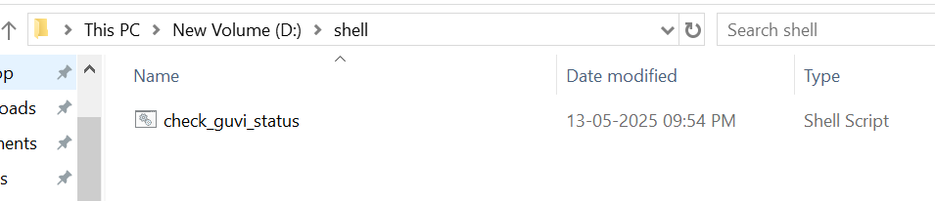

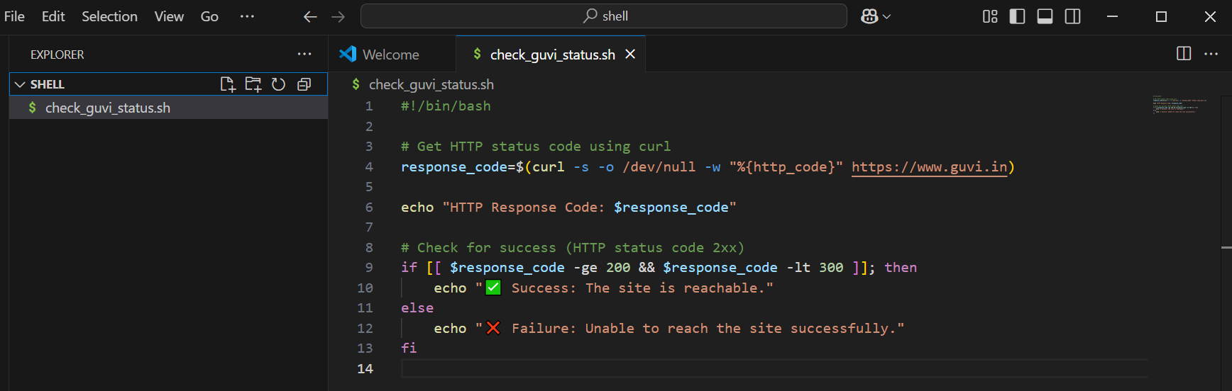

Running the Script

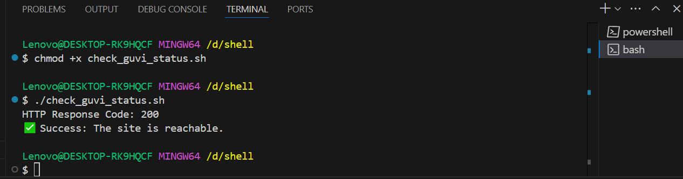

Excepted output :

HTTP Response Code: 200

✅ Success: The site is reachable.

Or

HTTP Response Code: 503

❌ Failure: Unable to reach the site successfully.

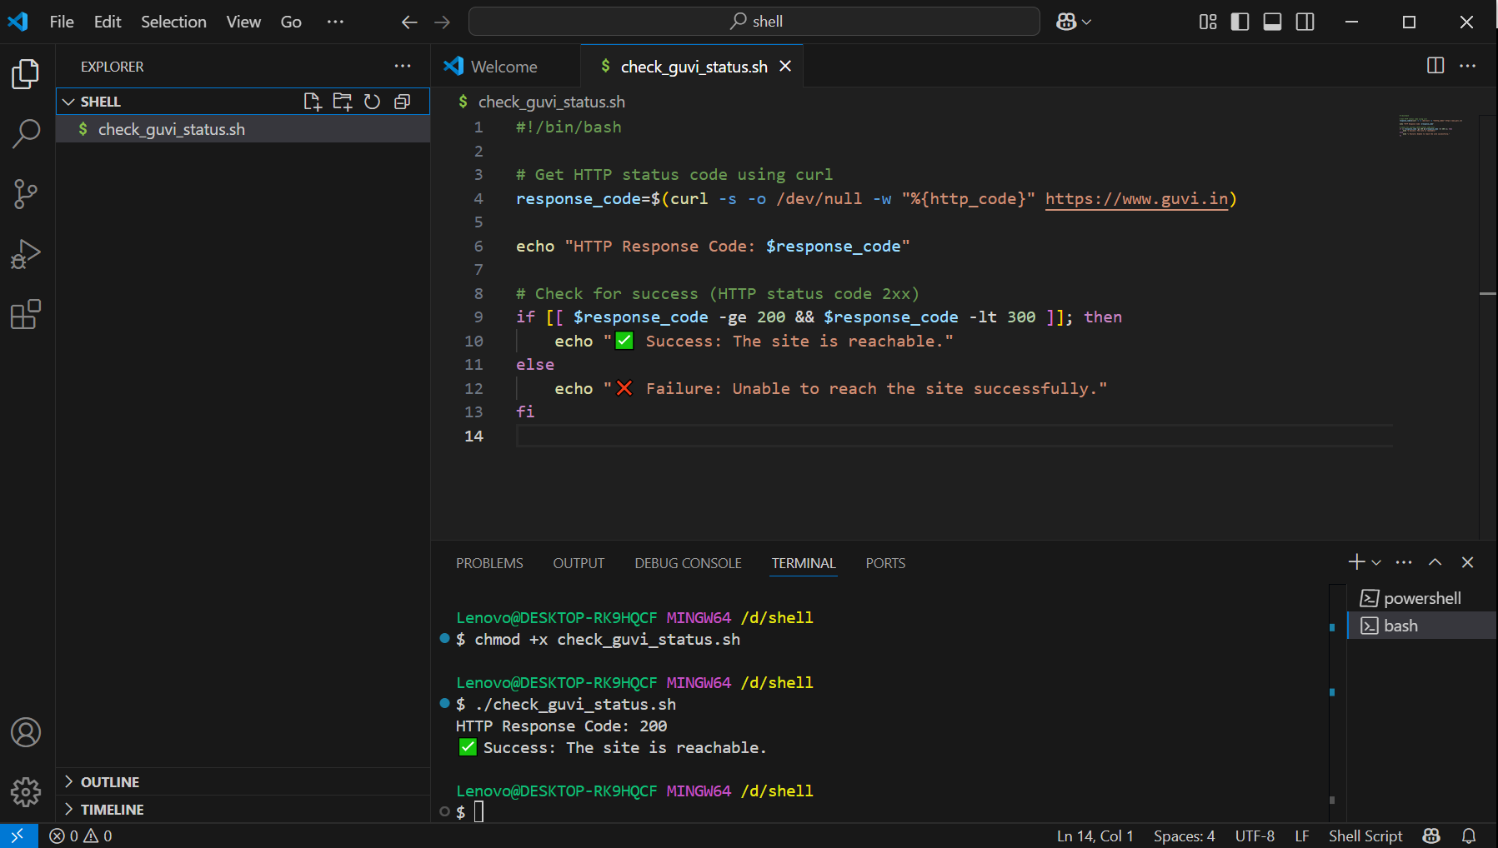

1. Given a file, replace all occurrence of the word "give" with "learning" from 5th line till the end in only those lines that contain the word "welcome"

Solution:

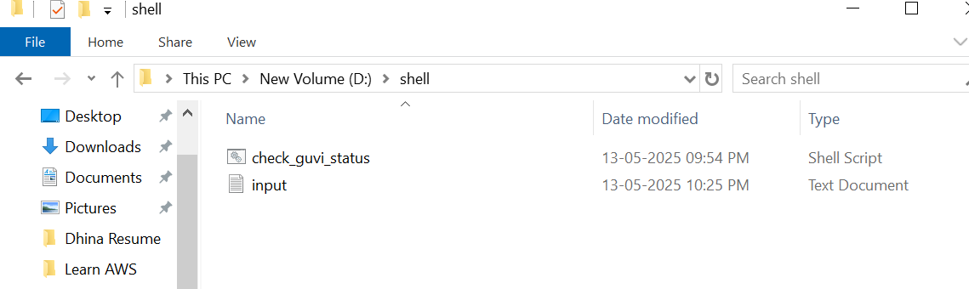

Input.txt

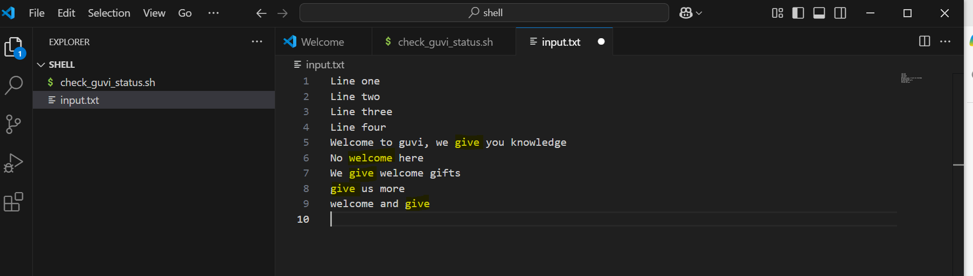

Open git bash:

awk 'NR < 5 { print } NR >= 5 { if ($0 ~ /welcome/) gsub(/give/, "learning"); print }' input.txt > output.txt

NR < 5 { print } ----- Print lines 1–4 unchanged

NR >= 5 ---- From line 5 onward...

if ($0 ~ /welcome/) ----- only if line contains "welcome"

gsub(/give/, "learning") Replace "give" with "learning" in that line

print Print the processed line

> output.txt Save the result in a new file

Output.txt

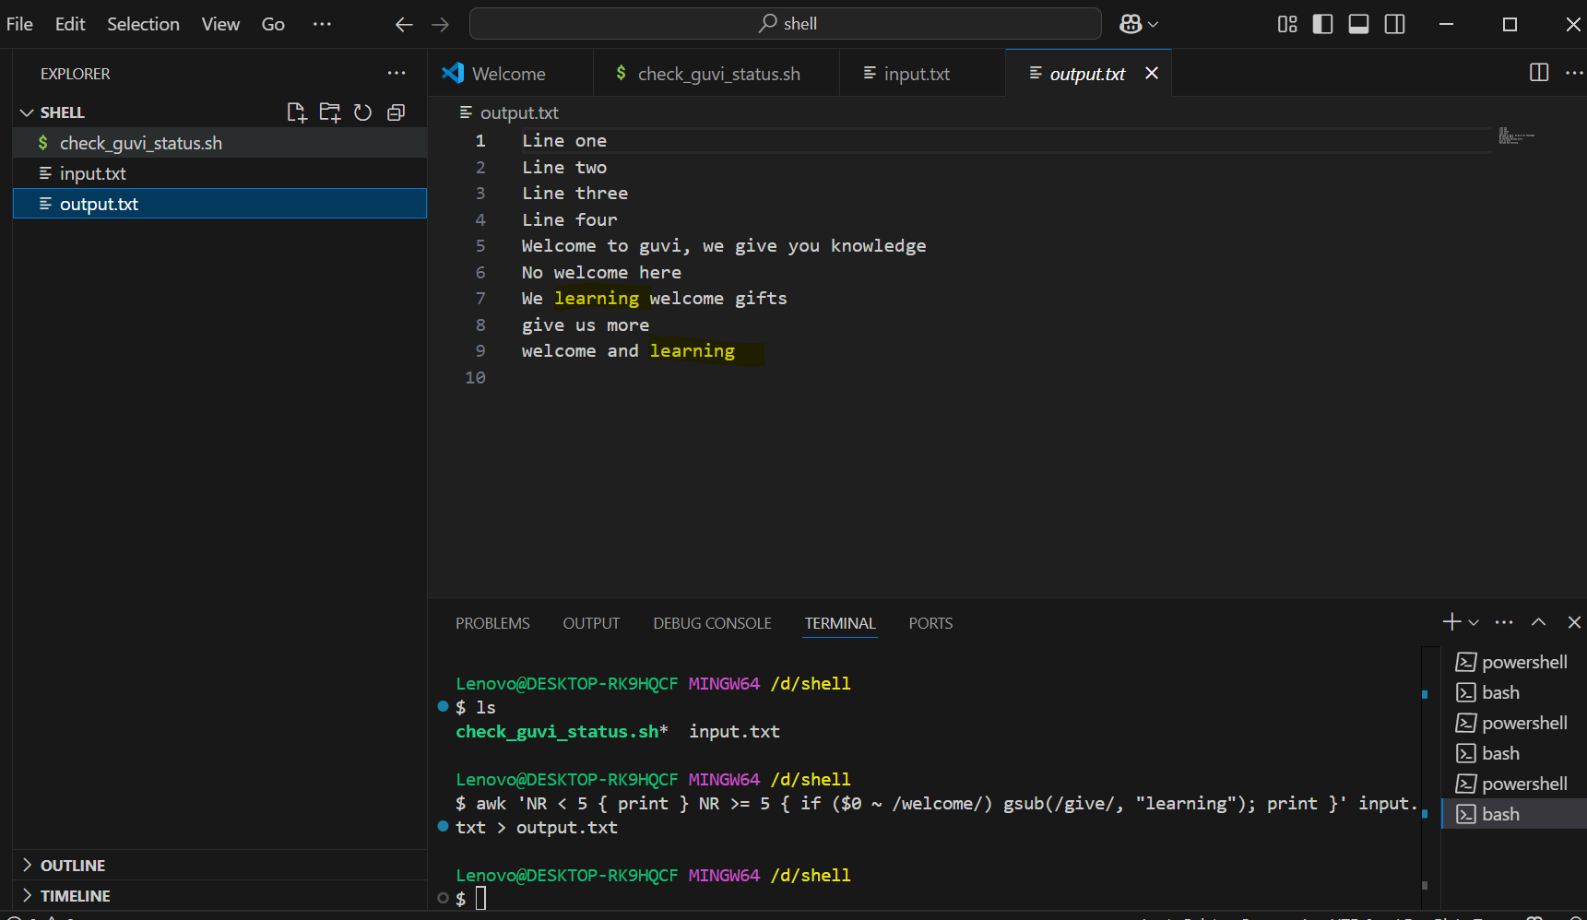

mv output.txt input.txt

**shell script** which automates this task:

replace_welcome_lines.sh

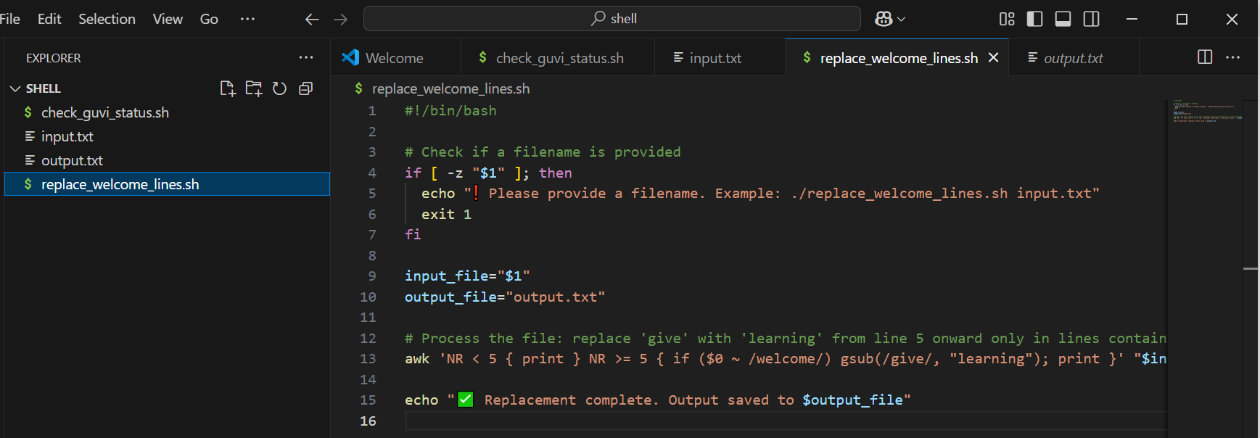

In vs code git bash terminal

chmod +x replace_welcome_lines.sh

Run :- ./replace_welcome_lines.sh input.txt

Excpected output :- ✅ Replacement complete. Output saved to output.txt

