**Terraform Task-2**

**Task Description:**

Create 2 EC2 instances on 2 different regions and install nginx using terraform script.

**Techstacks needs to be used :**

* AWS EC2
* Terraform
* AWS CLI

**How do I submit my work?**

* Push all your work files to GitHub (Code & O/P screenshot images must).
* Submit your URLs in the portal.

**Terms and Conditions?**

* You agree to not share this confidential document with anyone.
* You agree to open-source your code (it may even look good on your profile!). Do not mention our company’s name anywhere in the code.
* We will never use your source code under any circumstances for any commercial purposes; this is just a basic assessment task.

**NOTE:** Any violation of Terms and conditions is strictly prohibited. You are bound to adhere to it.

**Solution:**

**AWS IAM Access Key Creation**

Created a dedicated IAM user named terraform-user in AWS IAM and generated an Access Key and Secret Access Key for Terraform authentication.

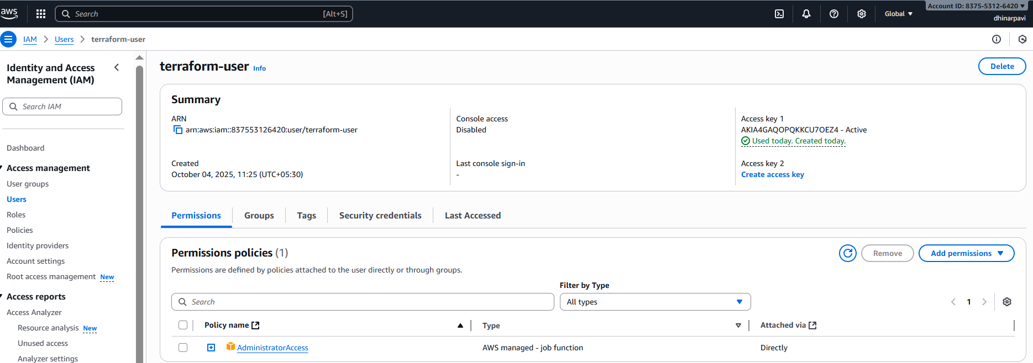

**AWS CLI Configuration**

Configured AWS CLI using the generated access keys to enable Terraform authentication with my AWS account.

Code/Command:

aws configure

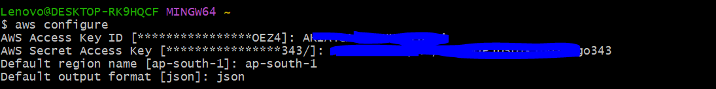

**Terraform Initialization**

Initialized Terraform in the project directory to download the AWS provider and prepare the working directory.

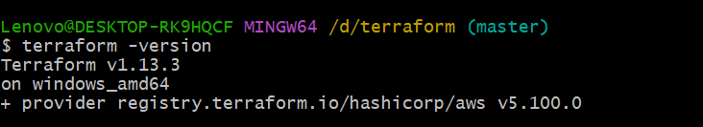

**Terraform Apply (Resource Creation)**

Executed terraform apply to provision two Amazon Linux EC2 instances in two different AWS regions (ap-south-1 and us-east-1).

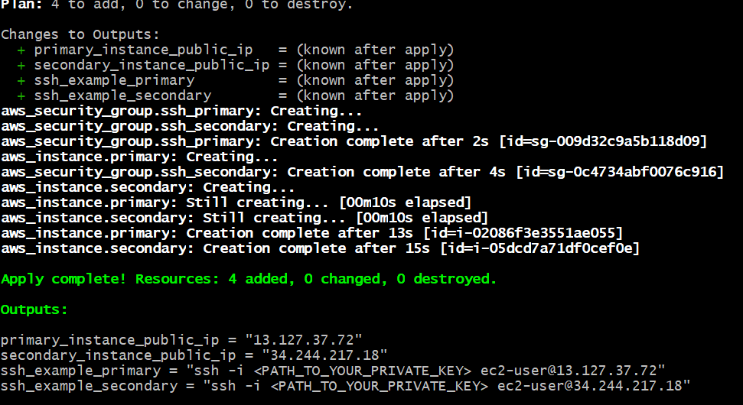

**AWS Console – EC2 Instances**

Verified both EC2 instances running successfully in the AWS Management Console under EC2 service.

**Region 1:** EC2 Dashboard → ap-south-1 (Mumbai)

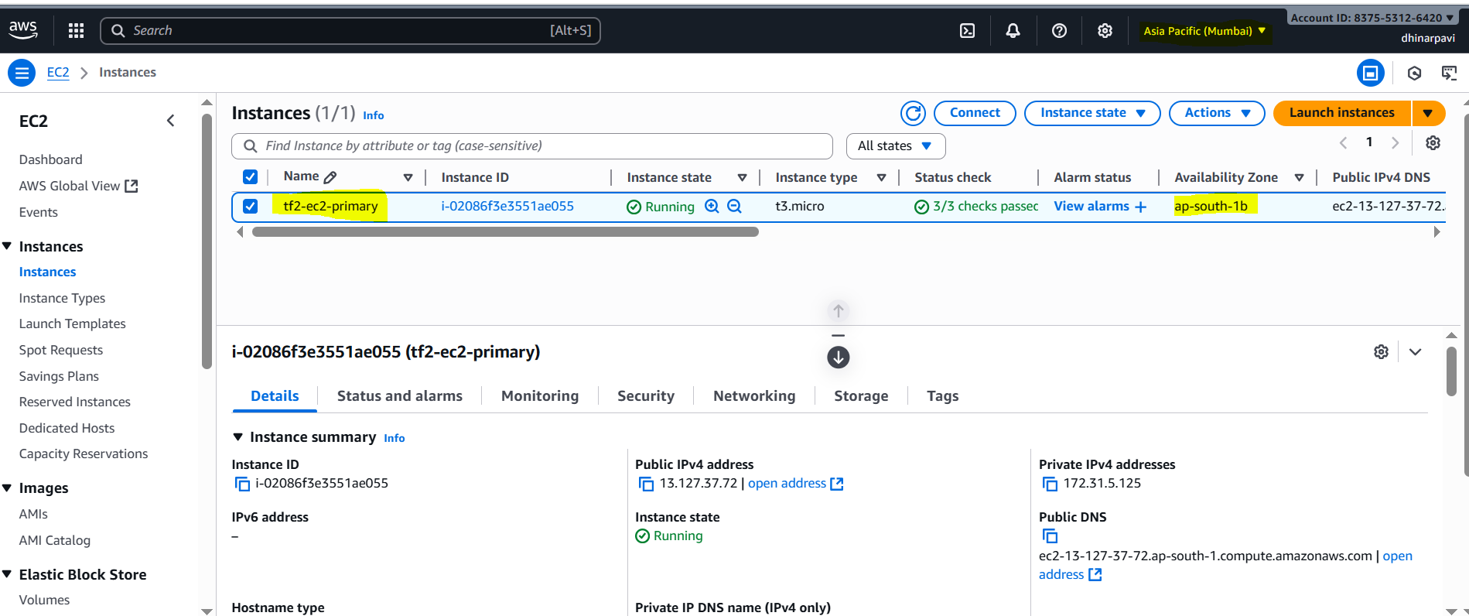

**Region 2:** Switch region → eu-west-1 (Europe)

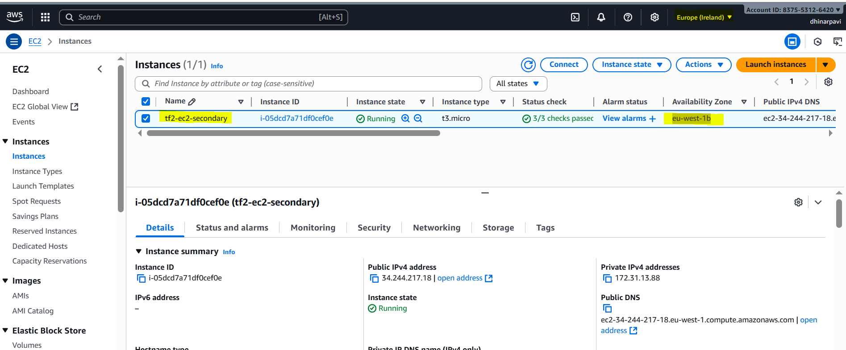

**SSH Login**

Successfully connected to the EC2 instance via SSH using the key pair created locally.

Console output

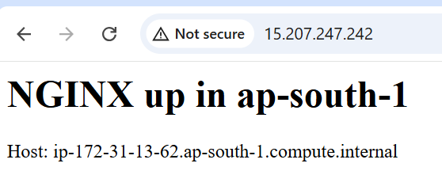

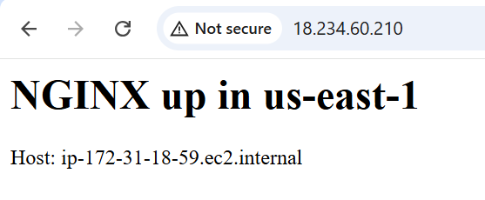

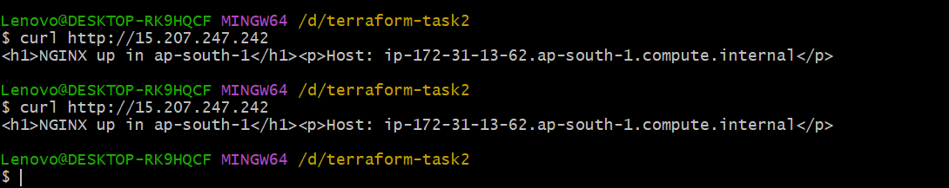

**Terraform repo in local**

