**PROBLEM STATEMENT**:

The project involves deploying IoT sensors near water bodies and flood-prone areas to monitor water levels and provide early flood warnings through a public platform. The objective is to enhance flood preparedness and response by issuing timely warnings to both the public and emergency response teams. This project includes defining objectives, designing the IoT sensor network, developing the warning platform, and integrating them using IoT technology and Python.

To overcome this we go with FLLOD MONITORING AND EARLY WARNING DETECTION using LED,Buzzer,DHT22,Pico wifi,Resistor,Ultrasonic sensor.

**HARDWARE REQUIRED:**

>> LED

>>ULTRASONIC SENSOR

>>BUZZER

>> DHT22

>>PICO WIFI

>>RESISTOR

**SOFTWARE REQUIRED**:

WOKWI ACCOUNT

**USES OF THE COMPONENT:**

*Ultrasonic sensor:*

The HC-SR04 sensor uses ultrasonic sound waves to determine the distance between the sensor and an object. It emits a high-frequency sound wave (ultrasonic pulse) and measures the time it takes for the sound wave to bounce back after hitting an object.

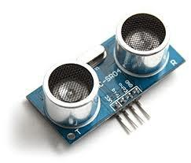

*LED*:

>> Green LEDs are often used in electronic devices and control panels as status indicators. They can signal that a device is powered on, functioning correctly, or to convey specific information.

>> Red LEDs are commonly used as indicator lights in various electronic devices and control panels. They can signify power on/off status, errors, or warnings.

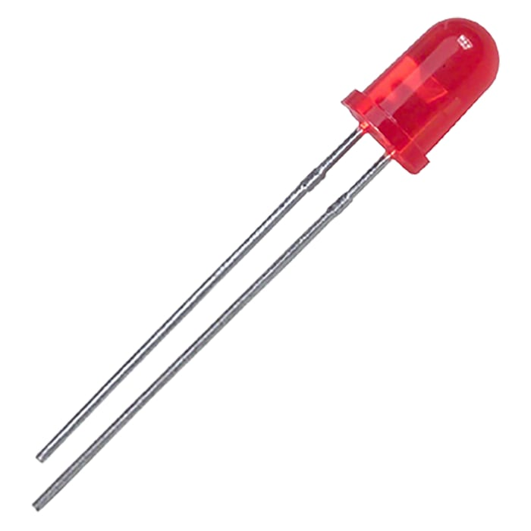

*DTH22:*

The DHT22 is a basic, low-cost digital temperature and humidity sensor. It uses a capacitive humidity sensor and a thermistor to measure the surrounding air, and spits out a digital signal on the data pin (no analog input pins needed).

Connections are simple, the first pin on the left to 3-5V power, the second pin to your data input pin and the right most pin to ground.

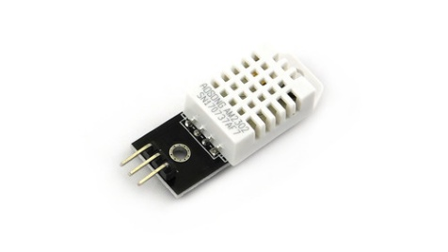

*RESISTOR:*

In electronic circuits, resistors are used to reduce current flow, adjust signal levels, to divide voltages, bias active elements, and terminate transmission lines, among other uses.

*BUZZER:*

A buzzer or beeper is an audio signaling device, which may be mechanical, electromechanical, or piezoelectric (piezo for short). Typical uses of buzzers and beepers include alarm devices, timers, train and confirmation of user input such as a mouse click or keystroke.

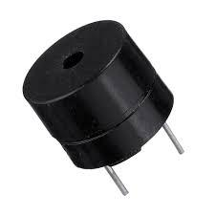

*PICO WIFI:*

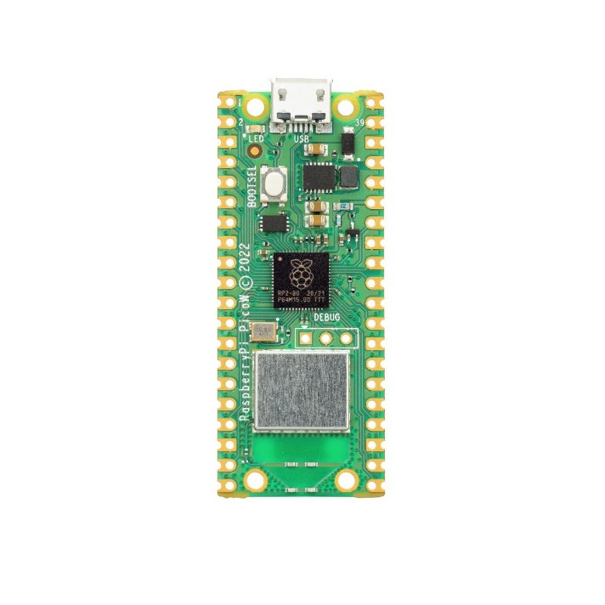 Raspberry Pi Pico W is a new Raspberry Pi product that adds WiFi capability to the Raspberry Pi Pico, allowing you to connect the device to a WiFi network.

**SIMULATION:** 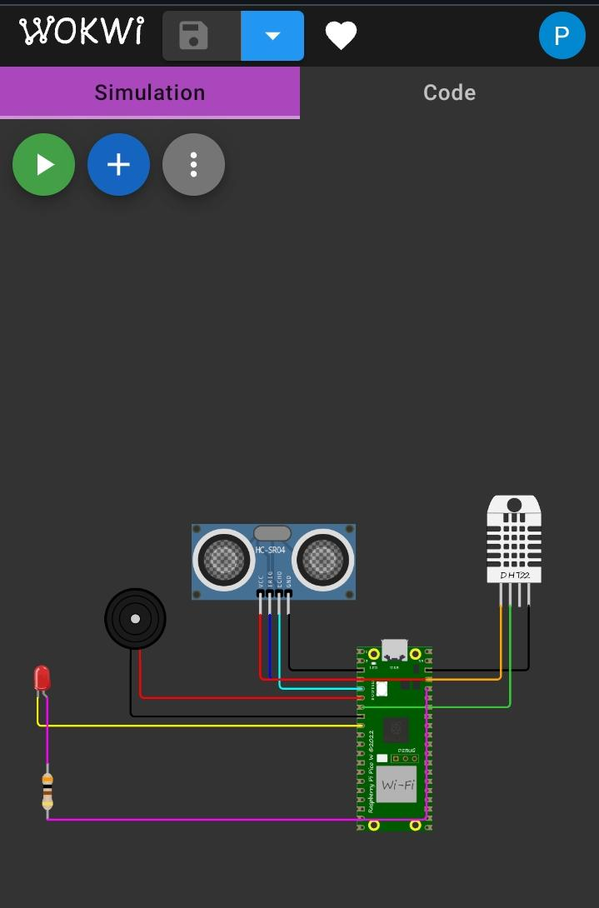

*SIMULATION LINK:*

[*https://wokwi.com/projects/378661131954863105*](wokwi)

*Coding:*

Import time

Import machine

Import dht

# Define GPIO pins

TRIG_PIN = machine.Pin(2, machine.Pin.OUT)

ECHO_PIN = machine.Pin(3, machine.Pin.IN)

BUZZER_PIN = machine.Pin(4, machine.Pin.OUT)

DHT_PIN = machine.Pin(5)

LED_PIN = machine.Pin(6, machine.Pin.OUT)

Def distance_measurement():

# Trigger ultrasonic sensor

TRIG_PIN.on()

Time.sleep_us(10)

TRIG_PIN.off()

# Wait for echo to be HIGH (start time)

While not ECHO_PIN.value():

Pass

Pulse_start = time.ticks_us()

# Wait for echo to be LOW (end time)

While ECHO_PIN.value():

Pass

Pulse_end = time.ticks_us()

# Calculate distance

Pulse_duration = time.ticks_diff(pulse_end, pulse_start)

Distance = pulse_duration / 58 # Speed of sound (343 m/s) divided by 2

Return distance

Def read_dht_sensor():

D = dht.DHT22(DHT_PIN)

d.measure()

return d.temperature(), d.humidity()

buzz_start_time = None # To track when the buzzer started

while True:

dist = distance_measurement()

temp, humidity = read_dht_sensor()

# Check if the distance is less than a threshold (e.g., 50 cm)

If dist < 50:

# Turn on the buzzer and LED

BUZZER_PIN.on()

LED_PIN.on()

Status = “Flooding Detected”

Buzz_start_time = time.ticks_ms()

Elif buzz_start_time is not None and time.ticks_diff(time.ticks_ms(), buzz_start_time) >= 60000: # 1 minute

# Turn off the buzzer and LED after 1 minute

BUZZER_PIN.off()

LED_PIN.off()

Status = “No Flooding Detected”

Else:

Status = “No Flooding Detected”

Print(f”Distance: {dist:.2f} cm”)

Print(f”Temperature: {temp:.2f}°C, Humidity: {humidity:.2f}%”)

Print(“Status:”, status)

Time.sleep(2)

**CONCLUSION:**

Finally, it is concluded that, the system can detect and hypothesize the flood earlier. The project is based on embedded system and close loop control system. System consists of hardware and software applications to detect water level of rivers, dams etc. System automatically detects the change in level of water and alerts the system when it crosses the threshold value(less than 20cm). The system include ultrasonic sensor to detect the rise in water level and alert if distance between water and sensor is less than 20 cm. DHT11 sense the temperature and humidity which help to analysis the environmental factor for flooding. If the water level crosses the threshold value than Raspberry pi turns the buzzer and led turn on which symbolizes the warning for early flood**.**

**Future Enhancement:**

This project can be made useful in various purposes when the system is enhanced as per the requirement of the relevant field. But here the main concern is to enhance the system so that it can be highly applicable for the determination of water level in river and warn the people in real time. The further enhancement which can be carried out may be:

The temperature and the humidity sensor having higher operating range can be used for the application various regions.

The distance sensor having higher range of operation can be used for larger system.

The water flow sensor can be used to determine the discharge of water which also aids on early detection of flood.

The system can be implemented in various places and the data of one system can be used to alert the other interconnected system so that the system become more feasible, fast and effective.

The web API can be made more advanced to handle the overall data of the different connected system.

Along with SMS the people can be alerted through phone calls, android app, web pages etc.