W03_D01_Home_Assignment
AI Extension: Implement playwright/typescript with vibe coding
Analyze my entire code base for selenim java (Feature file, Page class, Feature + Page class)
- Go step by step once up on my approval proceed with next step (Chain of thought method)
—After analyzing this give me the important files in which implementation is done——
—Proceed with Playwright Typescript implementation——
- Ask mode first:
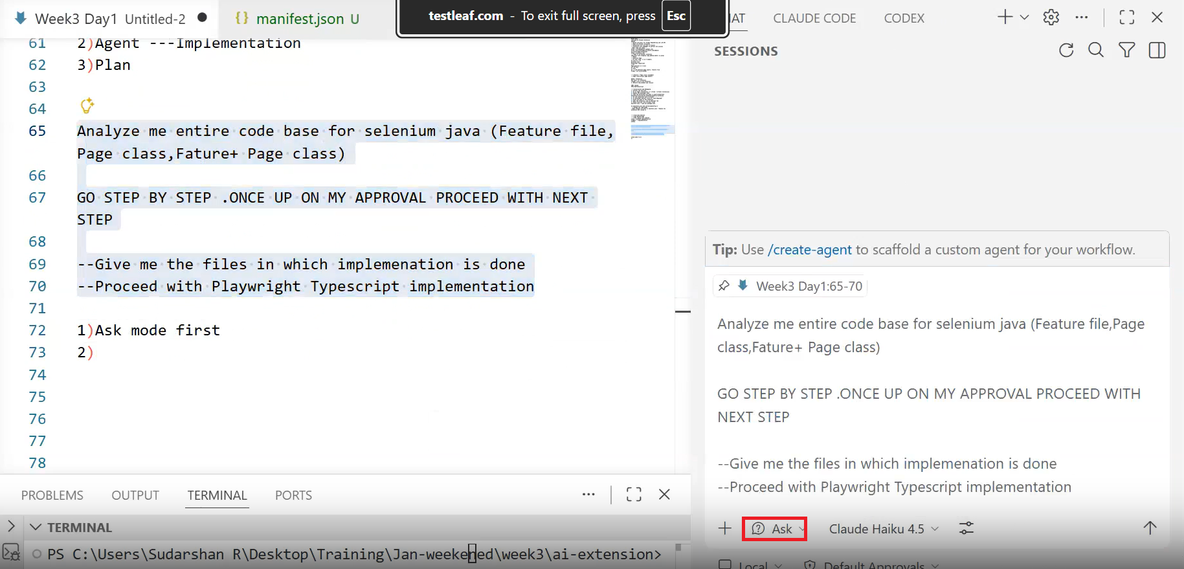
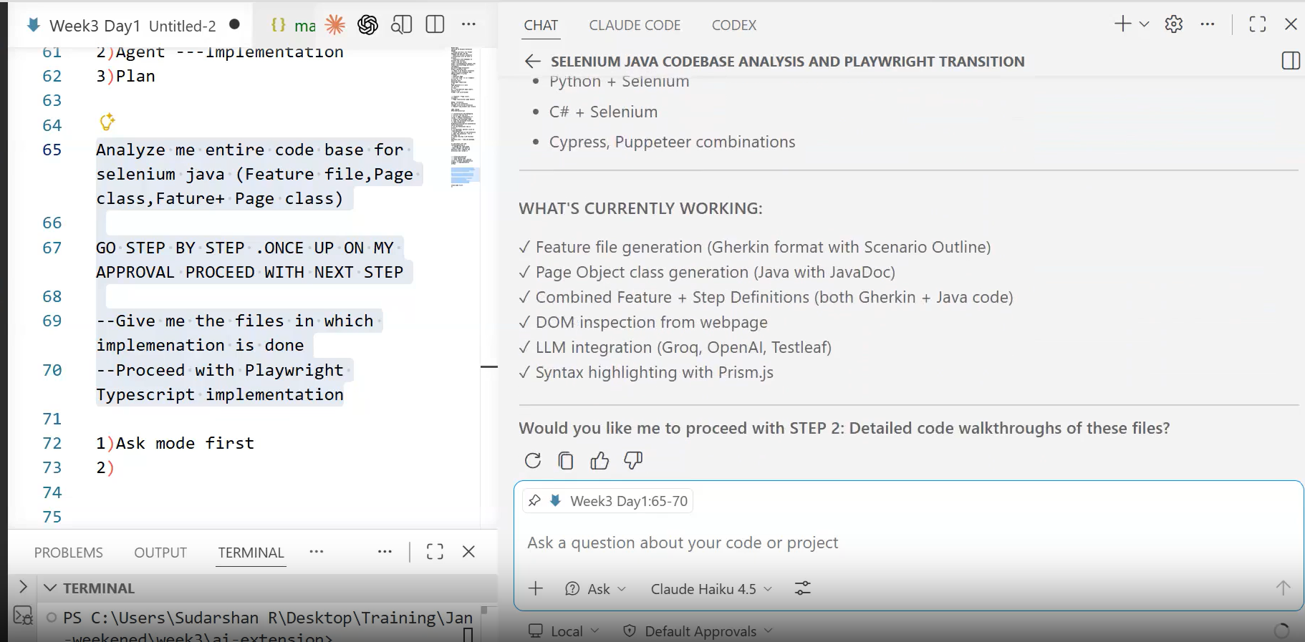

Step 2: proceed/detailed walkthrough:
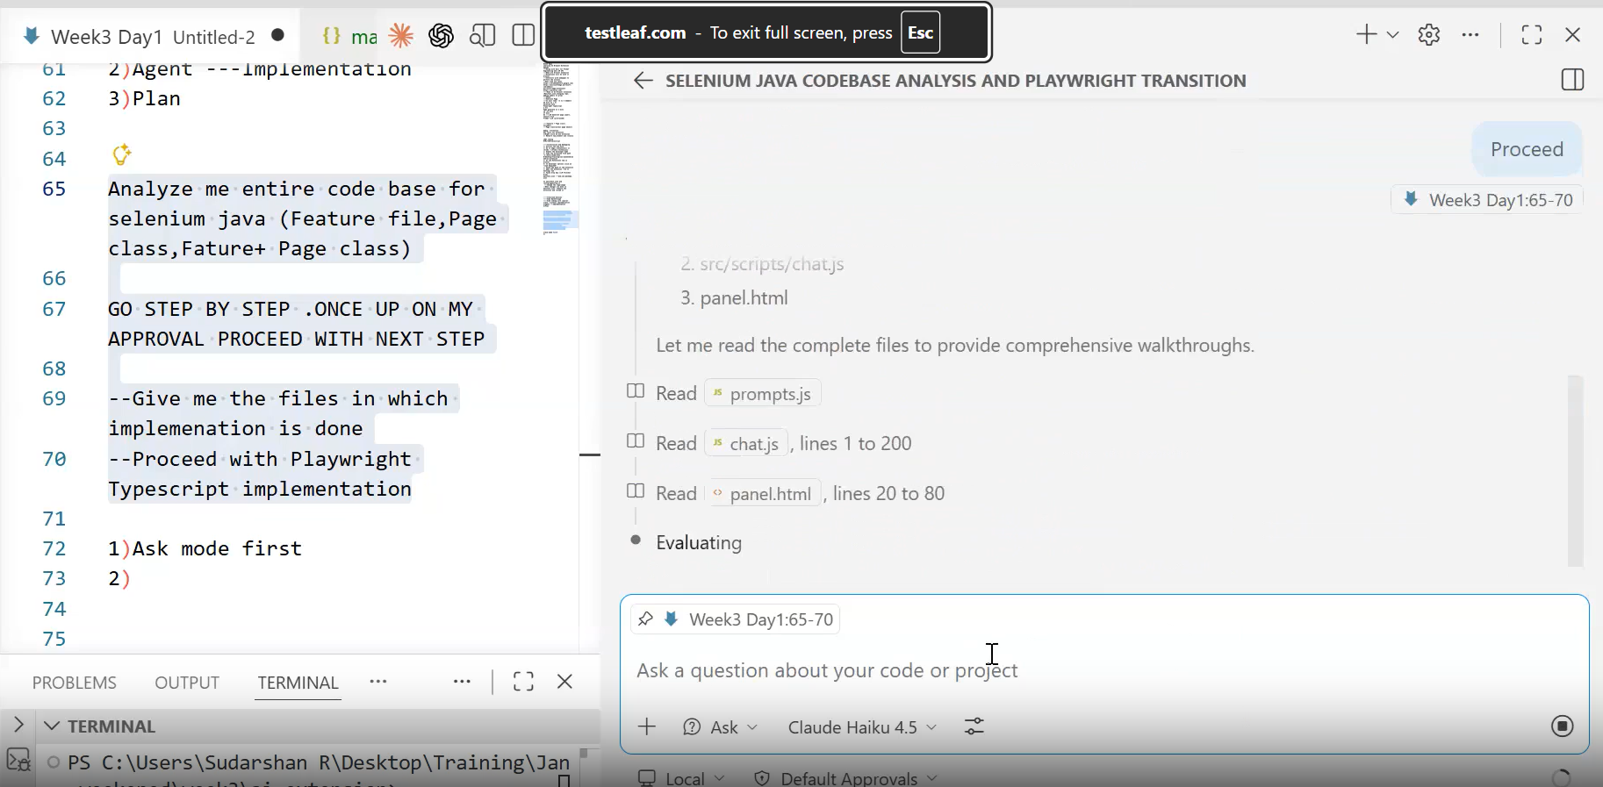

Give proceed command further:
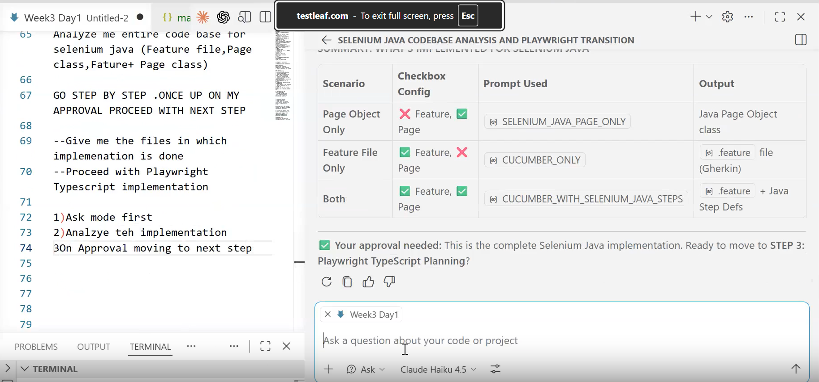

Proceed with implemetation Step by step using Agent parameter:
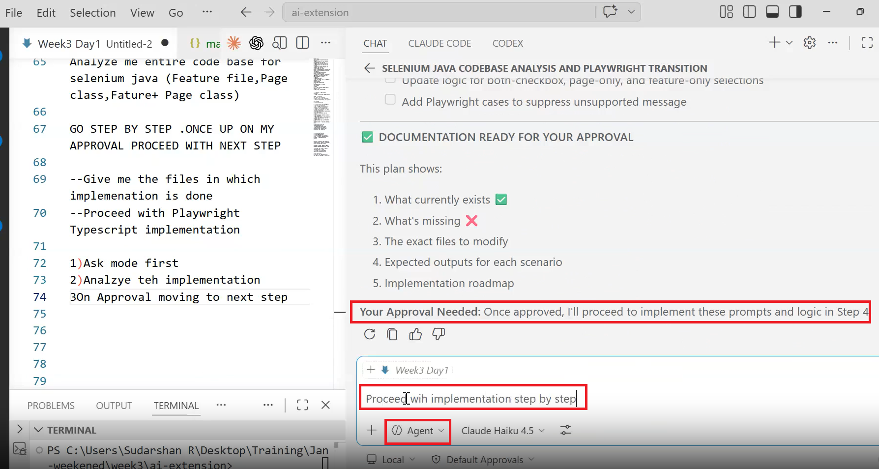
To do list visible all the 6 will be done
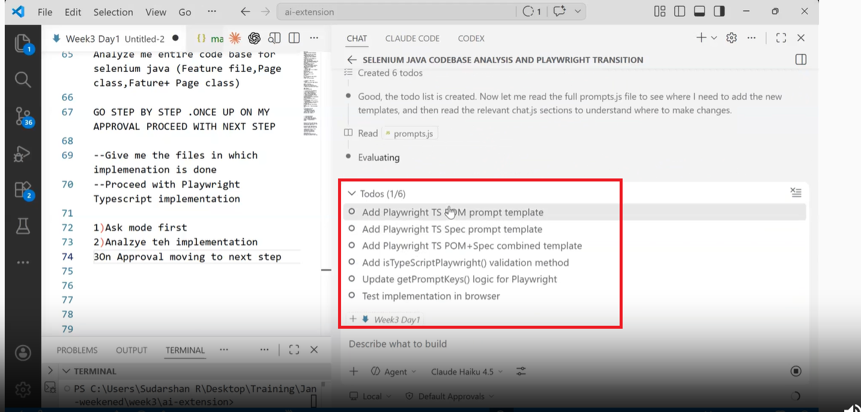

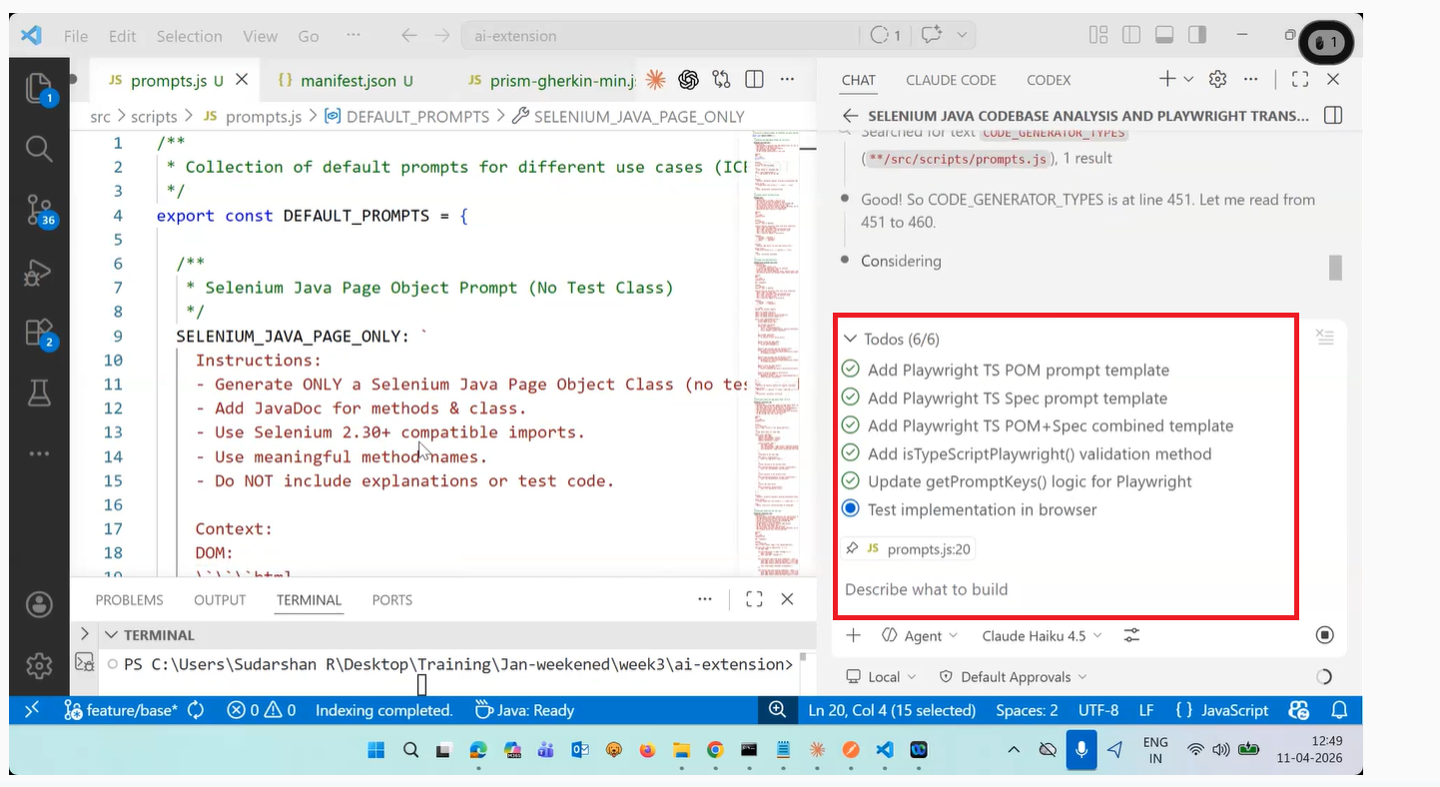
NOTE:
Whenever you use extension just close and reopen it.
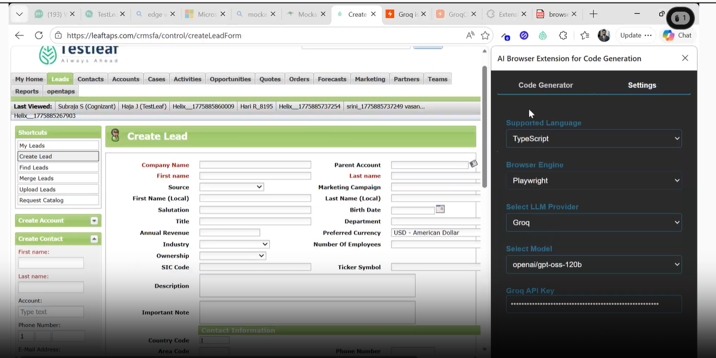
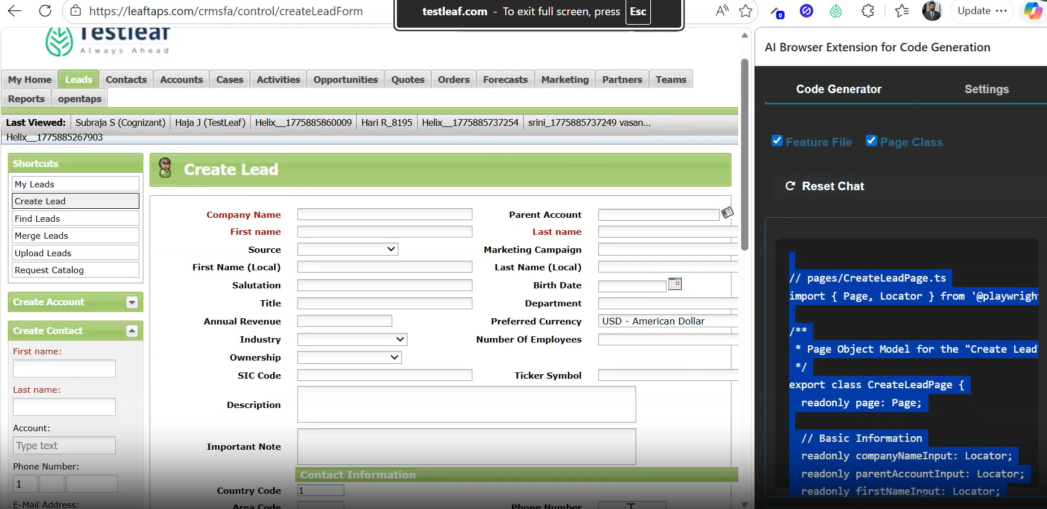
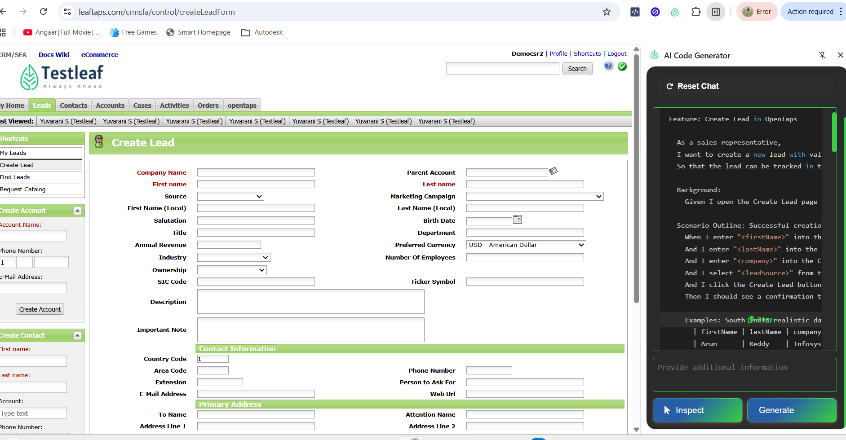
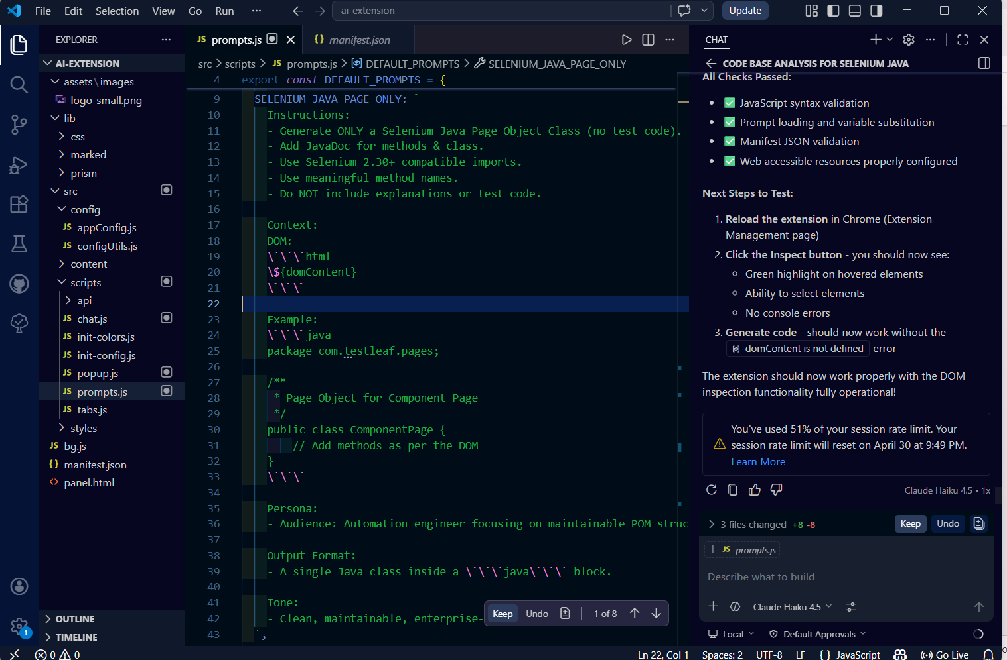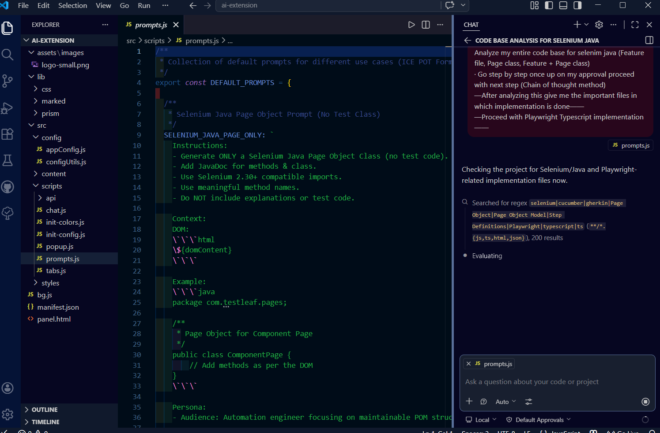
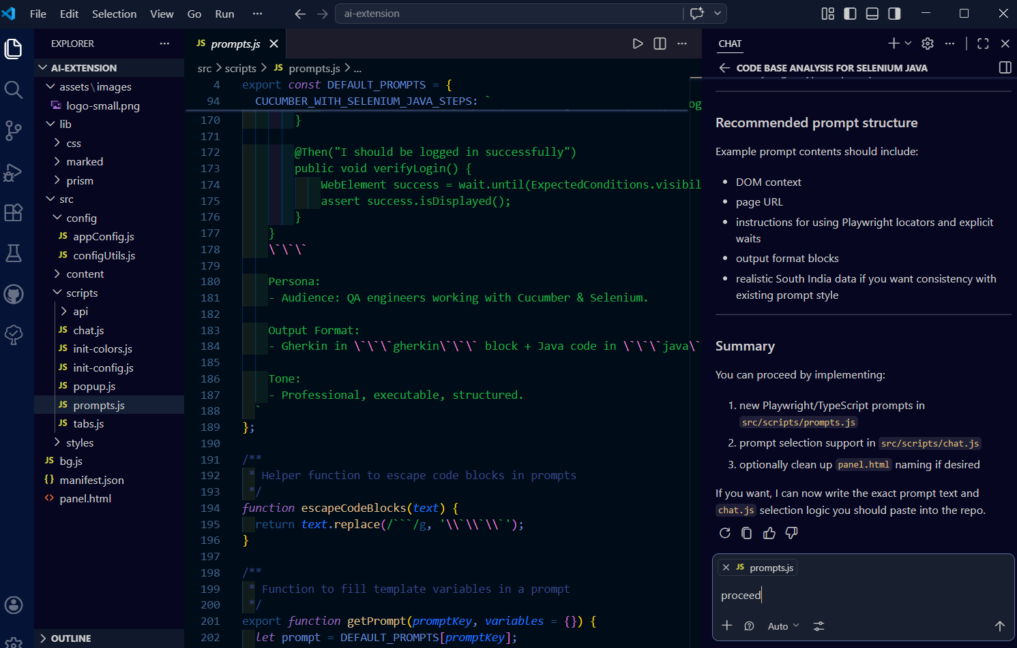Proceed with implemetation Step by step using Agent parameter