# CHATBOT DEPLOYMENT WITH IBM CLOUD WATSON ASSISTANT

PHASE-5: PROJECT DOCUMENTATION&SUBMISSION

NAME: PAVITHRAN.K

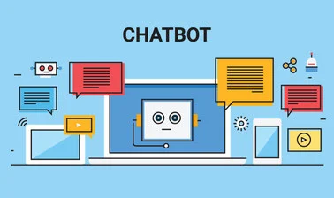

**INTRODUCTION:**

The "Chatbot Deployment with IBM Cloud Watson Assistant" project is a comprehensive exploration of creating, deploying, and managing chatbots using the IBM Cloud Watson Assistant platform. Chatbots have become indispensable tools for businesses seeking to enhance customer engagement, streamline operations, and provide efficient and personalized user experiences. This project aims to demonstrate how organizations can harness the power of IBM Cloud Watson Assistant to build and deploy chatbots effectively

## **PROBLEM DEFINITION:**

The project involves creating a chatbot using IBM Cloud Watson Assistant. The goal is to develop a virtual guide that assists users on messaging platforms like Facebook Messenger and Slack. The chatbot should provide helpful information, answer frequently asked questions (FAQS), and offer a friendly conversational experience. The project includes designing the chatbot's persona, configuring responses, integrating with messaging platforms, and ensuring a seamless user experience.

## **DESIGN THINKING:**

Design thinking is a human-centered approach to solving complex problems and creating innovative solutions. When applied to the deployment of a chatbot using IBM Cloud Watson Assistant, it helps ensure that the final product is user-centric, efficient, and effective. Here's how design thinking principles can be applied to this project:

### EMPATHIZE:

Understand the needs and pain points of both the end-users and the organization deploying the chatbot. What are their goals, challenges, and expectations?

Conduct user interviews, surveys, and stakeholder discussions to gather insights.

### DEFINE:

Clearly define the problem statement and project objectives. What specific challenges is the chatbot deployment meant to address?

Develop user personas and use cases to capture different user scenarios.

### IDEATE:

Brainstorm creative solutions for chatbot deployment. Encourage diverse perspectives and explore different deployment strategies.

Use techniques like ideation workshops to generate ideas collaboratively.

### PROTOTYPE:

Create a prototype of the chatbot deployment process. This can be a simplified version of the deployment workflow.

Consider using wireframes or mockups to visualize the chatbot's user interface and integration points.

### TEST:

Gather feedback on the prototype from potential users and stakeholders. Are there any usability issues or concerns?

Iterate on the design based on user feedback to improve the deployment process.

### IMPLEMENT:

Begin implementing the chatbot deployment based on the refined design. Follow best practices for setting up Watson Assistant on the IBM Cloud platform.

Consider scalability, security, and compliance during the implementation phase.

### TEST(again):

Conduct rigorous testing of the deployed chatbot. Verify that it accurately understands user inputs, provides relevant responses, and performs well under various scenarios.

Perform load testing to ensure the chatbot can handle expected user traffic.

### DEPLOY:

Deploy the chatbot to production environments, taking into account integration with websites, apps, or messaging platforms.

Monitor the deployment for any issues or bottlenecks and be prepared to make adjustments.

EVALUATE:

Continuously assess the chatbot's performance using key metrics such as response time, intent recognition accuracy, and user satisfaction.

Collect feedback from users and stakeholders to identify areas for improvement.

**INNOVATIVE IDEAS:**

1.Personalized Academic Advisor Bot:

Create a chatbot that serves as a virtual academic advisor. It can help students select courses, track progress toward their degree, and offer career guidance based on their academic history and goals.

2.Student Mental Health and Well-being Bot:

Develop a chatbot focused on supporting students' mental health and well-being. It can provide resources for stress management, connect students with counselors, and offer mindfulness exercises.

3.Campus Navigation and Event Guide:

Build a chatbot that helps students and visitors navigate the campus, find buildings, and provides information about campus events, including lectures, clubs, and social activities.

4.Smart Lecture Assistant:

Create a chatbot that assists students during lectures or virtual classes by answering questions, providing additional resources, and offering real-time clarification on course materials.

5.Library Research Bot:

Develop a chatbot that aids students in conducting research in the library. It can help search for academic papers, suggest relevant resources, and provide citation guidance.

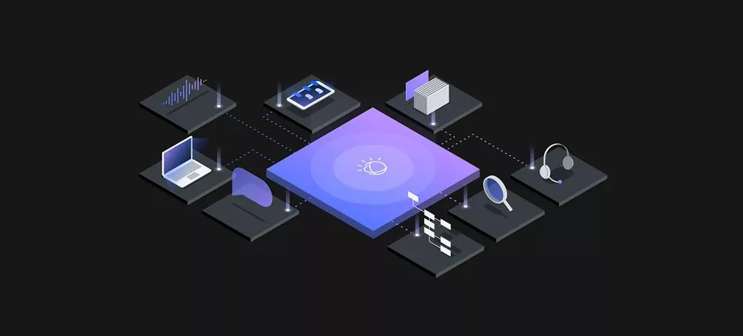

6.Financial Aid and Scholarships Advisor:

Build a chatbot that assists students in understanding the financial aid process, finding scholarships, and managing their tuition payments.

7.Language Learning Buddy:

Create a chatbot that helps international students improve their language skills in the host country by facilitating conversations, offering language lessons, and cultural insights.

8.Job and Internship Search Bot:

Design a chatbot that helps students search for job and internship opportunities, prepare for interviews, and build their professional network.

9.Healthy Eating and Nutrition Assistant:

Develop a chatbot that provides students with information on healthy eating, suggests meal plans, and offers tips for maintaining a balanced diet.

10.Campus Sustainability Bot:

Create a chatbot that educates students on sustainability practices, offers tips on reducing waste, and encourages eco-friendly choices on campus

**DATASET:**

1. First, we need to gather the dataset. If you already have a dataset in mind, please provide the

file or URL location. If not, I can help you find suitable datasets based on your project

requirements.

2. Once we have the dataset, we'll proceed with loading it into our system. Depending on the

format of the dataset (e.g., CSV, JSON, text file), we'll use the appropriate libraries or functions

to read the data.

3. After loading the dataset, we'll examine its structure and contents. This step involves checking

the number of records, identifying the columns or fields available, and understanding the data

format.

4. Next, we'll preprocess the dataset to ensure it's clean and properly formatted for training your

chatbot. This may include tasks like removing duplicates, handling missing values, and converting

text to lowercase.

5. Additionally, we might need to perform some natural language processing (NLP) tasks, such

as tokenization, stemming, or lemmatization, depending on your specific requirements.

6. We can then split the dataset into the necessary subsets, such as training, validation, and

testing sets. The proportions of these subsets can vary depending on the size of your dataset and

the training requirements.

7. Finally, we'll save the preprocessed dataset in an appropriate format that can be easily

accessed and utilized by your chatbot deployment framework

**DEFINING THE CHATBOT PERSONA:**

**Understand Your Audience**:

The first step is to understand your target audience. Who will be interacting with your chatbot? What are

their preferences, needs, and pain points? Knowing your audience will help you create a persona that

resonates with them.

**Determine the Chatbot's Purpose:**

Clearly define the primary purpose of your chatbot. Is it meant for customer support, information

retrieval, sales assistance, or something else? The persona should align with this purpose to establish trust

and reliability.

**Personality Traits:**

Decide on the personality traits of your chatbot. Is it formal, friendly, casual, or professional?

The chosen traits should be consistent with your brand image and the expectations of your

audience.

**Name and Image:**

Give your chatbot a name and, if relevant, an image or avatar. This makes the chatbot more

relatable and memorable to users.

Tone of Voice: Define the tone of voice your chatbot will use when interacting with users. Will it

be empathetic, informative, humorous, or a combination of these? The tone should align with

the personality traits chosen.

**Designing the Conversation Flow**:

Once the chatbot persona is established, you can move on to designing the conversation flow.

This involves structuring the way your chatbot interacts with users, guiding them through their

journey. Here's how to do it:

**Identify Key User Goals:**

Clearly define the primary goals users are likely to have when interacting with your chatbot.

Whether it's making a reservation, checking product availability, or troubleshooting issues,

understanding these goals is crucial.

**Create Intents:**

In Watson Assistant, intents represent user expressions of their goals. Develop a list of intents

that your chatbot should recognize, such as "book a table" or "check product availability."

**Define Entities:**

Entities are used to extract specific information from user input. For example, if a user says, "I

want to book a table for two," the entity could extract "two" as the number of people. Define

relevant entities for your use case.

**Dialog Flow:**

Construct a dialog flow that guides users through the conversation. Define nodes for each step,

creating a structured path for the chatbot-user interaction. Watson Assistant's graphical

interface is a valuable tool for this.

**User Prompts:**

Craft user prompts and responses for each node in the dialog. Ensure that responses are aligned

with the chatbot's persona and purpose, delivering a consistent and engaging experience.

**Create a Watson Assistant Service:**

Log in to your IBM Cloud account or create one if you don't have an account.

Once you're logged in, navigate to the IBM Cloud catalog and search for "Watson Assistant."

Create a new Watson Assistant service by providing a name and selecting your region.

**Create an Assistant:**

After creating the Watson Assistant service, open it.

In the Watson Assistant dashboard, click on "Create assistant."

Provide a name for your assistant and click "Create."

**Create Intents:**

Intents are used to define the different ways users can express their queries. To create intents:

Click on "Add intent" in the Intents section.

Give the intent a name, such as "Greeting," and provide examples of user queries that trigger this intent, like "Hello," "Hi there," etc.

Create multiple intents to cover various user queries.

**Create Entities:**

Entities are used to extract specific information from user queries. To create entities:

Click on "Add entity" in the Entities section.

Name the entity, such as "Location," and define its values, like "New York," "San Francisco," etc.

Assign entity values to different intents to indicate when they should be extracted.

**Create Dialog Nodes**:

Dialog nodes are used to define how your chatbot responds to user queries. To create dialog nodes:

Click on the "Create+" button in the Dialog section.

Define the conditions (triggers) for the dialog node. For example, if the intent is "Greeting" and the location is "New York."

In the response section, provide the chatbot's reply, such as "Hello from New York!" You can use variables to personalize responses.

Create multiple dialog nodes to handle different user scenarios.

**Build Your Dialog Flow:**

Connect dialog nodes to create a conversation flow. For example, if the user's intent is "Greeting," you can link it to the corresponding dialog node to respond to greetings. You can also create branches in your conversation flow for more complex interactions.

**Test Your Assistant:**

Use the chat panel in the Watson Assistant interface to test your assistant. Enter sample queries to see how your assistant responds. Make adjustments as needed.

**Deploy Your Assistant**:

Once you're satisfied with your chatbot's configuration, you can deploy it to make it accessible through various channels (e.g., a website, Facebook Messenger, etc.). Follow the deployment instructions provided by IBM Cloud.

**Integrate with Your Application:**

To integrate your chatbot with your application, you'll need to use the IBM Watson Assistant API or SDKs, which will vary depending on your development platform.

**Monitor and Improve:**

Continuously monitor user interactions and refine your intents, entities, and dialog nodes to improve the chatbot's performance

**Integrating with Facebook Messenger**

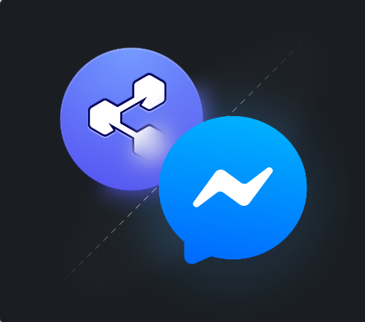

Set Up Facebook Developer Account:

* Create a Facebook Developer account if you don't already have one.
* Set up a new Facebook App and configure it for Messenger.

Obtain Page Access Token:

In your Facebook App settings, obtain a Page Access Token. This token is necessary for your chatbot to send and receive messages.

Configure webhook:

* Set up a webhook to receive messages from Facebook Messenger. Your webhook should be hosted on a public server that Facebook can reach.
* Subscribe to the messaging events you want to handle, such as messages, post backs, and message deliveries.

Develop the Chatbot Backend:

* Create a backend server that can receive and process messages from Facebook Messenger.
* Use a programming language and framework of your choice, such as Node.js, Python, or Ruby.
* Implement natural language processing (NLP) to understand user input and generate meaningful responses.

Maintain Conversation State:

* Keep track of user conversations to maintain context.
* Store user sessions and history to understand the flow of the conversation.

Generate Informed Responses:

* Use NLP libraries like spaCy or Dialogflow to understand user intent and extract relevant entities from messages.
* Ensure that responses are accurate and up-to-date, especially when providing factual information.

Handle Common Scenarios:

* Implement fallback responses for when the chatbot doesn't understand a query.
* Manage user interactions gracefully, including handling greetings, goodbyes, and interruptions.

Security and Privacy:

* Implement security measures to protect user data.
* Authenticate users if necessary and handle sensitive information securely.

Testing and Refining:

* Regularly test your chatbot to ensure it provides accurate responses.
* Collect user feedback and use it to refine the chatbot's performance.

Deployment:

* Deploy your chatbot to a production server.
* Monitor its performance and make updates as needed.

**Integrating with Slack**

Create a Slack App:

Create a new Slack App within your Slack workspace.

Obtain OAuth Tokens:

* Configure the app with the necessary permissions and scopes.
* Obtain OAuth tokens for your app to access channels and interact with users.

Configure Slash Commands or Events API:

Depending on your chatbot's functionality, you can use Slash Commands or Events API to receive messages and events from Slack.

Develop the Chatbot Backend:

* Create a backend server that can handle Slack interactions.
* Use a programming language and framework of your choice.
* Implement NLP and context management for smooth conversations.

Maintain Conversation Context:

Keep track of the conversation context and history to provide relevant responses.

Generate Informed Responses:

* Utilize NLP to understand user input and extract important information.
* Ensure responses are informative and accurate.

Testing and Refining:

* Thoroughly test your chatbot within Slack and collect user feedback.
* Continuously refine responses and behavior based on feedback and usage patterns.

## **CONCLUSION:**

In conclusion, deploying a chatbot using IBM Cloud Watson Assistant is a multifaceted endeavor that necessitates careful planning, precise execution, and ongoing enhancement. This project has equipped organizations and developers with the knowledge and best practices needed to harness chatbots' potential for elevating customer engagement, operational efficiency, and user experiences in today's digital landscape. By adhering to these principles, organizations can position themselves for success and innovation in an ever-evolving digital world.

I