**SMART TICKETING SYSTEM IN METRO RAIL**

**A PROJECT REPORT**

***Submitted by***

|  |  |
| --- | --- |
| **GOWTHAM.D** | **15L315** |
| **PAVITHRAN.K.S** | **15L332** |
| **SRIDHAR.A** | **15L344** |
| **VEERAPANDIAN.C** | **15L350** |

***in partial fulfilment for the award of the degree of***

**BACHELOR OF ENGINEERING**

**IN**

**ELECTRONICS AND COMMUNICATION ENGINEERING**

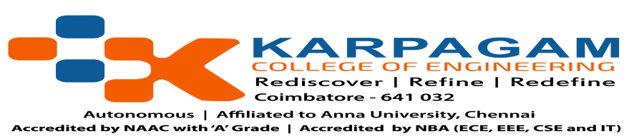

**ANNA UNIVERSITY, CHENNAI**

**OCTOBER -2018**

**KARPAGAM COLLEGE OF ENGINEERING**

(Autonomous)

**COIMBATORE – 641 032**

**SMART TICKETING SYSTEM IN METRO RAIL**

Bonafide record of work done by

|  |  |
| --- | --- |
| **GOWTHAM.D** | **15L315** |
| **PAVITHRAN.K.S** | **15L332** |
| **SRIDHAR.A** | **15L344** |
| **VEERAPANDIAN.C** | **15L350** |

Dissertation submitted in partial fulfilment of the requirements for the degree of

**BACHELOR OF ENGINEERING**

**IN**

**ELECTRONICS AND COMMUNICATION ENGINEERING**

of Anna University, Chennai

**OCTOBER-2018**

...…………………… …………..……………….

**Mr.G.Arun Francis ME.,(Ph.D) Dr.A. Rajendran Ph.D.**

Faculty guide Head of the Department



Certified that the candidate was examined in the viva-voce examination held on

………………….

…………………….. …………………………..

(Internal Examiner) (External Examiner)