**CHAPTER 1**

**INTRODUCTION**

**1.1 INTRODUCTION TO THE PROJECT:**

Radio Frequency Identification (abbreviated as RFID) has been an emerging technology in recent years. RFID technology can be effectively employed in number of applications due to its penchant for efficiency. Radio Frequency Identification (RFID) is a generic term for technologies that use radio waves to automatically identify and track product, animal, or person by means of using RFID tags that are applied or incorporated on them. An RFID system consists of a tag, basically a microchip with an antenna and an interrogator or reader with an antenna. A fundamental system of RFID consists of two primary components: The reader circuit and tag. The RFID tag and the reader circuit set up communication via waves of electromagnetic nature.

In most RFID tags contain at least two parts.

i). First one is an integrated circuit for storing and processing information, modulating and demodulating a RF signal, and other specialized functions.

ii). Second is an antenna for receiving and transmitting the signal. The data is stored in RFID tags which respond to the reader by transforming the energy of radio frequency queries from the reader and sending back the information. A computer hosting a specific RFID application pilots the reader and it processes the data it sends.

Radio Frequency Identification (RFID) establishes the identity of subjects in the physical world using uniquely numbered electronic tags.RFID is an electronic technology whereby digital data encoded in an RFID tag is retrieved utilizing a reader. In contrast to bar code technology, RFID systems do not require line-of-sight access to the tag in order to retrieve the tag’s data .

So here passive RFID cards are used which store a 12 bit code. Every card has a unique 12 bit code and hence it is assigned to each passenger separately, and would be provided at the time of boarding the train.

According to the unique code of the passenger, each and every passenger would be allotted a specific time period to use the power socket in the reservation bogie of the Indian rails.

After the specified time period is over the power supply to the socket is cut off. Also there would be four more chances to use the power port by that particular person. And lastly there would be an emergency chance too for the passenger to use the power port. Each and every chance would be of different time periods including the last emergency chance. So that every passenger gets equal chance to use the power port for charging and thereby wastage of power is also prevented.

This work suggests the use of RFID technology with Embedded system to provide an improved and efficient automated train ticketing system with RFID tag. An efficient utilization of RFID with Embedded System facilitate the smart ticketing in metro trains is proposed. This system explains the installation of RFID reader circuit in each and every train stations in metro rail to facilitate the calculation of ticket charges and valid time This task is implemented by using an automated Database system which makes the transactions faster, easier and free of ambiguity. This system very useful for passengers.

**CHAPTER 2**

**PROJECT MODULES**

**2.1 Block Diagram of the Project:**

**ARDUINO UNO**

**LCD DISPLAY**

**POWER SUPPLY**

**BUZZER**

**RFID READER**

**RFID TAG**

**MOTOR DRIVER**

**MOTOR**

Figure 2.1 Block Diagram

**2.1.1 Description Of Block Diagram**

The main advantage of the RFID tag is that each tag has a unique sequence number and hence there is no possibility of duplication . Also, the cost of manufacturing a RFID tag is appreciably less. Hence it makes the availability of RFID Tags to the public a viable option.

The proposed system RFID reader circuit is installed at the entry point and at the exit of the platform gate . When the passenger enters the platform gate , the passenger should display the tag in front of the reader circuit placed at the platform gate. If we have time then only door will open or door will not open The detailed operation of the system is further explained below.

Firstly the RFID reader will be initialized and would be in the reading mode and hence a message would be displayed on the screen to asking the passengers to please swipe his/her particular RFID card. As soon as a passenger swipes his/her card across the RFID reader, the RFID reader reads the card and transmits the 12 bit unique code of the particular card to the microcontroller at 9600 baud rate and then the microcontroller (like at mega 328 as shown here in block diagram) detects that particular passenger and displays his/her name on lcd by comparing his card’s no. with the database inside of it. Then next thing done is recognizing which turn or chance is that particular passenger is using for using the power port for recharging. Then according to the no, of chance of that passenger the microcontroller closes the relay for that specific period of time which is mentioned for that particular turn [[3](https://www.omicsonline.org/open-access/rfid-based-swipe-card-and-draw-power-in-indian-railways-2332-0796-1000144.php?aid=54742#3)-[5](https://www.omicsonline.org/open-access/rfid-based-swipe-card-and-draw-power-in-indian-railways-2332-0796-1000144.php?aid=54742#5)].

For example, if there is a passenger of RFID card no. 23456DE2QW24 and this no. is assigned to be the second passenger by the [**railway**](https://www.omicsonline.org/searchresult.php?keyword=railway) database at the departure station of that particular station and while travelling in the reservation bogie, he finds need to recharge his mobile; he will try to find the [**power**](https://www.omicsonline.org/searchresult.php?keyword=power) port and then swipe his card. Then the MPU will recognize him as passenger no. 2 and then as he is using the power port for first time, he will be assigned the first chance of timer and his timer will start and the relay will close the power port circuit and that passenger will be able to use the power port for a particular period of time. Then after the timer is reaches zero the relay opens up and hence the circuit breaks and the turns counter is also incremented by one. In this way the passenger would be able to use the power port for 6 times for different intervals of time and after which the RFID card would get expired.

**2.2 ARDUINO UNO**

**Arduino Uno** is a microcontroller board based on the ATmega328P. It has 14 digital input/output pins (of which 6 can be used as PWM outputs), 6 analog inputs, a 16 MHz quartz crystal, a USB connection, a power jack, an ICSP header and a reset button. It contains everything needed to support the microcontroller; simply connect it to a computer with a USB cable or power it with a AC-to-DC adapter or battery to get started.. You can tinker with your UNO without worring too much about doing something wrong, worst case scenario you can replace the chip for a few dollars and start over again.

"Uno" means one in Italian and was chosen to mark the release of ARDUINO Software (IDE) 1.0. The Uno board and version 1.0 of ARDUINO Software (IDE) were the reference versions of ARDUINO, now evolved to newer releases. The Uno board is the first in a series of USB ARDUINO boards, and the reference model for the ARDUINO platform; for an extensive list of current, past or outdated boards see the ARDUINO index of boards.

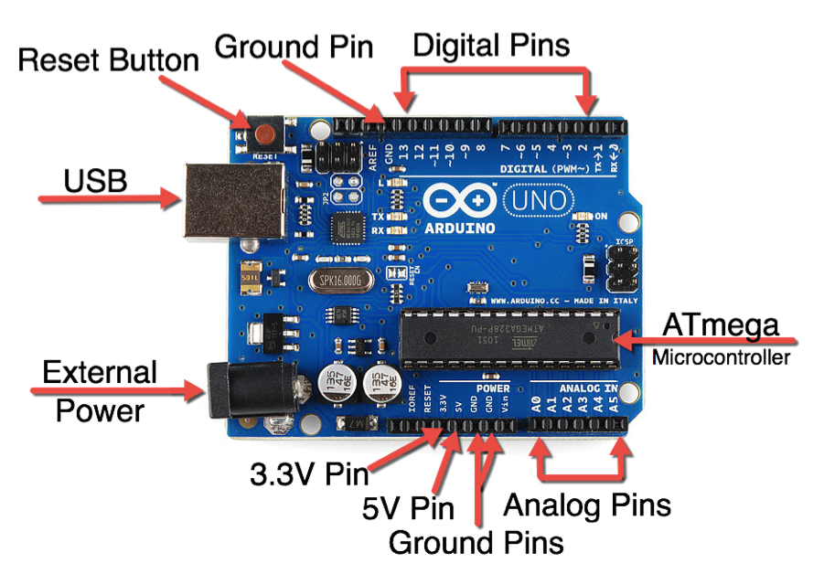

Figure 2.2.a Arduino UNO

**2.2.1 POWER**

The Arduino Uno can be powered via the USB connection or with an external power supply. The power source is selected automatically.

External (non-USB) power can come either from an AC-to-DC adapter (wall-wart) or battery. The adapter can be connected by plugging a 2.1mm center-positive plug into the board's power jack. Leads from a battery can be inserted in the Gnd and Vin pin headers of the POWER connector.

The board can operate on an external supply of 6 to 20 volts. If supplied with less than 7V, however, the 5V pin may supply less than five volts and the board may be unstable. If using more than 12V, the voltage regulator may overheat and damage the board. The recommended range is 7 to 12 volts.

The power pins are as follows:

* **VIN.** The input voltage to the Arduino board when it's using an external power source (as opposed to 5 volts from the USB connection or other regulated power source). You can supply voltage through this pin, or, if supplying voltage via the power jack, access it through this pin.
* **5V.**This pin outputs a regulated 5V from the regulator on the board. The board can be supplied with power either from the DC power jack (7 - 12V), the USB connector (5V), or the VIN pin of the board (7-12V). Supplying voltage via the 5V or 3.3V pins bypasses the regulator, and can damage your board. We don't advise it.
* **3V3.** A 3.3 volt supply generated by the on-board regulator. Maximum current draw is 50 mA.
* **GND.** Ground pins.

**2.2.2 ARDUINO UNO TO ATMEGA328 PIN MAPPING**

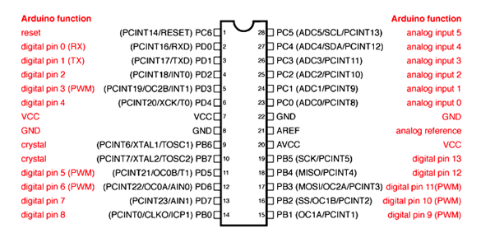

Figure 2.2.b ATMEGA328 Pin Mapping

**2.2.3 INPUT AND OUTPUT**

Each of the 14 digital pins on the Uno can be used as an input or output, using pinMode(), digitalWrite(), and digitalRead() functions. They operate at 5 volts. Each pin can provide or receive a maximum of 40 mA and has an internal pull-up resistor (disconnected by default) of 20-50 kOhms. In addition, some pins have specialized functions:

* **Serial: 0 (RX) and 1 (TX).** Used to receive (RX) and transmit (TX) TTL serial data. These pins are connected to the corresponding pins of the ATmega8U2 USB-to-TTL Serial chip.
* **External Interrupts: 2 and 3.** These pins can be configured to trigger an interrupt on a low value, a rising or falling edge, or a change in value. See the attachInterrupt() function for details.
* **PWM: 3, 5, 6, 9, 10, and 11.** Provide 8-bit PWM output with the analogWrite() function
* **SPI: 10 (SS), 11 (MOSI), 12 (MISO), 13 (SCK).** These pins support SPI communication using the SPI library.
* **LED: 13.** There is a built-in LED connected to digital pin 13. When the pin is HIGH value, the LED is on, when the pin is LOW, it's off.
* The Uno has 6 analog inputs, labeled A0 through A5, each of which provide 10 bits of resolution (i.e. 1024 different values). By default they measure from ground to 5 volts, though is it possible to change the upper end of their range using the AREF pin and the analogReference() function. Additionally, some pins have specialized functionality:
* **TWI: A4 or SDA pin and A5 or SCL pin.** Support TWI communication using the Wire library.
* There are a couple of other pins on the board:
* **AREF.** Reference voltage for the analog inputs. Used with analogReference().
* **Reset.** Bring this line LOW to reset the microcontroller. Typically used to add a reset button to shields which block the one on the board.

See also the mapping between Arduino pins and ATmega328 ports. The mapping for the Atmega8, 168, and 328 is identical.

**2.2.4 Communication**

ARDUINO can be used to communicate with a computer, another ARDUINO board or other microcontrollers. The ATmega328P microcontroller provides UART TTL (5V) serial communication which can be done using digital pin 0 (Rx) and digital pin 1 (Tx). An ATmega16U2 on the board channels this serial communication over USB and appears as a virtual com port to software on the computer. The ATmega16U2 firmware uses the standard USB COM drivers, and no external driver is needed. However, on Windows, a .inf file is required. The ARDUINO software includes a serial monitor which allows simple textual data to be sent to and from the ARDUINO board. There are two RX and TX LEDs on the ARDUINO board which will flash when data is being transmitted via the USB-to-serial chip and USB connection to the computer (not for serial communication on pins 0 and 1). A Software Serial library allows for serial communication on any of the Uno's digital pins. The ATmega328P also supports I2C (TWI) and SPI communication. The ARDUINO software includes a Wire library to simplify use of the I2C bus.

**2.2.5 APPLICATIONS**

* Prototyping of Electronics Products and Systems
* Multiple DIY Projects.
* Easy to use for beginner level DIYers and makers.
* Projects requiring Multiple I/O interfaces and communications.

**2.3 POWER SUPPLY**

Almost all basic household electronic circuits need an unregulated AC to be converted to constant DC, in order to operate the electronic device. All devices will have a certain power supply limit and the electronic circuits inside these devices must be able to supply a constant DC voltage within this limit. That is, all the active and passive electronic devices will have a certain DC operating point (Q-point or Quiescent point), and this point must be achieved by the source of DC power. The DC power supply is practically converted to each and every stage in an electronic system. Thus a common requirement for all this phases will be the DC power supply. All low power system can be run with a battery. But, for long time operating devices, batteries could prove to be costly and complicated. The best method used is in the form of an unregulated power supply –a combination of a transformer, rectifier and a filter. The diagram is shown below.

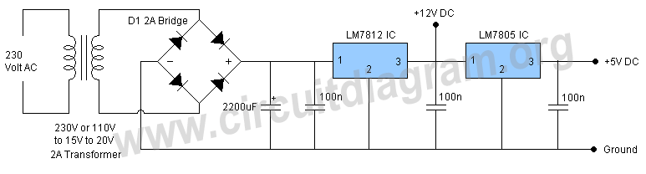

Figure 2.3 Rectifier

As shown in the figure above, a small step down transformer is used to reduce the voltage level to the devices needs. In India, a 1 Ø supply is available at 230 volts. The output of the transformer is a pulsating sinusoidal AC voltage, which is converted to pulsating DC with the help of a rectifier. This output is given to a filter circuit which reduces the AC ripples, and passes the DC components. But here are certain disadvantages in using an unregulated power supply.

* **1. Poor Regulation –**When the load varies, the output does not appear constant. The output voltage changes by a great value due to the huge change in current drawn from the supply. This is mainly due to the high internal resistance of the power supply (>30 Ohms).
* **2. AC Supply Main Variations –**The maximum variations in AC supply mains is give or take 6% of its rated value . But this value may go higher in some countries (180-280 volts). When the value is higher it’s DC voltage output will differ largely.
* **3. Temperature Variation –**The use of semiconductor devices in electronic devices may cause variation in temperature.
* These variations in dc output voltage may cause inaccurate or erratic operation or even malfunctioning of many electronic circuits. For instance, in oscillators the frequency will shift, in transmitters output will get distorted, and in amplifiers the operating point will shift causing bias instability.
* All the above listed problems are overcome with the help of a  [voltage regulator](http://www.circuitstoday.com/voltage-regulators) which is employed in conjunction with an unregulated power supply. Thus, the ripple voltage is largely reduced. Thus, the supply becomes a regulated power supply.
* The internal circuitry of a regulated power supply also contains certain current limiting circuits which helps the supply circuit from getting fried from inadvertent circuits. Nowadays, all the power supplies use [**IC’s**](http://www.circuitstoday.com/integrated-circuits) to reduce ripples, enhance voltage regulation and for widened control options. Programmable power supplies are also available to allow remote operation that is useful in many settings.

**2.3.1 REGULATED POWER SUPPLY**

Regulated power supply is an electronic circuit that is designed to provide a constant dc voltage of predetermined value across load terminals irrespective of ac mains fluctuations or load variations.

**Voltage regulator**

**Power supply**

**Ac input**

Figure 2.3.1 Block diagram of Regulated Power Supply

A regulated power supply essentially con­sists of an ordinary power supply and a volt­age regulating device, as illustrated in the figure. The output from an ordinary power supply is fed to the voltage regulating device that provides the final output. The output voltage remains constant irrespective of variations in the ac input voltage or variations in output (or load) current.

Figure given below shows the complete circuit of a regulated power supply with a transistor series regulator as a regulating device. The ac voltage, typically 230 Vrms is connected to a transformer which transforms that ac voltage to the level for the desired dc output. A bridge rectifier then provides a full-wave rectified voltage that is initially filtered by a ∏ (or C-L-C) filter to produce a dc voltage. The resulting dc voltage usually has some ripple or ac voltage variation. A regulating circuit use this dc input to provide a dc voltage that not only has much less ripple voltage but also remains constant even if the input dc voltage varies somewhat or the load connected to the output dc voltage changes. The regulated dc supply is available across a voltage divider.

Often more than one dc voltage is required for the operation of electronic circuits. A single power supply can provide as many as voltages as are required by using a voltage (or potential) divider, as illustrated in the figure. As illustrated in the figure, a potential divider is a single tapped resistor connected across the output terminals of the supply. The tapped resistor may consist of two or three resistors connected in series across the supply. In fact, bleeder resistor may also be employed as a potential divider

**2.3.2 Power Supply Characteristics**

There are various factors that determine the quality of the power supply like the load voltage, load current, voltage regulation, source regulation, output impedance, ripple rejection, and so on. Some of the characteristics are briefly explained below:

1. **Load Regulation** – The load regulation or load effect is the change in regulated output voltage when the load current changes from minimum to maximum value.

**Load regulation = Vno-load – Vfull-load**

 Vno-load – Load Voltage at no load

Vfull-load – Load voltage at full load.

From the above equation we can understand that when Vno-load occurs the load resistance is infinite, that is, the out terminals are open circuited. Vfull-load occurs when the load resistance is of the minimum value where voltage regulation is lost.

**% Load Regulation = [(Vno-load – Vfull-load)/Vfull-load] * 100**

2. **Minimum Load Resistance** – The load resistance at which a power supply delivers its full-load rated current at rated voltage is referred to as minimum load resistance.

**Minimum Load Resistance = Vfull-load/Ifull-load**

The value of Ifull-load, full load current should never increase than that mentioned in the data sheet of the power supply.

3. **Source/Line Regulation** – In the block diagram, the input line voltage has a nominal value of 230 Volts but in practice, here are considerable variations in ac supply mains voltage. Since this ac supply mains voltage is the input to the ordinary power supply, the filtered output of the bridge rectifier is almost directly proportional to the ac mains voltage.

The source regulation is defined as the change in regulated output voltage for a specified rage of lie voltage.

4. **Output Impedance** – A regulated power supply is a very stiff dc voltage source. This means that the output resistance is very small. Even though the external load resistance is varied, almost no change is seen in the load voltage. An ideal voltage source has an output impedance of zero.

5. **Ripple Rejection** – Voltage regulators stabilize the output voltage against variations in input voltage. Ripple is equivalent to a periodic variation in the input voltage. Thus, a voltage regulator attenuates the ripple that comes in with the unregulated input voltage. Since a voltage regulator uses negative feedback, the distortion is reduced by the same factor as the gain.

**2.4 DC MOTOR**

A DC motor is any motor within a class of electrical machines whereby direct current electrical power is converted into mechanical power. Most often, this type of motor relies on forces that magnetic fields produce. Regardless of the type, DC motors have some kind of internal mechanism, which is electronic or electromechanical. In both cases, the direction of current flow in part of the motor is changed periodically.

The speed of a DC motor is controlled using a variable supply voltage or by changing the strength of the current within its field windrings. While smaller DC motors are commonly used in the making of appliances, tools, toys, and automobile mechanisms, such as electric car seats, larger DC motors are used in hoists, elevators, and electric vehicles.

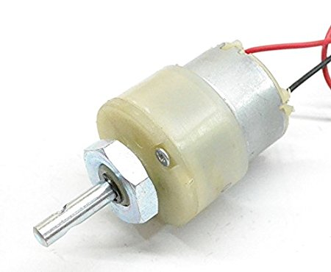

Figure 2.4 DC Motor

Here we are using 12V DC 60 RPM motor. 60RPM Centre Shaft Economy Series DC Motor is high quality low cost DC geared motor. It has steel gears and pinions to ensure longer life and better wear and tear properties. The gears are fixed on hardened steel spindles polished to a mirror finish. The output shaft rotates in a plastic bushing. The whole assembly is covered with a plastic ring. Gearbox is sealed and lubricated with lithium grease and require no maintenance. The motor is screwed to the gear box from inside.  
Although motor gives 60 RPM at 12V but motor runs smoothly from 4V to 12V and gives wide range of RPM, and torque. Tables below gives fairly good idea of the motor’s performance in terms of RPM and no load current as a function of voltage and stall torque, stall current as a function of voltage.

**2.4.1 MOTOR DRIVER**

Here we are using a l298n h-bridge type dc motor driver. This allows you to control the speed and direction of two DC motors, or control one bipolar stepper motor with ease. The L298N H-bridge module can be used with motors that have a voltage of between 5 and 35V DC.

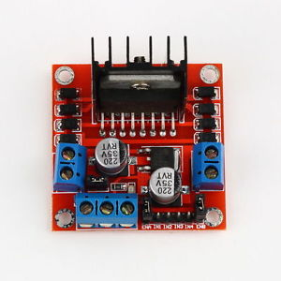

Figure 2.4.1 Motor Driver

There is also an onboard 5V regulator, so if your supply voltage is up to 12V you can also source 5V from the board.

1. DC motor 1 "+" or stepper motor A+
2. DC motor 1 "-" or stepper motor A-
3. 12V jumper - remove this if using a supply voltage greater than 12V DC. This enables power to the onboard 5V regulator
4. Connect your motor supply voltage here, maximum of 35V DC. Remove 12V jumper if >12V DC
5. GND
6. 5V output if 12V jumper in place, ideal for powering your Arduino (etc)
7. DC motor 1 enable jumper. Leave this in place when using a stepper motor. Connect to PWM output for DC motor speed control.
8. IN1
9. IN2
10. IN3
11. IN4
12. DC motor 2 enable jumper. Leave this in place when using a stepper motor. Connect to PWM output for DC motor speed control.
13. DC motor 2 "+" or stepper motor B+
14. DC motor 2 "-" or stepper motor B-

**2.5 BUZZER**

The piezo buzzer produces sound based on reverse of the piezoelectric effect. The generation of pressure variation or strain by the application of electric potential across a piezoelectric material is the underlying principle. These buzzers can be used alert a user of an event corresponding to a switching action, counter signal or sensor input. They are also used in alarm circuits.  
The buzzer produces a same noisy sound irrespective of the voltage variation applied to it. It consists of piezo crystals between two conductors. When a potential is applied across these crystals, they push on one conductor and pull on the other. This, push and pull action, results in a sound wave. Most buzzers produce sound in the range of 2 to 4 kHz.

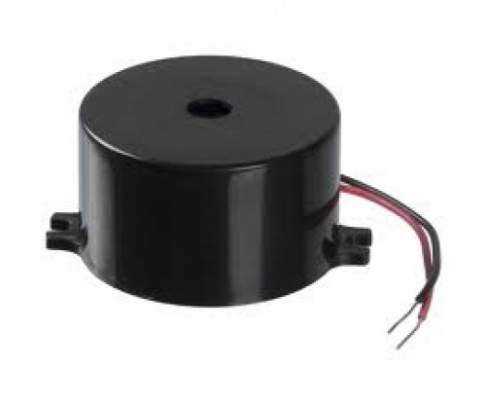

Figure 2.4 Buzzer

**2.5.1 FEATURES**

Durable

Shock proof

Easy to use

**2.5.2 SPECIFICATIONS**

Size : 12 x 9.5mm

Rated voltage : 5V

Operating voltage : 4 to 7V

Sound output : minimum 85db

Current consumption: maximum 25mA

Storage temperature : -30 to +70 degrees Celsius

Weight : 1.3g

**2.6 RFID MODULE**

The EM-18 RFID Reader module operating at 125kHz is an inexpensive solution for your RFID based application. The Reader module comes with an on-chip antenna and can be powered up with a 5V power supply. Power-up the module and connect the transmit pin of the module to recieve pin of your microcontroller. Show your card within the reading distance and the card number is thrown at the output. Optionally the module can be configured for also a weigand output.

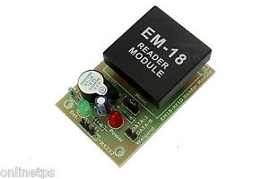

Figure 2.6 RFID Module

An RFID system consists of two separate components: a tag and a reader. Tags are analogous to barcode labels, and come in different shapes and sizes. The tag contains an antenna connected to a small microchip containing up to two kilobytes of data. The reader, or scanner, functions similarly to a barcode scanner; however, while a barcode scanner uses a laser beam to scan the barcode, an RFID scanner uses electromagnetic waves. To transmit these waves, the scanner uses an antenna that transmits a signal, communicating with the tags antenna. The tags antenna receives data from the scanner and transmits its particular chip information to the scanner.

The data on the chip is usually stored in one of two types of memory. The most common is Read-Only Memory (ROM); as its name suggests, read-only memory cannot be altered once programmed onto the chip during the manufacturing process. The second type of memory is Read/Write Memory; though it is also programmed during the manufacturing process, it can later be altered by certain devices.

The RFID tag consists of a powered or nonpowered microchip and an antenna. The three different types of tags are described below.

Passive tags are the simplest, smallest and cheapest version of an RFID tag as they do not contain a built-in power source and consequently cannot initiate communication with a reader. As the available power from the reader field diminishes rapidly with distance, passive tags have practical read ranges that vary from about 10 mm up to about 5 metres.

Semi-passive tags have built-in batteries and do not require energy from the reader field to power the microchip. This allows them to function with much lower signal power levels and act over greater distances.

**2.6.1 APPLICATIONS**

* e-Payment
* e-Toll Road Pricing
* e-Ticketing for Events
* e-Ticketing for Public Transport
* Access Control
* PC Access
* Authentication
* Printer / Production Equipment.
  1. **LCD DISPLAY**

We always use devices made up of Liquid Crystal Displays (LCDs) like computers, digital watches and also DVD and CD players. They have become very common and have taken a giant leap in the screen industry by clearly replacing the use of Cathode Ray Tubes (CRT). CRT draws more power than LCD and are also bigger and heavier. LCD’s have made displays thinner than CRT’s. Even while comparing the LCD screen to an LED screen, the power consumption is lesser as it works on the basic principle of blocking light rather than dissipating.  All of us have seen an LCD, but no one knows the exact working of it. Let us take a look at the working of an LCD.

The material “liquid crystal” was discovered accidentally by the botanist Freidrich Reinitzer as early as 1888. However the commercially available liquid crystals were not developed until the late 1960’s. We get the definition of LCD from the name “Liquid Crystal” itself. It is actually a combination of two states of matter – the solid and the liquid. They have both the properties of solids and liquids and maintain their respective states with respect to another. Solids usually maintain their state unlike liquids who change their orientation and move everywhere in the particular liquid. Further studies have showed that liquid crystal materials show more of a liquid state than that of a solid. It must also be noted that liquid crystals are more heat sensitive than usual liquids. A little amount of heat can easily turn the liquid crystal into a liquid. This is the reason why they are also used to make thermometers.

* + 1. **PIN DIAGRAM:**

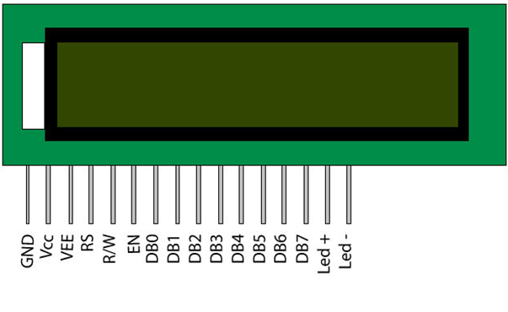

Figure 2.7.1 Pin Diagram of LCD

**2.7.2 Pin Description:**

|  |  |  |
| --- | --- | --- |
| **Pin No** | **Function** | **Name** |
| 1 | Ground (0V) | Ground |
| 2 | Supply voltage; 5V (4.7V – 5.3V) | Vcc |
| 3 | Contrast adjustment; through a variable resistor | VEE |
| 4 | Selects command register when low; and data register when high | Register Select |
| 5 | Low to write to the register; High to read from the register | Read/write |
| 6 | Sends data to data pins when a high to low pulse is given | Enable |
| 7 | 8-bit data pins | DB0 |
| 8 | DB1 |
| 9 | DB2 |
| 10 | DB3 |
| 11 | DB4 |
| 12 | DB5 |
| 13 | DB6 |
| 14 | DB7 |
| 15 | Backlight VCC (5V) | Led+ |
| 16 | Backlight Ground (0V) | Led- |

**2.7.3 Features of 16×2 LCD module**

* Operating Voltage is 4.7V to 5.3V
* Current consumption is 1mA without backlight
* Alphanumeric LCD display module, meaning can display alphabets and numbers
* Consists of two rows and each row can print 16 characters.
* Each character is build by a 5×8 pixel box
* Can work on both 8-bit and 4-bit mode
* It can also display any custom generated characters
* Available in Green and Blue Backlight.

**CHAPTER 3**

**DESIGN AND IMPLEMENTATON**

**3.1 Bridge Rectifier And Voltage Rectifier**

**3.1.1 Introduction**

Figure 3.1.1 Bridge Rectifier

A bridge rectifier is an arrangement of four or more diodes in a bridg**e** circuit configuration which provides the same output polarity for either input polarity. It is used for converting an alternating current (AC) input into a direct current (DC) output.

A rectifier is an electrical device composed of one or more diodes that converts alternating current (AC) to direct current (DC). A diode is like a one-way valve that allows an electrical current to flow in only one direction. This process is called rectification.

**3.1.2 Block Diagram**

Figure 3.1.2 Block Diagram of Bridge Rectifier

**3.2 16 x 2 Character LCD**

* 5 x 8 dots with cursor
* Built-in controller (KS 0066 or Equivalent)
* +5V power supply (Also available for + 3V)
* 1/16 duty cycle
* B/L to be driven by pin 1, pin 2 or pin 15, pin 16 or A.K (LED)
* N.V. optional for + 3V power supply

3.2 16x2 Character LCD

**CHAPTER 4**

**FLOWCHART**

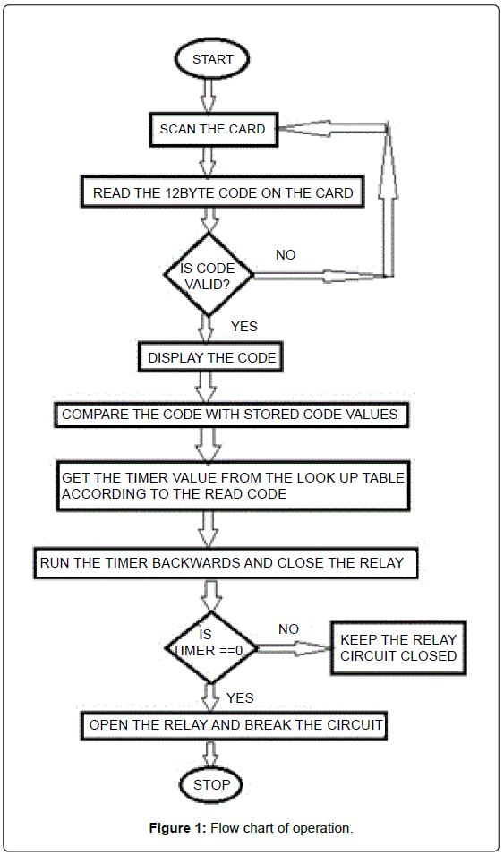

Figure 4.1 FlowChart

**CHAPTER 5**

**CONCULSION AND FUTURE SCOPE**

**5.1 Conclusion**

Even though numerous limitations and unresolved issues still hinder the widespread application of RFID. Despite these challenges, RFID continues to make inroads into inventory control systems, and it’s only a matter of time before the component cost–––s fall low enough to make RFID an attractive economic proposition. Furthermore, extensive engineering efforts are under way to overcome current technical limitations and to build accurate and reliable tag reading systems.

In order to implement contemporary system of “RFID based swipe card draw power in Indian Railways” the embedded systems plat- form has utilized. And hence this proposed project seems to brought about equality among masses and also conserve the power

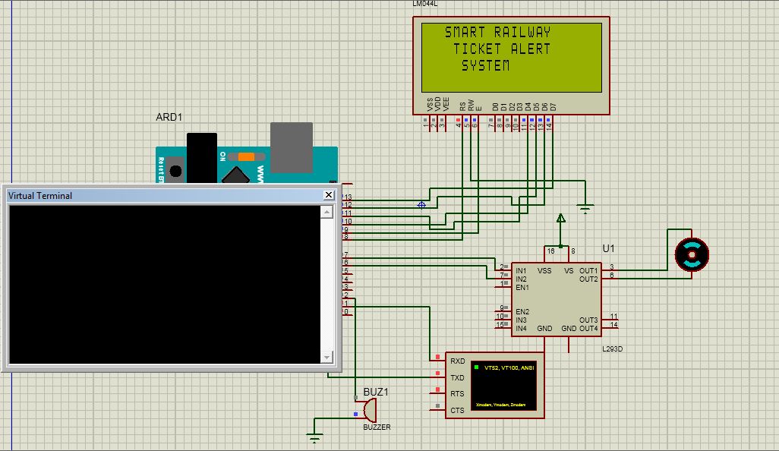

Figure 5.1.1 Initial Output

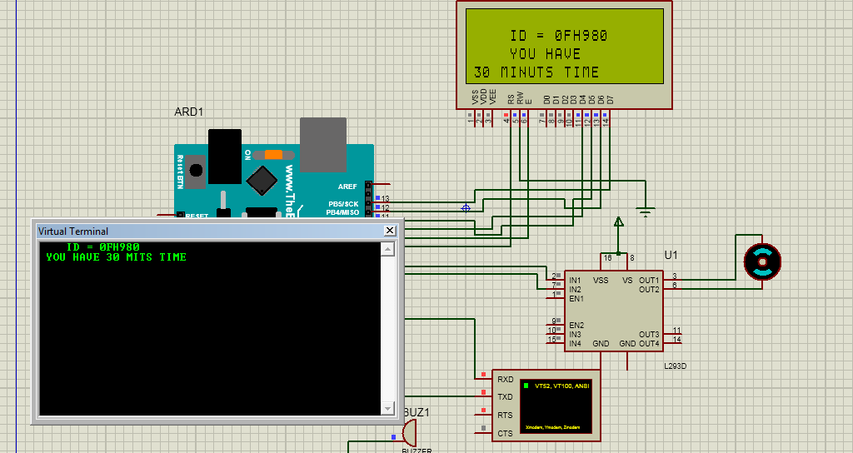

Figure 5.1.2 Final Output

**5.2 Future Scope**

The scope for the project RFID based fast Ticketing System for Local Trains has thus been thoroughly studied and also the implementation of the same has been taken care of successfully. Even if currently this system is meant to be implemented just for academic project purpose but the motive behind this project is to actually create a revolution in the ticketing world for the ease of the commuters of the 22nd century.

**REFERENCES**

[1]. 2009 First International Workshop on Near Field Communication “NFC Ticketing: a Prototype and Usability test of an NFC-based Virtual Ticketing application”.

[2]. Existing scenario of near field communication in transport sectorGautam, J. ; Kumar, Y. ; Gupta, A. Signal Processing and Integrated Networks (SPIN), 2014 International Conference on DOI: 10.1109/SPIN.2014.6776972Publication Year: 2014 , Page(s): 327 – 332

[3]. A Distributed Integrated Fare Collection and AccountingSystem for Metropolitan Railway Transit Pint sangChang Ubiquitous Intelligence & Computing and 9th International Conference on Autonomic & Trusted Computing (UIC/ATC), 2012 9th International Conference on DOI: 10.1109/UICATC.2012.147 Publication Year: 2012 , Page(s): 797 – 802