**ENVIRONMENTAL POLLUATION ANALISYSIS**

*A project report submitted to ICT Academy of Kerala*

*in partial fulfillment of the requirements*

*for the certification of*

**CERTIFIED SPECIALIST**

**IN**

**DATA SCIENCE & ANALYTICS**

submitted by

**SEETHAL PV**

**THEJASWINI GM**

**PAVITHRA D NAICK**



**ICT ACADEMY OF KERALA**

**THIRUVANANTHAPURAM, KERALA, INDIA**

**Feb 2022**

**List of Figures**

**List of Abbreviations**

**Table of Contents**

**Abstract**

## AIR QUALITY DATA IN INDIA (2015-2020)

Air is what keeps humans alive. Monitoring it and understanding its quality is of immense importance to our well-being.

The dataset contains the information about the Air quality data in India (2015-2020). It contains air quality data and AQI (Air Quality Index) at daily level of various stations across multiple cities in India.

In this project we are calculating the Air Quality Index by of each city by using 12 compositions of air pollutants.

Using calculated AQI, classified to good, satisfactory, moderate, poor, very poor, severe.

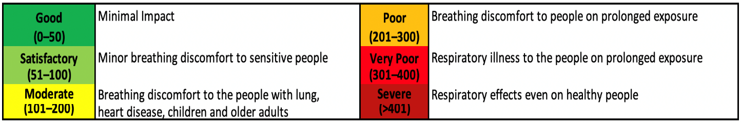

Fig.1

In this project we are mainly focusing on AQI for classifying the air quality, by using the field AQI and to predict the best model for the dataset.

**1. Problem Definition**

**1.1 Overview**

Air is what keeps humans alive. Monitoring it and understanding its quality is of immense importance to our well-being. The dataset is having air quality data of different cities in India from year 2015 to 2020. The air quality index (AQI) is an index for reporting air quality on a daily basis. A low AQI indicates good air quality and low levels of pollution while a higher AQI suggests increased concentrations of pollutants in the air which is extremely detrimental to human health.

The air quality index is composed of 12 pollutants (PM2.5, PM10, NO, NO2, NOx, NH3, CO, SO2, O3, Benzene, Toluene, Xylene). AQI scores and categories: Good (0–50) Satisfactory (51–100) Moderately polluted (101–200) Poor (201–300) Very poor (301–400) Severe (401–500).

**1.2 Problem Statement**

In this project, we will be using the day-wise AQI dataset which contains information regarding the daily level of pollutants and AQI in around 26 Indian cities from 2015-2020. We are mainly focusing on AQI Bucket for classifying the air quality, by using the field AQI and to predict the best model for the dataset.

**2. Introduction**

**3. Literature Survey**

**7. Result**

**8. Conclusion**

**References**