**ABSTRACT**

**D**omain: Environmental Pollution Analysis

Air is what keeps humans alive. Monitoring it and understanding its quality is of immense importance to our well-being.

The dataset contains the information about the Air quality data in India (2015-2020).It contains air quality data and AQI (Air Quality Index) at daily level of various stations across multiple cities in India.

In this project we are calculating the Air Quality Index by of each stations which are labelled under station id for each date given in date field by using 12 compositions of air(PM2.5,PM10,NO,NO2,NOx,NH3,CO,SO2,O3, Benzene, Toluene, Xylene).

Using calculated AQI, classified to good ,satisfactory ,moderate ,poor, very poor ,severe.

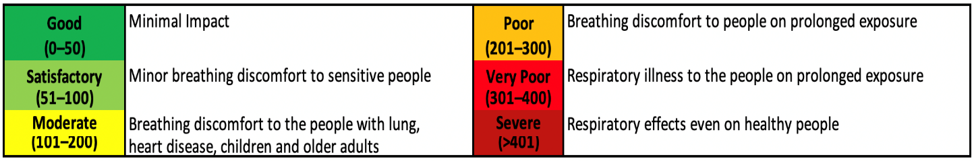

In this project we are mainly focusing on AQI Bucket for classifying the air quality, by using the field AQI and to predict the best model for the dataset.

Group Members

Pavithra D Naick

Seethal P V

Thejaswini G M