ACTIVITY Using PostgreSQL

Course Code & Name: DSA0503-Query Processing for Data Science
Name:A.Pavithra Reg. No: 192424347

- Create the Department Table (Parent Table) with attributes Department_ID INTEGER
PRIMARY KEY, Department_Name TEXT
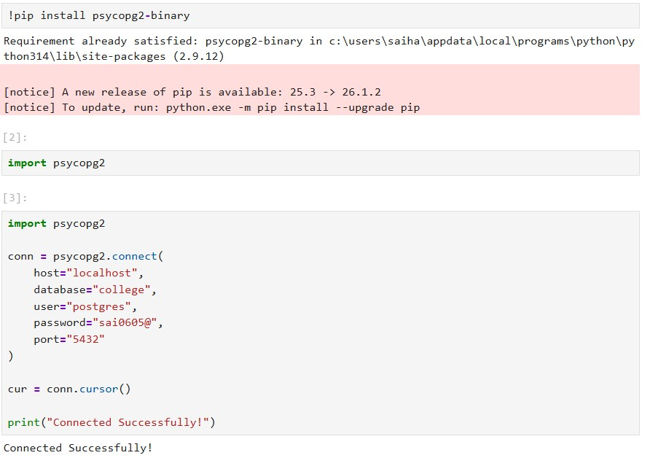
Department Table - Queries:
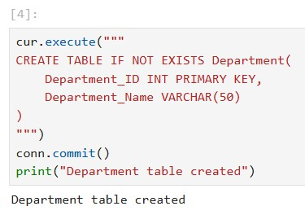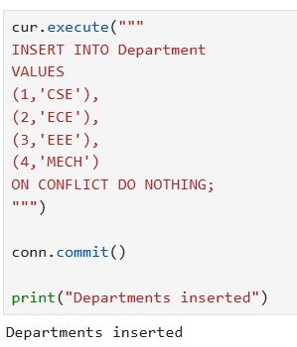

Output:
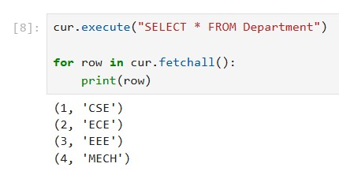
- Create the Student Table (Child Table) with the following attributes: Student_ID INTEGER
PRIMARY KEY, Name TEXT, Age INTEGER, Department_ID INTEGER, CGPA REAL,
FOREIGN KEY (Department_ID) REFERENCES Department(Department_ID)

Student Table - Queries:
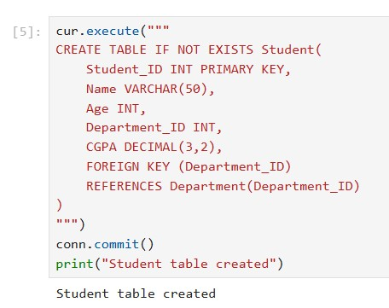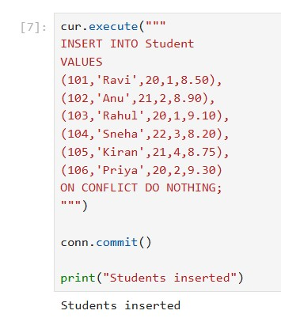

Output:
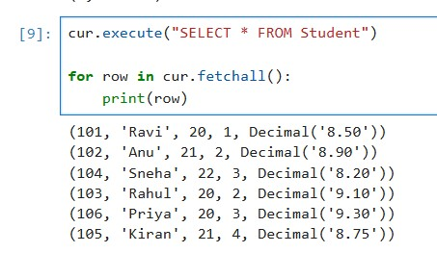

- Display students from CSE department.
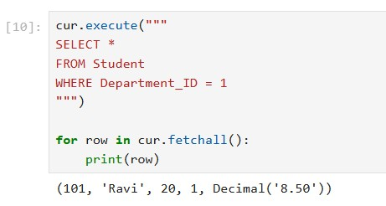

- Count students in each department.
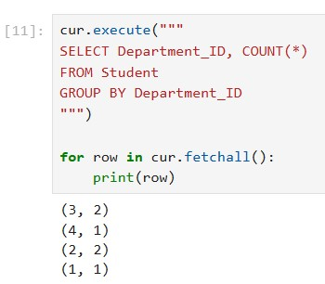

- Update the foreign key. For eg., change the department of a student Query:
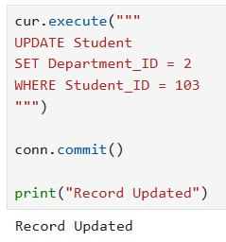
Output:
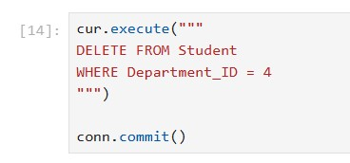

- Delete a department
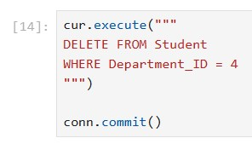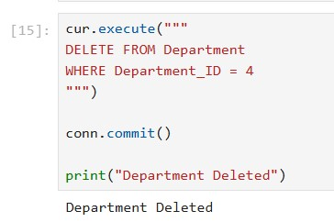

- Display each student's name along with the corresponding department name using an SQL JOIN.
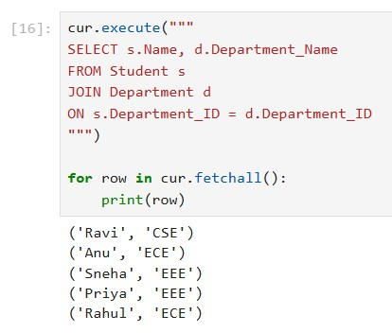
- Display the number of students in each department.
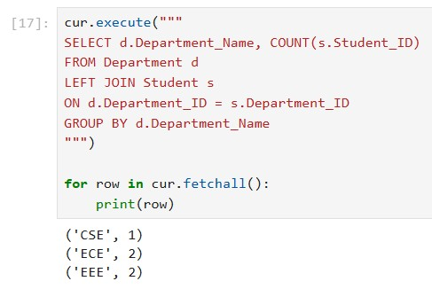
- Display the names of students belonging to the Computer Science department.
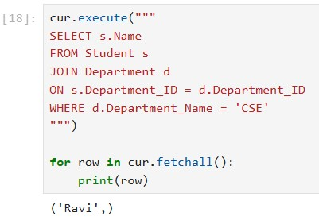
- Update the department of a student by changing the foreign key value and display the updated record.
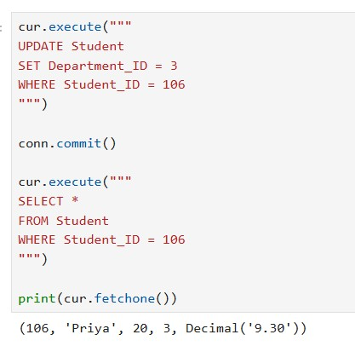
- Display departments that currently have no students assigned using an appropriate SQL JOIN.
