DSA0503 - Query Processing for Data Science

CO2 - Assessment Tool 1 - Database Design and Connectivity

NAME:A PAVITHRA REG NO:192424347

Q.No.1 – Student Database Design and Connectivity

Question
A college wants to automate the management of student records. Design an SQLite database containing a Student table with appropriate fields and a primary key. Write a Python program to connect to the SQLite database, create the table if it does not exist, insert at least five student records, and display all the records stored in the table.

Aim
To create an SQLite database, store student details, and display all records using Python.

Algorithm
- Import the sqlite3 module.
- Connect to the SQLite database.
- Create the Student table if it does not exist.
- Insert five student records.
- Retrieve all records from the table.
- Display the records.
- Close the database connection.

Python Code
import sqlite3

# Connect to SQLite database
conn = sqlite3.connect("college.db")
cursor = conn.cursor()

# Create Student table
cursor.execute("""
CREATE TABLE IF NOT EXISTS Student(
StudentID INTEGER PRIMARY KEY,
Name TEXT,
Department TEXT,
CGPA REAL
)
""")

# Delete old records (optional)
cursor.execute("DELETE FROM Student")

# Insert student records
students = [
(101, "Rahul", "CSE", 8.5),
(102, "Anjali", "ECE", 9.1),
(103, "Kiran", "EEE", 8.0),
(104, "Sneha", "IT", 9.3),
(105, "Arjun", "MECH", 7.8)
]

cursor.executemany("INSERT INTO Student VALUES (?, ?, ?, ?)", students)

conn.commit()

# Display records
cursor.execute("SELECT * FROM Student")
records = cursor.fetchall()

print("Student Records")
print("----------------------------")
for row in records:
print(row)

conn.close()

OUTPUT:

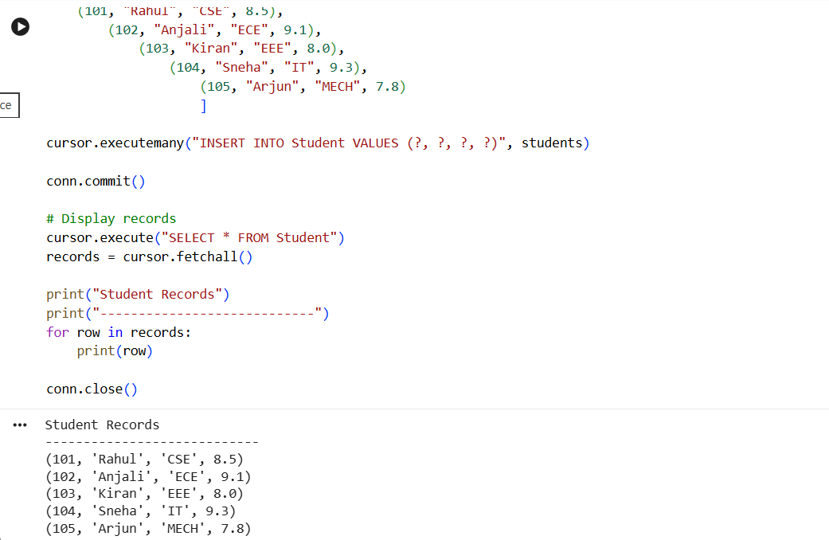

Q.No.2 – Department and Employee Management System

Question
A company stores department information and employee details in separate tables. Design Department and Employee tables using appropriate primary and foreign keys. Write a Python program to connect to the MySQL database, create both tables, insert sample records, and display employee names along with their corresponding department names using an SQL JOIN query.

Aim
To create Department and Employee tables in MySQL and retrieve employee details using an SQL JOIN query.

Algorithm
- Import the mysql.connector module.
- Connect to the MySQL database.
- Create Department and Employee tables.
- Insert department records.
- Insert employee records.
- Execute an INNER JOIN query.
- Display employee names with department names.
- Close the connection.
Python Code
import mysql.connector

# Connect to MySQL
conn = mysql.connector.connect(
host="localhost",
user="root",
password="root",
database="company"
)

cursor = conn.cursor()

# Create Department table
cursor.execute("""
CREATE TABLE IF NOT EXISTS Department(
DeptID INT PRIMARY KEY,
DeptName VARCHAR(50)
)
""")

# Create Employee table
cursor.execute("""
CREATE TABLE IF NOT EXISTS Employee(
EmpID INT PRIMARY KEY,
EmpName VARCHAR(50),
Salary FLOAT,
DeptID INT,
FOREIGN KEY (DeptID) REFERENCES Department(DeptID)
)
""")

# Delete old records (optional)
cursor.execute("DELETE FROM Employee")
cursor.execute("DELETE FROM Department")

# Insert departments
departments = [
(1, "HR"),
(2, "Finance"),
(3, "IT")
]

cursor.executemany(
"INSERT INTO Department (DeptID, DeptName) VALUES (%s, %s)",
departments
)

# Insert employees
employees = [
(101, "Amit", 45000, 1),
(102, "Priya", 55000, 2),
(103, "Rohit", 60000, 3),
(104, "Neha", 50000, 3)
]

cursor.executemany(
"INSERT INTO Employee (EmpID, EmpName, Salary, DeptID) VALUES (%s, %s, %s, %s)",
employees
)

conn.commit()

# JOIN Query
cursor.execute("""
SELECT Employee.EmpName, Department.DeptName
FROM Employee
INNER JOIN Department
ON Employee.DeptID = Department.DeptID
""")

print("Employee Name\tDepartment")
print("------------------------------")
for row in cursor.fetchall():
print(row[0], "\t", row[1])

conn.close()
OUTPUT
