DSA0503 - Query Processing for Data Science

CO1 - Assessment Tool 2 - Application Based Questions

NAME:A PAVITHRA REG NO:192424347

QUESTION:
Student Admission Data Cleaning (10 Marks)
A university has received a CSV file containing student admission records collected from multiple departments. The file contains duplicate records, missing phone numbers, inconsistent capitalization of department names, and extra spaces in student names. Write a Python program to read the CSV file, perform appropriate data wrangling operations to clean and standardize the data, remove duplicate records, and save the cleaned dataset into a new CSV file suitable for further analysis.
CODE:
import pandas as pd

# Read CSV file
df = pd.read_csv("student_admission.csv")

print("Original Data")
print(df)

# Remove extra spaces
df["StudentName"] = df["StudentName"].str.strip()

# Standardize department names
df["Department"] = df["Department"].str.strip().str.title()

# Fill missing phone numbers
df["Phone"] = df["Phone"].fillna("Not Available")

# Remove duplicate records
df = df.drop_duplicates()

# Save cleaned data
df.to_csv("student_admission_cleaned.csv", index=False)

print("\nCleaned Data")
print(df)

print("\nCleaned file saved successfully.")

OUTPUT:
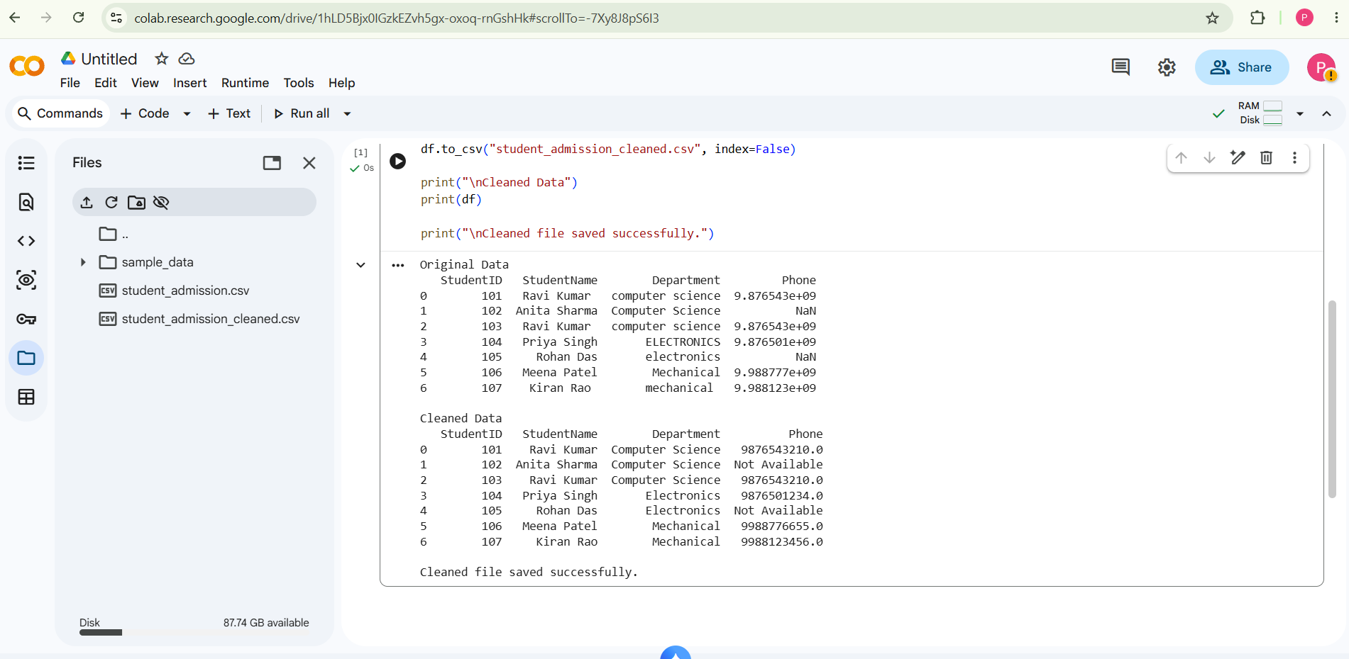

QUESTION:
Employee Data Integration (10 Marks)
A company maintains employee details in a CSV file and department information in a JSON file. Both files contain a common Department ID field. Write a Python program to read the two files, combine the employee and department information, identify records with missing department details, and generate a consolidated dataset that can be stored in a relational database.

CODE:
import pandas as pd

# Read employee CSV
employees = pd.read_csv("employee.csv")

# Read department JSON
departments = pd.read_json("department.json")

print("Employee Data")
print(employees)

print("\nDepartment Data")
print(departments)

# Merge both datasets
merged = pd.merge(
employees,
departments,
on="DepartmentID",
how="left"
)

# Find missing department details
missing = merged[merged["DepartmentName"].isnull()]

print("\nEmployees with Missing Department Details")
print(missing)

# Fill missing department names
merged["DepartmentName"] = merged["DepartmentName"].fillna("Department Not Found")

# Save consolidated dataset
merged.to_csv("employee_consolidated.csv", index=False)

print("\nConsolidated Data")
print(merged)

print("\nFile saved successfully.")

OUTPUT:
