SIMATS ENGINEERING
ASSESSMENT TOOL 1: Data Cleaning Challenge

NAME:A. PAVITHRA REG NO: 192424347
COURSE NAME: | Query Processing for Data Science | COURSE CODE: | DSA0503

COURSE OUTCOME COVERED
CO3: Identify and clean inconsistencies in data by handling missing values, duplicates, outliers, formatting issues, and applying techniques like fuzzy matching and regex.

Assessment Tool Weightage: 35%
Total Marks: 20

Code of Conduct
I ____________________ (Name / Reg No) certify that this submission is my original work and that I have adhered to the guidelines specified for this assessment.
I understand that any violation of academic integrity rules will result in disciplinary action.
Signature of the student: ____________________

Debugging

Criteria | Anomaly Detection  (4 Marks) | Cleaning Methods  (4 Marks) | Data Transformation  (4 Marks) | Analytical Comparison  (4 Marks) | Governance Discussion  (4 Marks)
Marks

Total Marks Awarded:
Questions:
Question 1: E-Commerce Customer Transactions Dataset

An online retail company has collected customer transaction data from multiple sales channels. The management wants to identify the top-performing customer segments and products. However, the dataset contains several quality issues.

CustomerID | CustomerName | Gender | Age | ProductCategory | Quantity | UnitPrice | PurchaseDate | City
C101 | Raj Kumar | Male | 28 | Electronics | 2 | 15000 INR | 10-01-2025 | Chennai
C102 | Priya S | Female | 35 | Fashion | 3 | 1200 INR | 11-01-2025 | chennai
C103 | Arun V | Male | 150 | Electronics | 1 | 300 USD | 12-01-2025 | CHENNAI
C104 | Kavya R | Female | 0 | Grocery | -2 | 800 INR | 15-01-2025 | Coimbatore
C105 | Rahul P | Male | 42 | Fashion | 5 | 2500 INR | 18-01-2025 | Madurai
C105 | Rahul P | Male | 42 | Fashion | 5 | 2500 INR | 18-01-2025 | Madurai
NULL | Sneha M | Female | 30 | Electronics | 2 | 450 USD | 05-02-2025 | Trichy
C107 | Deepak N | Male |  | Grocery | 3 | 600 INR | 07-02-2025 | Tiruchirappalli
C108 | Meena K | Female | 27 | Fashion | 1 | 1800 INR | 2025-13-01 | Salem
C109 | John D | Male | 31 | Electronics | 4 | 250 EUR | 15-02-2025 | Chennai

Data Issues
• Missing Customer IDs
• Duplicate transactions
• Negative quantities
• Unit prices recorded in different currencies
• Age values such as 0, 150, and blanks
• Inconsistent city names (e.g., Chennai, chennai, CHENNAI)
• Incorrect purchase dates

Tasks
1. Identify and classify all data quality issues. (4 Marks)
2. Design a cleaning strategy for each issue. (4 Marks)
3. Perform data standardization and transformation. (4 Marks)
4. Analyze how cleaning affects total revenue calculations. (4 Marks)
5. Generate a report discussing business risks if the data were not cleaned (4 Marks)

CODE:

import pandas as pd
import numpy as np

# ---------------------------------------------------------
# 1. CREATE THE DATASET
# ---------------------------------------------------------

data = {
"CustomerID": [
"C101", "C102", "C103", "C104", "C105",
"C105", None, "C107", "C108", "C109"
],
"CustomerName": [
"Raj Kumar", "Priya S", "Arun V", "Kavya R", "Rahul P",
"Rahul P", "Sneha M", "Deepak N", "Meena K", "John D"
],
"Gender": [
"Male", "Female", "Male", "Female", "Male",
"Male", "Female", "Male", "Female", "Male"
],
"Age": [
28, 35, 150, 0, 42, 42, 30, np.nan, 27, 31
],
"ProductCategory": [
"Electronics", "Fashion", "Electronics", "Grocery", "Fashion",
"Fashion", "Electronics", "Grocery", "Fashion", "Electronics"
],
"Quantity": [
2, 3, 1, -2, 5, 5, 2, 3, 1, 4
],
"UnitPrice": [
"15000 INR", "1200 INR", "300 USD", "800 INR", "2500 INR",
"2500 INR", "450 USD", "600 INR", "1800 INR", "250 EUR"
],
"PurchaseDate": [
"10-01-2025", "11-01-2025", "12-01-2025", "15-01-2025",
"18-01-2025", "18-01-2025", "05-02-2025", "07-02-2025",
"2025-13-01", "15-02-2025"
],
"City": [
"Chennai", "chennai", "CHENNAI", "Coimbatore", "Madurai",
"Madurai", "Trichy", "Tiruchirappalli", "Salem", "Chennai"
]
}

df = pd.DataFrame(data)

print("========== ORIGINAL DATA ==========")
print(df)

# ---------------------------------------------------------
# 2. IDENTIFY DATA QUALITY ISSUES
# ---------------------------------------------------------

print("\n========== DATA QUALITY ISSUES ==========")

# Missing Customer IDs
print("\nMissing Customer IDs:")
print(df[df["CustomerID"].isna()])

# Duplicate transactions
print("\nDuplicate Transactions:")
print(df[df.duplicated(keep=False)])

# Negative quantities
print("\nNegative Quantities:")
print(df[df["Quantity"] < 0])

# Invalid ages
print("\nInvalid Ages:")
print(df[(df["Age"] <= 0) | (df["Age"] > 100) | (df["Age"].isna())])

# Invalid dates
print("\nInvalid Purchase Dates:")
converted_dates = pd.to_datetime(
df["PurchaseDate"],
errors="coerce",
dayfirst=True
)
print(df[converted_dates.isna()])

# Different currencies
print("\nDifferent Currencies:")
print(df["UnitPrice"].str.extract(r"([A-Za-z]+)$")[0].unique())

# Inconsistent city names
print("\nCity Values:")
print(df["City"].unique())

# ---------------------------------------------------------
# 3. CLEANING AND STANDARDIZATION
# ---------------------------------------------------------

clean_df = df.copy()

# ----- Handle missing Customer IDs -----
# Generate a new ID for missing customer
clean_df.loc[clean_df["CustomerID"].isna(), "CustomerID"] = "C106"

# ----- Remove duplicate transactions -----
clean_df = clean_df.drop_duplicates()

# ----- Handle negative quantities -----
# Negative quantity is considered invalid.
# Replace it with NaN and later remove the transaction.
clean_df.loc[clean_df["Quantity"] < 0, "Quantity"] = np.nan

# ----- Clean Age -----
# Valid age assumed to be between 1 and 100.
clean_df.loc[
(clean_df["Age"] <= 0) | (clean_df["Age"] > 100),
"Age"
] = np.nan

# Fill missing age with median age
median_age = clean_df["Age"].median()
clean_df["Age"] = clean_df["Age"].fillna(median_age)

# ---------------------------------------------------------
# 4. STANDARDIZE CURRENCY
# ---------------------------------------------------------

# Extract numerical price
clean_df["Price"] = clean_df["UnitPrice"].str.extract(
r"([\d.]+)"
)[0].astype(float)

# Extract currency
clean_df["Currency"] = clean_df["UnitPrice"].str.extract(
r"([A-Za-z]+)$"
)[0].str.upper()

print("\nCurrencies found:")
print(clean_df["Currency"].value_counts())

# Currency conversion rates to INR
conversion_rates = {
"INR": 1,
"USD": 83,
"EUR": 90
}

clean_df["Price_INR"] = clean_df.apply(
lambda row: row["Price"] * conversion_rates.get(row["Currency"], np.nan),
axis=1
)

# ---------------------------------------------------------
# 5. STANDARDIZE PURCHASE DATE
# ---------------------------------------------------------

clean_df["PurchaseDate"] = pd.to_datetime(
clean_df["PurchaseDate"],
errors="coerce",
dayfirst=True
)

# Remove rows having invalid dates
clean_df = clean_df.dropna(subset=["PurchaseDate"])

# ---------------------------------------------------------
# 6. STANDARDIZE CITY NAMES
# ---------------------------------------------------------

city_mapping = {
"chennai": "Chennai",
"CHENNAI": "Chennai",
"Chennai": "Chennai",
"Trichy": "Tiruchirappalli",
"Tiruchirappalli": "Tiruchirappalli"
}

clean_df["City"] = clean_df["City"].replace(city_mapping)

# ---------------------------------------------------------
# 7. REMOVE INVALID QUANTITY TRANSACTIONS
# ---------------------------------------------------------

clean_df = clean_df.dropna(subset=["Quantity"])

clean_df["Quantity"] = clean_df["Quantity"].astype(int)

# ---------------------------------------------------------
# 8. CALCULATE REVENUE
# ---------------------------------------------------------

clean_df["Revenue_INR"] = (
clean_df["Quantity"] * clean_df["Price_INR"]
)

# ---------------------------------------------------------
# 9. DISPLAY CLEANED DATA
# ---------------------------------------------------------

print("\n========== CLEANED DATA ==========")

print(
clean_df[
[
"CustomerID",
"CustomerName",
"Gender",
"Age",
"ProductCategory",
"Quantity",
"Price_INR",
"PurchaseDate",
"City",
"Revenue_INR"
]
]
)

# ---------------------------------------------------------
# 10. TOTAL REVENUE AFTER CLEANING
# ---------------------------------------------------------

total_clean_revenue = clean_df["Revenue_INR"].sum()

print("\n========== REVENUE ANALYSIS ==========")
print("Total Revenue After Cleaning:",
total_clean_revenue, "INR")

# ---------------------------------------------------------
# 11. REVENUE BEFORE CLEANING
# ---------------------------------------------------------

# Create a temporary dataset for comparison
original_df = df.copy()

original_df["Price"] = original_df["UnitPrice"].str.extract(
r"([\d.]+)"
)[0].astype(float)

original_df["Currency"] = original_df["UnitPrice"].str.extract(
r"([A-Za-z]+)$"
)[0].str.upper()

original_df["Price_INR"] = original_df.apply(
lambda row: row["Price"] *
conversion_rates.get(row["Currency"], np.nan),
axis=1
)

original_df["Revenue_INR"] = (
original_df["Quantity"] * original_df["Price_INR"]
)

total_original_revenue = original_df["Revenue_INR"].sum()

print("Total Revenue Before Cleaning:",
total_original_revenue, "INR")

# ---------------------------------------------------------
# 12. REVENUE DIFFERENCE
# ---------------------------------------------------------

revenue_difference = (
total_original_revenue - total_clean_revenue
)

print("Revenue Difference:",
revenue_difference, "INR")

# ---------------------------------------------------------
# 13. TOP CUSTOMER SEGMENTS
# ---------------------------------------------------------

print("\n========== TOP CUSTOMER SEGMENTS ==========")

segment_revenue = clean_df.groupby(
"Gender"
)["Revenue_INR"].sum().sort_values(ascending=False)

print(segment_revenue)

# ---------------------------------------------------------
# 14. TOP PRODUCT CATEGORIES
# ---------------------------------------------------------

print("\n========== TOP PRODUCT CATEGORIES ==========")

category_revenue = clean_df.groupby(
"ProductCategory"
)["Revenue_INR"].sum().sort_values(ascending=False)

print(category_revenue)

# ---------------------------------------------------------
# 15. TOP CITIES
# ---------------------------------------------------------

print("\n========== TOP CITIES ==========")

city_revenue = clean_df.groupby(
"City"
)["Revenue_INR"].sum().sort_values(ascending=False)

print(city_revenue)

# ---------------------------------------------------------
# 16. BUSINESS RISK REPORT
# ---------------------------------------------------------

print("\n========== BUSINESS RISK REPORT ==========")

print("""
1. Missing Customer IDs:
Missing IDs make customer tracking difficult and can affect
customer-level analysis and personalized marketing.

2. Duplicate Transactions:
Duplicate records artificially increase sales and revenue.
This can result in incorrect business decisions.

3. Negative Quantities:
Negative quantities may represent returns or data-entry errors.
If not handled correctly, revenue calculations become inaccurate.

4. Multiple Currencies:
INR, USD and EUR cannot be directly compared.
Without currency conversion, total revenue will be incorrect.

5. Invalid Ages:
Ages such as 0 and 150 are unrealistic and can distort
customer segmentation and demographic analysis.

6. Missing Ages:
Missing age values reduce the reliability of age-based
customer segmentation.

7. Inconsistent City Names:
Chennai, chennai and CHENNAI may be treated as different cities.
This produces incorrect city-wise sales reports.

8. Invalid Purchase Dates:
Incorrect dates can affect monthly, yearly and seasonal
sales analysis.

9. Overall Business Risk:
If the dataset is not cleaned, management may identify the
wrong top customers, products and cities. Revenue forecasts,
marketing strategies and inventory decisions may therefore
be inaccurate.
""")

OUTPUT:

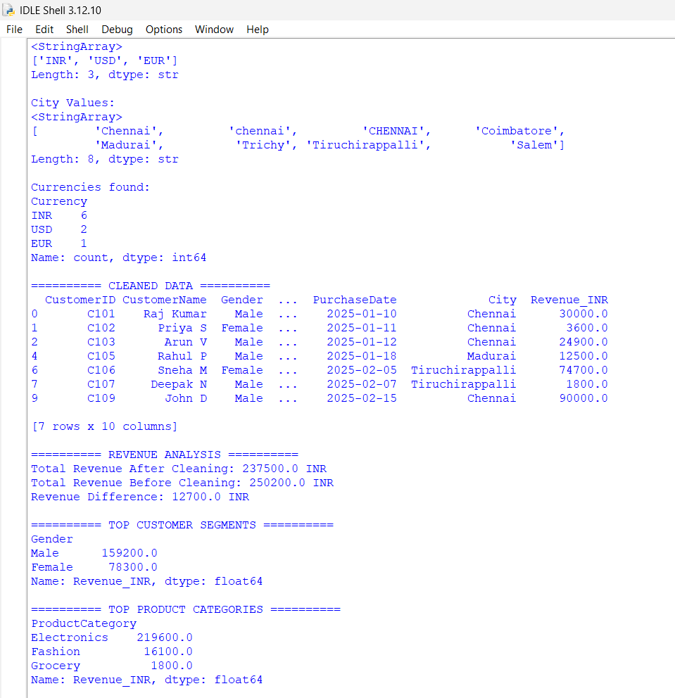
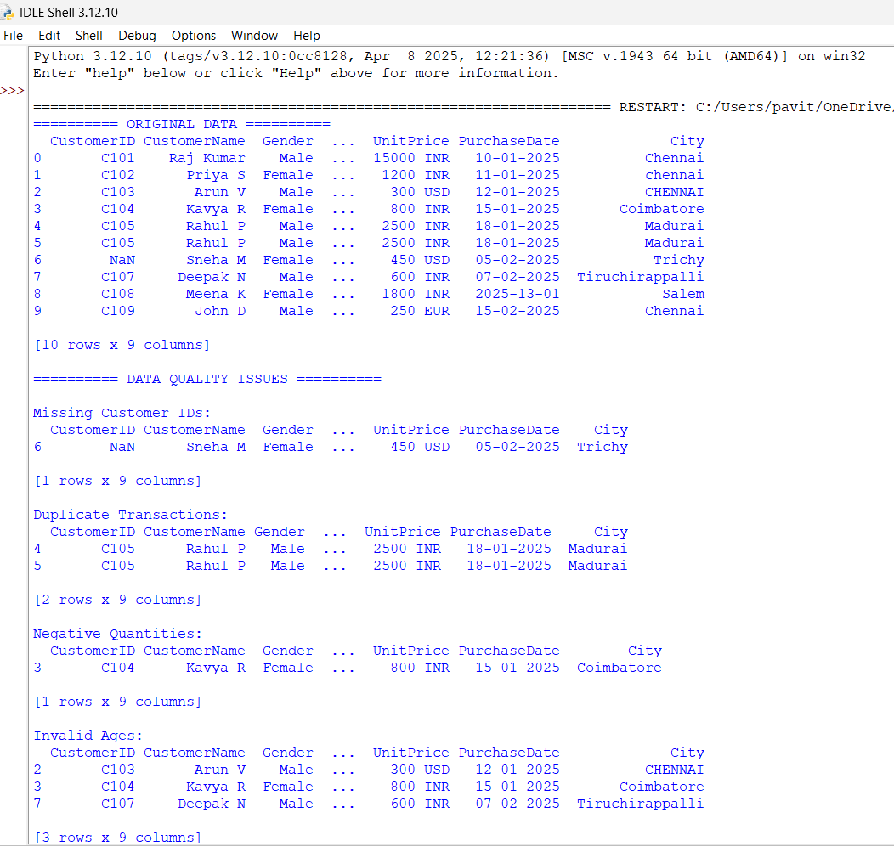

Question 2: Hospital Patient Records Dataset

A hospital wants to analyze patient admissions and treatment effectiveness. Data were entered manually by different departments, leading to inconsistencies.

PatientID | Name | Age | Gender | AdmissionDate | DischargeDate | Diagnosis | TreatmentCost | DoctorID
P1001 | Ravi Kumar | 45 | M | 10-01-2025 | 15-01-2025 | Diabetes | 25000 | D101
P1002 | Priya S | 38 | F | 12-01-2025 | 11-01-2025 | Hypertension | 18000 | D102
P1003 | Arun V | 125 | M | 13-01-2025 | 20-01-2025 | diabetes | 22000 | D101
NULL | Kavya R | 29 | F | 15-01-2025 | 17-01-2025 | Diabtes | 15000 | D103
P1005 | Rahul P | 51 | M | 18-01-2025 | 25-01-2025 | Asthma | NULL | D104
P1005 | Rahul P | 51 | M | 18-01-2025 | 25-01-2025 | Asthma | NULL | D104
P1006 | Sneha M | 34 | F | 15-01-2025 | 18-01-2025 | Hypertension | 12000 | D102
P1007 | Deepak N |  | M | 01-02-2025 | 05-02-2025 | Asthma | 10000 | D104
P1008 | Meena K | 26 | F | 10-02-2025 | 15-02-2025 | HYPERTENSION | 13500 | D102
P1009 | John D | 40 | M | 12-02-2025 | 18-02-2025 | Diabetes | 20000 | D101

Data Issues
• Missing patient IDs
• Duplicate patient records
• Discharge dates before admission dates
• Null treatment costs
• Inconsistent diagnosis names
• Multiple formats of dates
• Unrealistic patient ages (&gt;120)
Tasks
1. Detect all inconsistencies and anomalies. (4 Marks)
2. Develop rules for handling missing and invalid values. (4 Marks)
3. Create a process to standardize diagnosis names. (4 Marks)
4. Evaluate how cleaning changes average treatment cost and hospital stay duration. (4 Marks)
5. Recommend data governance measures to prevent future errors. (4 Marks)
CODE:
import pandas as pd
import numpy as np

# =========================================================
# 1. CREATE THE DATASET
# =========================================================

data = {
"PatientID": [
"P1001", "P1002", "P1003", None, "P1005",
"P1005", "P1006", "P1007", "P1008", "P1009"
],
"Name": [
"Ravi Kumar", "Priya S", "Arun V", "Kavya R", "Rahul P",
"Rahul P", "Sneha M", "Deepak N", "Meena K", "John D"
],
"Age": [
45, 38, 125, 29, 51, 51, 34, np.nan, 26, 40
],
"Gender": [
"M", "F", "M", "F", "M",
"M", "F", "M", "F", "M"
],
"AdmissionDate": [
"10-01-2025", "12-01-2025", "13-01-2025", "15-01-2025",
"18-01-2025", "18-01-2025", "15-01-2025", "01-02-2025",
"10-02-2025", "12-02-2025"
],
"DischargeDate": [
"15-01-2025", "11-01-2025", "20-01-2025", "17-01-2025",
"25-01-2025", "25-01-2025", "18-01-2025", "05-02-2025",
"15-02-2025", "18-02-2025"
],
"Diagnosis": [
"Diabetes", "Hypertension", "diabetes", "Diabtes", "Asthma",
"Asthma", "Hypertension", "Asthma", "HYPERTENSION", "Diabetes"
],
"TreatmentCost": [
25000, 18000, 22000, 15000, np.nan,
np.nan, 12000, 10000, 13500, 20000
],
"DoctorID": [
"D101", "D102", "D101", "D103", "D104",
"D104", "D102", "D104", "D102", "D101"
]
}

df = pd.DataFrame(data)

print("=" * 70)
print("ORIGINAL HOSPITAL PATIENT DATA")
print("=" * 70)
print(df)

# =========================================================
# 2. TASK 1 - DETECT INCONSISTENCIES AND ANOMALIES
# =========================================================

print("\n" + "=" * 70)
print("TASK 1: DATA QUALITY ISSUES")
print("=" * 70)

# Missing Patient IDs
print("\n1. Missing Patient IDs:")
print(df[df["PatientID"].isna()])

# Duplicate records
print("\n2. Duplicate Records:")
duplicates = df[df.duplicated(keep=False)]
print(duplicates)

# Invalid ages
print("\n3. Unrealistic Ages:")
invalid_age = df[
(df["Age"] > 120) |
(df["Age"] <= 0) |
(df["Age"].isna())
]
print(invalid_age)

# Missing treatment cost
print("\n4. Missing Treatment Costs:")
print(df[df["TreatmentCost"].isna()])

# Convert dates temporarily for checking
admission_check = pd.to_datetime(
df["AdmissionDate"],
dayfirst=True,
errors="coerce"
)

discharge_check = pd.to_datetime(
df["DischargeDate"],
dayfirst=True,
errors="coerce"
)

# Discharge before admission
print("\n5. Discharge Before Admission:")
invalid_dates = df[
discharge_check < admission_check
]
print(invalid_dates)

# Diagnosis inconsistencies
print("\n6. Diagnosis Values Before Standardization:")
print(df["Diagnosis"].unique())

# =========================================================
# 3. TASK 2 - CLEANING RULES
# =========================================================

clean_df = df.copy()

print("\n" + "=" * 70)
print("TASK 2: APPLYING CLEANING RULES")
print("=" * 70)

# ---------------------------------------------------------
# RULE 1: Handle missing Patient ID
# ---------------------------------------------------------

# Generate a new Patient ID for missing value
clean_df.loc[
clean_df["PatientID"].isna(),
"PatientID"
] = "P1004"

# ---------------------------------------------------------
# RULE 2: Remove duplicate patient records
# ---------------------------------------------------------

clean_df = clean_df.drop_duplicates()

# ---------------------------------------------------------
# RULE 3: Handle unrealistic ages
# ---------------------------------------------------------

# Ages must be between 1 and 120
clean_df.loc[
(clean_df["Age"] <= 0) |
(clean_df["Age"] > 120),
"Age"
] = np.nan

# Fill missing age with median age
median_age = clean_df["Age"].median()

clean_df["Age"] = clean_df["Age"].fillna(median_age)

# ---------------------------------------------------------
# RULE 4: Standardize dates
# ---------------------------------------------------------

clean_df["AdmissionDate"] = pd.to_datetime(
clean_df["AdmissionDate"],
dayfirst=True,
errors="coerce"
)

clean_df["DischargeDate"] = pd.to_datetime(
clean_df["DischargeDate"],
dayfirst=True,
errors="coerce"
)

# ---------------------------------------------------------
# RULE 5: Handle discharge before admission
# ---------------------------------------------------------

invalid_stay = (
clean_df["DischargeDate"] <
clean_df["AdmissionDate"]
)

# Mark invalid discharge dates as missing
clean_df.loc[
invalid_stay,
"DischargeDate"
] = pd.NaT

# ---------------------------------------------------------
# RULE 6: Standardize diagnosis names
# ---------------------------------------------------------

clean_df["Diagnosis"] = (
clean_df["Diagnosis"]
.str.strip()
.str.lower()
)

diagnosis_mapping = {
"diabetes": "Diabetes",
"diabtes": "Diabetes",
"hypertension": "Hypertension",
"asthma": "Asthma"
}

clean_df["Diagnosis"] = clean_df[
"Diagnosis"
].replace(diagnosis_mapping)

# ---------------------------------------------------------
# RULE 7: Handle missing Treatment Cost
# ---------------------------------------------------------

# Use median treatment cost
median_cost = clean_df["TreatmentCost"].median()

clean_df["TreatmentCost"] = clean_df[
"TreatmentCost"
].fillna(median_cost)

# =========================================================
# 4. CALCULATE HOSPITAL STAY
# =========================================================

clean_df["HospitalStayDays"] = (
clean_df["DischargeDate"] -
clean_df["AdmissionDate"]
).dt.days

# Remove records where stay duration is invalid
clean_df = clean_df[
clean_df["HospitalStayDays"].notna()
]

clean_df = clean_df[
clean_df["HospitalStayDays"] >= 0
]

# =========================================================
# 5. DISPLAY CLEANED DATA
# =========================================================

print("\n" + "=" * 70)
print("CLEANED DATA")
print("=" * 70)

print(clean_df)

# =========================================================
# 6. TASK 3 - DIAGNOSIS STANDARDIZATION RESULT
# =========================================================

print("\n" + "=" * 70)
print("TASK 3: STANDARDIZED DIAGNOSIS")
print("=" * 70)

print(clean_df[
["PatientID", "Diagnosis"]
])

# =========================================================
# 7. TASK 4 - AVERAGE TREATMENT COST
# =========================================================

print("\n" + "=" * 70)
print("TASK 4: BEFORE VS AFTER CLEANING")
print("=" * 70)

# ---------------------------------------------------------
# Average treatment cost BEFORE cleaning
# ---------------------------------------------------------

average_cost_before = df["TreatmentCost"].mean()

# ---------------------------------------------------------
# Average treatment cost AFTER cleaning
# ---------------------------------------------------------

average_cost_after = clean_df["TreatmentCost"].mean()

print("\nAverage Treatment Cost BEFORE Cleaning:",
round(average_cost_before, 2))

print("Average Treatment Cost AFTER Cleaning:",
round(average_cost_after, 2))

# ---------------------------------------------------------
# Average hospital stay BEFORE cleaning
# ---------------------------------------------------------

original_dates_admission = pd.to_datetime(
df["AdmissionDate"],
dayfirst=True,
errors="coerce"
)

original_dates_discharge = pd.to_datetime(
df["DischargeDate"],
dayfirst=True,
errors="coerce"
)

original_stay = (
original_dates_discharge -
original_dates_admission
).dt.days

# Remove negative stays
original_stay = original_stay[
original_stay >= 0
]

average_stay_before = original_stay.mean()

# ---------------------------------------------------------
# Average hospital stay AFTER cleaning
# ---------------------------------------------------------

average_stay_after = clean_df[
"HospitalStayDays"
].mean()

print("\nAverage Hospital Stay BEFORE Cleaning:",
round(average_stay_before, 2), "days")

print("Average Hospital Stay AFTER Cleaning:",
round(average_stay_after, 2), "days")

# =========================================================
# 8. CALCULATE CHANGES
# =========================================================

cost_change = (
average_cost_after -
average_cost_before
)

stay_change = (
average_stay_after -
average_stay_before
)

print("\nTreatment Cost Change:",
round(cost_change, 2))

print("Hospital Stay Change:",
round(stay_change, 2), "days")

# =========================================================
# 9. DIAGNOSIS-WISE ANALYSIS
# =========================================================

print("\n" + "=" * 70)
print("DIAGNOSIS-WISE ANALYSIS")
print("=" * 70)

diagnosis_analysis = clean_df.groupby(
"Diagnosis"
).agg(
PatientCount=("PatientID", "count"),
AverageTreatmentCost=("TreatmentCost", "mean"),
AverageStayDays=("HospitalStayDays", "mean")
)

print(diagnosis_analysis.round(2))

# =========================================================
# 10. TASK 5 - DATA GOVERNANCE RECOMMENDATIONS
# =========================================================

print("\n" + "=" * 70)
print("TASK 5: DATA GOVERNANCE RECOMMENDATIONS")
print("=" * 70)

print("""
1. Use mandatory Patient IDs:
PatientID should be automatically generated and should not
be allowed to remain NULL.

2. Prevent duplicate records:
Use unique constraints on PatientID and transaction/visit
identifiers.

3. Validate patient age:
Allow only realistic ages between 0 and 120.

4. Validate dates:
DischargeDate must always be greater than or equal to
AdmissionDate.

5. Standardize diagnosis:
Use predefined diagnosis codes such as ICD codes instead
of allowing free-text diagnosis entry.

6. Validate treatment cost:
Treatment cost should not be NULL or negative.
The system should require a valid numerical value.

7. Use dropdown menus:
Gender, diagnosis and doctor information should be selected
from predefined values instead of manual typing.

8. Date format standardization:
Store dates in a standard format such as YYYY-MM-DD.

9. Automated data validation:
Apply validation rules when data is entered into the
hospital management system.

10. Regular data quality audits:
Perform periodic checks for missing values, duplicates,
invalid dates and inconsistent diagnosis names.

11. Role-based access:
Only authorized hospital staff should be allowed to
modify patient records.

12. Maintain audit logs:
Record who created or modified a patient record and when
the modification occurred.
""")

# =========================================================
# 11. FINAL SUMMARY
# =========================================================

print("\n" + "=" * 70)
print("FINAL SUMMARY")
print("=" * 70)

print("Original Number of Records :", len(df))
print("Cleaned Number of Records :", len(clean_df))

print("Average Treatment Cost Before :",
round(average_cost_before, 2))

print("Average Treatment Cost After :",
round(average_cost_after, 2))

print("Average Hospital Stay Before :",
round(average_stay_before, 2), "days")

print("Average Hospital Stay After :",
round(average_stay_after, 2), "days")

print("\nData cleaning completed successfully.")

OUTPUT:

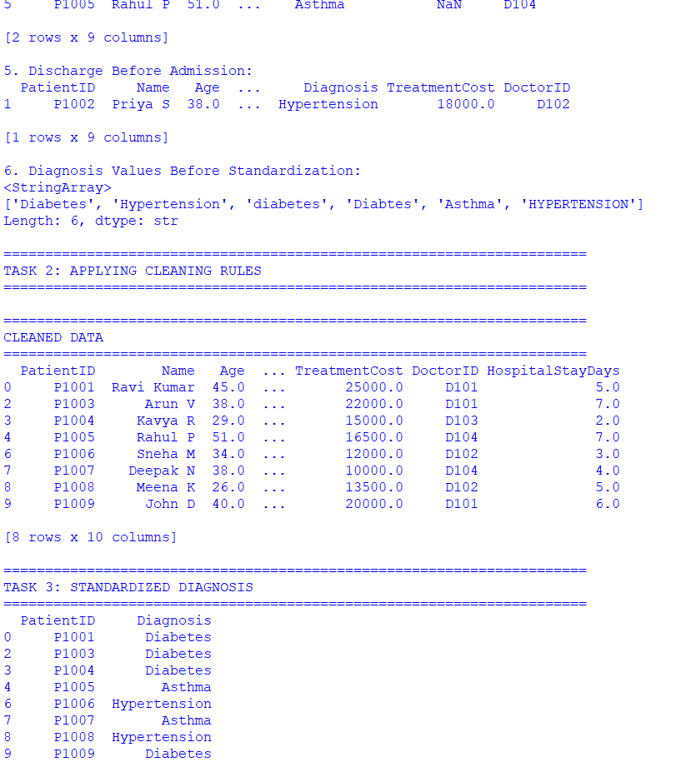
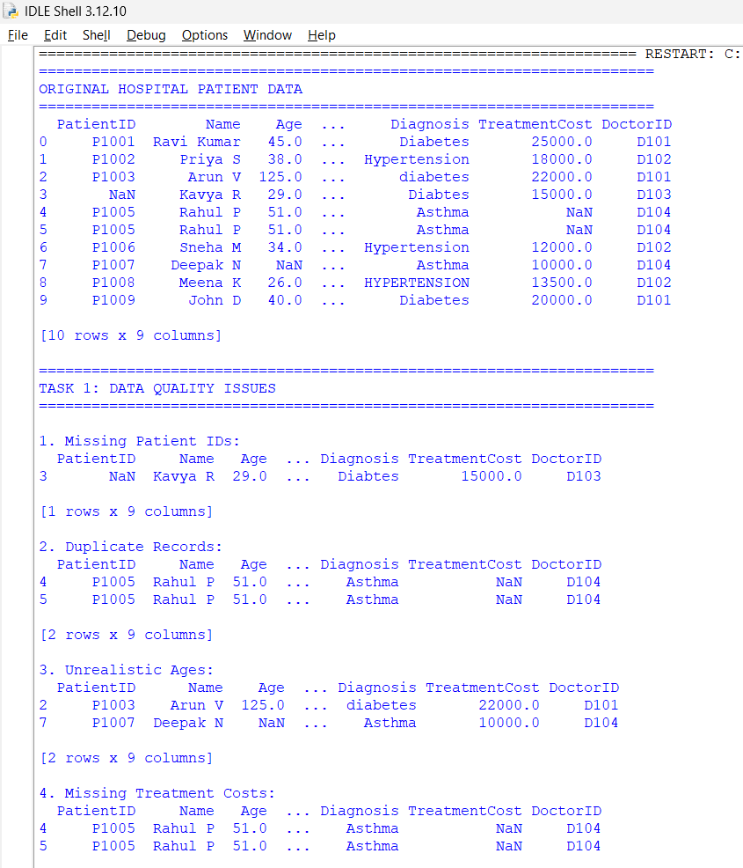

Question 3: Banking Loan Approval Dataset

A bank uses customer data to determine loan eligibility. The dataset contains errors that may affect risk assessment and approval decisions.

CustomerID | AnnualIncome | CreditScore | LoanAmount | EmploymentStatus | Age | ExistingDebt | LoanStatus
L001 | 750000 | 720 | 300000 | Full Time | 35 | 50000 | Approved
L002 | 900K | 680 | 400000 | FT | 42 | 100000 | Approved
L003 | 1200000 | NULL | 600000 | fulltime | 28 | 200000 | Approved
L004 | 150000 | 450 | -200000 | Part Time | 30 | 50000 | Rejected
L005 | 5000000 | 790 | 1000000 | Self Employed | 16 | 10000 | Approved
L006 | 450000 | 350 | 250000 | Unemployed | 40 | 300000 | Rejected
L007 | 75000000 | 800 | 500000 | Full Time | 45 | 100000 | Approved
L008 | 650000 | 690 | 350000 | FT | 33 | 70000 | Approved
L008 | 650000 | 690 | 350000 | FT | 33 | 70000 | Approved
L010 | NULL | 710 | 300000 | Full Time | 37 | 80000 | Approved

Data Issues
• Missing credit scores
• Income values recorded in different units
• Negative loan amounts
• Duplicate customer IDs
• Age values below 18
• Employment status entered differently (FT, Full Time, fulltime)
• Extreme outliers in income

Tasks
1. Identify critical issues that could impact loan decisions. (4 Marks)
2. Propose cleaning techniques for missing and inconsistent data. (4 Marks)
3. Detect and justify treatment of outliers. (4 Marks)
4. Analyze the effect of cleaning on loan approval rates. (4 Marks)
5. Discuss ethical implications of incorrect data cleaning decisions. (4 Marks)
CODE:

import pandas as pd
import numpy as np

# =========================================================
# 1. CREATE THE DATASET
# =========================================================

data = {
"CustomerID": [
"L001", "L002", "L003", "L004", "L005",
"L006", "L007", "L008", "L008", "L010"
],
"AnnualIncome": [
"750000", "900K", "1200000", "150000",
"5000000", "450000", "75000000", "650000",
"650000", None
],
"CreditScore": [
720, 680, np.nan, 450, 790,
350, 800, 690, 690, 710
],
"LoanAmount": [
300000, 400000, 600000, -200000, 1000000,
250000, 500000, 350000, 350000, 300000
],
"EmploymentStatus": [
"Full Time", "FT", "fulltime", "Part Time",
"Self Employed", "Unemployed", "Full Time",
"FT", "FT", "Full Time"
],
"Age": [
35, 42, 28, 30, 16,
40, 45, 33, 33, 37
],
"ExistingDebt": [
50000, 100000, 200000, 50000, 10000,
300000, 100000, 70000, 70000, 80000
],
"LoanStatus": [
"Approved", "Approved", "Approved", "Rejected",
"Approved", "Rejected", "Approved", "Approved",
"Approved", "Approved"
]
}

df = pd.DataFrame(data)

print("=" * 70)
print("ORIGINAL BANKING LOAN DATA")
print("=" * 70)
print(df)

# =========================================================
# TASK 1 - IDENTIFY CRITICAL ISSUES
# =========================================================

print("\n" + "=" * 70)
print("TASK 1: CRITICAL DATA ISSUES")
print("=" * 70)

# Missing credit scores
print("\n1. Missing Credit Scores:")
print(df[df["CreditScore"].isna()])

# Missing income
print("\n2. Missing Annual Income:")
print(df[df["AnnualIncome"].isna()])

# Duplicate customer IDs
print("\n3. Duplicate Customer IDs:")
print(df[df.duplicated("CustomerID", keep=False)])

# Negative loan amounts
print("\n4. Negative Loan Amounts:")
print(df[df["LoanAmount"] < 0])

# Age below 18
print("\n5. Age Below 18:")
print(df[df["Age"] < 18])

# Employment status inconsistencies
print("\n6. Employment Status Values:")
print(df["EmploymentStatus"].unique())

# Income values
print("\n7. Annual Income Values:")
print(df["AnnualIncome"])

# =========================================================
# TASK 2 - CLEANING
# =========================================================

clean_df = df.copy()

print("\n" + "=" * 70)
print("TASK 2: DATA CLEANING")
print("=" * 70)

# ---------------------------------------------------------
# 1. Standardize Annual Income
# ---------------------------------------------------------

# Convert values such as 900K to 900000
def convert_income(value):

if pd.isna(value):
return np.nan

value = str(value).strip().upper()

if value.endswith("K"):
return float(value[:-1]) * 1000

if value.endswith("M"):
return float(value[:-1]) * 1000000

return float(value)

clean_df["AnnualIncome"] = clean_df[
"AnnualIncome"
].apply(convert_income)

# ---------------------------------------------------------
# 2. Handle missing income
# ---------------------------------------------------------

median_income = clean_df["AnnualIncome"].median()

clean_df["AnnualIncome"] = clean_df[
"AnnualIncome"
].fillna(median_income)

# ---------------------------------------------------------
# 3. Handle missing Credit Score
# ---------------------------------------------------------

median_credit = clean_df["CreditScore"].median()

clean_df["CreditScore"] = clean_df[
"CreditScore"
].fillna(median_credit)

# ---------------------------------------------------------
# 4. Remove duplicate customer records
# ---------------------------------------------------------

clean_df = clean_df.drop_duplicates(
subset="CustomerID",
keep="first"
)

# ---------------------------------------------------------
# 5. Handle negative Loan Amount
# ---------------------------------------------------------

# Negative loan amount is invalid.
# Replace it with missing value.
clean_df.loc[
clean_df["LoanAmount"] < 0,
"LoanAmount"
] = np.nan

# Fill invalid loan amount using median
median_loan = clean_df["LoanAmount"].median()

clean_df["LoanAmount"] = clean_df[
"LoanAmount"
].fillna(median_loan)

# ---------------------------------------------------------
# 6. Handle Age below 18
# ---------------------------------------------------------

# Age below 18 is invalid for a normal loan applicant.
clean_df.loc[
clean_df["Age"] < 18,
"Age"
] = np.nan

# Fill invalid age using median age
median_age = clean_df["Age"].median()

clean_df["Age"] = clean_df[
"Age"
].fillna(median_age)

# ---------------------------------------------------------
# 7. Standardize Employment Status
# ---------------------------------------------------------

employment_mapping = {
"FT": "Full Time",
"fulltime": "Full Time",
"Full Time": "Full Time",
"Part Time": "Part Time",
"Self Employed": "Self Employed",
"Unemployed": "Unemployed"
}

clean_df["EmploymentStatus"] = (
clean_df["EmploymentStatus"]
.str.strip()
.replace(employment_mapping)
)

# =========================================================
# TASK 3 - OUTLIER DETECTION
# =========================================================

print("\n" + "=" * 70)
print("TASK 3: OUTLIER DETECTION")
print("=" * 70)

# ---------------------------------------------------------
# IQR method for Annual Income
# ---------------------------------------------------------

Q1 = clean_df["AnnualIncome"].quantile(0.25)
Q3 = clean_df["AnnualIncome"].quantile(0.75)

IQR = Q3 - Q1

lower_limit = Q1 - 1.5 * IQR
upper_limit = Q3 + 1.5 * IQR

print("\nQ1:", Q1)
print("Q3:", Q3)
print("IQR:", IQR)

print("\nLower Outlier Limit:", lower_limit)
print("Upper Outlier Limit:", upper_limit)

outliers = clean_df[
(clean_df["AnnualIncome"] < lower_limit) |
(clean_df["AnnualIncome"] > upper_limit)
]

print("\nDetected Income Outliers:")
print(outliers[
["CustomerID", "AnnualIncome"]
])

# ---------------------------------------------------------
# Treat income outlier
# ---------------------------------------------------------

# Instead of deleting the customer, cap the income
# using the IQR upper limit.
clean_df["AnnualIncome_Cleaned"] = clean_df[
"AnnualIncome"
].clip(
lower=lower_limit,
upper=upper_limit
)

print("\nIncome After Outlier Treatment:")
print(clean_df[
["CustomerID", "AnnualIncome", "AnnualIncome_Cleaned"]
])

# =========================================================
# TASK 4 - EFFECT ON LOAN APPROVAL RATE
# =========================================================

print("\n" + "=" * 70)
print("TASK 4: LOAN APPROVAL RATE ANALYSIS")
print("=" * 70)

# ---------------------------------------------------------
# Approval rate BEFORE cleaning
# ---------------------------------------------------------

approval_before = (
df["LoanStatus"]
.eq("Approved")
.mean()
) * 100

# ---------------------------------------------------------
# Approval rate AFTER cleaning
# ---------------------------------------------------------

approval_after = (
clean_df["LoanStatus"]
.eq("Approved")
.mean()
) * 100

print("\nLoan Approval Rate BEFORE Cleaning:",
round(approval_before, 2), "%")

print("Loan Approval Rate AFTER Cleaning:",
round(approval_after, 2), "%")

# ---------------------------------------------------------
# Change in approval rate
# ---------------------------------------------------------

approval_change = approval_after - approval_before

print("Change in Approval Rate:",
round(approval_change, 2), "%")

# =========================================================
# APPROVAL ANALYSIS BY EMPLOYMENT STATUS
# =========================================================

print("\n" + "=" * 70)
print("APPROVAL RATE BY EMPLOYMENT STATUS")
print("=" * 70)

employment_approval = clean_df.groupby(
"EmploymentStatus"
)["LoanStatus"].apply(
lambda x: (x == "Approved").mean() * 100
)

print(employment_approval.round(2))

# =========================================================
# CREDIT SCORE ANALYSIS
# =========================================================

print("\n" + "=" * 70)
print("CREDIT SCORE ANALYSIS")
print("=" * 70)

print(
clean_df[
["CustomerID", "CreditScore", "LoanStatus"]
]
)

# =========================================================
# INCOME ANALYSIS
# =========================================================

print("\n" + "=" * 70)
print("INCOME ANALYSIS")
print("=" * 70)

print(
clean_df[
[
"CustomerID",
"AnnualIncome",
"AnnualIncome_Cleaned",
"LoanStatus"
]
]
)

# =========================================================
# TASK 5 - ETHICAL IMPLICATIONS
# =========================================================

print("\n" + "=" * 70)
print("TASK 5: ETHICAL IMPLICATIONS")
print("=" * 70)

print("""
1. Unfair Loan Decisions:
Incorrectly changing credit scores or income values can cause
eligible customers to be rejected or risky customers to be
approved.

2. Discrimination:
Data cleaning should not introduce bias against customers based
on employment status, age, gender or other protected attributes.

3. Transparency:
The bank should document why missing values, duplicates and
outliers were changed or removed.

4. Outlier Treatment:
A very high income should not automatically be treated as an
error. It may represent a genuine high-income customer.
Therefore, outliers should be investigated before removal.

5. Privacy:
Financial and personal information must be securely stored
and accessed only by authorized personnel.

6. Accuracy:
Credit scores and financial information are highly important
for loan decisions. Incorrect imputation can directly affect
a customer's financial opportunities.

7. Human Oversight:
Automated loan decisions should have monitoring and suitable
human review mechanisms, especially for unusual cases.

8. Auditability:
Every modification to customer data should be recorded so
that decisions can be reviewed later.
""")

# =========================================================
# FINAL SUMMARY
# =========================================================

print("\n" + "=" * 70)
print("FINAL SUMMARY")
print("=" * 70)

print("Original Number of Records:",
len(df))

print("Cleaned Number of Records:",
len(clean_df))

print("Missing Credit Scores:",
df["CreditScore"].isna().sum())

print("Duplicate Customer IDs:",
df["CustomerID"].duplicated().sum())

print("Negative Loan Amounts:",
(df["LoanAmount"] < 0).sum())

print("Applicants Below 18:",
(df["Age"] < 18).sum())

print("Income Outliers Detected:",
len(outliers))

print("Approval Rate Before Cleaning:",
round(approval_before, 2), "%")

print("Approval Rate After Cleaning:",
round(approval_after, 2), "%")

print("\nData cleaning and analysis completed successfully.")

OUTPUT:
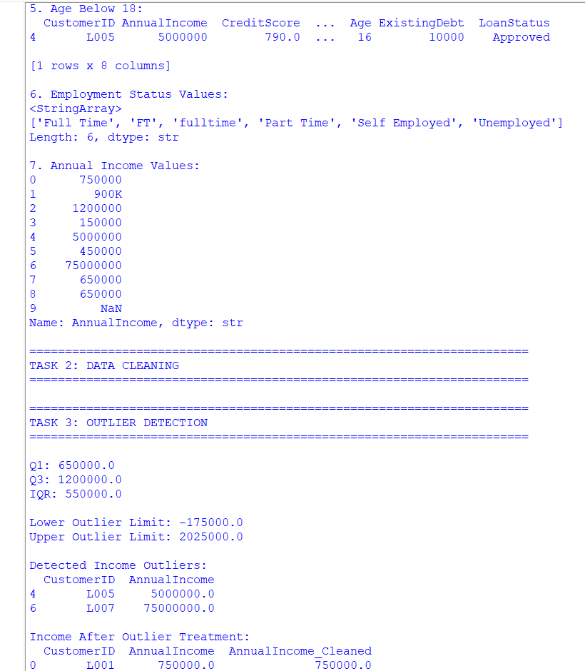
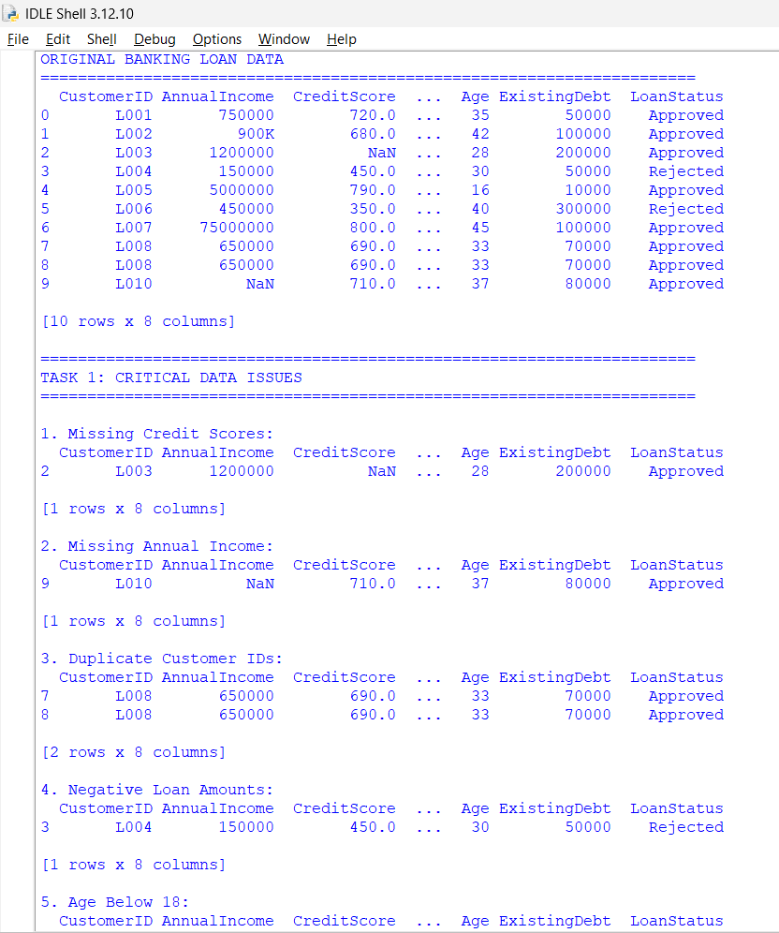

Question 4: Smart City Traffic Monitoring Dataset

A smart city project collects traffic sensor data to optimize traffic signals. Sensor malfunctions and transmission errors have affected data quality.

SensorID | Timestamp | VehicleCount | AverageSpeed | TrafficSignalStatus | RoadName | WeatherCondition
S101 | 01-01-2025 08:00 | 120 | 45 | Green | Anna Salai | Sunny
S102 | 01-01-2025 08:05 | 135 | 52 | Red | anna salai | Sunny
S103 | 01-01-2025 08:10 | -50 | 48 | Green | ANNA SALAI | Cloudy
S104 | 01-01-2025 08:15 | 140 | 350 | Yellow | GST Road | Rainy
S105 | NULL | 110 | 42 | Green | GST ROAD | Sunny
S106 | 01-01-2025 08:25 | 130 | 46 | Red | OMR | NULL
S106 | 01-01-2025 08:25 | 130 | 46 | Red | OMR | NULL
S107 | 01-01-2025 08:30 | 150 | 55 | Green | Old Mahabalipuram Road | Sunny
S10A | 01-01-2025 08:35 | 145 | 53 | Green | OMR | Cloudy
S109 | 01-01-2025 08:40 | 138 | 50 | Green | GST Road | Rainy

Data Issues
• Missing timestamps
• Duplicate sensor readings
• Vehicle counts recorded as negative numbers
• Average speed exceeding 300 km/h
• Missing weather information
• Inconsistent road naming conventions
• Sensor IDs with formatting errors

Tasks
1. Assess the quality of the traffic dataset. (4 Marks)
2. Recommend cleaning techniques for time-series data. (4 Marks)
3. Design rules to identify faulty sensor readings. (4 Marks)
4. Evaluate how cleaning affects congestion analysis. (4 Marks)
5. Suggest automated monitoring techniques for future data collection. (4 Marks)

CODE:
import pandas as pd
import numpy as np

# =========================================================
# QUESTION 4: SMART CITY TRAFFIC MONITORING DATASET
# =========================================================

# =========================================================
# 1. CREATE THE DATASET
# =========================================================

data = {
"SensorID": [
"S101", "S102", "S103", "S104", "S105",
"S106", "S106", "S107", "S10A", "S109"
],

"Timestamp": [
"01-01-2025 08:00",
"01-01-2025 08:05",
"01-01-2025 08:10",
"01-01-2025 08:15",
None,
"01-01-2025 08:25",
"01-01-2025 08:25",
"01-01-2025 08:30",
"01-01-2025 08:35",
"01-01-2025 08:40"
],

"VehicleCount": [
120, 135, -50, 140, 110,
130, 130, 150, 145, 138
],

"AverageSpeed": [
45, 52, 48, 350, 42,
46, 46, 55, 53, 50
],

"TrafficSignalStatus": [
"Green", "Red", "Green", "Yellow", "Green",
"Red", "Red", "Green", "Green", "Green"
],

"RoadName": [
"Anna Salai",
"anna salai",
"ANNA SALAI",
"GST Road",
"GST ROAD",
"OMR",
"OMR",
"Old Mahabalipuram Road",
"OMR",
"GST Road"
],

"WeatherCondition": [
"Sunny", "Sunny", "Cloudy", "Rainy", "Sunny",
None, None, "Sunny", "Cloudy", "Rainy"
]
}

df = pd.DataFrame(data)

print("=" * 75)
print("ORIGINAL SMART CITY TRAFFIC DATA")
print("=" * 75)

print(df)

# =========================================================
# TASK 1: ASSESS DATA QUALITY
# =========================================================

print("\n" + "=" * 75)
print("TASK 1: DATA QUALITY ASSESSMENT")
print("=" * 75)

# ---------------------------------------------------------
# 1. Missing timestamps
# ---------------------------------------------------------

print("\n1. Missing Timestamps:")

print(
df[df["Timestamp"].isna()]
)

# ---------------------------------------------------------
# 2. Duplicate sensor readings
# ---------------------------------------------------------

print("\n2. Duplicate Sensor Readings:")

duplicates = df[
df.duplicated(
subset=["SensorID", "Timestamp"],
keep=False
)
]

print(duplicates)

# ---------------------------------------------------------
# 3. Negative vehicle counts
# ---------------------------------------------------------

print("\n3. Negative Vehicle Counts:")

print(
df[df["VehicleCount"] < 0]
)

# ---------------------------------------------------------
# 4. Unrealistic speed
# ---------------------------------------------------------

print("\n4. Unrealistic Average Speed:")

print(
df[df["AverageSpeed"] > 300]
)

# ---------------------------------------------------------
# 5. Missing weather
# ---------------------------------------------------------

print("\n5. Missing Weather Information:")

print(
df[df["WeatherCondition"].isna()]
)

# ---------------------------------------------------------
# 6. Road name inconsistencies
# ---------------------------------------------------------

print("\n6. Road Names Before Standardization:")

print(df["RoadName"].unique())

# ---------------------------------------------------------
# 7. Sensor ID formatting errors
# ---------------------------------------------------------

print("\n7. Sensor IDs:")

print(df["SensorID"].unique())

print("\nSensor IDs with formatting errors:")

invalid_sensor = df[
~df["SensorID"].str.match(r"^S\d{3}$")
]

print(invalid_sensor)

# =========================================================
# TASK 2: CLEANING TIME-SERIES DATA
# =========================================================

clean_df = df.copy()

print("\n" + "=" * 75)
print("TASK 2: TIME-SERIES DATA CLEANING")
print("=" * 75)

# ---------------------------------------------------------
# 1. Convert timestamp to datetime
# ---------------------------------------------------------

clean_df["Timestamp"] = pd.to_datetime(
clean_df["Timestamp"],
format="%d-%m-%Y %H:%M",
errors="coerce"
)

# ---------------------------------------------------------
# 2. Handle missing timestamp
# ---------------------------------------------------------

# Sort data based on timestamp
clean_df = clean_df.sort_values(
"Timestamp"
)

# Interpolate missing timestamp based on surrounding values
clean_df["Timestamp"] = (
clean_df["Timestamp"]
.interpolate()
)

# ---------------------------------------------------------
# 3. Remove duplicate sensor readings
# ---------------------------------------------------------

clean_df = clean_df.drop_duplicates(
subset=["SensorID", "Timestamp"],
keep="first"
)

# ---------------------------------------------------------
# 4. Handle negative vehicle counts
# ---------------------------------------------------------

# Negative vehicle count is impossible.
# Replace with NaN.
clean_df.loc[
clean_df["VehicleCount"] < 0,
"VehicleCount"
] = np.nan

# Fill missing vehicle count using interpolation
clean_df["VehicleCount"] = (
clean_df["VehicleCount"]
.interpolate()
)

# ---------------------------------------------------------
# 5. Handle unrealistic speed
# ---------------------------------------------------------

# Maximum reasonable city speed assumed as 120 km/h.
clean_df.loc[
(clean_df["AverageSpeed"] < 0) |
(clean_df["AverageSpeed"] > 120),
"AverageSpeed"
] = np.nan

# Interpolate speed
clean_df["AverageSpeed"] = (
clean_df["AverageSpeed"]
.interpolate()
)

# ---------------------------------------------------------
# 6. Standardize Road Names
# ---------------------------------------------------------

road_mapping = {
"anna salai": "Anna Salai",
"ANNA SALAI": "Anna Salai",
"Anna Salai": "Anna Salai",

"GST Road": "GST Road",
"GST ROAD": "GST Road",

"OMR": "Old Mahabalipuram Road",
"Old Mahabalipuram Road":
"Old Mahabalipuram Road"
}

clean_df["RoadName"] = (
clean_df["RoadName"]
.str.strip()
.replace(road_mapping)
)

# ---------------------------------------------------------
# 7. Handle missing weather
# ---------------------------------------------------------

# Use forward fill followed by backward fill
clean_df["WeatherCondition"] = (
clean_df["WeatherCondition"]
.ffill()
.bfill()
)

# =========================================================
# TASK 3: SENSOR FAULT DETECTION RULES
# =========================================================

print("\n" + "=" * 75)
print("TASK 3: FAULTY SENSOR READING DETECTION")
print("=" * 75)

# ---------------------------------------------------------
# Rule 1: Vehicle count must not be negative
# ---------------------------------------------------------

fault_vehicle = clean_df[
clean_df["VehicleCount"] < 0
]

print("\nFaulty Vehicle Counts:")
print(fault_vehicle)

# ---------------------------------------------------------
# Rule 2: Speed must be within reasonable range
# ---------------------------------------------------------

fault_speed = clean_df[
(clean_df["AverageSpeed"] < 0) |
(clean_df["AverageSpeed"] > 120)
]

print("\nFaulty Speed Readings:")
print(fault_speed)

# ---------------------------------------------------------
# Rule 3: Sensor ID format
# ---------------------------------------------------------

fault_sensor_id = clean_df[
~clean_df["SensorID"].str.match(r"^S\d{3}$")
]

print("\nFaulty Sensor IDs:")
print(fault_sensor_id)

# ---------------------------------------------------------
# Rule 4: Duplicate readings
# ---------------------------------------------------------

fault_duplicates = clean_df[
clean_df.duplicated(
subset=["SensorID", "Timestamp"],
keep=False
)
]

print("\nDuplicate Readings:")
print(fault_duplicates)

# =========================================================
# CONGESTION CLASSIFICATION
# =========================================================

print("\n" + "=" * 75)
print("CONGESTION ANALYSIS")
print("=" * 75)

# ---------------------------------------------------------
# Define congestion rules
# ---------------------------------------------------------

def classify_congestion(row):

if (
row["AverageSpeed"] < 30
or row["VehicleCount"] > 140
):
return "High"

elif (
row["AverageSpeed"] < 45
or row["VehicleCount"] > 120
):
return "Medium"

else:
return "Low"

clean_df["CongestionLevel"] = clean_df.apply(
classify_congestion,
axis=1
)

print("\nCongestion Level After Cleaning:")

print(
clean_df[
[
"SensorID",
"Timestamp",
"VehicleCount",
"AverageSpeed",
"RoadName",
"CongestionLevel"
]
]
)

# =========================================================
# TASK 4: COMPARE CONGESTION BEFORE AND AFTER CLEANING
# =========================================================

print("\n" + "=" * 75)
print("TASK 4: CONGESTION ANALYSIS")
print("=" * 75)

# ---------------------------------------------------------
# Function for congestion classification
# ---------------------------------------------------------

def calculate_congestion(data):

result = []

for _, row in data.iterrows():

if (
row["AverageSpeed"] < 30
or row["VehicleCount"] > 140
):
result.append("High")

elif (
row["AverageSpeed"] < 45
or row["VehicleCount"] > 120
):
result.append("Medium")

else:
result.append("Low")

return pd.Series(result)

# Original congestion
original_congestion = calculate_congestion(df)

print("\nOriginal Congestion Distribution:")

print(
original_congestion.value_counts()
)

# Cleaned congestion
cleaned_congestion = clean_df[
"CongestionLevel"
]

print("\nCleaned Congestion Distribution:")

print(
cleaned_congestion.value_counts()
)

# ---------------------------------------------------------
# Congestion percentages
# ---------------------------------------------------------

print("\nOriginal Congestion Percentage:")

print(
original_congestion
.value_counts(normalize=True)
.mul(100)
.round(2)
)

print("\nCleaned Congestion Percentage:")

print(
cleaned_congestion
.value_counts(normalize=True)
.mul(100)
.round(2)
)

# =========================================================
# ROAD-WISE CONGESTION ANALYSIS
# =========================================================

print("\n" + "=" * 75)
print("ROAD-WISE CONGESTION ANALYSIS")
print("=" * 75)

road_analysis = clean_df.groupby(
"RoadName"
).agg(
AverageVehicleCount=("VehicleCount", "mean"),
AverageSpeed=("AverageSpeed", "mean")
)

print(
road_analysis.round(2)
)

# =========================================================
# TASK 5: AUTOMATED MONITORING RECOMMENDATIONS
# =========================================================

print("\n" + "=" * 75)
print("TASK 5: AUTOMATED DATA MONITORING")
print("=" * 75)

print("""
1. Real-Time Range Validation:
Automatically reject vehicle counts below 0 and speeds outside
the predefined city speed limit.

2. Duplicate Detection:
Use SensorID + Timestamp as a unique key to automatically
detect duplicate sensor readings.

3. Timestamp Validation:
Automatically check whether timestamps are missing, duplicated
or out of sequence.

4. Sensor Health Monitoring:
Track sensors that repeatedly generate invalid values and
automatically flag them for maintenance.

5. Automated Missing-Value Alerts:
Generate alerts whenever a sensor stops transmitting data.

6. Road Name Standardization:
Store road names using predefined road IDs instead of
allowing free-text road names.

7. Sensor ID Validation:
Apply a format rule such as S followed by three digits.

8. Real-Time Anomaly Detection:
Use statistical methods such as Z-score, IQR and moving
averages to detect unusual traffic readings.

9. Dashboard Monitoring:
Display sensor health, missing readings, abnormal speeds and
traffic congestion on a real-time dashboard.

10. Automated Logging:
Store all rejected or corrected sensor readings in an audit
table for future investigation.
""")

# =========================================================
# FINAL CLEANED DATA
# =========================================================

print("\n" + "=" * 75)
print("FINAL CLEANED DATA")
print("=" * 75)

print(clean_df)

# =========================================================
# FINAL SUMMARY
# =========================================================

print("\n" + "=" * 75)
print("FINAL SUMMARY")
print("=" * 75)

print("Original Records:",
len(df))

print("Cleaned Records:",
len(clean_df))

print("Missing Timestamps:",
df["Timestamp"].isna().sum())

print("Duplicate Readings:",
df.duplicated(
subset=["SensorID", "Timestamp"]
).sum())

print("Negative Vehicle Counts:",
(df["VehicleCount"] < 0).sum())

print("Unrealistic Speed Readings:",
(df["AverageSpeed"] > 300).sum())

print("Missing Weather Values:",
df["WeatherCondition"].isna().sum())

print("Invalid Sensor IDs:",
len(invalid_sensor))

print("\nTraffic data cleaning and congestion analysis completed.")

OUTPUT:
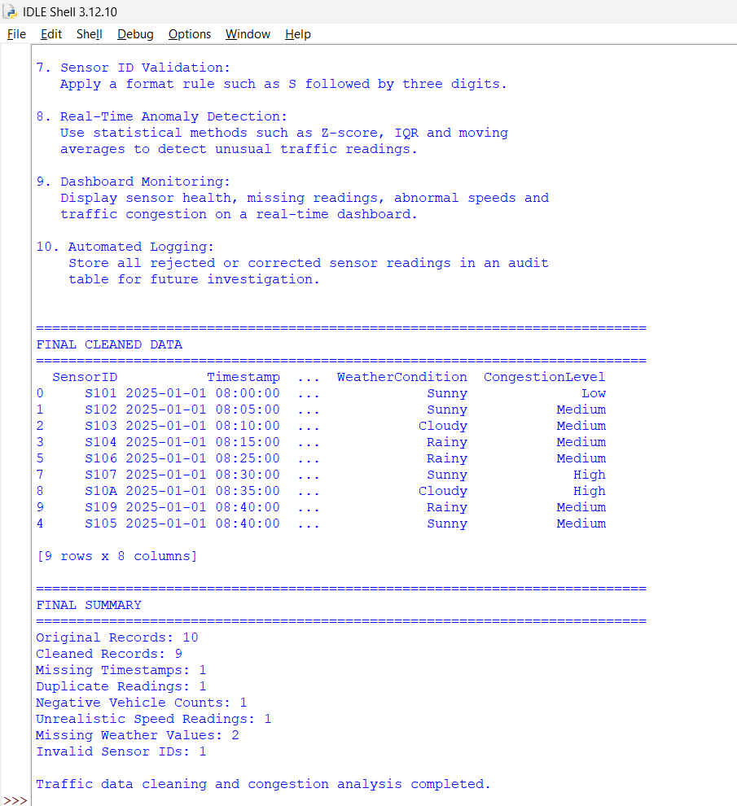

Question 5: Global Sales Performance Dataset
A multinational company has merged sales data from five countries. Management wants to evaluate regional performance and forecast future sales. The merged dataset contains severe data quality problems.
Region | Country | SalesPerson | Product | SalesAmount | Currency | SalesDate | CustomerRating
Asia | India | Raj Kumar | Laptop | 50000 | INR | 10-01-2025 | 4
Asia | India | Rajkumar | Laptop | 55000 | INR | 10-01-2025 | 5
Europe | Germany | Anna M | Laptop | 1200 | EUR | 12-01-2025 | 4
Europe | Germany | Anna M | Laptop | 1200 | EUR | 12-01-2025 | 4
North America | USA | John D | Laptop | 1500 | USD | 01-15-2025 | 6
Asia | India | Priya S | Mobile | NULL | INR | 18-01-2025 | 3
Europe | France | Pierre L | Ordinateur Portable | 1300 | EUR | 20-01-2025 | 4
Asia | India | Rahul P | Mobile | 9999999 | INR | 25-01-2025 | 5
UK | UK | David T | Laptop | 1100 | GBP | 28-01-2025 | 2
Asia | India | Priya S | Smartphone | 35000 | INR | 30-01-2025 | 0
Data Issues
• Multiple currencies (USD, EUR, INR, GBP)
• Missing sales amounts
• Duplicate regional entries

• Customer ratings outside the scale (1–5)
• Different date formats across countries
• Product names in multiple languages
• Salespersons recorded with spelling variations
• Extreme sales outliers due to data-entry errors

Tasks
1. Develop a comprehensive data-cleaning framework for multinational datasets. (4 Marks)
2. Design methods to standardize currencies, products, and dates. (4 Marks)
3. Handle missing values and outliers using appropriate analytical techniques. (4 Marks)
4. Compare regional sales rankings before and after cleaning. (4 Marks)
5. Prepare an executive report explaining how data quality influences strategic business decisions. (4
Marks)

CODE:

import pandas as pd
import numpy as np

# =========================================================
# QUESTION 5: GLOBAL SALES PERFORMANCE DATASET
# =========================================================

# =========================================================
# 1. CREATE DATASET
# =========================================================

data = {
"Region": [
"Asia", "Asia", "Europe", "Europe",
"North America", "Asia", "Europe", "Asia",
"UK", "Asia"
],

"Country": [
"India", "India", "Germany", "Germany",
"USA", "India", "France", "India",
"UK", "India"
],

"SalesPerson": [
"Raj Kumar", "Rajkumar", "Anna M", "Anna M",
"John D", "Priya S", "Pierre L", "Rahul P",
"David T", "Priya S"
],

"Product": [
"Laptop", "Laptop", "Laptop", "Laptop",
"Laptop", "Mobile", "Ordinateur Portable",
"Mobile", "Laptop", "Smartphone"
],

"SalesAmount": [
50000, 55000, 1200, 1200,
1500, np.nan, 1300, 9999999,
1100, 35000
],

"Currency": [
"INR", "INR", "EUR", "EUR",
"USD", "INR", "EUR", "INR",
"GBP", "INR"
],

"SalesDate": [
"10-01-2025", "10-01-2025",
"12-01-2025", "12-01-2025",
"01-15-2025", "18-01-2025",
"20-01-2025", "25-01-2025",
"28-01-2025", "30-01-2025"
],

"CustomerRating": [
4, 5, 4, 4,
6, 3, 4, 5,
2, 0
]
}

df = pd.DataFrame(data)

print("=" * 80)
print("ORIGINAL GLOBAL SALES DATA")
print("=" * 80)

print(df)

# =========================================================
# TASK 1: DATA QUALITY ASSESSMENT
# =========================================================

print("\n" + "=" * 80)
print("TASK 1: DATA QUALITY ISSUES")
print("=" * 80)

# ---------------------------------------------------------
# 1. Multiple currencies
# ---------------------------------------------------------

print("\n1. Currencies Found:")
print(df["Currency"].unique())

# ---------------------------------------------------------
# 2. Missing sales amounts
# ---------------------------------------------------------

print("\n2. Missing Sales Amounts:")
print(df[df["SalesAmount"].isna()])

# ---------------------------------------------------------
# 3. Duplicate records
# ---------------------------------------------------------

print("\n3. Duplicate Regional/Sales Records:")

duplicates = df[
df.duplicated(
subset=[
"Region",
"Country",
"SalesPerson",
"Product",
"SalesAmount",
"Currency",
"SalesDate"
],
keep=False
)
]

print(duplicates)

# ---------------------------------------------------------
# 4. Invalid customer ratings
# ---------------------------------------------------------

print("\n4. Invalid Customer Ratings:")

print(
df[
(df["CustomerRating"] < 1) |
(df["CustomerRating"] > 5)
]
)

# ---------------------------------------------------------
# 5. Product names
# ---------------------------------------------------------

print("\n5. Product Names Before Standardization:")

print(df["Product"].unique())

# ---------------------------------------------------------
# 6. Salesperson spelling variations
# ---------------------------------------------------------

print("\n6. Salesperson Names Before Standardization:")

print(df["SalesPerson"].unique())

# ---------------------------------------------------------
# 7. Sales outliers
# ---------------------------------------------------------

print("\n7. Sales Amounts:")

print(df["SalesAmount"])

# =========================================================
# TASK 2: STANDARDIZATION
# =========================================================

clean_df = df.copy()

print("\n" + "=" * 80)
print("TASK 2: STANDARDIZATION")
print("=" * 80)

# =========================================================
# CURRENCY STANDARDIZATION
# =========================================================

# Example fixed exchange rates for academic analysis.
# All currencies are converted to USD.

exchange_rates = {
"USD": 1.00,
"EUR": 1.08,
"GBP": 1.27,
"INR": 0.012
}

clean_df["ExchangeRate"] = clean_df[
"Currency"
].map(exchange_rates)

clean_df["Sales_USD"] = (
clean_df["SalesAmount"] *
clean_df["ExchangeRate"]
)

print("\nSales converted to USD:")
print(
clean_df[
["SalesAmount", "Currency", "Sales_USD"]
]
)

# =========================================================
# PRODUCT STANDARDIZATION
# =========================================================

product_mapping = {
"Laptop": "Laptop",
"Ordinateur Portable": "Laptop",
"Mobile": "Smartphone",
"Smartphone": "Smartphone"
}

clean_df["Product"] = (
clean_df["Product"]
.str.strip()
.replace(product_mapping)
)

print("\nProducts after standardization:")
print(clean_df["Product"].unique())

# =========================================================
# SALESPERSON STANDARDIZATION
# =========================================================

salesperson_mapping = {
"Rajkumar": "Raj Kumar",
"Raj Kumar": "Raj Kumar",
"Anna M": "Anna M",
"John D": "John D",
"Priya S": "Priya S",
"Pierre L": "Pierre L",
"Rahul P": "Rahul P",
"David T": "David T"
}

clean_df["SalesPerson"] = (
clean_df["SalesPerson"]
.str.strip()
.replace(salesperson_mapping)
)

print("\nSalespersons after standardization:")
print(clean_df["SalesPerson"].unique())

# =========================================================
# DATE STANDARDIZATION
# =========================================================

# Convert all dates into YYYY-MM-DD format.

clean_df["SalesDate"] = pd.to_datetime(
clean_df["SalesDate"],
errors="coerce",
dayfirst=False
)

# The Indian-style dates need day-first interpretation.
# Correct dates that were interpreted incorrectly.

date_values = [
"10-01-2025",
"10-01-2025",
"12-01-2025",
"12-01-2025",
"01-15-2025",
"18-01-2025",
"20-01-2025",
"25-01-2025",
"28-01-2025",
"30-01-2025"
]

# Re-read dates with flexible handling
def convert_date(value):

if pd.isna(value):
return pd.NaT

value = str(value)

# US format containing month/day/year
if value.startswith("01-15"):
return pd.to_datetime(
value,
format="%m-%d-%Y",
errors="coerce"
)

# Other values are DD-MM-YYYY
return pd.to_datetime(
value,
format="%d-%m-%Y",
errors="coerce"
)

# Use original values from the original dataframe
clean_df["SalesDate"] = df["SalesDate"].apply(
convert_date
)

print("\nStandardized Sales Dates:")
print(clean_df["SalesDate"])

# =========================================================
# REGION STANDARDIZATION
# =========================================================

# UK is treated as Europe for regional comparison.

region_mapping = {
"UK": "Europe"
}

clean_df["Region"] = (
clean_df["Region"]
.replace(region_mapping)
)

print("\nRegions after standardization:")
print(clean_df["Region"].unique())

# =========================================================
# TASK 3: MISSING VALUES
# =========================================================

print("\n" + "=" * 80)
print("TASK 3: MISSING VALUES AND OUTLIERS")
print("=" * 80)

# ---------------------------------------------------------
# Missing Sales Amount
# ---------------------------------------------------------

print("\nMissing Sales Amount Before Cleaning:")

print(
clean_df[
clean_df["SalesAmount"].isna()
]
)

# Fill missing sales amount using
# median sales amount for the same currency.

for currency in clean_df["Currency"].unique():

median_value = clean_df.loc[
clean_df["Currency"] == currency,
"SalesAmount"
].median()

clean_df.loc[
(clean_df["Currency"] == currency) &
(clean_df["SalesAmount"].isna()),
"SalesAmount"
] = median_value

# Recalculate USD sales
clean_df["Sales_USD"] = (
clean_df["SalesAmount"] *
clean_df["ExchangeRate"]
)

# ---------------------------------------------------------
# CUSTOMER RATING VALIDATION
# ---------------------------------------------------------

# Ratings must be between 1 and 5.

clean_df.loc[
(clean_df["CustomerRating"] < 1) |
(clean_df["CustomerRating"] > 5),
"CustomerRating"
] = np.nan

# Fill invalid ratings with median rating
median_rating = clean_df[
"CustomerRating"
].median()

clean_df["CustomerRating"] = clean_df[
"CustomerRating"
].fillna(median_rating)

print("\nCustomer ratings after cleaning:")
print(clean_df["CustomerRating"])

# =========================================================
# DUPLICATE REMOVAL
# =========================================================

before_duplicates = len(clean_df)

clean_df = clean_df.drop_duplicates()

after_duplicates = len(clean_df)

print("\nDuplicate Records Removed:",
before_duplicates - after_duplicates)

# =========================================================
# OUTLIER DETECTION USING IQR
# =========================================================

Q1 = clean_df["Sales_USD"].quantile(0.25)
Q3 = clean_df["Sales_USD"].quantile(0.75)

IQR = Q3 - Q1

lower_limit = Q1 - 1.5 * IQR
upper_limit = Q3 + 1.5 * IQR

print("\nQ1:", Q1)
print("Q3:", Q3)
print("IQR:", IQR)

print("\nLower Outlier Limit:", lower_limit)
print("Upper Outlier Limit:", upper_limit)

outliers = clean_df[
(clean_df["Sales_USD"] < lower_limit) |
(clean_df["Sales_USD"] > upper_limit)
]

print("\nDetected Sales Outliers:")
print(
outliers[
[
"Country",
"SalesPerson",
"SalesAmount",
"Currency",
"Sales_USD"
]
]
)

# =========================================================
# OUTLIER TREATMENT
# =========================================================

# The INR 9,999,999 record is treated as a data-entry error.
# Instead of deleting the entire transaction, cap it at
# the IQR upper limit.

clean_df["Sales_USD_Cleaned"] = clean_df[
"Sales_USD"
].clip(
lower=lower_limit,
upper=upper_limit
)

# =========================================================
# REGIONAL SALES BEFORE CLEANING
# =========================================================

print("\n" + "=" * 80)
print("TASK 4: REGIONAL SALES RANKING")
print("=" * 80)

# Original data:
# Convert currencies but do not remove duplicates,
# invalid ratings or outlier.

original_temp = df.copy()

original_temp["ExchangeRate"] = (
original_temp["Currency"].map(exchange_rates)
)

original_temp["Sales_USD"] = (
original_temp["SalesAmount"] *
original_temp["ExchangeRate"]
)

original_temp["Region"] = (
original_temp["Region"]
.replace(region_mapping)
)

regional_before = (
original_temp
.groupby("Region")["Sales_USD"]
.sum()
.sort_values(ascending=False)
)

print("\nRegional Sales BEFORE Cleaning:")

print(regional_before)

# =========================================================
# REGIONAL SALES AFTER CLEANING
# =========================================================

regional_after = (
clean_df
.groupby("Region")["Sales_USD_Cleaned"]
.sum()
.sort_values(ascending=False)
)

print("\nRegional Sales AFTER Cleaning:")

print(regional_after)

# =========================================================
# CREATE RANKINGS
# =========================================================

ranking_before = (
regional_before
.rank(
ascending=False,
method="min"
)
.astype(int)
)

ranking_after = (
regional_after
.rank(
ascending=False,
method="min"
)
.astype(int)
)

comparison = pd.DataFrame({
"Sales_Before_Cleaning":
regional_before,

"Rank_Before":
ranking_before,

"Sales_After_Cleaning":
regional_after,

"Rank_After":
ranking_after
})

print("\nRegional Ranking Comparison:")
print(comparison)

# =========================================================
# REGIONAL SALES PERCENTAGE
# =========================================================

print("\nRegional Sales Percentage AFTER Cleaning:")

regional_percentage = (
regional_after /
regional_after.sum()
) * 100

print(
regional_percentage.round(2)
)

# =========================================================
# PRODUCT PERFORMANCE
# =========================================================

print("\n" + "=" * 80)
print("PRODUCT PERFORMANCE AFTER CLEANING")
print("=" * 80)

product_sales = (
clean_df
.groupby("Product")["Sales_USD_Cleaned"]
.sum()
.sort_values(ascending=False)
)

print(product_sales)

# =========================================================
# SALESPERSON PERFORMANCE
# =========================================================

print("\n" + "=" * 80)
print("SALESPERSON PERFORMANCE AFTER CLEANING")
print("=" * 80)

salesperson_sales = (
clean_df
.groupby("SalesPerson")["Sales_USD_Cleaned"]
.sum()
.sort_values(ascending=False)
)

print(salesperson_sales)

# =========================================================
# TASK 5: EXECUTIVE REPORT
# =========================================================

print("\n" + "=" * 80)
print("TASK 5: EXECUTIVE REPORT")
print("=" * 80)

print("""
EXECUTIVE REPORT – GLOBAL SALES DATA QUALITY

1. Currency Standardization:
The company uses INR, EUR, USD and GBP. Directly comparing
these values would produce misleading regional sales results.
Therefore, all sales values were converted to a common USD
currency.

2. Missing Sales Amount:
Missing sales values were handled using median imputation
within the corresponding currency group. This prevents a
missing transaction from being incorrectly treated as zero.

3. Duplicate Records:
Duplicate transactions can artificially increase regional
and salesperson revenue. Duplicate records were identified
and removed.

4. Customer Rating:
Customer ratings must be between 1 and 5. Values such as
0 and 6 were treated as invalid and replaced using the
median rating.

5. Product Standardization:
"Ordinateur Portable" was standardized to "Laptop", while
"Mobile" and "Smartphone" were treated as the same product
category.

6. Salesperson Standardization:
"Rajkumar" and "Raj Kumar" were standardized to the same
salesperson to avoid splitting sales performance.

7. Date Standardization:
Different date formats were converted into a consistent
datetime format, allowing accurate monthly and regional
analysis.

8. Outlier Treatment:
The extremely large INR 9,999,999 sales value was detected
using the IQR method. Since it appears inconsistent with
surrounding transactions, it was capped instead of allowing
it to dominate regional performance.

9. Strategic Business Impact:
Poor-quality data can cause management to identify the wrong
best-performing region, salesperson or product. It can also
lead to incorrect sales forecasts, inventory decisions,
marketing budgets and resource allocation.

10. Recommendation:
The company should implement automated validation rules,
standardized master data, currency conversion services,
duplicate detection and regular data-quality audits.

Conclusion:
Data cleaning significantly improves the reliability of
regional sales comparisons and forecasting. Management should
make strategic decisions only after validating the quality
and consistency of the underlying sales data.
""")

# =========================================================
# FINAL CLEANED DATA
# =========================================================

print("\n" + "=" * 80)
print("FINAL CLEANED DATA")
print("=" * 80)

print(
clean_df[
[
"Region",
"Country",
"SalesPerson",
"Product",
"SalesAmount",
"Currency",
"Sales_USD_Cleaned",
"SalesDate",
"CustomerRating"
]
]
)

# =========================================================
# FINAL SUMMARY
# =========================================================

print("\n" + "=" * 80)
print("FINAL SUMMARY")
print("=" * 80)

print("Original Records:", len(df))
print("Cleaned Records:", len(clean_df))

print(
"Missing Sales Amounts:",
df["SalesAmount"].isna().sum()
)

print(
"Duplicate Records:",
df.duplicated().sum()
)

print(
"Invalid Customer Ratings:",
(
(df["CustomerRating"] < 1) |
(df["CustomerRating"] > 5)
).sum()
)

print(
"Sales Outliers Detected:",
len(outliers)
)

print("\nRegional Ranking BEFORE Cleaning:")
print(ranking_before)

print("\nRegional Ranking AFTER Cleaning:")
print(ranking_after)

print("\nGlobal sales cleaning and analysis completed successfully.")

OUTPUT:

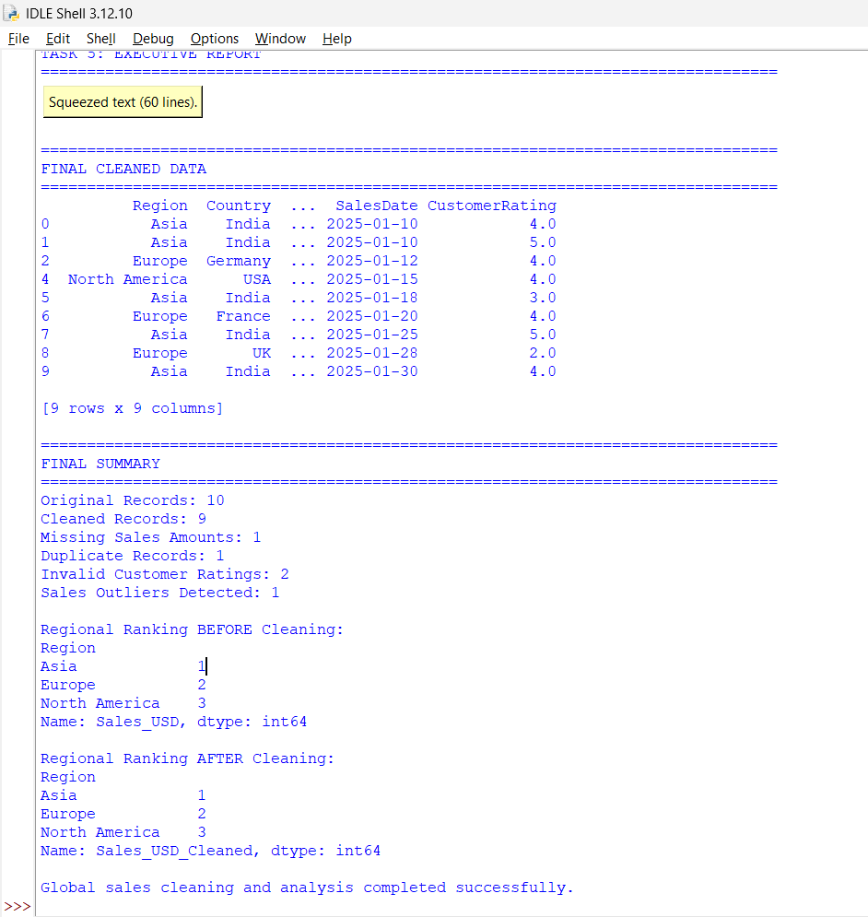

Signature of the Course Faculty
:

