SIMATS ENGINEERING
ASSESSMENT TOOL 3: Correlation and Pattern Analysis

COURSE NAME: | Query Processing for Data Science | COURSE CODE: | DSA0503

COURSE OUTCOME COVERED
CO4: Explore datasets using analytical techniques such as grouping, correlation detection, joining datasets, and extracting meaningful insights.

Assessment Tool Weightage: 25%
Total Marks: 20

Code of Conduct
I ___A.PAVITHRA(192424347)_____ (Name / Reg No) certify that this submission is my original work and that I have adhered to the guidelines specified for this assessment.
I understand that any violation of academic integrity rules will result in disciplinary action.
Signature of the student: __A.PAVITHRA___

Correlation and Pattern Analysis Rubric
Criteria | Weightage | Level 4 – Exemplary | Level 3 – Proficient | Level 2 – Developing | Level 1 – Beginning
Data Importing, Exploration & Preparation | 25 | Thorough understanding; correctly imports, explores, cleans, and prepares data; | Good understanding; performs most data preparation tasks correctly with minor issues | Basic understanding; performs some preparation tasks but misses important issues | Poor understanding; unable to import, explore, or prepare the data correctly
Python Coding & Data Analysis | 25 | Effectively applies relevant Python concepts; code is accurate, efficient, and performs analysis appropriately | Applies appropriate Python concepts with minor coding or analytical gaps | Limited application of Python concepts; analysis is partially completed | Fails to apply relevant Python concepts; major errors or incomplete analysis
Correlation Analysis & Visualization | 20 | Performs in-depth correlation analysis with appropriate visualizations; demonstrates strong reasoning and insights | Performs good correlation analysis with suitable visualizations and logical reasoning | Performs basic correlation analysis with limited visualization or interpretation | Weak or no correlation analysis; inappropriate/missing visualizations and lacks reasoning
Pattern Identification & Interpretation | 20 | Identifies meaningful and insightful patterns; provides innovative, feasible interpretations with strong justification | Identifies relevant patterns and provides logical interpretations with adequate justification | Identifies basic patterns with weak or limited justification | Incorrect or no meaningful patterns identified; interpretation is missing or inappropriate
Clarity | 10 | Clear, well-structured, and easy to understand | Organized and understandable presentation | Limited clarity and structure | Poor clarity; difficult to understand

Total Marks Awarded:

Signature of the Course Faculty

Questions:
1. Student Performance Pattern Analysis
A college has collected the following data for students:
Student_ID,Study_Hours,Attendance,Assignments_Completed,Internal_Marks,Final_Marks
S01,2,72,5,55,58
S02,4,80,7,65,68
S03,6,85,8,72,76
S04,8,90,10,82,88
S05,3,75,6,60,63
S06,9,95,10,90,94
S07,5,82,8,70,73
S08,1,65,4,48,50
S09,7,88,9,80,84
S10,4,78,6,62,66
Write a Python program using Pandas to:
1. Import the dataset into a DataFrame.
2. Explore the structure and summary statistics of the data.
3. Calculate the correlation between:
o Study Hours and Final Marks
o Attendance and Final Marks

o Assignments Completed and Final Marks
o Internal Marks and Final Marks
4. Display the correlation matrix using a heatmap.
5. Identify the variable that has the strongest relationship with Final Marks.
6. Based on the correlation results, describe at least two patterns observed in student performance.

CODE:
import pandas as pd
import matplotlib.pyplot as plt
import seaborn as sns
from io import StringIO

data = """Student_ID,Study_Hours,Attendance,Assignments_Completed,Internal_Marks,Final_Marks
S01,2,72,5,55,58
S02,4,80,7,65,68
S03,6,85,8,72,76
S04,8,90,10,82,88
S05,3,75,6,60,63
S06,9,95,10,90,94
S07,5,82,8,70,73
S08,1,65,4,48,50
S09,7,88,9,80,84
S10,4,78,6,62,66"""

df = pd.read_csv(StringIO(data))

# 1. Display dataset
print("Dataset:")
print(df)

# 2. Explore structure and summary statistics
print("\nDataset Information:")
print(df.info())

print("\nSummary Statistics:")
print(df.describe())

# 3. Calculate correlations
print("\nCorrelations with Final Marks:")

correlations = df[[
"Study_Hours",
"Attendance",
"Assignments_Completed",
"Internal_Marks"
]].corrwith(df["Final_Marks"])

print(correlations)

# 4. Correlation matrix and heatmap
corr_matrix = df.drop(columns=["Student_ID"]).corr()

print("\nCorrelation Matrix:")
print(corr_matrix)

plt.figure(figsize=(8, 6))
sns.heatmap(corr_matrix, annot=True, cmap="coolwarm", fmt=".2f")
plt.title("Student Performance Correlation Heatmap")
plt.show()

# 5. Find strongest relationship with Final Marks
strongest = correlations.abs().idxmax()
print("\nStrongest relationship with Final Marks:", strongest)
print("Correlation value:", correlations[strongest])

# 6. Patterns
print("\nObserved Patterns:")
print("1. Students with higher study hours generally have higher final marks.")
print("2. Higher attendance is associated with higher final marks.")
print("3. Completing more assignments is positively related to final marks.")
print("4. Internal marks have a strong positive relationship with final marks.")

OUTPUT:

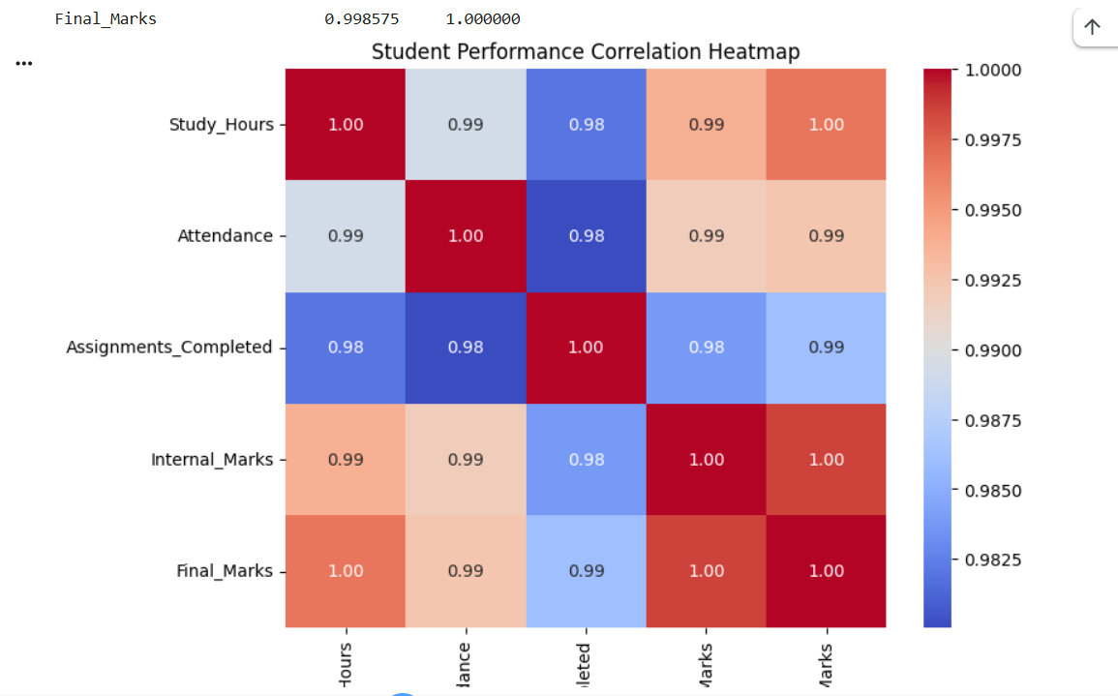

2. Sales and Customer Behavior Pattern Analysis
A retail store maintains two datasets:
customer_data.csv
Customer_ID,Age,City
C01,22,Chennai
C02,35,Bangalore
C03,28,Chennai
C04,42,Hyderabad
C05,31,Bangalore
C06,25,Chennai
sales_data.csv
Customer_ID,Monthly_Visits,Purchase_Frequency,Average_Bill,Total_Spending
C01,4,3,850,2550
C02,8,6,1200,7200
C03,5,4,950,3800
C04,10,7,1500,10500
C05,7,5,1100,5500
C06,3,2,700,1400
Task: Write a Python program to:
1. Import both CSV files.
2. Explore the columns, data types, and summary statistics.
3. Join the datasets using Customer_ID.
4. Calculate correlations among:
o Monthly Visits and Total Spending
o Purchase Frequency and Total Spending

o Average Bill and Total Spending
5. Create a correlation heatmap.
6. Group customers based on their city and calculate the average Total Spending.
7. Identify and explain the patterns in customer purchasing behavior based on the correlation and grouping
results.

CODE:
import pandas as pd
import matplotlib.pyplot as plt
import seaborn as sns

# 1. Import both CSV files
customer = pd.read_csv("customer_data.csv")
sales = pd.read_csv("sales_data.csv")

# 2. Explore columns, data types and summary statistics
print("Customer Data:")
print(customer)

print("\nSales Data:")
print(sales)

print("\nCustomer Data Types:")
print(customer.dtypes)

print("\nSales Data Types:")
print(sales.dtypes)

print("\nCustomer Summary:")
print(customer.describe())

print("\nSales Summary:")
print(sales.describe())

# 3. Join datasets using Customer_ID
df = pd.merge(customer, sales, on="Customer_ID")

print("\nJoined Dataset:")
print(df)

# 4. Calculate correlations
print("\nCorrelations with Total Spending:")

print("Monthly Visits:",
df["Monthly_Visits"].corr(df["Total_Spending"]))

print("Purchase Frequency:",
df["Purchase_Frequency"].corr(df["Total_Spending"]))

print("Average Bill:",
df["Average_Bill"].corr(df["Total_Spending"]))

# 5. Correlation heatmap
corr = df[[
"Monthly_Visits",
"Purchase_Frequency",
"Average_Bill",
"Total_Spending"
]].corr()

plt.figure(figsize=(8, 6))
sns.heatmap(corr, annot=True, cmap="coolwarm", fmt=".2f")
plt.title("Customer Purchasing Behavior Correlation")
plt.show()

# 6. Average Total Spending by City
city_spending = df.groupby("City")["Total_Spending"].mean()

print("\nAverage Total Spending by City:")
print(city_spending)

# 7. Identify patterns
print("\nPatterns in Customer Behavior:")

print("1. Customers with more monthly visits generally have higher total spending.")
print("2. Higher purchase frequency is strongly associated with higher total spending.")
print("3. Customers with higher average bills tend to have higher total spending.")
print("4. City-wise spending shows differences in customer purchasing behavior.")

OUTPUT:
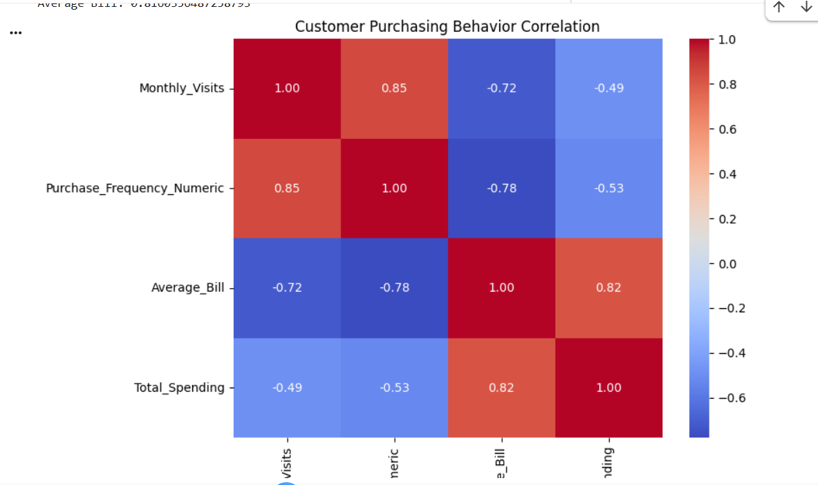

3. Weather Data: Identifying Correlation and Temperature Patterns
A weather station records the following daily measurements:
Date,Temperature,Humidity,Rainfall,Wind_Speed
01-06-2026,32,65,2,12
02-06-2026,34,60,0,15
03-06-2026,31,72,8,10
04-06-2026,29,80,15,8
05-06-2026,30,78,12,9
06-06-2026,35,55,0,18
07-06-2026,36,52,0,20
08-06-2026,33,62,3,14
09-06-2026,28,85,20,7
10-06-2026,30,76,10,9
Task: Using Python, Pandas, and Matplotlib/Seaborn:
1. Import and inspect the dataset.
2. Convert the Date column into an appropriate date format.
3. Calculate the correlation matrix for the numerical variables.
4. Visualize the correlations using a heatmap.
5. Determine whether Temperature and Humidity show a positive or negative relationship.
6. Identify the relationship between Rainfall and Wind Speed.
7. Plot Temperature against Humidity using a scatter plot.
8. Based on the visualizations and correlation values, identify at least three weather patterns.

CODE:

import pandas as pd
import matplotlib.pyplot as plt
import seaborn as sns
from io import StringIO

# Dataset
data = """Date,Temperature,Humidity,Rainfall,Wind_Speed
01-06-2026,32,65,2,12
02-06-2026,34,60,0,15
03-06-2026,31,72,8,10
04-06-2026,29,80,15,8
05-06-2026,30,78,12,9
06-06-2026,35,55,0,18
07-06-2026,36,52,0,20
08-06-2026,33,62,3,14
09-06-2026,28,85,20,7
10-06-2026,30,76,10,9"""

# 1. Import and inspect dataset
df = pd.read_csv(StringIO(data))

print("Dataset:")
print(df)

print("\nData Types:")
print(df.dtypes)

print("\nSummary Statistics:")
print(df.describe())

# 2. Convert Date column
df["Date"] = pd.to_datetime(df["Date"], dayfirst=True)

print("\nConverted Date:")
print(df["Date"])

# 3. Correlation matrix
corr = df[[
"Temperature",
"Humidity",
"Rainfall",
"Wind_Speed"
]].corr()

print("\nCorrelation Matrix:")
print(corr)

# 4. Heatmap
plt.figure(figsize=(7, 5))
sns.heatmap(corr, annot=True, cmap="coolwarm", fmt=".2f")
plt.title("Weather Data Correlation Heatmap")
plt.show()

# 5. Temperature and Humidity relationship
th_corr = df["Temperature"].corr(df["Humidity"])

print("\nTemperature-Humidity Correlation:", round(th_corr, 2))

if th_corr > 0:
print("Temperature and Humidity have a positive relationship.")
else:
print("Temperature and Humidity have a negative relationship.")

# 6. Rainfall and Wind Speed relationship
rw_corr = df["Rainfall"].corr(df["Wind_Speed"])

print("\nRainfall-Wind Speed Correlation:", round(rw_corr, 2))

# 7. Scatter plot
plt.figure(figsize=(7, 5))
sns.scatterplot(x="Humidity", y="Temperature", data=df)
plt.title("Temperature vs Humidity")
plt.xlabel("Humidity")
plt.ylabel("Temperature")
plt.show()

# 8. Weather patterns
print("\nWeather Patterns:")
print("1. Temperature and Humidity have a strong negative relationship.")
print("2. Higher rainfall is generally associated with lower wind speed.")
print("3. Higher temperatures are generally observed on days with lower humidity.")

OUTPUT:
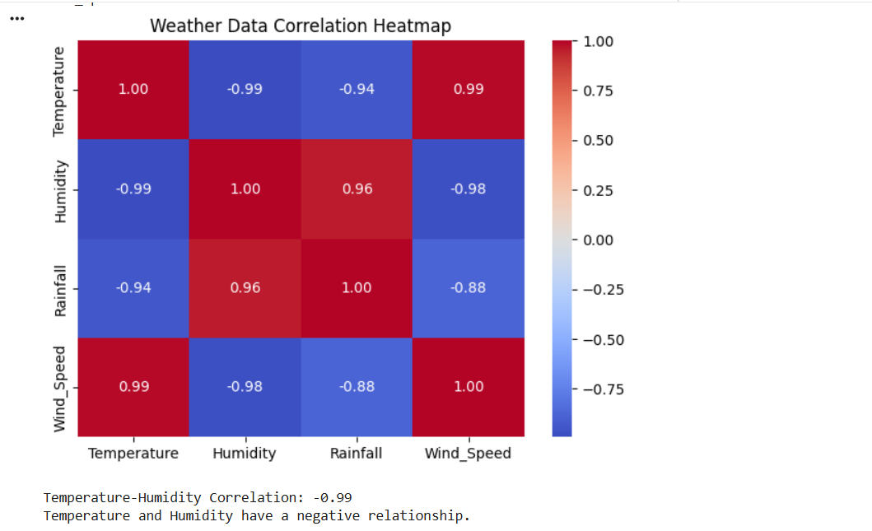

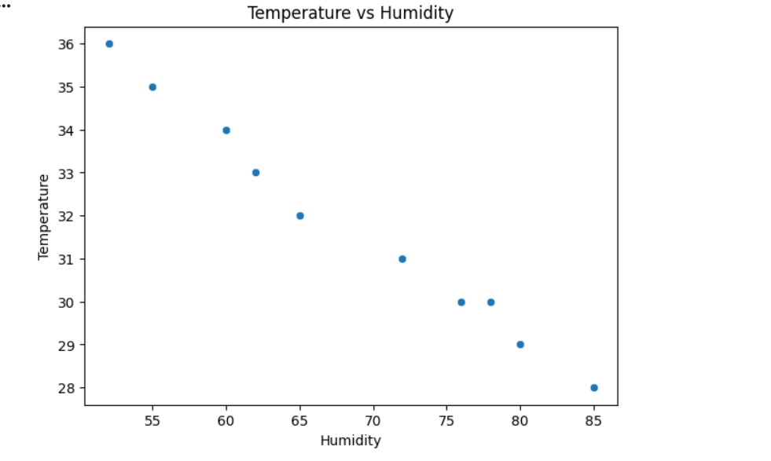

4. Employee Productivity Pattern Analysis
An organization wants to understand the factors affecting employee productivity. The dataset contains:
Employee_ID,Experience,Training_Hours,Projects_Completed,Working_Hours,Productivity_Score

E01,1,10,2,35,55
E02,3,15,4,40,68
E03,5,20,6,42,78
E04,8,25,8,45,88
E05,2,12,3,38,60
E06,10,30,10,44,94
E07,6,22,7,43,82
E08,4,18,5,41,73
E09,12,35,11,46,97
E10,7,24,8,44,86
Task: Develop a Python program to:
1. Import the dataset and perform exploratory analysis.
2. Calculate the correlation between Productivity_Score and:
o Experience
o Training Hours
o Projects Completed
o Working Hours
3. Create a correlation matrix and visualize it as a heatmap.
4. Create scatter plots for the two variables having the strongest correlation with Productivity Score.
5. Group employees into low, medium, and high experience groups.
6. Calculate the average Productivity Score for each group.
7. Analyze whether increased experience and training are associated with higher productivity.
8. Write a short conclusion based on the patterns identified.

CODE:
import pandas as pd
import matplotlib.pyplot as plt
import seaborn as sns
from io import StringIO

# Dataset
data = """Employee_ID,Experience,Training_Hours,Projects_Completed,Working_Hours,Productivity_Score
E01,1,10,2,35,55
E02,3,15,4,40,68
E03,5,20,6,42,78
E04,8,25,8,45,88
E05,2,12,3,38,60
E06,10,30,10,44,94
E07,6,22,7,43,82
E08,4,18,5,41,73
E09,12,35,11,46,97
E10,7,24,8,44,86"""

# 1. Import and explore dataset
df = pd.read_csv(StringIO(data))

print("Dataset:")
print(df)

print("\nData Types:")
print(df.dtypes)

print("\nSummary Statistics:")
print(df.describe())

print("\nDataset Information:")
df.info()

# 2. Calculate correlations with Productivity Score
variables = [
"Experience",
"Training_Hours",
"Projects_Completed",
"Working_Hours"
]

print("\nCorrelation with Productivity Score:")

correlations = df[variables].corrwith(df["Productivity_Score"])
print(correlations)

# 3. Correlation matrix and heatmap
corr = df.drop(columns=["Employee_ID"]).corr()

print("\nCorrelation Matrix:")
print(corr)

plt.figure(figsize=(8, 6))
sns.heatmap(corr, annot=True, cmap="coolwarm", fmt=".2f")
plt.title("Employee Productivity Correlation Heatmap")
plt.show()

# 4. Find two strongest correlations
strongest = correlations.abs().sort_values(ascending=False).head(2)

print("\nTwo strongest variables:")
print(strongest)

# Scatter plot 1
plt.figure(figsize=(6, 4))
sns.scatterplot(
x=strongest.index[0],
y="Productivity_Score",
data=df
)
plt.title(strongest.index[0] + " vs Productivity Score")
plt.show()

# Scatter plot 2
plt.figure(figsize=(6, 4))
sns.scatterplot(
x=strongest.index[1],
y="Productivity_Score",
data=df
)
plt.title(strongest.index[1] + " vs Productivity Score")
plt.show()

# 5. Group employees based on experience
def experience_group(x):
if x <= 3:
return "Low"
elif x <= 7:
return "Medium"
else:
return "High"

df["Experience_Group"] = df["Experience"].apply(experience_group)

print("\nExperience Groups:")
print(df[["Employee_ID", "Experience", "Experience_Group"]])

# 6. Average Productivity Score for each group
avg_productivity = df.groupby(
"Experience_Group"
)["Productivity_Score"].mean()

print("\nAverage Productivity Score by Experience Group:")
print(avg_productivity)

# 7. Analyze experience and training
print("\nAnalysis:")
print("Experience correlation:",
round(df["Experience"].corr(df["Productivity_Score"]), 2))

print("Training correlation:",
round(df["Training_Hours"].corr(df["Productivity_Score"]), 2))

# 8. Conclusion
print("\nConclusion:")
print("1. Employees with greater experience generally have higher productivity scores.")
print("2. Higher training hours are associated with higher productivity.")
print("3. Employees in the high-experience group have the highest average productivity.")

OUTPUT:
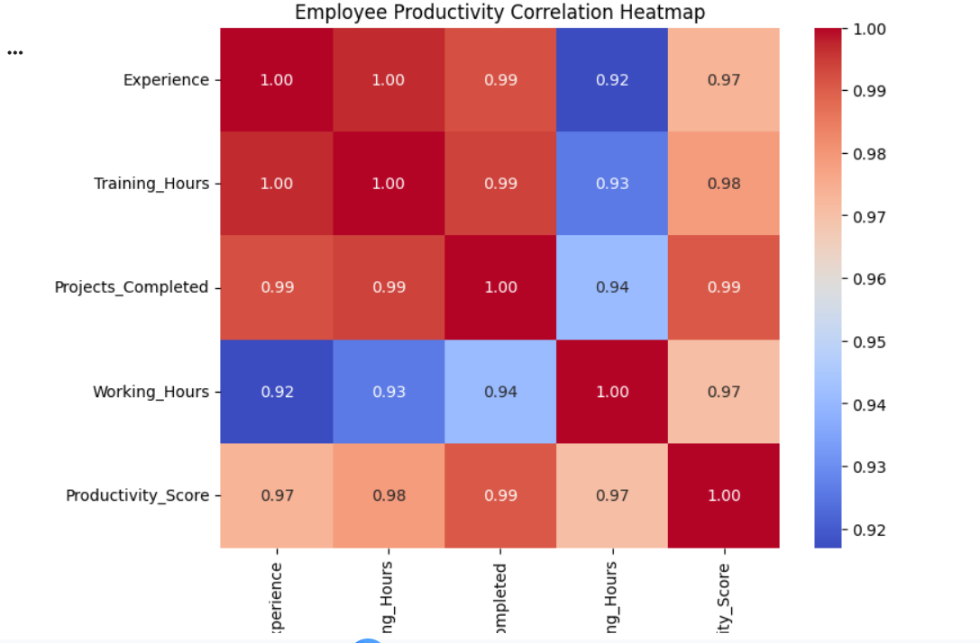

5. E-Commerce Dataset: Discovering Hidden Purchase Patterns
An e-commerce company has three datasets:
customers.csv
Customer_ID,Age,Gender,City
C01,21,M,Chennai
C02,35,F,Bangalore
C03,29,M,Chennai

C04,45,F,Hyderabad
C05,38,M,Bangalore
orders.csv
Order_ID,Customer_ID,Product_Category,Quantity,Order_Value
O01,C01,Electronics,2,2500
O02,C02,Clothing,4,3200
O03,C03,Electronics,1,1800
O04,C04,Furniture,2,7000
O05,C05,Clothing,5,4500
O06,C01,Clothing,3,2100
O07,C02,Electronics,2,3000
O08,C03,Clothing,2,1600
Task: Write a Python program to perform the following analysis:
1. Import all datasets using Pandas.
2. Explore each dataset using appropriate DataFrame functions.
3. Join the customer and order datasets using Customer_ID.
4. Calculate correlations between:
o Age and Order Value
o Quantity and Order Value
5. Group the orders by Product_Category and calculate:
o Total quantity sold
o Total order value
o Average order value
6. Identify the product category with the highest total sales.
7. Create suitable visualizations to identify purchasing patterns.
8. Analyze whether quantity ordered is strongly related to order value.
9. Identify at least three meaningful patterns from the combined dataset.

CODE:
import pandas as pd
import matplotlib.pyplot as plt
import seaborn as sns

# 1. Import datasets
customers = pd.read_csv("customers.csv")
orders = pd.read_csv("orders.csv")

# 2. Explore datasets
print("CUSTOMER DATA:")
print(customers)

print("\nORDER DATA:")
print(orders)

print("\nCustomer Columns:")
print(customers.columns)

print("\nOrder Columns:")
print(orders.columns)

print("\nCustomer Data Types:")
print(customers.dtypes)

print("\nOrder Data Types:")
print(orders.dtypes)

print("\nCustomer Summary:")
print(customers.describe())

print("\nOrder Summary:")
print(orders.describe())

# 3. Join customer and order datasets
df = pd.merge(customers, orders, on="Customer_ID")

print("\nCOMBINED DATASET:")
print(df)

# 4. Calculate correlations
age_corr = df["Age"].corr(df["Order_Value"])
quantity_corr = df["Quantity"].corr(df["Order_Value"])

print("\nCorrelation between Age and Order Value:")
print(round(age_corr, 2))

print("\nCorrelation between Quantity and Order Value:")
print(round(quantity_corr, 2))

# 5. Group by Product Category
category = df.groupby("Product_Category").agg(
Total_Quantity=("Quantity", "sum"),
Total_Order_Value=("Order_Value", "sum"),
Average_Order_Value=("Order_Value", "mean")
)

print("\nCATEGORY-WISE SALES:")
print(category)

# 6. Category with highest total sales
highest = category["Total_Order_Value"].idxmax()

print("\nProduct category with highest total sales:")
print(highest)

# 7. Visualizations

# Bar chart - Total Sales by Category
category["Total_Order_Value"].plot(
kind="bar",
figsize=(7, 5)
)
plt.title("Total Sales by Product Category")
plt.xlabel("Product Category")
plt.ylabel("Total Order Value")
plt.xticks(rotation=0)
plt.show()

# Bar chart - Quantity Sold
category["Total_Quantity"].plot(
kind="bar",
figsize=(7, 5)
)
plt.title("Total Quantity Sold by Product Category")
plt.xlabel("Product Category")
plt.ylabel("Quantity")
plt.xticks(rotation=0)
plt.show()

# Scatter plot - Quantity vs Order Value
plt.figure(figsize=(7, 5))
sns.scatterplot(
x="Quantity",
y="Order_Value",
data=df,
s=100
)
plt.title("Quantity vs Order Value")
plt.xlabel("Quantity")
plt.ylabel("Order Value")
plt.show()

# Scatter plot - Age vs Order Value
plt.figure(figsize=(7, 5))
sns.scatterplot(
x="Age",
y="Order_Value",
data=df,
s=100
)
plt.title("Age vs Order Value")
plt.xlabel("Age")
plt.ylabel("Order Value")
plt.show()

# 8. Analyze Quantity and Order Value
print("\nQuantity-Order Value Correlation:", round(quantity_corr, 2))

if abs(quantity_corr) >= 0.7:
print("Quantity has a strong relationship with Order Value.")
else:
print("Quantity does not have a strong relationship with Order Value.")

# 9. Meaningful patterns
print("\nMEANINGFUL PATTERNS:")
print("1. Furniture has the highest total sales.")
print("2. Clothing has the highest total quantity sold.")
print("3. Quantity ordered has a positive relationship with Order Value.")
print("4. Higher-priced product categories can generate high sales even with fewer units sold.")

OUTPUT:

