SIMATS ENGINEERING
ASSESSMENT TOOL 3: Dataset Integration

COURSE NAME: | Query Processing for Data Science | COURSE CODE: | DSA0503
NAME: A.PAVITHRA REG NO: 192424347

COURSE OUTCOME COVERED
CO3: Identify and clean inconsistencies in data by handling missing values, duplicates, outliers, formatting issues, and applying techniques like fuzzy matching and regex.

Assessment Tool Weightage: 30%
Total Marks: 20

Code of Conduct
I A. Pavithra (192424347) (Name / Reg No) certify that this submission is my original work and that I have adhered to the guidelines specified for this assessment.
I understand that any violation of academic integrity rules will result in disciplinary action.
Signature of the student: A.Pavithra

Dataset Integration Rubric

Criteria | Weightage | Level 4 - Exemplary | Level 3 - Proficient | Level 2 - Developing | Level 1 - Beginning
Dataset Understanding & Preparation | 30% | Correctly understands both datasets, identifies relevant columns/keys, and loads them properly. | Minor misunderstanding or preparation issue. | Loads datasets but needs some guidance in identifying relevant fields. | Unable to identify or prepare the datasets correctly.
Dataset Integration | 20% | Correctly integrates datasets using appropriate merge(), join(), or concat() and selects the correct integration key. | Integration is mostly correct with minor errors. | Performs integration with significant guidance or minor key/operation errors. | Unable to integrate the datasets correctly.
Data Processing & Analysis | 15% | Correctly performs all required calculations, filtering, grouping, or transformations on the integrated data. | Performs most required analysis correctly. | Performs basic analysis but misses some required operations. | Analysis is incorrect or incomplete.
Python/Pandas Implementation | 20% | Code is correct, efficient, well-structured, and uses appropriate Pandas functions. | Code works with minor inefficiencies/errors. | Code works partially and requires corrections. | Code contains major errors or does not execute.
Output & Interpretation | 15% | Clearly presents the required output and correctly interprets the results. | Output is correct with limited interpretation. | Output is partially correct or poorly presented. | Output is missing/incorrect and results are not interpreted.

Total Marks Awarded:

Signature of the Course Faculty

Questions:
Set 1 – Dataset Integration Tasks
- Employee–Department Integration
You are given two datasets:
• employees.csv — Employee_ID, Employee_Name, Department_ID, Salary
• departments.csv — Department_ID, Department_Name, Location
Task: Write a Python program using Pandas to integrate the two datasets based on Department_ID and create a new dataset containing employee name, department name, location, and salary.
CODE:

import pandas as pd

# Read the datasets
employees = pd.read_csv("employees.csv")
departments = pd.read_csv("departments.csv")

# Merge the two datasets using Department_ID
integrated_data = pd.merge(
employees,
departments,
on="Department_ID",
how="inner"
)

# Select the required columns
result = integrated_data[
["Employee_Name", "Department_Name", "Location", "Salary"]
]

# Display the integrated dataset
print(result)

# Save the result to a new CSV file
result.to_csv("employee_department_integrated.csv", index=False)

print("\nIntegrated dataset saved successfully!")

OUTPUT:

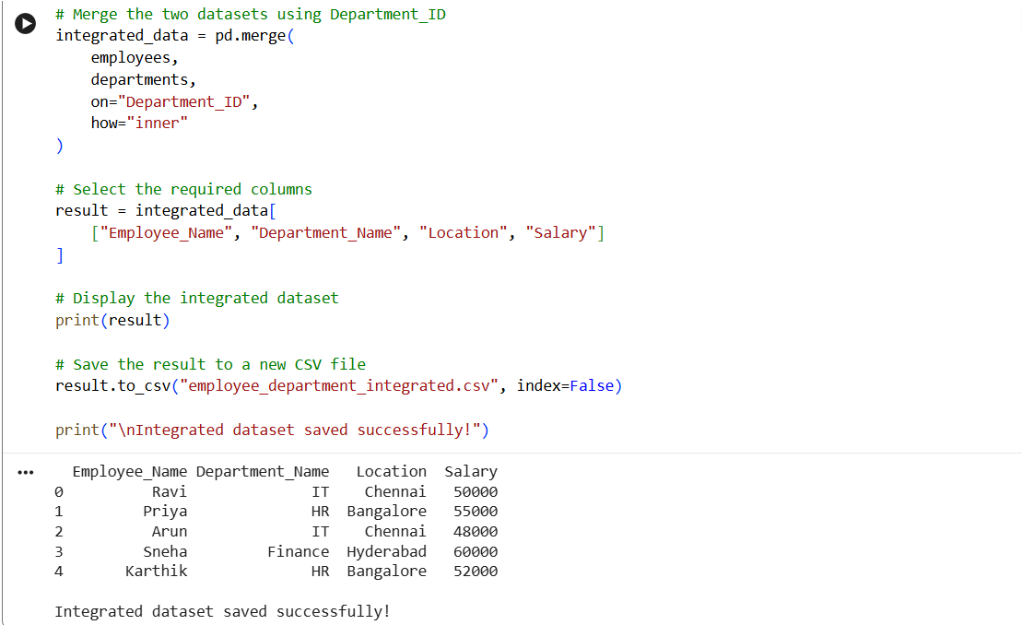

2. Customer–Transaction Integration
You are given:
customers.csv — Customer_ID, Customer_Name, City
transactions.csv — Transaction_ID, Customer_ID, Product, Amount
Task: Integrate the datasets using Customer_ID. Display the customer name, city, product, and transaction amount. Identify customers who have made transactions above ₹10,000.
CODE:

import pandas as pd

# Read the datasets
customers = pd.read_csv("customers.csv")
transactions = pd.read_csv("transactions.csv")

# Integrate the datasets using Customer_ID
integrated_data = pd.merge(
customers,
transactions,
on="Customer_ID",
how="inner"
)

# Display required columns
result = integrated_data[
["Customer_Name", "City", "Product", "Amount"]
]

print("Integrated Customer-Transaction Data:")
print(result)

# Identify transactions above ₹10,000
high_value = result[result["Amount"] > 10000]

print("\nCustomers with transactions above ₹10,000:")
print(high_value)

# Save the integrated dataset
result.to_csv("customer_transaction_integrated.csv", index=False)

# Save high-value transactions
high_value.to_csv("transactions_above_10000.csv", index=False)

print("\nFiles saved successfully!")

OUTPUT:

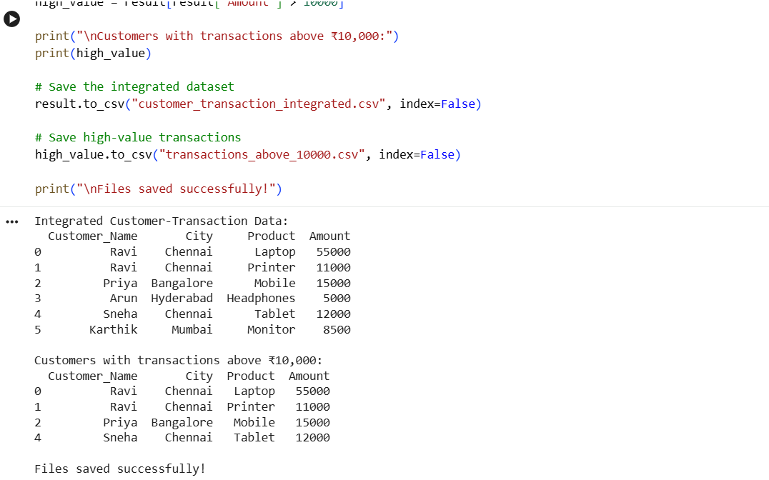

3. Student–Marks Integration
You are given:
students.csv — Student_ID, Student_Name, Department
marks.csv — Student_ID, Python, DBMS, Statistics
Task: Merge the datasets using Student_ID. Create a new column Total_Marks and identify students whose total marks are greater than 240.
CODE:
import pandas as pd

# Read the datasets
students = pd.read_csv("students.csv")
marks = pd.read_csv("marks.csv")

# Merge the datasets using Student_ID
integrated_data = pd.merge(
students,
marks,
on="Student_ID",
how="inner"
)

# Calculate Total Marks
integrated_data["Total_Marks"] = (
integrated_data["Python"] +
integrated_data["DBMS"] +
integrated_data["Statistics"]
)

# Display the integrated dataset
print("Integrated Student-Marks Data:")
print(integrated_data)

# Identify students with Total Marks greater than 240
high_scorers = integrated_data[
integrated_data["Total_Marks"] > 240
]

print("\nStudents with Total Marks greater than 240:")
print(high_scorers)

# Save the complete integrated dataset
integrated_data.to_csv("student_marks_integrated.csv", index=False)

# Save students scoring above 240
high_scorers.to_csv("students_above_240.csv", index=False)

print("\nFiles saved successfully!")

OUTPUT:

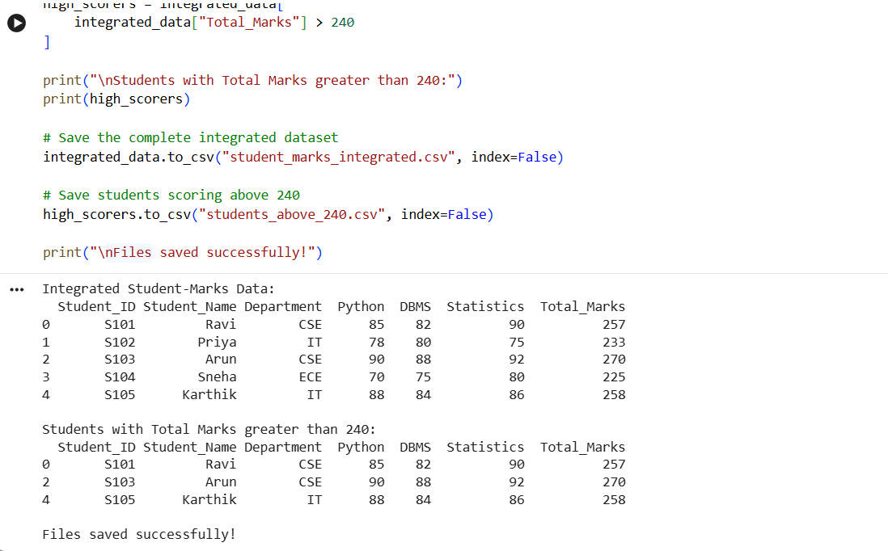

4. Product–Sales Integration
You are given:
products.csv — Product_ID, Product_Name, Category, Unit_Price
sales.csv — Sale_ID, Product_ID, Quantity, Sale_Date
Task: Integrate the two datasets using Product_ID. Calculate the total sales amount for each transaction using:
Total_Sales = Quantity × Unit_Price
Display the integrated dataset.

CODE:
import pandas as pd

# Read the datasets
products = pd.read_csv("products.csv")
sales = pd.read_csv("sales.csv")

# Merge the datasets using Product_ID
integrated_data = pd.merge(
sales,
products,
on="Product_ID",
how="inner"
)

# Calculate Total Sales
integrated_data["Total_Sales"] = (
integrated_data["Quantity"] * integrated_data["Unit_Price"]
)

# Display the integrated dataset
print("Integrated Product-Sales Data:")
print(integrated_data)

# Save the integrated dataset
integrated_data.to_csv("product_sales_integrated.csv", index=False)

print("\nIntegrated dataset saved successfully!")

OUTPUT:

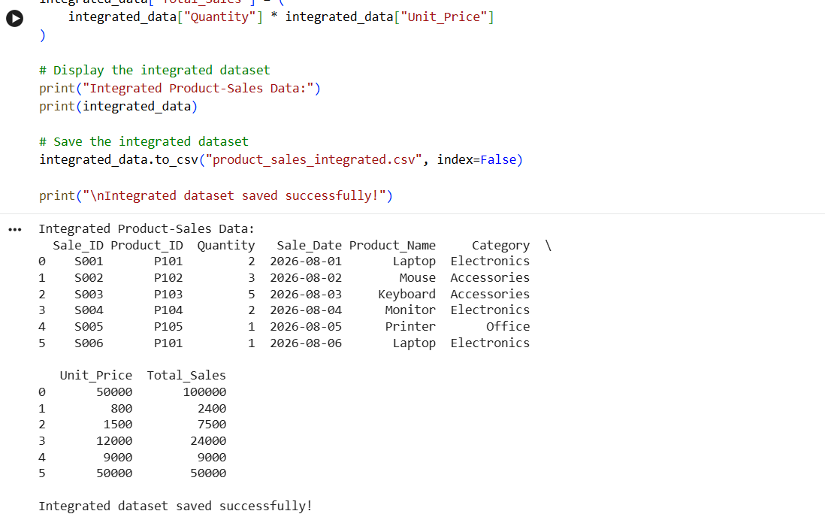

5. Hospital Patient–Visit Integration
You are given:
patients.csv — Patient_ID, Patient_Name, Age, Gender.
visits.csv — Visit_ID, Patient_ID, Doctor, Visit_Date, Fee
Task: Integrate the patient and visit datasets using Patient_ID. Display patient name, age, doctor, visit date, and fee. Calculate the total consultation fee paid by each patient.
CODE:
import pandas as pd

# Read the datasets
patients = pd.read_csv("patients.csv")
visits = pd.read_csv("visits.csv")

# Merge the datasets using Patient_ID
integrated_data = pd.merge(
patients,
visits,
on="Patient_ID",
how="inner"
)

# Display required columns
result = integrated_data[
["Patient_Name", "Age", "Doctor", "Visit_Date", "Fee"]
]

print("Integrated Patient-Visit Data:")
print(result)

# Calculate total consultation fee paid by each patient
total_fee = (
integrated_data
.groupby(["Patient_ID", "Patient_Name"])["Fee"]
.sum()
.reset_index()
)

total_fee.rename(
columns={"Fee": "Total_Consultation_Fee"},
inplace=True
)

print("\nTotal Consultation Fee Paid by Each Patient:")
print(total_fee)

# Save the integrated dataset
result.to_csv("patient_visit_integrated.csv", index=False)

# Save total fee report
total_fee.to_csv("total_consultation_fee.csv", index=False)

print("\nFiles saved successfully!")

OUTPUT:
