In this document, type only in the boxes provided (which you may enlarge if necessary) and only use the courier font
(this is what the courier font looks like)

Part 1 – Dataset Fundamentals

1a Dataset Code and Spreadsheet Used
Code (beginning with ds..) | Spreadsheet (csv/xlsx/xls)
ds321 | 6 class csv.csv
Note the above boxes MUST be filled correctly. If either are empty or not what you were allocated you will score 0 for part 1 (1a,1b,1c,1d) of this assignment. Markers have no discretion here.

1b
Produce the first 5 rows of the dataset. Only include the maximum 5 most interesting columns and rename them if necessary. Do not add any formatting (spaces etc.) unless produced by R.
(Only use the courier font for this and make sure the columns align. If you rename the columns to make them shorter, underneath the 5 rows list the renamings you have done e.g.
*acc renamed from “Acceration of the cars”)
 | Temp | Lum | Radius | AbsMag | Type
1 | 3068 | 0.002400 | 0.1700 | 16.12 | 0
2 | 3042 | 0.000500 | 0.1542 | 16.60 | 0
3 | 2600 | 0.000300 | 0.1020 | 18.70 | 0
4 | 2800 | 0.000200 | 0.1600 | 16.65 | 0
5 | 1939 | 0.000138 | 0.1030 | 20.06 | 0

Renamings:
- Temp renamed from Temperature (K)
- Lum renamed from Luminosity(L/Lo)
- Radius renamed from Radius(R/Ro)
- AbsMag renamed from Absolute magnitude(Mv)
- Type renamed from Star type

1c
What is the dataset about?
(Response limit: Max 30 words but ideally less)
This data set has the measurements of the stars, such as temperature, luminosity, radius, and absolute magnitude along with the type of the star, color, and spectrum.

1d
What does each line of the dataset represent?
(Response limit: Max 30 words)
Each line is a single recorded star with its physical attributes, star type designation by number, color, and spectral classification.

Part 2 – Descriptive Statistics

2a
Using ordinary measures basic descriptive statistics, summarize the dataset and highlight some salient features about it on initial viewing. Justify the points you make with numerical measures.
(Response limit: Max 200 words)
The dataset consists of 240-star records, whose temperatures vary from 1,939 K to 40,000 K. The mean and median temperatures are 10,497 K and 5,776 K respectively, indicating that there are some extremely hot stars that increase the mean value. The luminosity values go from near-zero to 849,420 times the Sun's luminosity. The mean and median of luminosity are 107,188.36 and 0.07 respectively, and there is a great difference between them, showing that few stars affect the mean value. Relative radius is distributed from 0.0084 to 1,948.5 times the Sun's radius, whereas the median of relative radius is 0.7625. The absolute magnitude varies from -11.92 to 20.06, and the mean and median are 4.382 and 8.313 respectively. There are six-star types: Brown Dwarfs, Red Dwarfs, White Dwarfs, Main Sequence stars, Supergiants and Hypergiants. All these types include 40 records each (i.e., one-sixth of all the records). There are 19-star colors and 7 spectral classes.

2B
What is the most surprising thing you can see when first looking at the data?(Response limit: Max 50 words)
The most surprising fact is that all six types of stars have precisely 40 records, making their distribution absolutely balanced among the total number of 240 observations. On the other hand, the luminosity range varies greatly, being from almost zero to 849,420 times the Sun’s luminosity.

Part 3 – A Simple Graph
3a
Draw a graph using pen and paper which shows something about the dataset. You may do a bar chart, a histogram, a pie chart or a scatterplot. Take a picture of it. (This must be hand drawn – anything computer generated will score for this category)
(Put image here with explanation below – max text 30 words)
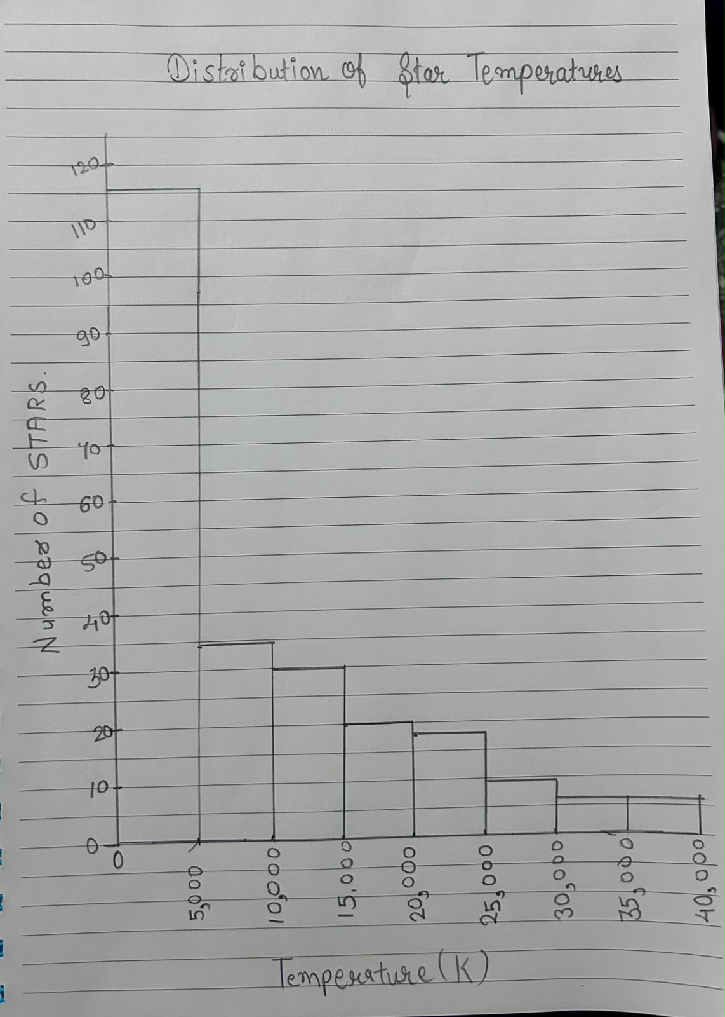

The histogram shows that most of the stars have temperatures ranging from 0 to 5,000 K. As the temperature increases, the number of stars decreases.

3b
Write some R code which would produce a graph something like the picture drawn with pen and paper above.
# Histogram of star temperatures
hist(stars[["Temperature (K)"]],
breaks = seq(0, 40000, by = 5000),
main = "Distribution of Star Temperatures",
xlab = "Temperature (K)",
ylab = "Number of Stars",
col = "lightblue",
include.lowest = TRUE)

Part 4 – Investigation Plan
4a
What interesting conclusions do you think it might be possible to make from a more in depth view of this data, and what real-world implications might it have?
(Response limit: Max 100 words)
A more thorough investigation can be conducted to study the differences in temperatures, luminosity, radii, and absolute magnitudes between the six-star classes. Such an investigation might find trends that will allow better understanding of the relationship between the properties of the stars and the classifications of the stars. For instance, it would be possible to learn about differences between the temperature distributions to find out which classes include hotter or cooler stars. Another trend that can be found through studying luminosity and radius of the stars is that between small, dim stars and large bright stars.

4b
Where do you see the greatest challenges in attempting such an in-depth view
(Response limit: Max 100 words)
The problem here is that there are only 240 stars in the dataset, and the patterns seen within the dataset might not represent all the stars in the universe. Some variables, such as luminosity and radius, have high variability and might be influenced by outliers. The data set also has some categorical variables, such as star color and spectrum class, that will need careful analysis. The next problem is understanding the scientific meaning of each variable unit before performing comparisons. The final problem is that relationship among the variables doesn't mean causality.

4c
Cite maximum 2 resources (using Harvard referencing) which you think might help in doing this assignment
- Dataset
Kaggle (n.d.) Star dataset to predict star types. Available at: https://www.kaggle.com/datasets/deepu1109/star-dataset
- Optional Supporting Resource
A. Gunawan, M. L. Fong Cheong and J. Poh, "An Essential Applied Statistical Analysis Course using RStudio with Project-Based Learning for Data Science," 2018 IEEE International Conference on Teaching, Assessment, and Learning for Engineering (TALE), Wollongong, NSW, Australia, 2018, pp. 581-588, doi: 10.1109/TALE.2018.8615145. keywords: {Education;Statistical analysis;Accidents;Big Data applications;Proposals;Correlation;applied statistical analysis;project-based learning;RStudio},

