Exercise 1: Setting Up JUnit

Scenario:

You need to set up JUnit in your Java project to start writing unit tests.

Steps:

1. Create a new Java project in your IDE (e.g., IntelliJ IDEA, Eclipse).

2. Add JUnit dependency to your project. If you are using Maven, add the following to your

pom.xml:

<dependency>

<groupId>junit</groupId>

<artifactId>junit</artifactId>

<version>4.13.2</version>

<scope>test</scope>

</dependency>

3. Create a new test class in your project.

src/test/java/com/example/junitdemo/SampleTest.java

package com.example.junitdemo;

import org.junit.jupiter.api.Test;

import static org.junit.jupiter.api.Assertions.*;

public class SampleTest {

*@Test*

void testSum() {

*assertEquals*(5, 2 + 3);

}

}

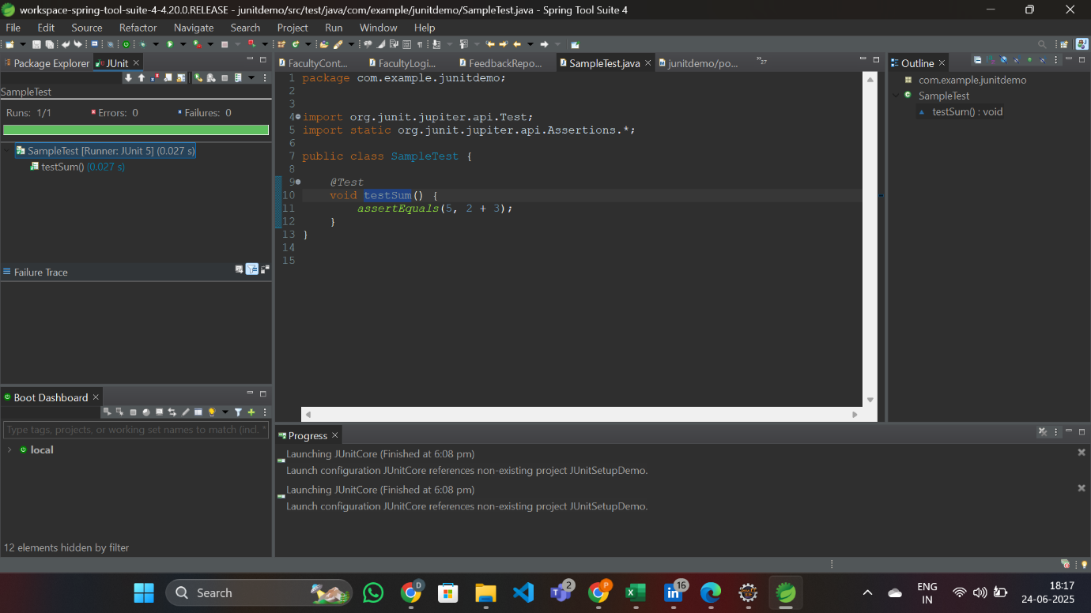

Exercise 3: Assertions in JUnit

Scenario:

You need to use different assertions in JUnit to validate your test results.

Steps:

1. Write tests using various JUnit assertions.

Solution Code:

public class AssertionsTest {

@Test

public void testAssertions() {

// Assert equals

assertEquals(5, 2 + 3);

// Assert true

assertTrue(5 > 3);

// Assert false

assertFalse(5 < 3);

// Assert null

assertNull(null);

// Assert not null

assertNotNull(new Object());

}

}

src/test/java/com/example/junitdemo/AssertionsTest.java

package com.example.junitdemo;

import org.junit.jupiter.api.Test;

import static org.junit.jupiter.api.Assertions.*;

public class AssertionsTest {

@Test

void testAssertions() {

// Assert equals

assertEquals(5, 2 + 3);

// Assert true

assertTrue(5 > 3);

// Assert false

assertFalse(5 < 3);

// Assert null

assertNull(null);

// Assert not null

assertNotNull(new Object());

}

}

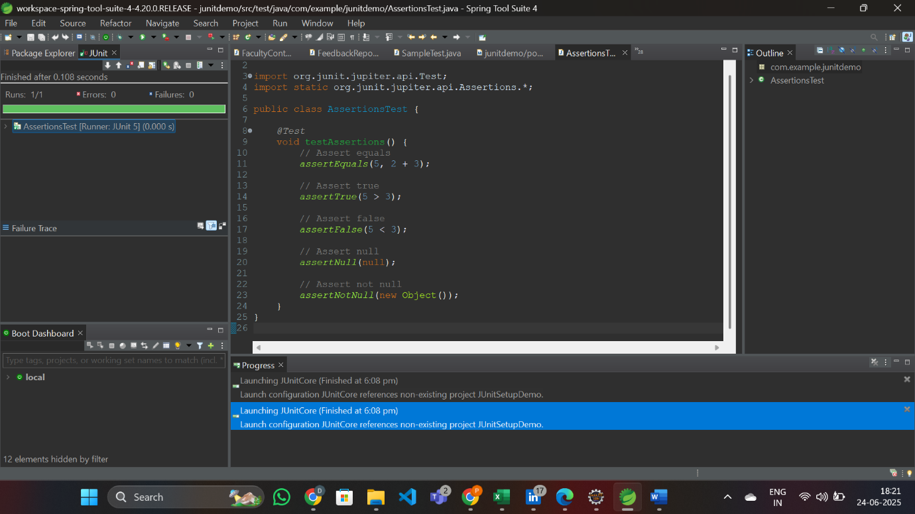

Exercise 4: Arrange-Act-Assert (AAA) Pattern, Test Fixtures, Setup and

Teardown Methods in JUnit

Scenario:

You need to organize your tests using the Arrange-Act-Assert (AAA) pattern and use setup

and teardown methods.

Steps:

1. Write tests using the AAA pattern.

2. Use @Before and @After annotations for setup and teardown methods.

src/test/java/com/example/junitdemo/CalculatorTest.java

package com.example.junitdemo;

import org.junit.jupiter.api.*;

import static org.junit.jupiter.api.Assertions.*;

public class CalculatorTest {

private Calculator calculator;

// Setup method: runs before each test

@BeforeEach

void setUp() {

calculator = new Calculator();

System.out.println("Setup complete.");

}

// Teardown method: runs after each test

@AfterEach

void tearDown() {

System.out.println("Teardown after test.");

}

@Test

void testAddition() {

// Arrange

int a = 5;

int b = 3;

// Act

int result = calculator.add(a, b);

// Assert

assertEquals(8, result);

}

@Test

void testSubtraction() {

// Arrange

int a = 10;

int b = 4;

// Act

int result = calculator.subtract(a, b);

// Assert

assertEquals(6, result);

}

}

src/test/java/com/example/junitdemo/Calculator.java

package com.example.junitdemo;

public class Calculator {

public int add(int a, int b) {

return a + b;

}

public int subtract(int a, int b) {

return a - b;

}

}

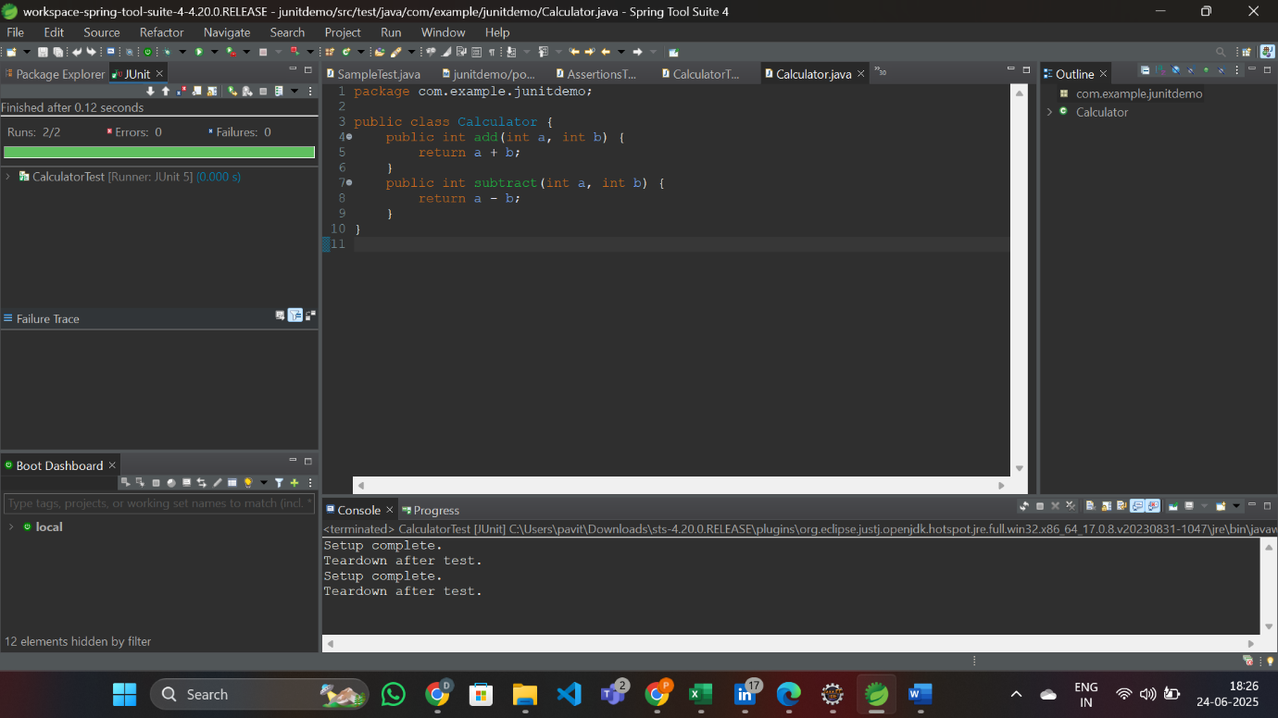

Exercise 1: Mocking and Stubbing

Scenario:

You need to test a service that depends on an external API. Use Mockito to mock the

external API and stub its methods.

Steps:

1. Create a mock object for the external API.

2. Stub the methods to return predefined values.

3. Write a test case that uses the mock object.

Solution Code:

import static org.mockito.Mockito.*;

import org.junit.jupiter.api.Test;

import org.mockito.Mockito;

public class MyServiceTest {

@Test

public void testExternalApi() {

ExternalApi mockApi = Mockito.mock(ExternalApi.class);

when(mockApi.getData()).thenReturn("Mock Data");

MyService service = new MyService(mockApi);

String result = service.fetchData();

assertEquals("Mock Data", result);

}

}

<dependencies>

<!-- JUnit 5 -->

<dependency>

<groupId>org.junit.jupiter</groupId>

<artifactId>junit-jupiter</artifactId>

<version>5.10.0</version>

<scope>test</scope>

</dependency>

<!-- Mockito -->

<dependency>

<groupId>org.mockito</groupId>

<artifactId>mockito-core</artifactId>

<version>5.11.0</version>

<scope>test</scope>

</dependency>

</dependencies>

ExternalApi.java

package com.example;

public interface ExternalApi {

String getData();

}

MyService.java

package com.example;

public class MyService {

private ExternalApi externalApi;

public MyService(ExternalApi externalApi) {

this.externalApi = externalApi;

}

public String fetchData() {

return externalApi.getData();

}

}

src/test/java → **New > JUnit Test Case** → Name: MyServiceTest

package com.example.junitdemo;

import org.junit.jupiter.api.Test;

import static org.mockito.Mockito.*;

import static org.junit.jupiter.api.Assertions.*;

public class MyServiceTest {

*@Test*

public void testExternalApi() {

ExternalApi mockApi = *mock*(ExternalApi.class);

*when*(mockApi.getData()).thenReturn("Mock Data");

MyService service = new MyService(mockApi);

String result = service.fetchData();

*assertEquals*("Mock Data", result);

*verify*(mockApi, *times*(1)).getData();

*verifyNoMoreInteractions*(mockApi);

}

}

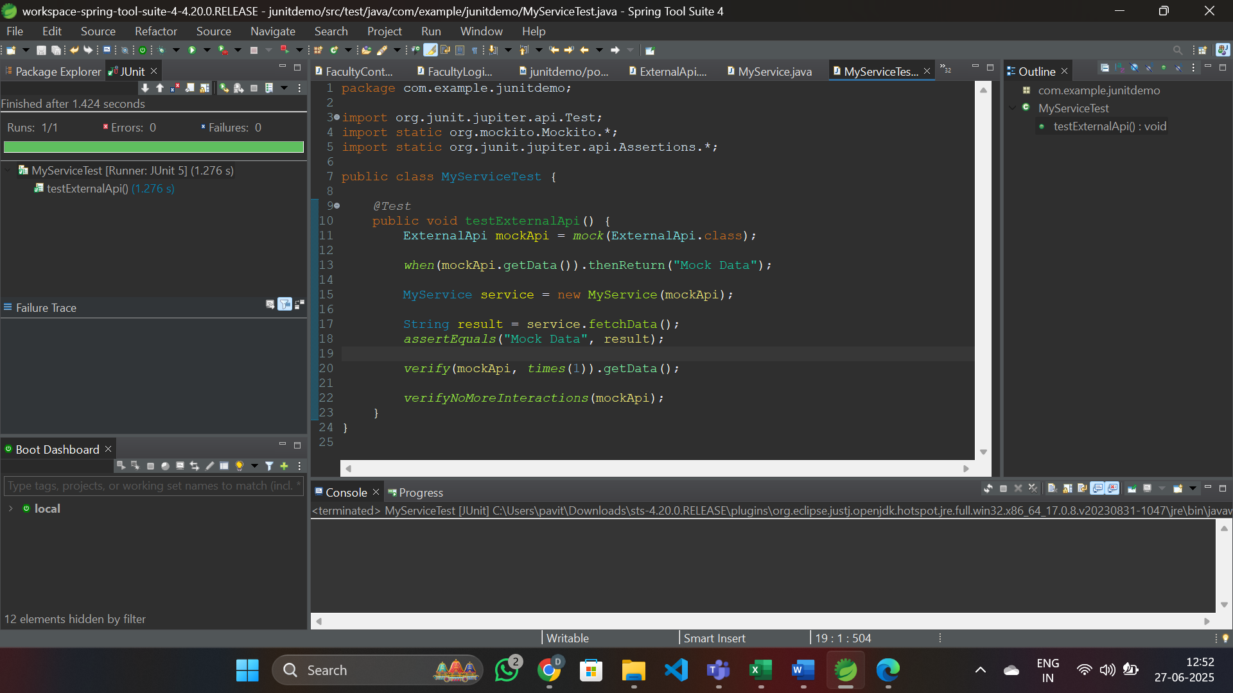

Exercise 2: Verifying Interactions

Scenario:

You need to ensure that a method is called with specific arguments.

Steps:

1. Create a mock object.

2. Call the method with specific arguments.

3. Verify the interaction.

Solution Code:

import static org.mockito.Mockito.*;

import org.junit.jupiter.api.Test;

import org.mockito.Mockito;

public class MyServiceTest {

@Test

public void testVerifyInteraction() {

ExternalApi mockApi = Mockito.mock(ExternalApi.class);

MyService service = new MyService(mockApi);

service.fetchData();

verify(mockApi).getData();

}

}

ExternalApi.java

package com.example.junitdemo;

public interface ExternalApi {

String sendMessage(String userId, String message);

}

MyService.java

package com.example.junitdemo;

public class MyService {

private ExternalApi api;

public MyService(ExternalApi api) {

this.api = api;

}

public void processMessage() {

System.out.println("Calling ExternalApi.sendMessage...");

api.sendMessage("user123", "Hello Mockito");

System.out.println("Message sent via ExternalApi.");

}

}

MyServiceTest.java

package com.example.junitdemo;

import org.junit.jupiter.api.Test;

import static org.mockito.Mockito.*;

public class MyServiceTest {

*@Test*

public void testVerifyInteractionWithArguments() {

System.***out***.println("Starting test...");

ExternalApi mockApi = *mock*(ExternalApi.class);

MyService service = new MyService(mockApi);

service.processMessage();

*verify*(mockApi).sendMessage("user123", "Hello Mockito");

System.***out***.println("Mock verified successfully.");

}

}

