### Ktern

### **Create a Task**

Just click the + button in the top right corner

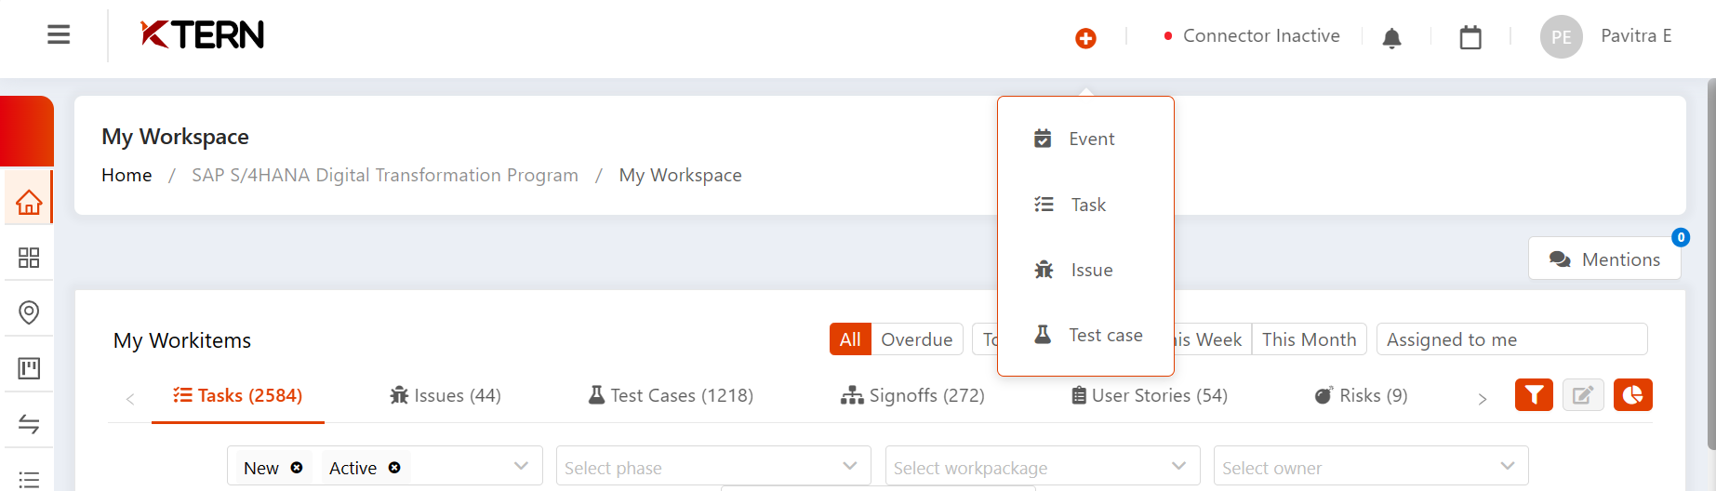

### Overview tab

### **Mandatory Elements:**

* Give name for the task
* Set the status
* Select the parent that your task will be located : Parent Task.
* Assign an owner
* Set the priority

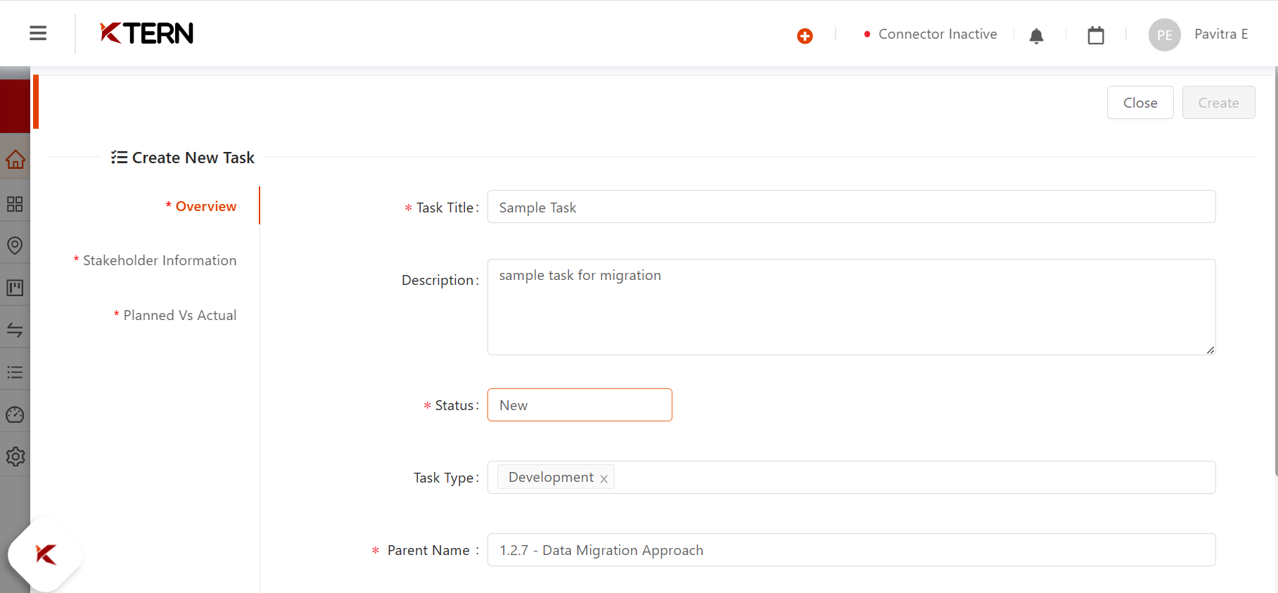

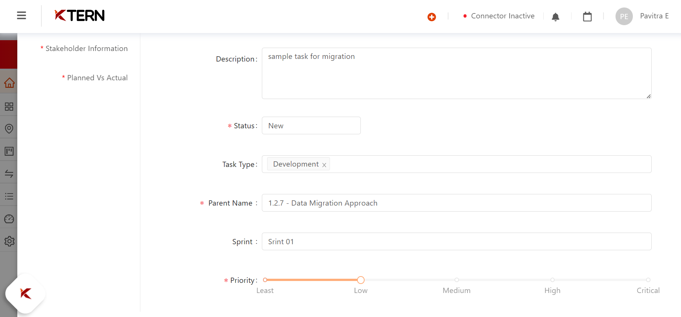

### Stakeholder Information

### **Mandatory Elements:**

* Give the name of the person responsible for the task.

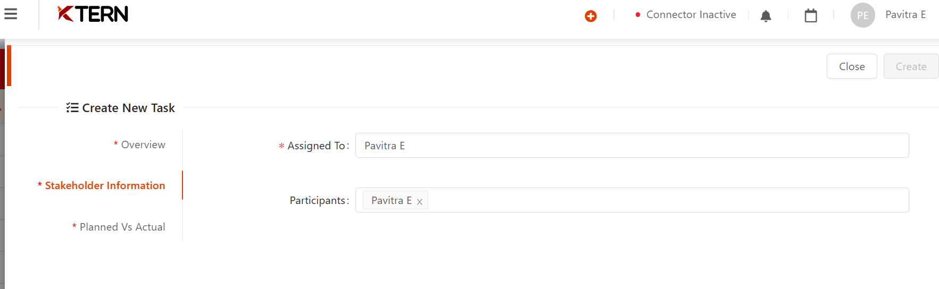

### Planned vs Actual

### **Mandatory Elements:**

* Give the planned dates

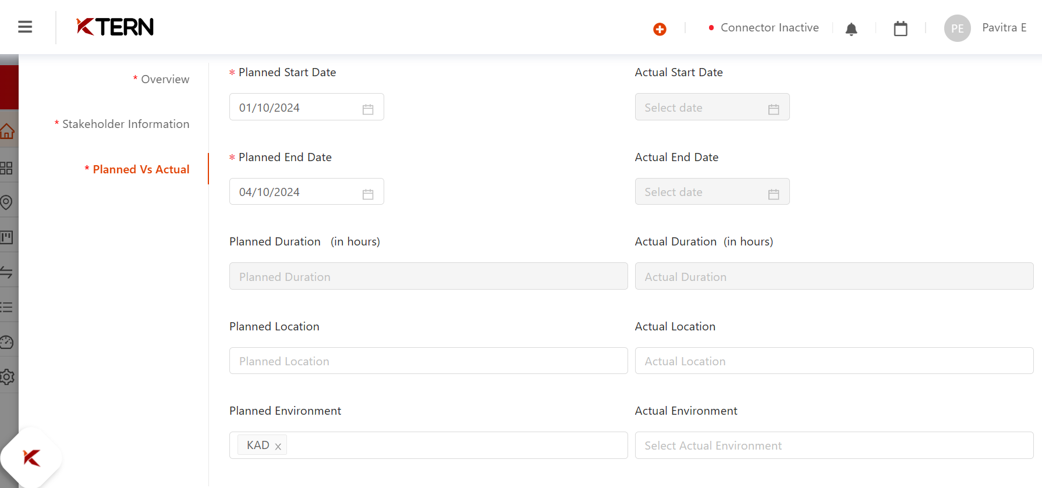

### **Create a Issue**

### Overview tab

### **Mandatory Elements:**

* Give name for the issue.
* Give the description
* Set the status
* Give the test case
* Set the priority

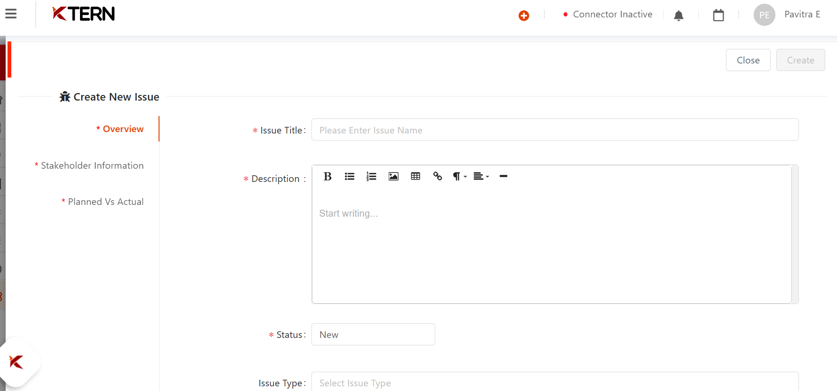

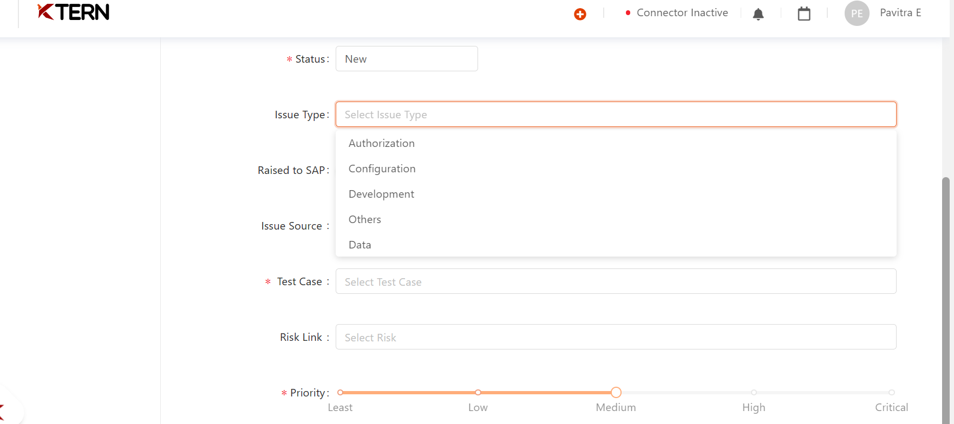

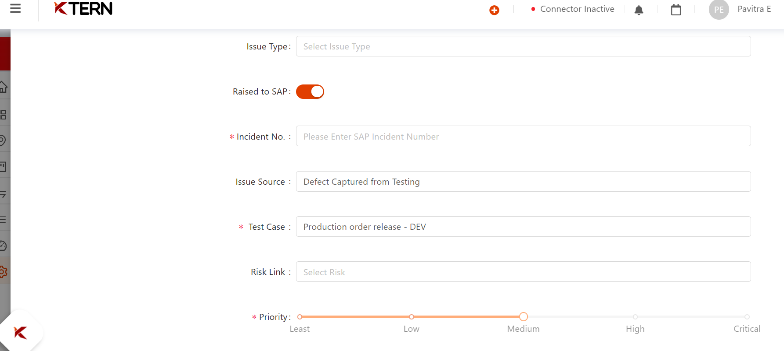

### Stakeholder Information

### **Mandatory Elements:**

* Give the name of the person responsible for the task.

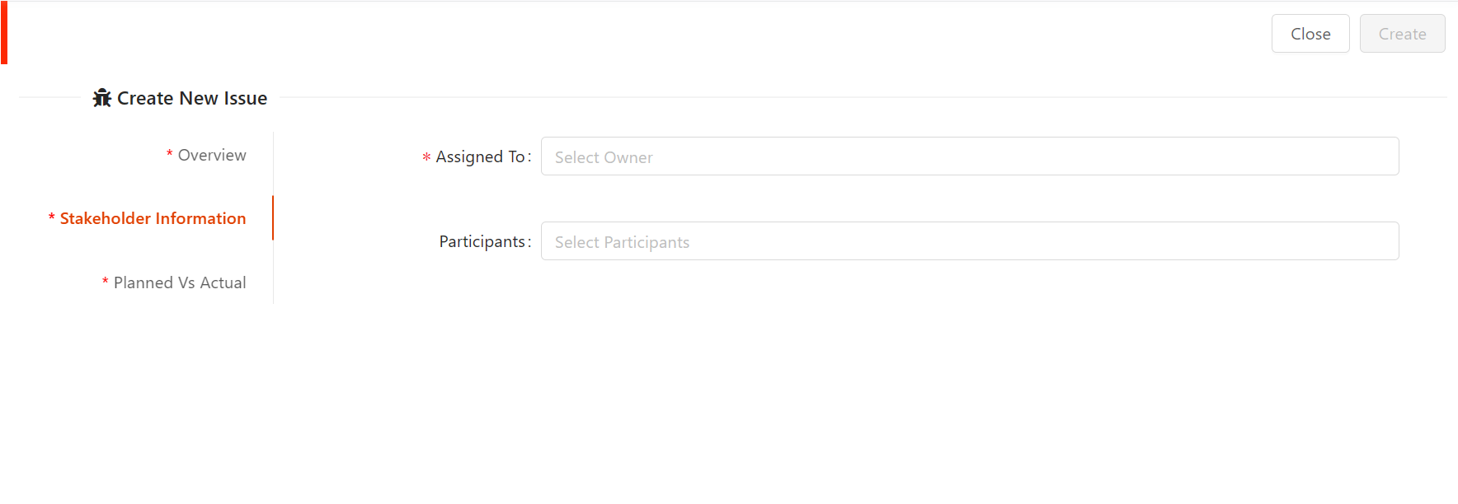

### 

### 

### Planned vs Actual

### **Mandatory Elements:**

* Give the planned dates

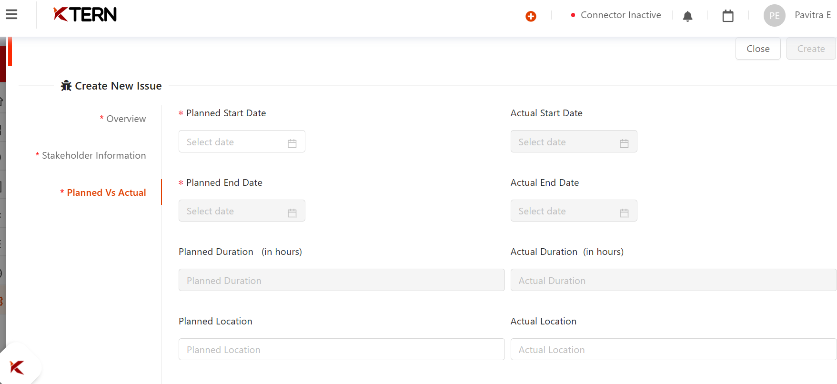

### **Create a Testcase**

### Overview tab

### **Mandatory Elements:**

* Give name for the test case.
* Set the status
* Choose the test plan
* Choose the test scenario

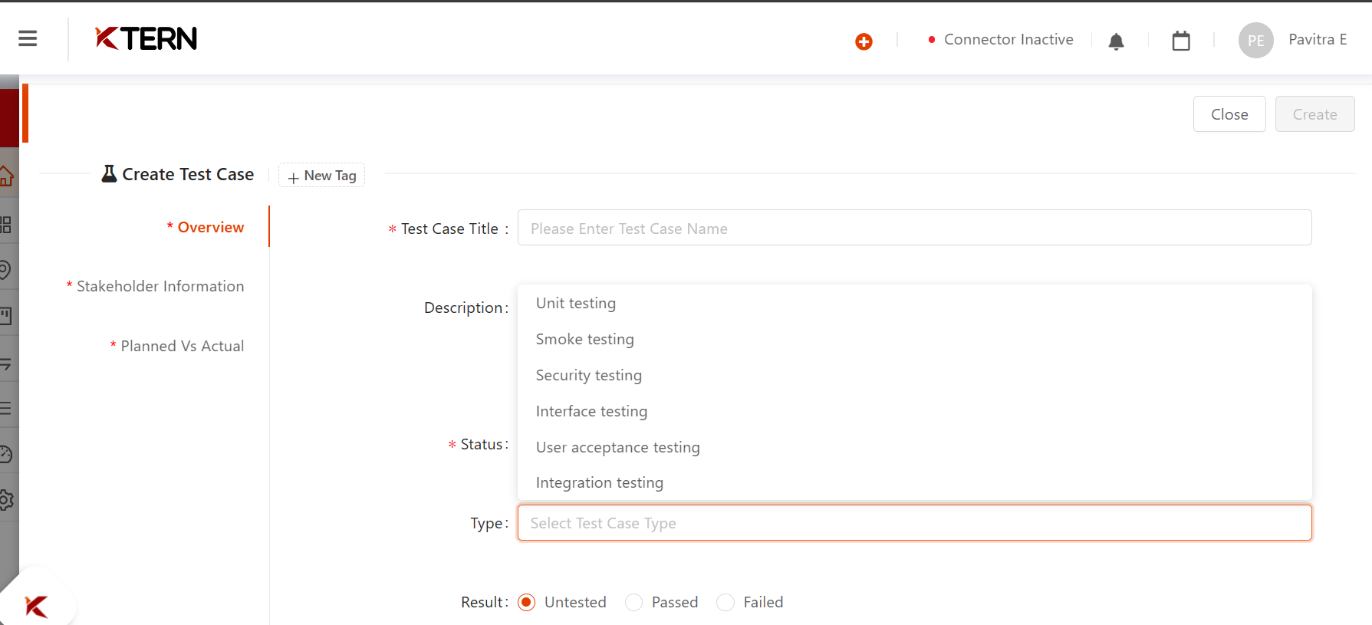

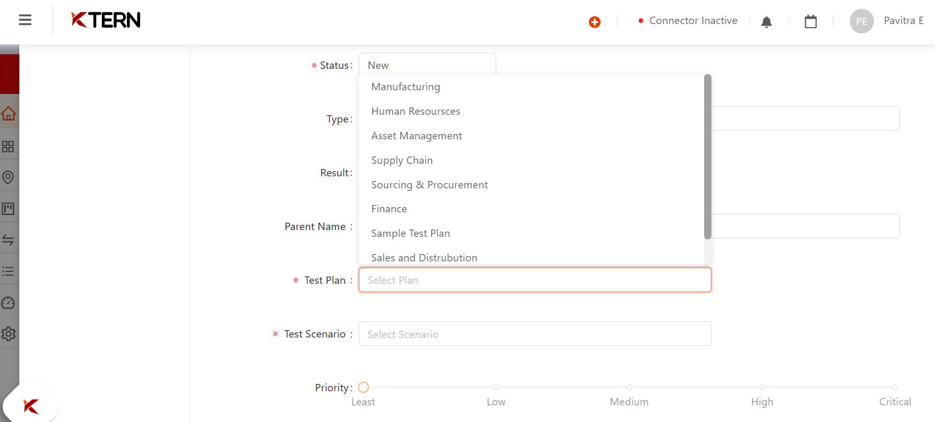

### Stakeholder Information

### **Mandatory Elements:**

* Give the name of the person responsible for the task.

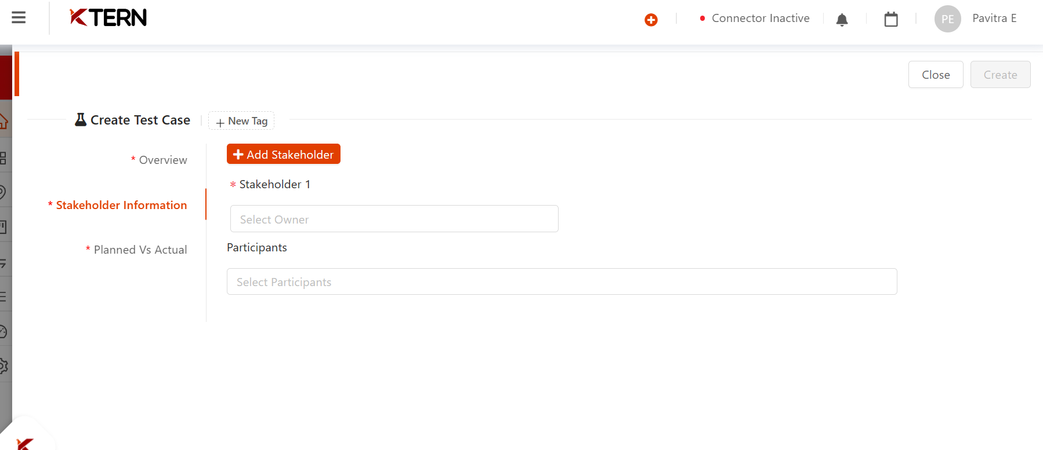

We can also add new stakeholders.

### Planned vs Actual

### **Mandatory Elements:**

* Give the planned dates
* Set the status

