

Department of Electrical & Electronics Engineering

Micro-architectural Design of Digital system

Course Project Report On

“ Iterative & Recursive Fibonacci Sequence Generation in Assembly for a 5-Stage Pipelined Processor ”

Under the Guidance of
Dr. Saroja V Siddamal

Project Associates

Rachana B Y 01FE23BEE106
Arpita Alagur 01FE23BEE111
Sristi Bhat 01FE23BEC146
Pavitra Kambar 01FE23BEC379

VI Semester

Academic Year 2025-26

Department of Electrical & Electronics Engineering

CERTIFICATE

This is to certify that the Mini Project entitled “Iterative & Recursive Fibonacci Sequence Generation in Assembly for a 5-Stage Pipelined Processor” is a work carried out by, Rachana Y (01FE23BEE106) , Arpita A (01FE23BEE111) Sristi Bhat (01FE23BEC146) and Pavitra Kambar (01FE23BEC379), bonafide students of Department of EEE & EEC, KLE Technological University, Hubballi for the partial fulfillment of the Course Project assigned for VI semester. The Course project report has been approved as it satisfies the academic requirements specified by the University.

………………………… | ……………………………. | .………………………
Signature of the Guide | Signature of the H.O.D | Signature of the Registrar
(Dr. Saroja V. Siddamal) | (Dr. Saroja V. Siddamal) | (Dr. B.S. Anami)
Name of Examiner |  | Signature with Date
1.
2.

Acknowledgements

Our report acknowledges some guidance, supervision and a lot of inspiration. It is a time to acknowledge our obligations to all who have extended their cooperation all along our study tenure of project work.
We wish to place on record our profound privilege and deep sense of gratitude to Prof. Dr.Saroja V. Siddamal for her wholehearted guidance without which this endeavor would not have been possible. We are also thankful to him for his guidance and support throughout the project work.
Our grateful regards are to Dr. Saroja V. Siddamal, HOD, Department of Electrical and Electronics Engineering for her continual support and inspiration to us, which contributed to the success of our project. Dr. B.S. Anami , our respected Registrar for having provided us the academic environment which nurtured our practical skills contributing to the success of our project.
Our diction falls short of word to gratify the faculty members of our department for being the primary source of inspiration and strength for our project study.
Lastly with unquantifiable affection we wish to express our sincere feelings to our parents and family members in the form of words which are restrictive in expression and quantum.

- Project Associates

Abstract

This project presents the design and implementation of Iterative and Recursive Fibonacci Sequence Generation in Assembly Language on a 5-Stage Pipelined Processor. The Fibonacci sequence is a widely used numerical series in computer science and serves as an effective benchmark for evaluating processor functionality and instruction execution. In this work, both iterative and recursive approaches are implemented using assembly language instructions and executed on a MIPS-style 5-stage pipelined processor consisting of Instruction Fetch (IF), Instruction Decode (ID), Execute (EX), Memory Access (MEM), and Write Back (WB) stages.
The iterative implementation generates Fibonacci numbers using loops and register updates, while the recursive implementation utilizes repeated function calls and stack-based execution. The processor is designed in Verilog HDL and simulated using Xilinx ISE to verify correct functionality. The execution of arithmetic, branch, memory access, and control-flow instructions is analyzed within the pipelined environment. Simulation results demonstrate successful generation of the Fibonacci sequence using both methods and highlight the differences in execution behavior, resource utilization, and computational complexity.
The project provides practical insight into assembly language programming, pipelined processor design, and the impact of iterative and recursive algorithms on processor performance. The successful implementation validates the operation of the 5-stage pipeline architecture and demonstrates its capability to execute complex computational tasks efficiently.

Contents

- Introduction 1

- Problem statement 2

- Objectives 3

- Design 4
4.1 Overview of System Architecture 4
4.2 Pipelined MIPS Processor Block Diagram 5

- FSM/Algorithm 7

- Timing diagram 9

- Key results obtained 10

- Hardware implementation 11

- Assembly Code 12

10. Conclusion 13

- Introduction
The Fibonacci sequence is one of the most well-known numerical sequences in mathematics, where each number is obtained by adding the two preceding numbers, beginning with 0 and 1. The sequence follows the pattern 0, 1, 1, 2, 3, 5, 8, 13, 21, and so on. Because of its simple structure and wide range of applications, the Fibonacci sequence is frequently used in computer science, algorithm development, digital system design, and processor performance studies. Implementing this sequence provides an effective way to understand arithmetic operations, register management, looping structures, and instruction execution within a processor.
To improve processing speed and efficiency, modern processors use a technique called pipelining. In a pipelined processor, instruction execution is divided into multiple stages so that several instructions can be processed simultaneously. A commonly used architecture is the 5-stage pipeline, which consists of Instruction Fetch (IF), Instruction Decode (ID), Execute (EX), Memory Access (MEM), and Write Back (WB) stages. By allowing different instructions to occupy different stages at the same time, pipelining increases instruction throughput and enhances overall processor performance.
In this project, the Fibonacci sequence is generated using an iterative assembly language program executed on a 5-stage pipelined processor. The iterative method is selected because it is straightforward, efficient, and requires fewer hardware resources compared to recursive implementations. The program begins by initializing the first two Fibonacci numbers and then repeatedly computes the subsequent terms through addition and register updates. During execution, various processor functions such as arithmetic operations, register transfers, loop control, and branching are utilized.
The processor is designed using Verilog HDL and follows a MIPS-style pipelined architecture. Pipeline registers are inserted between stages to ensure smooth instruction flow and support concurrent execution. The design is verified using Xilinx ISE/ISim, where simulation waveforms are analyzed to observe program execution, register updates, and program counter behavior. Through this implementation, the project demonstrates both the practical generation of the Fibonacci sequence and the working principles of a 5-stage pipelined processor.

- Problem Statement
The Fibonacci sequence is widely used as a benchmark in computer science because it involves repetitive calculations, register updates, and control-flow operations. As processors become more complex, understanding how such algorithms are executed within a pipelined architecture becomes important for studying processor behavior and performance.
This project focuses on implementing an iterative Fibonacci sequence generation program using assembly language and executing it on a 5-stage pipelined processor. The challenge lies in ensuring that instructions move correctly through each pipeline stage while maintaining proper data flow and program execution. The processor must accurately fetch, decode, execute, and write back instructions to generate the required Fibonacci sequence without errors.
By implementing and testing the Fibonacci algorithm on a pipelined processor, the project provides a practical understanding of how assembly programs interact with processor hardware. It also helps in analyzing key concepts such as arithmetic operations, register utilization, branching, and instruction flow within a pipelined environment. The correctness of the design is verified through simulation and hardware implementation, demonstrating the successful execution of the Fibonacci sequence generation program.

- Objectives

• To design and implement a MIPS-style 5-stage pipelined processor using Verilog HDL.

• To develop assembly language programs for both iterative and recursive Fibonacci sequence generation.

• To understand the functionality of the five pipeline stages: Instruction Fetch (IF), Instruction Decode (ID), Execute (EX), Memory Access (MEM), and Write Back (WB).

• To study the execution of arithmetic, memory access, branch, and function call instructions in a pipelined environment.

• To observe the flow of instructions through pipeline registers and analyze instruction-level parallelism.

• To verify the correctness of Fibonacci sequence generation through simulation and waveform analysis.

• To evaluate the behavior and performance of the pipelined processor during program execution.

• To gain practical knowledge of computer architecture concepts such as pipelining, register operations, control flow, and instruction execution.

- Design

4.1 Overview of System Architecture
The proposed system consists of a MIPS-style 32-bit 5-stage pipelined processor designed to execute assembly language programs for iterative and recursive Fibonacci sequence generation. The processor is implemented using Verilog HDL and follows the classical pipeline organization consisting of Instruction Fetch (IF), Instruction Decode (ID), Execute (EX), Memory Access (MEM), and Write Back (WB) stages.
The architecture includes the following major components:
Program Counter (PC)
Instruction Memory
Register File
Arithmetic Logic Unit (ALU)
Data Memory
Control Unit
Pipeline Registers (IF/ID, ID/EX, EX/MEM, MEM/WB)
Output Interface
The Program Counter controls instruction sequencing, while the Instruction Memory stores the assembly program. The Register File provides operand storage, and the ALU performs arithmetic and logical operations required for Fibonacci computation. Pipeline registers enable simultaneous execution of multiple instructions by transferring intermediate data between pipeline stages.
For iterative Fibonacci generation, the processor repeatedly updates register values through arithmetic operations and loop control instructions. For recursive Fibonacci generation, the processor executes function calls and memory operations to support recursive computation. The generated Fibonacci values can be observed through simulation waveforms or FPGA output interfaces.
The pipelined architecture improves instruction throughput by allowing multiple instructions to be processed concurrently, thereby demonstrating instruction-level parallelism and efficient processor utilization.

4.2 Pipelined MIPS Processor Block Diagram

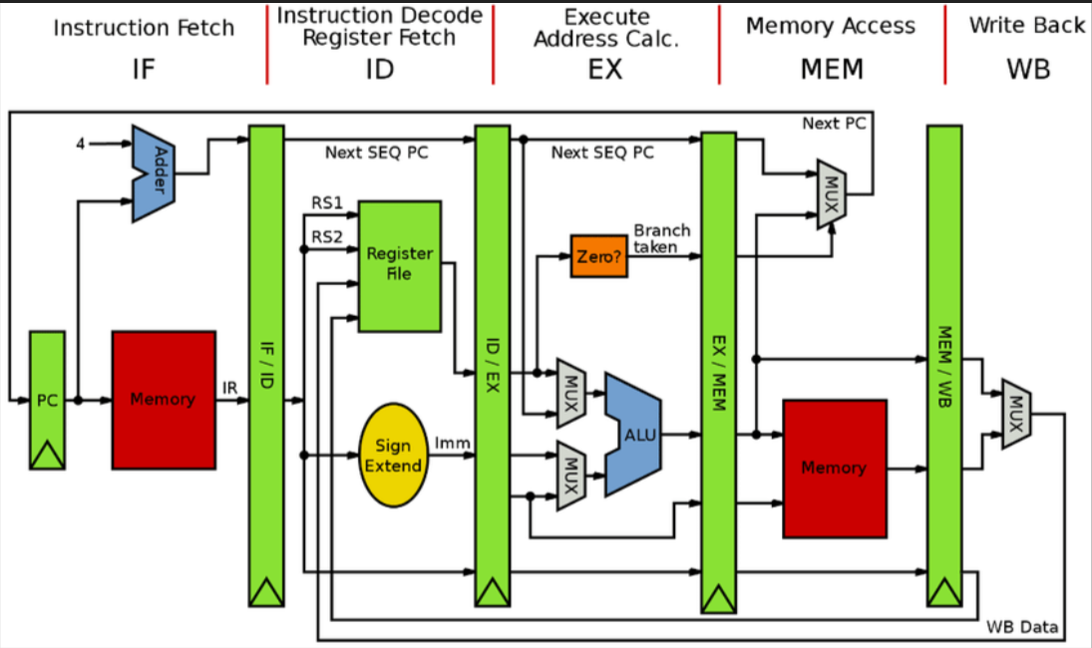
Figure 4.2 : Block Diagram of the 5-Stage Pipelined MIPS Processor

Program Counter (PC)
Stores the address of the next instruction to be executed.

Instruction Memory
Stores the Fibonacci sequence generation program.

Register File
Contains 32 general-purpose registers used for operand storage and intermediate results.

Arithmetic Logic Unit (ALU)
Performs arithmetic operations such as addition, subtraction, comparison, and shifting.

Control Unit
Generates control signals required for instruction execution.

Pipeline Registers
IF/ID
ID/EX
EX/MEM
MEM/WB
These registers transfer data between pipeline stages.

Data Memory
Supports memory access instructions.

Output Interface
Register R7 is connected directly to the FPGA LEDs, allowing generated Fibonacci numbers to be displayed.
The processor executes instructions concurrently in multiple stages, increasing throughput and demonstrating instruction-level parallelism.

- FSM/ Algorithm

Algorithm
Step 1: Initialize the first Fibonacci term F(0) = 0.
Step 2: Initialize the second Fibonacci term F(1) = 1.
Step 3: Initialize loop counter i = 0.
Step 4: Set the maximum number of Fibonacci terms N.
Step 5: Compare i with N.
Step 6: If i ≥ N, terminate execution.
Step 7: Display the current Fibonacci term.
Step 8: Compute the next Fibonacci term.
Step 9: Update the previous and current Fibonacci values.
Step 10: Increment the loop counter.
Step 11: Repeat from Step 5.

FSM States
S0 – Initialization
Load initial values into registers.
S1 – Comparison
Compare loop counter with the limit using SLT instruction.
S2 – Display
Transfer the current Fibonacci value to the output register connected to LED s.
S3 – Computation
Compute the next Fibonacci term using the ADD instruction.
S4 – Update
Update previous and current Fibonacci registers.
S5 – Increment
Increment the loop counter.
S6 – Branch
Check loop condition and return to S1 if more terms are required.
S7 – Halt
Stop processor execution using the HLT instruction.

- Timing diagram

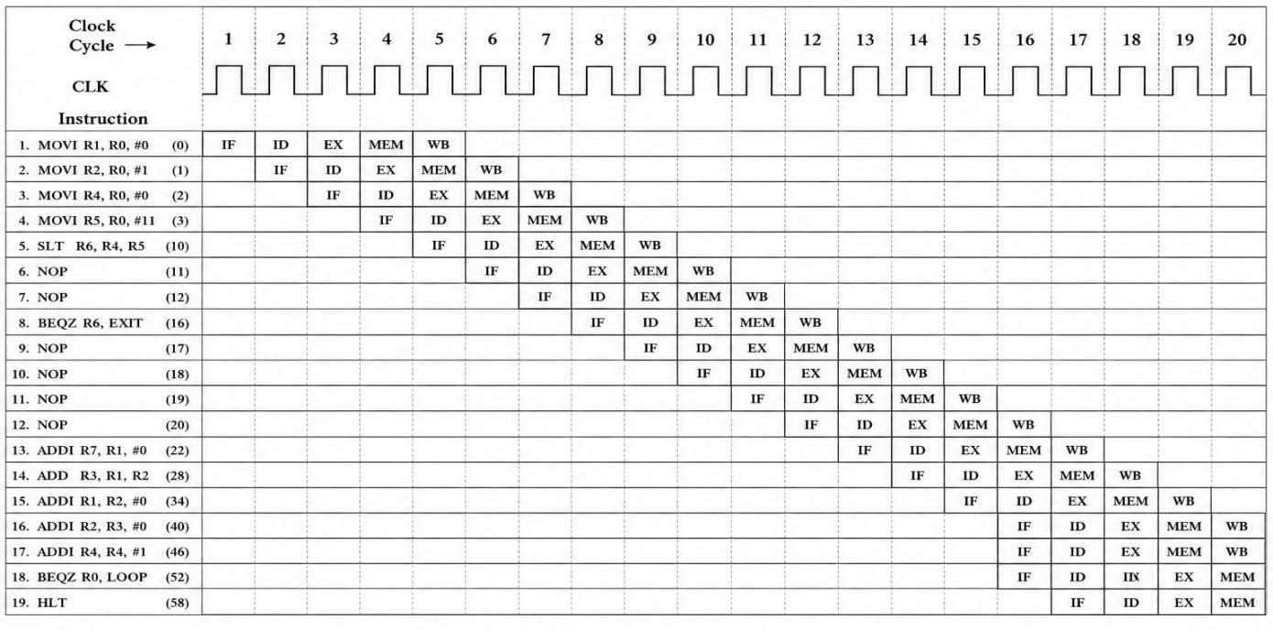
Figure 6.1 Timing diagram showcasing the instruction execution.

- Key results obtained

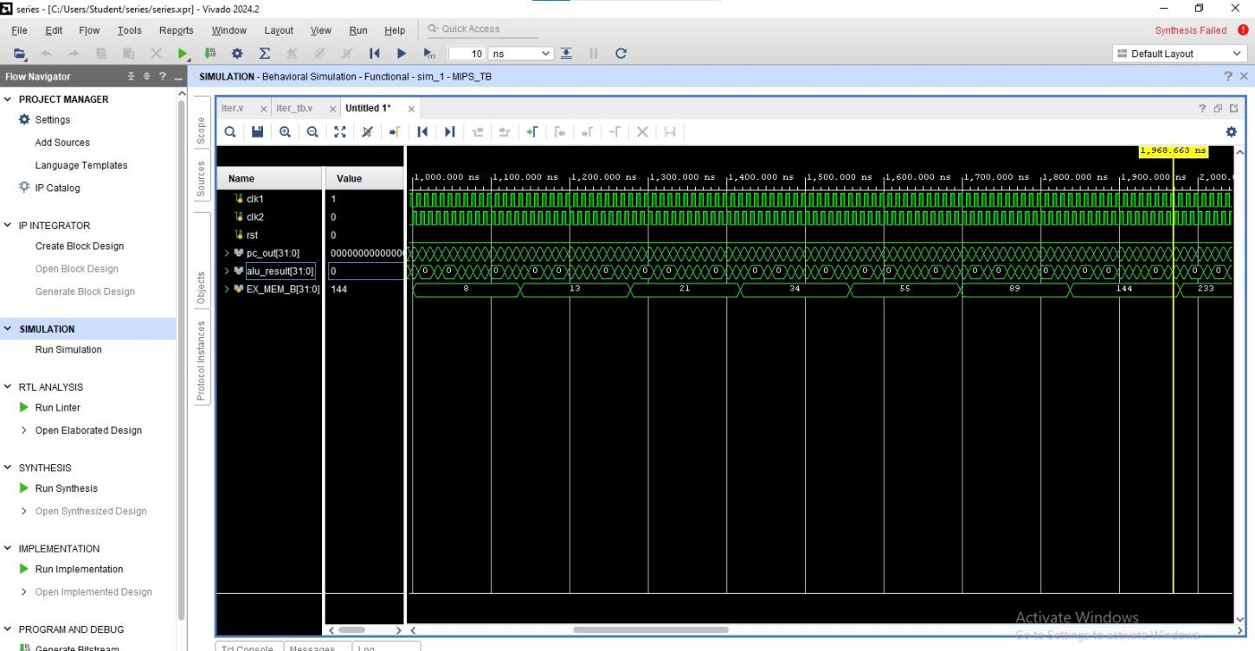

Figure 7.1 Simulation Waveform of Iterative Fibonacci Sequence Generation on a 5-Stage Pipelined Processor

• Successful implementation of a 5-stage pipelined processor in Verilog HDL.
• Correct execution of the iterative Fibonacci sequence generation program.
• Proper operation of IF, ID, EX, MEM, and WB stages.
• Successful branch execution and loop control.
• Correct generation of Fibonacci numbers:
0, 1, 1, 2, 3, 5, 8, 13, 21, 34, 55.
• Successful display of Fibonacci values on FPGA LEDs through register R7.
• Verification through simulation waveforms and hardware testing.

- Hardware implementation

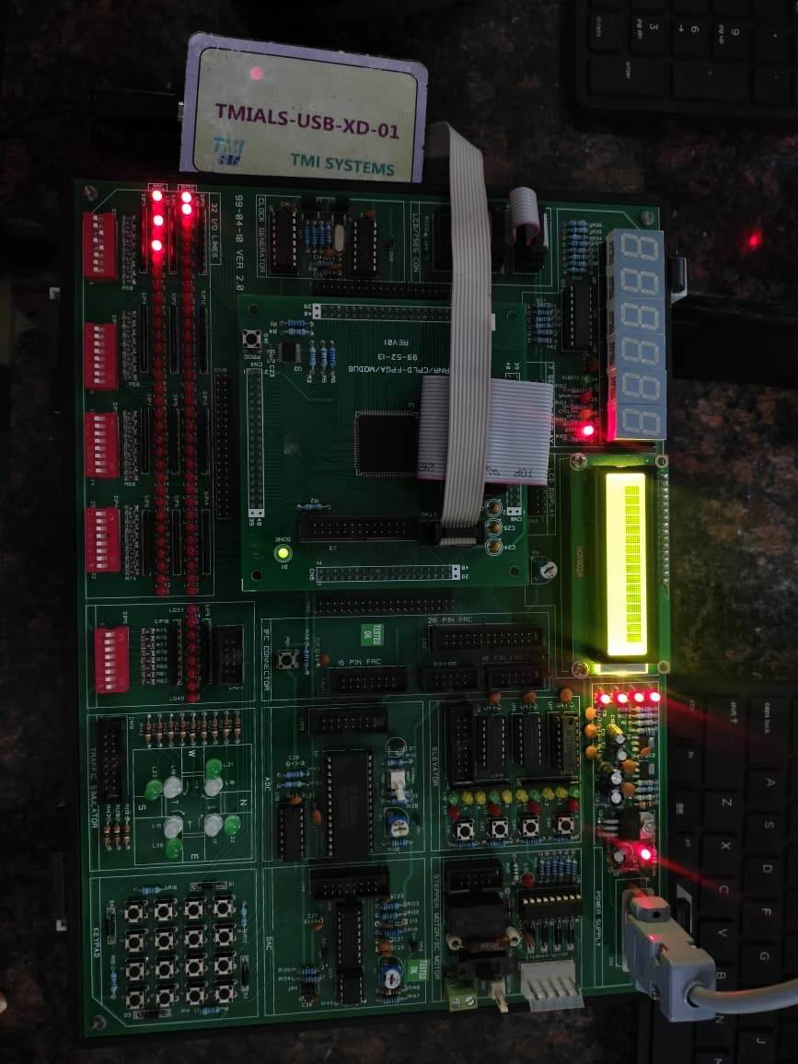
The processor was implemented on a Spartan-6 FPGA using Xilinx ISE Design Suite. A clock divider was incorporated to slow down processor execution, allowing the generated Fibonacci numbers to be observed on the onboard LEDs. The assembly program was preloaded into instruction memory, and the processor executed the instructions sequentially through the five pipeline stages.
The FPGA board clock served as the system clock input. The lower eight bits of register R7 were connected to the LED outputs, enabling real-time visualization of the generated Fibonacci sequence. Hardware testing confirmed that the processor correctly generated and displayed the Fibonacci numbers, validating both the processor architecture and the assembly program implementation.
The successful FPGA implementation demonstrates the practical realization of a pipelined processor executing an iterative algorithm and highlights the effectiveness of hardware-software integration in digital system design.

- Assembly Code
MOVI R1, #0 ; First Fibonacci number
MOVI R2, #1 ; Second Fibonacci number
MOVI R4, #0 ; Loop counter i
MOVI R5, #11 ; Generate 11 terms
MOVI R7, #0 ; LED output register
LOOP:
SLT R6, R4, R5 ; Check if i < N
BEQZ R6, EXIT ; Exit if false
ADDI R7, R1, #0 ; Display current Fibonacci term
ADD R3, R1, R2 ; Next Fibonacci number
ADDI R1, R2, #0 ; Shift sequence
ADDI R2, R3, #0
ADDI R4, R4, #1 ; i++
BEQZ R0, LOOP ; Unconditional jump
EXIT:
HLT

Conclusion
This project successfully implemented an iterative Fibonacci sequence generator using assembly language on a 5-stage pipelined processor designed in Verilog HDL. The processor architecture included the standard stages of Instruction Fetch, Instruction Decode, Execute, Memory Access, and Write Back, enabling efficient instruction processing through pipelining.
The Fibonacci generation program demonstrated the execution of arithmetic, comparison, and branch instructions within a pipelined environment. Simulation results confirmed correct instruction execution, proper pipeline operation, and accurate generation of the Fibonacci sequence. The output values were successfully displayed through FPGA LEDs, validating both the hardware design and the assembly program.
Overall, the project provided practical experience in processor design, assembly programming, pipeline execution, and FPGA-based implementation, thereby enhancing understanding of modern computer architecture concepts.

