

**INTRODUCTION**

**PureKart is an e-commerce company started in 2023, offering a wide range of products across categories like furniture, electronics, and home essentials. It is designed to provide a seamless shopping experience with easy navigation, efficient product management, and secure transactions.**

**With a strong focus on quality, affordability, and reliability, PureKart connects customers with trusted suppliers, ensuring they get the best products at competitive prices. Whether you're looking for home essentials, tech gadgets, or stylish accessories, PureKart makes online shopping simple and hassle-free.**

**OBJECTIVE :-**

1. **Customer Insights & Engagement:**
   * Analyze customer purchase behavior, repeat transactions, and high-value customers.
   * Identify customer retention patterns and engagement levels.
2. **Sales & Revenue Analysis:**
   * Track revenue trends, best-selling products, and seasonal demand variations.
   * Identify high-revenue categories and supplier contributions.
3. **Order & Shipment Optimization:**
   * Monitor order fulfillment times and detect shipment delays.
   * Identify bottlenecks in logistics and improve delivery efficiency.

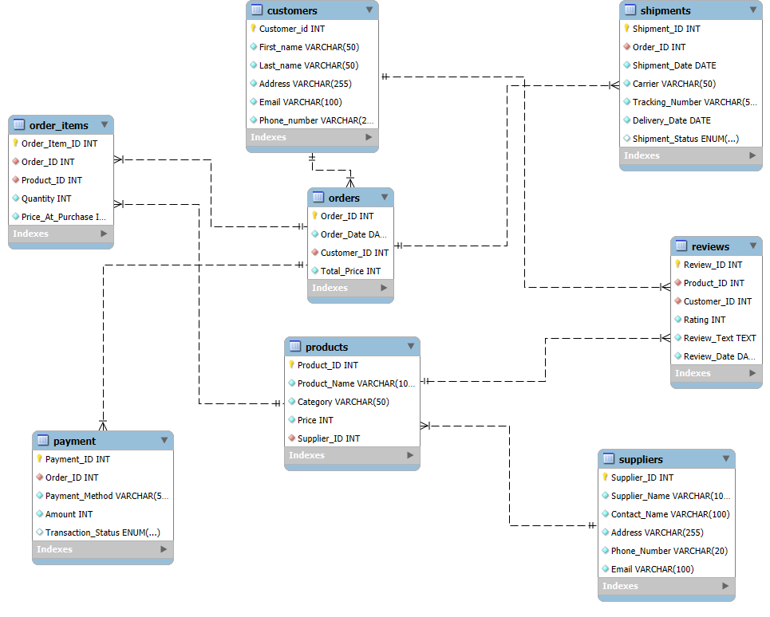

1. **Insights**

**1. Customer Insights & Engagement**

* High-Value Customers: The top 10 customers have spent between 16,000 and 20,000.
* Repeat Transactions: Many customers have made only two purchases, suggesting low repeat transaction rates and potential for improvement in customer retention.

**2. Sales & Revenue Analysis**

* **Revenue Trends:** Sales **peak in November** ($4.1M), showing strong **seasonal demand** during the holiday period.
* **Best-Selling Products:** **4K Monitors, Air Purifiers, and Standing Desks** are top sellers, highlighting demand for **electronics and home essentials**.
* **Category Performance:** **Electronics ($13.5M) and Home & Kitchen ($10.3M)** are the highest revenue-generating categories.
* **Supplier Contributions:** Some suppliers, such as **Next Level Systems and Modern Tech Enterprises**, generate **high revenue**, while **several suppliers contribute significantly less**.

**3. Order & Shipment Optimization**

* **Carrier Performance:** **UPS, DHL, and FedEx** have similar **average delivery times (4.5 days)**, but DHL has the **highest number of pending shipments**.
* **Logistics Bottlenecks:** A **high number of pending shipments** suggests **inefficiencies in supply chain management** and possible issues with carrier performance.

**Recommendations**

**1. Customer Insights & Engagement**

* **Loyalty Program:** Introduce **reward points, exclusive deals, or discounts** to encourage repeat purchases and increase customer retention.
* **Personalized Engagement:** Identify **inactive customers** and send targeted promotions, reminders, or re-engagement emails.
* **Subscription or Membership Model:** Introduce **subscription-based services** for high-demand products to encourage frequent purchases.

**2. Sales & Revenue Analysis**

* **Seasonal Promotions:** Launch **targeted marketing campaigns** before peak months (October–December) to **maximize seasonal revenue**.
* **Stock Optimization:** Ensure **high-demand products are always available** by improving inventory management and forecasting.
* **Supplier Performance Review:** **Negotiate better contracts** with top-performing suppliers and reconsider partnerships with **underperforming** suppliers.

**3. Order & Shipment Optimization**

* **Optimize Order Processing:** Improve **warehouse efficiency** and **automate order fulfillment** to minimize shipment delays.
* **Carrier Performance Monitoring:** **Analyze shipment delays with DHL** and **shift shipments** to faster carriers if necessary.
* **Predictive Demand Planning:** Use **historical data to forecast demand** and align logistics accordingly to prevent shipment backlogs.
* **Customer Communication:** Notify customers **proactively about delays** and offer **compensation (discounts, free shipping, faster replacements)** to maintain customer satisfaction

**SQL Queries**

**TO CREATE DATABASE**

**CREATE DATABASE PUREKART;**

**TO USE DATABASE**

**USE PUREKART;**

**FLOWSTRUCTURE**

**Customers Table --> Stores customer details with unique identifiers.**

**Orders Table --> Stores order details placed by customers.**

**Order_Items Table --> Stores details of products within each order.**

**Products Table --> Stores product details including category and price.**

**Suppliers Table --> Stores details of product suppliers.**

**Shipments Table --> Stores details of order shipments, including status and tracking.**

**Payment Table --> Stores payment transactions linked to orders.**

**Reviews Table --> Stores customer reviews and ratings for products.**

**CREATE TABLE Customers (**

**Customer_id INT PRIMARY KEY NOT NULL,**

**First_name VARCHAR(50) NOT NULL,**

**Last_name VARCHAR(50) NOT NULL,**

**Address VARCHAR(255) NOT NULL,**

**Email VARCHAR(100) UNIQUE NOT NULL,**

**Phone_number VARCHAR(20) NOT NULL**

**);**

**CREATE TABLE Order_Items (**

**Order_Item_ID INT PRIMARY KEY NOT NULL,**

**Order_ID INT NOT NULL,**

**Product_ID INT NOT NULL,**

**Quantity INT NOT NULL,**

**Price_At_Purchase INT NOT NULL,**

**FOREIGN KEY (Order_ID)**

**REFERENCES Orders (Order_ID),**

**FOREIGN KEY (Product_ID)**

**REFERENCES Products (Product_ID)**

**);**

**CREATE TABLE Orders (**

**Order_ID INT PRIMARY KEY NOT NULL,**

**Order_Date DATE NOT NULL,**

**Customer_ID INT NOT NULL,**

**Total_Price INT NOT NULL,**

**FOREIGN KEY (Customer_ID)**

**REFERENCES Customers (Customer_ID)**

**);**

**CREATE TABLE Payment (**

**Payment_ID INT PRIMARY KEY NOT NULL,**

**Order_ID INT NOT NULL,**

**Payment_Method VARCHAR(50) NOT NULL,**

**Amount INT NOT NULL,**

**Transaction_Status ENUM('Pending', 'Completed', 'Failed', 'Refunded') DEFAULT 'Pending',**

**FOREIGN KEY (Order_ID)**

**REFERENCES Orders (Order_ID)**

**);**

**CREATE TABLE Products (**

**Product_ID INT PRIMARY KEY NOT NULL,**

**Product_Name VARCHAR(100) NOT NULL,**

**Category VARCHAR(50) NOT NULL,**

**Price INT NOT NULL,**

**Supplier_ID INT NOT NULL,**

**FOREIGN KEY (SUPPLIER_ID)**

**REFERENCES SUPPLIERS (SUPPLIER_ID)**

**);**

**CREATE TABLE Reviews (**

**Review_ID INT PRIMARY KEY NOT NULL,**

**Product_ID INT NOT NULL,**

**Customer_ID INT NOT NULL,**

**Rating INT NOT NULL,**

**Review_Text TEXT NOT NULL,**

**Review_Date DATE NOT NULL,**

**FOREIGN KEY (Product_ID)**

**REFERENCES Products (Product_ID),**

**FOREIGN KEY (Customer_ID)**

**REFERENCES Customers (Customer_ID)**

**);**

**CREATE TABLE Shipments (**

**Shipment_ID INT PRIMARY KEY NOT NULL,**

**Order_ID INT NOT NULL,**

**Shipment_Date DATE NOT NULL,**

**Carrier VARCHAR(50) NOT NULL,**

**Tracking_Number VARCHAR(50) NOT NULL,**

**Delivery_Date DATE NOT NULL,**

**Shipment_Status ENUM('Pending', 'Shipped', 'In Transit', 'Delivered', 'Returned') DEFAULT 'PENDING',**

**FOREIGN KEY (Order_ID)**

**REFERENCES Orders (Order_ID)**

**);**

**CREATE TABLE Suppliers (**

**Supplier_ID INT PRIMARY KEY NOT NULL,**

**Supplier_Name VARCHAR(100) NOT NULL,**

**Contact_Name VARCHAR(100) NOT NULL,**

**Address VARCHAR(255) NOT NULL,**

**Phone_Number VARCHAR(20) NOT NULL,**

**Email VARCHAR(100) UNIQUE NOT NULL**

**);**

**a) Analyze customer purchase behavior, repeat transactions, and high-value customers**

**SELECT c.Customer_ID, c.First_name, c.Last_name,**

**COUNT(o.Order_ID) AS Total_Orders,**

**SUM(o.Total_Price) AS Total_Spent**

**FROM customers c**

**JOIN orders o ON c.Customer_ID = o.Customer_ID**

**GROUP BY c.Customer_ID, c.First_name, c.Last_name**

**ORDER BY Total_Spent DESC**

**lim 10;**

**9953 John Gonzalez 2 16956**

**9803 John Williams 2 19652**

**8941 John Philip 2 17124**

**7922 Mary Lopez 2 16193**

**7387 Mary Douglas 2 16953**

**5737 Mary Wayne 2 16443**

**4114 James Natalie 2 17567**

**3613 James Samuel 2 16814**

**1733 James Roger 2 16293**

**1416 James Thomas 2 16522**

**b) Identify customer retention patterns and engagement levels**

**SELECT c.Customer_ID, c.First_name, c.Last_name,**

**MIN(o.Order_Date) AS First_Order,**

**MAX(o.Order_Date) AS Last_Order,**

**COUNT(o.Order_ID) AS Order_Frequency,**

**DATEDIFF(MAX(o.Order_Date), MIN(o.Order_Date)) AS Customer_Lifetime**

**FROM customers c**

**JOIN orders o ON c.Customer_ID = o.Customer_ID**

**GROUP BY c.Customer_ID, c.First_name, c.Last_name**

**ORDER BY Order_Frequency DESC;**

**a) Track revenue trends, best-selling products, and seasonal demand variations**

**SELECT DATE_FORMAT(o.Order_Date, '%Y-%m') AS Month,**

**SUM(o.Total_Price) AS Monthly_Revenue**

**FROM orders o**

**GROUP BY Month**

**ORDER BY Month;**

**Month Revenue**

**2023-11 2763210**

**2023-12 3360874**

**2024-01 3667467**

**2024-02 3300234**

**2024-03 3756182**

**2024-04 3493875**

**2024-05 3590178**

**2024-06 3355559**

**2024-07 3760489**

**2024-08 3737832**

**2024-09 3526284**

**2024-10 3772437**

**2024-11 411217**

**SELECT p.Product_Name, SUM(oi.Quantity) AS Total_Sold**

**FROM order_items oi**

**JOIN products p ON oi.Product_ID = p.Product_ID**

**GROUP BY p.Product_Name**

**ORDER BY Total_Sold DESC**

**LIMIT 10;**

**Products Total_Sold**

**Monitor Stand 1972**

**Microphone 2001**

**External SSD 2003**

**Storage Shelf 2007**

**Bluetooth Headphones 2021**

**Kitchen Blender 2024**

**Standing Desk 2030**

**Air Purifier 2031**

**Throw Pillows 2072**

**4K Monitor 2280**

**b) Identify high-revenue categories and supplier contributions**

**SELECT p.Category, SUM(oi.Quantity * oi.Price_At_Purchase) AS Total_Revenue**

**FROM order_items oi**

**JOIN products p ON oi.Product_ID = p.Product_ID**

**GROUP BY p.Category**

**ORDER BY Total_Revenue DESC;**

**Products Revenue**

**Electronics 13589459**

**Home & Kitchen 10359661**

**Accessories 9382866**

**Furniture 5799804**

**SELECT s.Supplier_Name, SUM(oi.Quantity * oi.Price_At_Purchase) AS Supplier_Revenue**

**FROM order_items oi**

**JOIN products p ON oi.Product_ID = p.Product_ID**

**JOIN suppliers s ON p.Supplier_ID = s.Supplier_ID**

**GROUP BY s.Supplier_Name**

**ORDER BY Supplier_Revenue DESC;**

**top**

**Supplier Name Revenue**

**Next Level Systems 3086535**

**Modern Tech Enterprises 2538901**

**Unified Trading Co. 2253309**

**Ultimate Services 2133660**

**Strategic Partners Co. 2063326**

**Advanced Hardware Corp. 1860573**

**Precision Suppliers LLC 1857838**

**Premier Logistics Inc. 1842462**

**Core Technologies 1707715**

**InnovativeSolutions Co. 1691406**

**Bottom**

**SELECT s.Supplier_Name, SUM(oi.Quantity * oi.Price_At_Purchase) AS Supplier_Revenue**

**FROM order_items oi**

**JOIN products p ON oi.Product_ID = p.Product_ID**

**JOIN suppliers s ON p.Supplier_ID = s.Supplier_ID**

**GROUP BY s.Supplier_Name**

**ORDER BY Supplier_Revenue ASC;**

**Supplier name Revenue**

**Smart Solutions Ltd. 437781**

**Future Tech 788158**

**Quantum Enterprises 819090**

**Digital Innovations LLC 858911**

**Elite Electronics 1151293**

**ProfessionalSupplyChain 1187917**

**Alpha Industries Ltd. 1188860**

**Reliable Resources Inc. 1247014**

**Global Goods Ltd. 1275157**

**Excel DistributionGroup 1343964**

**a) Monitor order fulfillment times and detect shipment delays**

**SELECT s.Shipment_ID, o.Order_ID, o.Order_Date, s.Shipment_Date, s.Delivery_Date,**

**DATEDIFF(s.Shipment_Date, o.Order_Date) AS Processing_Time,**

**DATEDIFF(s.Delivery_Date, s.Shipment_Date) AS Delivery_Duration**

**FROM shipments s**

**JOIN orders o ON s.Order_ID = o.Order_ID**

**ORDER BY Delivery_Duration DESC;**

**b) Identify bottlenecks in logistics and improve delivery efficiency**

**SELECT Carrier, AVG(DATEDIFF(Delivery_Date, Shipment_Date)) AS Avg_Delivery_Time**

**FROM shipments**

**GROUP BY Carrier**

**ORDER BY Avg_Delivery_Time DESC;**

**Carrieer AVG dEL.time**

**UPS 4.5066**

**DHL 4.5045**

**FedEx 4.4939**

**SELECT Carrier , COUNT(*) AS Pending_Shipments**

**FROM shipments**

**WHERE Shipment_Status = 'Pending'**

**GROUP BY Shipment_Status, Carrier;**

**Carrier Pending_Shipment**

**UPS 1134**

**FedEx 1183**

**DHL 1242**