VIT - Computer Networks Project
REVIEW 2 - DESIGN & IMPLEMENTATION
Assessment 9 component | Upload on VTOP on or before 9 October 2026

Adaptive Multi-Error FEC Link Layer for High-Interference Environments
An extension of the approved project "Fast-Lane FEC for Automated Toll Booths"

Team: [Your Name] [Reg. No.] | [Teammate Name] [Reg. No.]
Guide: [Guide Name, Designation]
Progress status: version v0.2 (feedback, ARQ/HARQ, adaptive controller, dashboard)
Source code: github.com/PavitranVC/Adaptive-FEC-Link

Contents
1. Introduction and Problem Statement
2. System Architecture
3. Detailed Design
4. Methodology / Algorithms
5. Database / UML / DFD
6. Module Development
7. Working Prototype
8. Implementation Progress
9. Test Cases
10. Initial Results
11. Individual Contribution
12. Plan for Review 3 and References

1. Introduction and Problem Statement
Think about a car going through an automated toll booth. The booth has to read a 96-bit RFID tag ID in the short time the car is in range, and the radio link it uses is noisy. Some bits get flipped at random, and now and then a passing truck or another reader wipes out a whole run of bits. If a read fails, the toll is missed or the car has to stop. Asking the car to send the ID again is not a great answer either, because the car may already be gone by the time the request arrives. So the receiver should fix the errors itself, using forward error correction (FEC), and a CRC-32 checksum [5] on top makes sure a wrong ID is never accepted by mistake.
Our project grows the approved topic "Fast-Lane FEC for Automated Toll Booths" into an adaptive, multi-error FEC link layer. We simulate it in software as three UDP programs: a vehicle, a noisy channel and a tollgate. To see how the codes behave on very different noise, we also added a second scenario, a hospital with MRI and CT equipment, where interference comes in bursts.

Objectives
- Write a family of error-correcting codes ourselves in C11 without external libraries: Hamming, SECDED, BCH and Reed-Solomon [1], [2], plus a bit interleaver and a CRC-32 for error detection.
- Model the noise with three models (binary symmetric channel, Gilbert-Elliott [3], [4] and single bursts), packaged into two interference profiles.
- Build a real three-process UDP link with a feedback path, so that it behaves like a working system and not only a set of calculations.
- Compare plain FEC with Stop-and-Wait ARQ, Hybrid ARQ and an adaptive controller that picks a stronger or weaker code based on what the receiver reports.
- Measure success rate, silent-wrong rate, goodput, retransmissions and latency, using seeded random numbers so anyone can repeat a run and get the same answer.

2. System Architecture
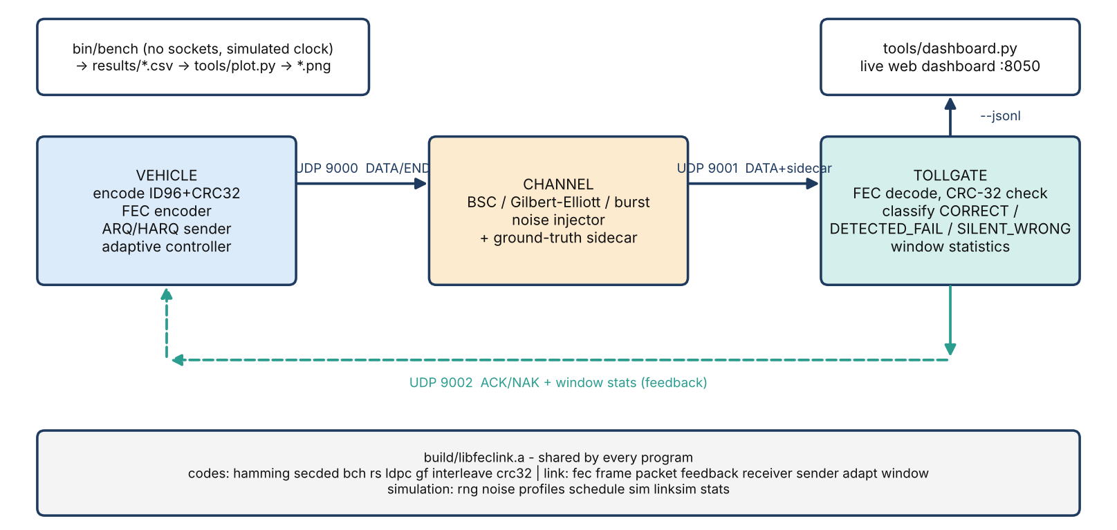
Figure 1. System architecture: three UDP processes, feedback path and shared library.
The vehicle appends a CRC-32 to the 96-bit ID, encodes the result with the chosen code and sends it on UDP port 9000. The channel program flips bits according to the noise model and passes the frame on to port 9001, together with a small extra field that holds the true ID. That field is only used for scoring and the decoder never reads it. The tollgate decodes the frame, checks the CRC and labels the result, then replies on port 9002 with an ACK or NAK and some recent statistics. All three programs link the same library, which means the benchmark and the real UDP programs run exactly the same code.
Table 1. Components
Component | Responsibility
bin/vehicle | encode, send, sender state machine (FEC / ARQ / HARQ), adaptive controller
bin/channel | noise injection (BSC / GE / burst), ground-truth sidecar, optional header corruption
bin/tollgate | decode, CRC-32, classification, feedback, per-frame log and coloured bit map
bin/bench | in-process sweeps (no sockets) -> results/*.csv
tools/dashboard.py | stdlib-only live web dashboard fed by the tollgate JSON-lines log

Frame classification
- CORRECT - CRC passes and ID equals the truth.
- DETECTED_FAIL - CRC fails or the decoder flags an uncorrectable block; the system knows not to bill.
- SILENT_WRONG - CRC passes but the ID is wrong; the dangerous case, measurable only because the channel attaches ground truth that the decoder never reads (checked by a test).

3. Detailed Design

3.1 Frame format
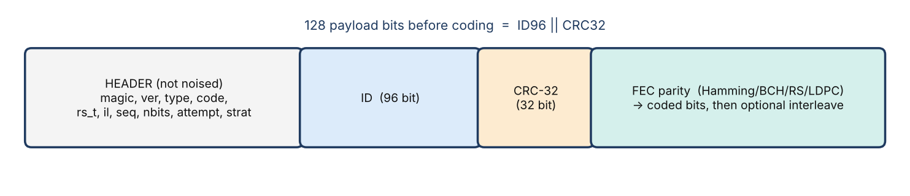
Figure 2. Frame layout: unprotected header plus FEC(ID96 || CRC32).
The 16-byte header holds the magic number, version, type, code, rs_t, interleave depth, sequence number, bit count, attempt number and strategy. In this version the channel leaves the header alone; that was a deliberate decision (DD-01) to keep the first experiments simple. The payload is 128 bits before coding.

3.2 Codes implemented
Table 2. Codes available at this review (LDPC is planned as a stretch for Review 3)
Code | Rate | Corrects | Notes
uncoded | 1.0000 | - | baseline
Hamming(7,4) | 0.571 | 1 | cheap fallback; syndrome = error position
Hamming(15,11) | 0.711 | 1 | higher rate
SECDED(8,4) | 0.500 | 1 (+2 detected) | extended Hamming
BCH(15,7) | 0.449 | 2 | GF(16), Berlekamp-Massey + Chien
BCH(31,16) | 0.516 | 3 | best on random errors (original codes)
Reed-Solomon RS(16+2t,16) | 0.889 .. 0.333 | t bytes (default 4) | GF(256), shortened, Forney; bursts

3.3 Interference profiles
Table 3. Interference profiles (modelling assumptions, not field measurements)
Profile | BSC | Gilbert-Elliott | Burst
TOLL_PLAZA (primary) | p = 0.01 | p_gb 0.002, p_bg 0.5, e_good 0.005, e_bad 0.5 | L = 4 bits in 20% of frames
HOSPITAL_IMAGING (secondary) | p = 0.02 | p_gb 0.005, p_bg 0.08 (mean burst 12.5 bits), e_good 0.002, e_bad 0.5 | L = 16 bits in 50% of frames

3.4 Link strategies
Table 4. Strategies (--strategy)
Strategy | Behaviour
fec | one shot, no retransmission
arq | Stop-and-Wait, uncoded + CRC, retransmit on timeout/NAK (the strawman)
harq | HARQ type I: FEC first, retransmit only when CRC fails (no soft combining)
adaptive | vehicle changes the code level from receiver window statistics (W = 32 frames)

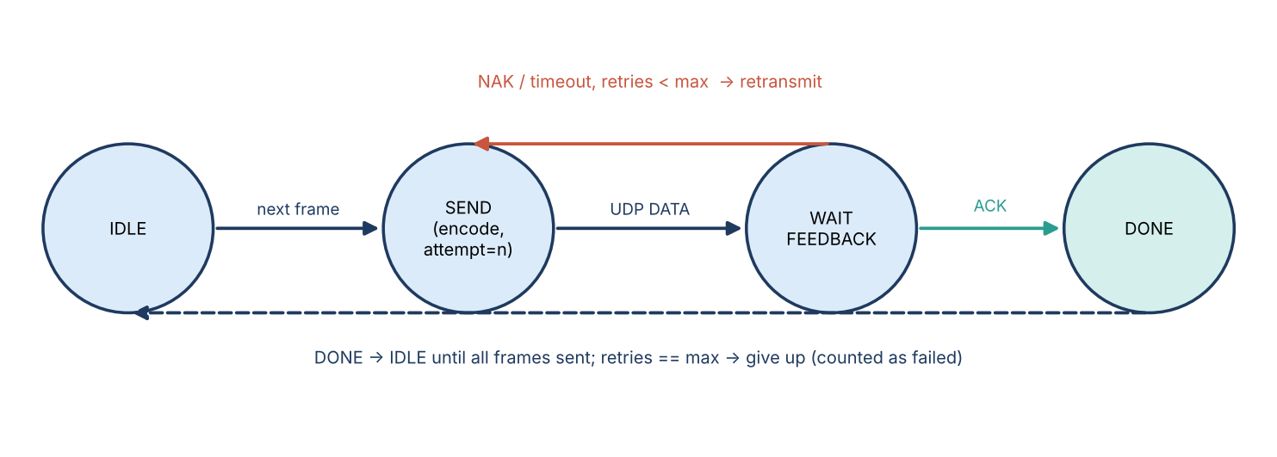
Figure 3. Sender state machine (ARQ/HARQ/adaptive).

3.5 Adaptive controller
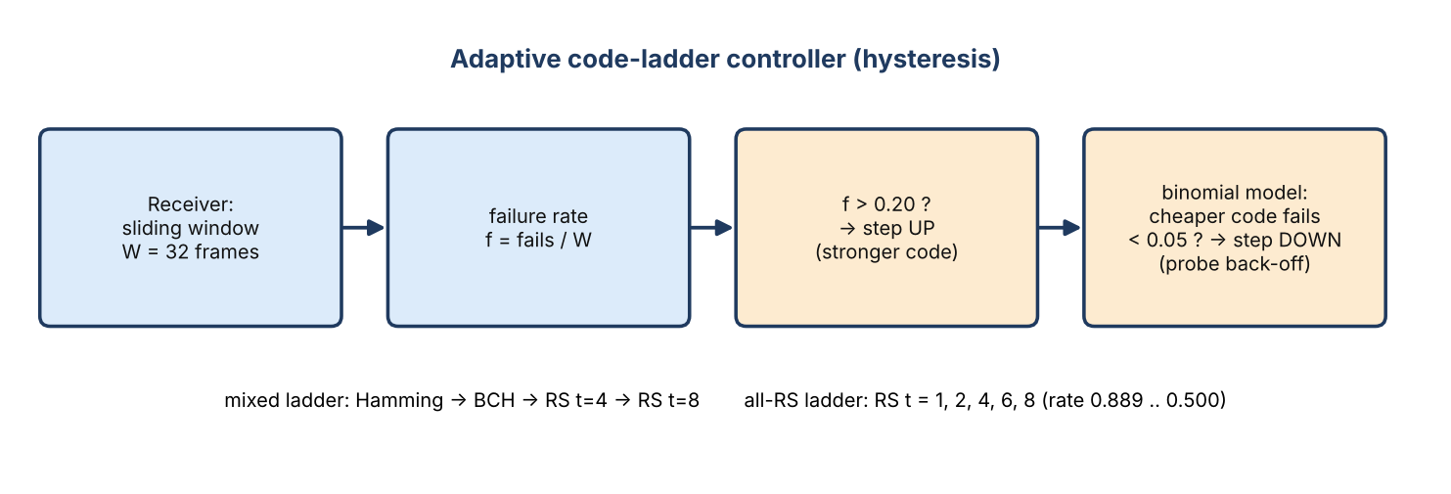
Figure 4. Adaptive code-ladder controller with hysteresis.
The tollgate keeps a sliding window of the last 32 frames and reports how many failed. If more than 20% failed, the vehicle moves up to a stronger code. Moving down is harder on purpose: it only happens when a binomial model says the cheaper code would fail less than 5% of the time, and a probe back-off stops the controller from bouncing between levels. Our first version checked after every single frame and flipped levels 14 times in one run. Checking once per window fixed that, and we wrote the lesson in the design log.

4. Methodology / Algorithm
- CRC-32 (IEEE 802.3): the checksum is the remainder of m(x)*x^32 divided by G(x). It can detect errors but never fix them, and a random wrong word gets through with probability of only about 2^-32.
- Hamming: the parity-check matrix H has the numbers 1 to n as its columns, so the syndrome of a received word is simply the position of the flipped bit. SECDED adds one overall parity bit so a single error can be told apart from a double error.
- BCH: the generator g(x) is the lcm of the minimal polynomials of alpha^1 to alpha^2t. To decode we compute the syndromes S_j = r(alpha^j), use Berlekamp-Massey to find the error-locator polynomial and then a Chien search to find where the errors are.
- Reed-Solomon over GF(256): the same steps, but working on whole bytes, plus Forney's formula to get the error values. A burst of up to 8t bits only damages a few bytes, which is why RS survives bursts that wreck bit-level codes.
- Block interleaver: bits are written row by row and sent column by column, so a burst of L bits turns into about L/d errors per codeword. This helps bit-level codes but, surprisingly, hurts RS: on the hospital profile RS t=4 dropped from 83.4% to 59.8% with depth 8.
- Noise: BSC flips bits independently; Gilbert-Elliott is a two-state Markov chain whose state carries over from frame to frame; the burst model flips a run of L bits. Everything draws from one seeded random number generator, so a run can always be repeated.
How we evaluate: goodput is the number of correct frames times 128 payload bits, divided by every coded bit sent, so parity bits and retransmissions count against it. Latency comes from a simulated clock with an RTT of 20 ms, a timeout of 100 ms, at most 4 retries and a 160 kbit/s link. These values are our assumptions.

5. Database / UML / DFD
The system does not use a relational database. Everything it stores is in files: a per-frame CSV or JSON-lines log (D1 in the data-flow diagram) and the benchmark CSVs in results/. The diagrams below show how data moves through the system and how the software is organised.
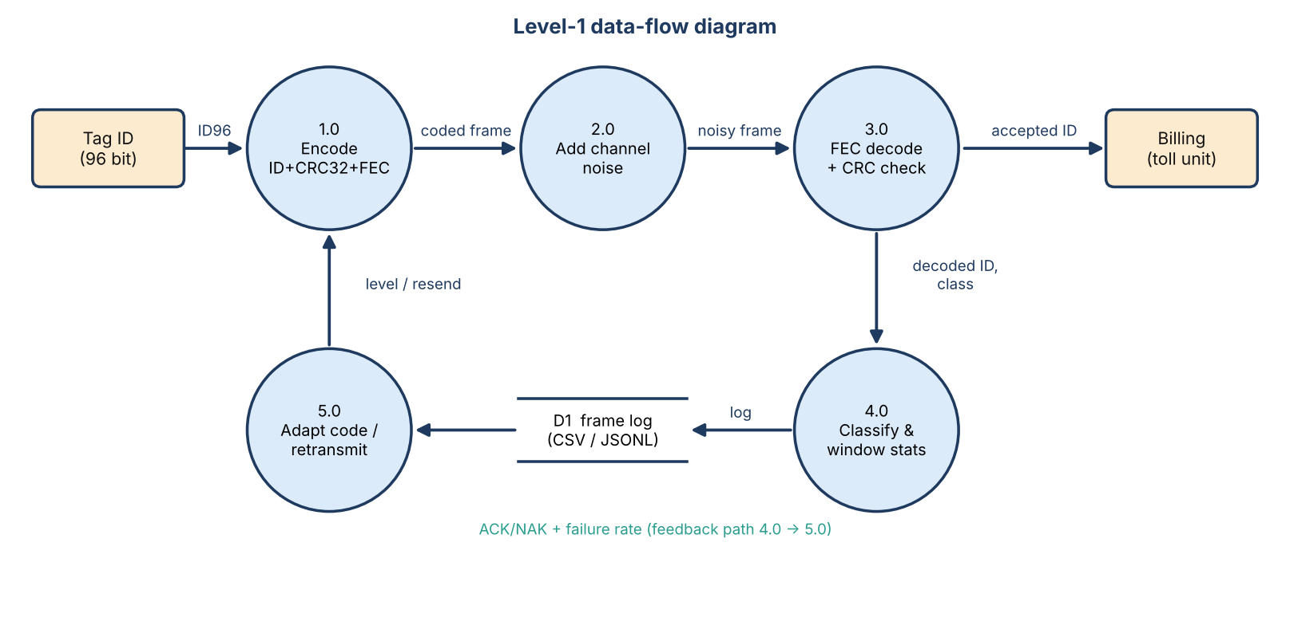
Figure 5. Level-1 data-flow diagram.
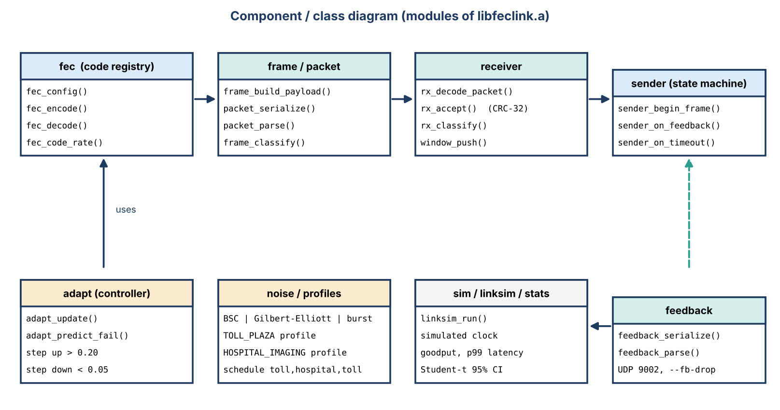
Figure 6. Component/class diagram of the shared library.

Log record (per frame)
Table 5. Per-frame log schema (tollgate.csv / --jsonl)
Field | Meaning
seq, code, attempt | frame number, code used, transmission attempt
flipped, corrected | bits flipped by the channel / corrected by the decoder
crc_ok, class | CRC result and CORRECT / DETECTED_FAIL / SILENT_WRONG
decode_us | decode latency in microseconds

6. Module Development
Table 6. Library modules (19 at v0.1, 26 at v0.2)
Module(s) | Responsibility
bits, crc32, rng, gf | bit utilities, CRC-32 (IEEE 802.3), seeded RNG, GF(2^m) arithmetic
hamming, secded, bch, rs, ldpc, interleave | the error-correcting codes and the bit block interleaver
fec | single registry: choose a code, encode, decode, rate, description
frame, packet | payload ID96 || CRC32; wire header (v2, 16 bytes), parsing and validation
noise, profiles, schedule | BSC / Gilbert-Elliott / burst, the two profiles, toll->hospital->toll schedule
receiver | decode, CRC check, classification (never reads ground truth)
sender, adapt, window, feedback | ARQ/HARQ state machine, adaptive ladder controller, sliding-window statistics, ACK/NAK wire format
sim, linksim, stats | in-process link simulator on a simulated clock, goodput/latency, Student-t 95% CIs
apps/vehicle, channel, tollgate | the three UDP processes
tools/bench, plot.py, dashboard.py | benchmark, plots, live dashboard

We worked in phases and wrote the tests first. A phase was only committed once `make test` passed.

7. Working Prototype
The prototype runs on Linux, WSL and macOS. All you need is a C compiler and make; Python 3 is only needed for the dashboard and the plots.
git clone https://github.com/PavitranVC/Adaptive-FEC-Link.git && cd Adaptive-FEC-Link
make # build vehicle, channel, tollgate, bench
make test # unit + integration tests
make demo # one-terminal live demo (toll plaza)
make demo-hospital # bursty hospital profile
make demo-adaptive # adaptive FEC on toll -> hospital -> toll
make dashboard # live web dashboard on http://127.0.0.1:8050
In a demo of 20 frames on the toll profile with Hamming(7,4), all 20 frames came out CORRECT, with no DETECTED_FAIL and no SILENT_WRONG. The channel flipped 48 of 4,480 bits (a measured BER of 0.0107 against the model's 0.0100) and the decoder fixed all 48. The tollgate also prints a coloured bit map for each frame that shows which bits were flipped and which were corrected.

8. Implementation Progress
Table 7. Implementation progress
Phase / version | Deliverable | Status
Phase 0 | scaffolding, Makefile, folder layout, docs | Done
Phase 1 | bit utils, CRC-32, Hamming(7,4)/(15,11), SECDED(8,4) | Done
Phase 2 | BSC, Gilbert-Elliott, burst noise, two profiles | Done
Phase 3 | UDP pipeline: vehicle, channel, tollgate, CLI, logs, demos | Done
Phase 4 | BCH(15,7), BCH(31,16): GF(2^m), Berlekamp-Massey, Chien | Done
Phase 5 | in-process benchmark and plots | Done
Phase 6 | Reed-Solomon over GF(256) + generic interleaver | Done
v0.2 | ground-truth integrity check, Stop-and-Wait ARQ, HARQ, adaptive controller, dashboard | Done
v0.3 (planned) | fair baselines (always-strongest code), multi-seed statistics, failure injection, sanitizers | Next
v0.4 (planned) | continuous integration, report, optional LDPC stretch | Next

At v0.2 the project has 26 library modules, 20 unit-test programs with 123 test cases, an integration script that runs real three-process UDP scenarios, 12 plots and 4 benchmark CSV files.

9. Test Cases
We wrote each test before the code it checks. `make test` builds and runs all of them, and everything passed at the time of this review.
Table 8. Test cases (v0.2)
ID | Area | Test | Expected result
T1 | bits / CRC-32 | known vectors; single, double and triple bit errors on 128-bit messages | every 1-, 2-, 3-bit error detected
T2 | Hamming | every single-bit error at every position | corrected
T3 | Hamming + CRC | 2-bit error on plain Hamming | miscorrects; CRC-32 catches it
T4 | SECDED | 2-bit errors | detected, not miscorrected
T5 | noise | measured flip rate / burst length vs parameter | statistically close to model
T6 | BCH(15,7) | every error pattern of weight <= 2 (exhaustive) | corrected
T7 | BCH(31,16) | randomized patterns of weight <= 3 | corrected
T8 | Reed-Solomon | up to t byte errors and bursts; interleaver round trip | corrected
T9 | receiver integrity | ground truth stripped from the packet | classification unchanged (decoder never reads truth)
T10 | feedback / sender | ACK, NAK, timeout, retry limit | correct state transitions
T11 | adaptive controller | step up on bursts, step down on calm, no flapping | level follows channel, no flapping
T12 | integration | real UDP runs: reproducibility by seed, hospital profile, BCH, RS, interleaver, ARQ, HARQ with 30% feedback loss, adaptive schedule | all scenarios pass
T13 | dashboard | JSON-lines log -> state over HTTP | correct counts

10. Initial Results
These numbers use a single seed (42) and 5,000 frames per point. GE means Gilbert-Elliott with p_gb = 0.005, and the noise parameters are our own assumptions. Every value is a frame success rate.
Table 9. Initial code comparison (benchmark E1)
code | rate | toll BSC p=0.01 | toll GE | hospital GE | burst L=16
uncoded | 1.0000 | 0.2700 | 0.3328 | 0.3952 | 0.0000
Hamming(7,4) | 0.5714 | 0.9354 | 0.7752 | 0.4170 | 0.0014
Hamming(7,4) + il8 | 0.5714 | 0.9360 | 0.9394 | 0.6106 | 0.0956
Hamming(15,11) | 0.7111 | 0.8956 | 0.7822 | 0.4720 | 0.0004
SECDED(8,4) | 0.5000 | 0.9174 | 0.7406 | 0.3654 | 0.0008
BCH(15,7) | 0.4491 | 0.9932 | 0.8978 | 0.3912 | 0.0044
BCH(31,16) | 0.5161 | 0.9986 | 0.9596 | 0.4936 | 0.0126
BCH(31,16) + il8 | 0.5161 | 0.9980 | 0.9978 | 0.8374 | 1.0000
RS t=4 | 0.6667 | 0.9634 | 0.9756 | 0.8336 | 1.0000

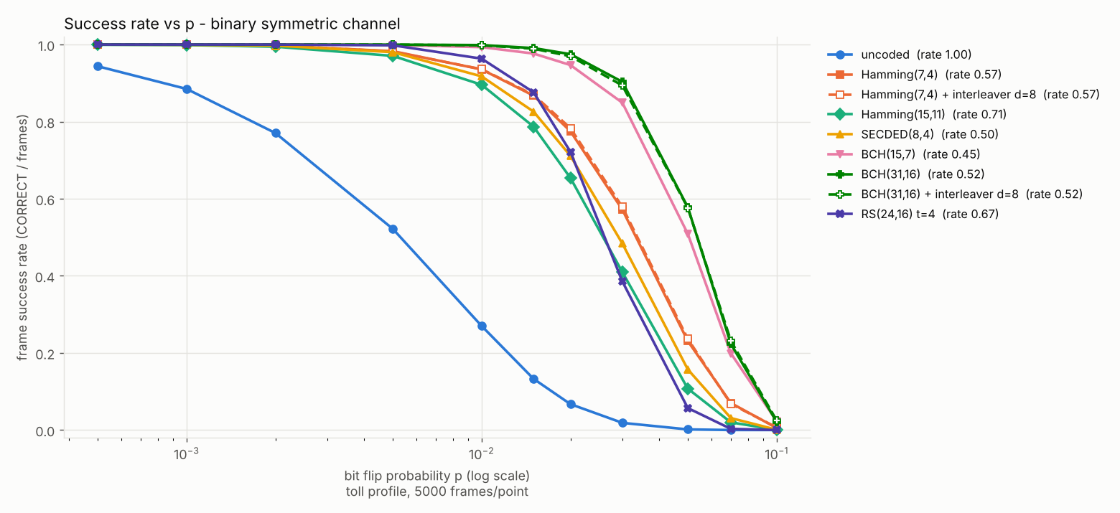
Figure 7. Frame success rate vs BSC bit-error probability.
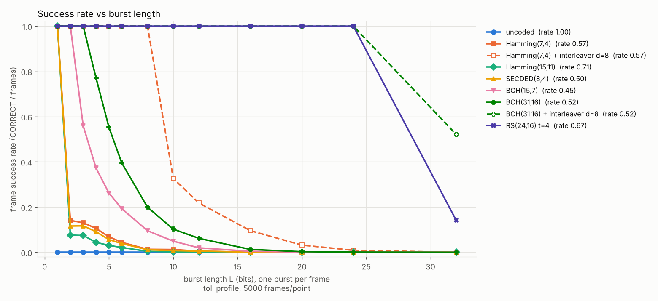
Figure 8. Frame success rate vs burst length: bit-level codes collapse, Reed-Solomon and interleaving survive.

Initial strategy comparison (toll -> hospital -> toll, seed 42)
Table 10. Strategies at v0.2
strategy | success | retx / frame | p99 latency (ms)
Stop-and-Wait ARQ (uncoded) | 0.8194 | 1.7828 | 94.009
HARQ BCH(31,16) | 0.9940 | 0.1980 | 76.226
Adaptive (mixed ladder) | 0.9994 | 0.0764 | 33.211

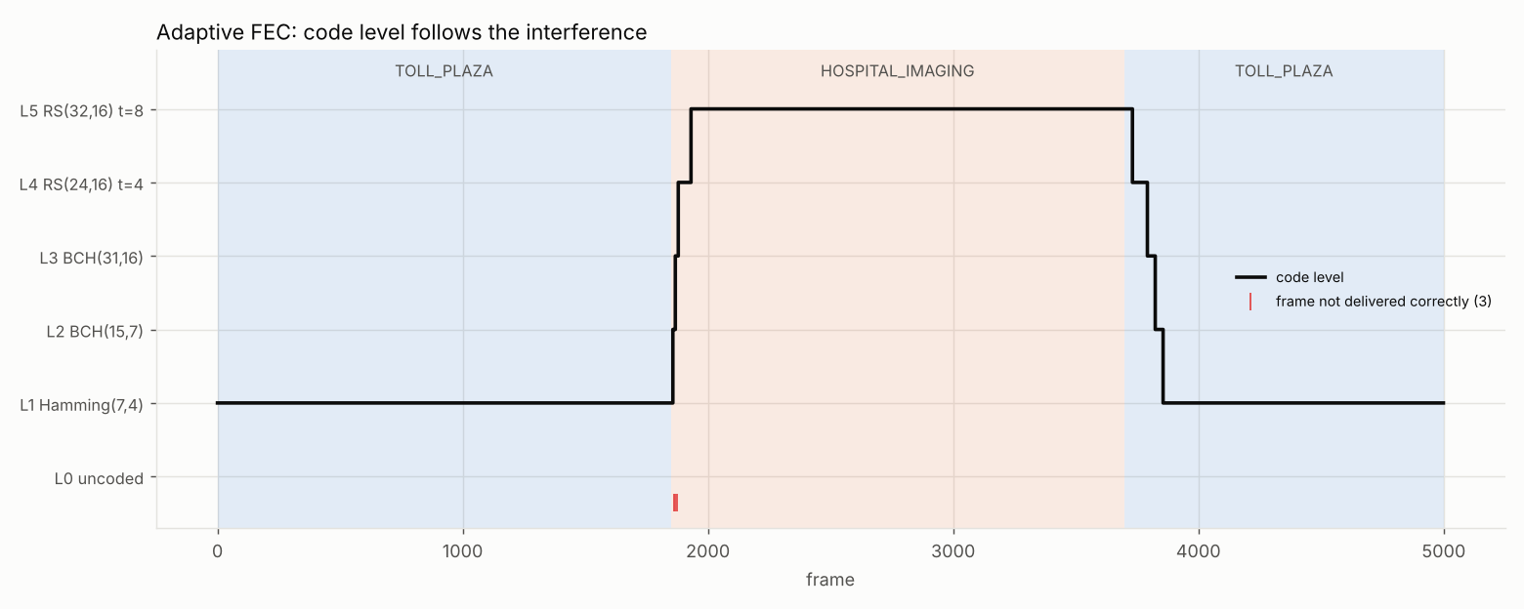
Figure 9. Adaptive level over time: the controller reacts within about 80 frames to the hospital burst and does not flap.

Observations
- BCH(31,16) does best on random errors (0.9986 at p = 0.01), while bursts need Reed-Solomon or an interleaver.
- Out of 1,395,000 frames per profile, none was SILENT_WRONG. The CRC-32 caught every miscorrection.
- The adaptive scheme brings retransmissions down from 1.78 per frame (plain ARQ) to 0.076, and p99 latency from 94 ms to 33 ms.
- One thing we have not checked yet is whether the adaptive controller really beats simply always using the strongest code, and all of this comes from one seed. That is the first job after this review.
Keep in mind that these results come from one seed, a simulated channel with assumed parameters and no hardware.

11. Individual Contribution
To be completed by the team before upload. The repository history (`git log --author`) can back this up.
Table 11. Individual contributions
Member | Reg. No. | Contribution (this review)
[Your Name] | [Reg. No.] | All coding and implementation: system architecture; CRC-32, bit utilities, seeded RNG and GF(2^m) arithmetic; Hamming, SECDED, BCH and Reed-Solomon codes and the interleaver; BSC, Gilbert-Elliott and burst noise models and the two profiles; the vehicle, channel and tollgate UDP programs; Stop-and-Wait ARQ, HARQ and the adaptive controller; the benchmark, plots and dashboard; unit, integration and failure tests.
[Teammate Name] | [Reg. No.] | Documentation and demo preparation: report writing, diagrams and figure captions, test-case documentation, collecting and checking results, demo scripts and rehearsal.

12. Plan for Review 3 and References
- Compare the adaptive controller against HARQ with a fixed RS t=4 and RS t=8, using goodput as the main measure.
- Repeat the experiments over 20 seeds and report 95% confidence intervals and paired differences, plus a test of how RTT changes the result.
- Try to break the system on purpose with malformed, truncated and duplicate packets, a lost END message and a busy port, and run everything under ASan and UBSan.
- Set up continuous integration, write the final report, attempt LDPC as an extra, and prepare the live demonstration and the comparison with the existing approach.
References
[1] S. Lin and D. J. Costello, Error Control Coding, 2nd ed. Upper Saddle River, NJ: Pearson Prentice Hall, 2004.
[2] R. E. Blahut, Algebraic Codes for Data Transmission. Cambridge, UK: Cambridge University Press, 2003.
[3] E. N. Gilbert, "Capacity of a burst-noise channel," Bell Syst. Tech. J., vol. 39, no. 5, pp. 1253-1265, Sept. 1960.
[4] E. O. Elliott, "Estimates of error rates for codes on burst-noise channels," Bell Syst. Tech. J., vol. 42, no. 5, pp. 1977-1997, Sept. 1963.
[5] IEEE Std 802.3, IEEE Standard for Ethernet (CRC-32 frame check sequence).
Supporting material in the project repository: docs/DESIGN_DECISIONS.md, docs/ALGORITHMS.md.

