VIT - Computer Networks Project
REVIEW 3 - FINAL PROJECT
Assessment 10 component | Review window 26 - 30 October 2026

Adaptive Multi-Error FEC Link Layer for High-Interference Environments
An extension of the approved project "Fast-Lane FEC for Automated Toll Booths"

Team: [Your Name] [Reg. No.] | [Teammate Name] [Reg. No.]
Guide: [Guide Name, Designation]
Final version v0.4 - complete implementation, evaluation and live demonstration
Source code: github.com/PavitranVC/Adaptive-FEC-Link

Contents
1. Executive Summary
2. Complete Working Project
3. Final System Architecture
4. Complete Implementation
5. Live Demonstration
6. Test Results
7. Performance Analysis
8. Comparison with Existing System
9. Achievement of Objectives
10. Innovation and Real-World Application
11. Limitations
12. Future Enhancement
13. Outcome (Conference / Patent / Journal / Book Chapter)
14. Individual Contribution and References

1. Executive Summary
A moving vehicle has to get its 96-bit RFID tag ID to a roadside toll unit over a noisy wireless link, and it may not be around long enough for a retransmission. To deal with this we wrote everything ourselves in C11: the CRC-32 [6], a seeded random number generator, the GF(2^m) arithmetic, the Hamming, SECDED, BCH, Reed-Solomon and LDPC codes [1]-[3], and a bit interleaver. On top of that we built a three-program UDP simulator (vehicle, noisy channel, tollgate) with three noise models and two profiles, a toll plaza and a hospital imaging room. We then compared plain FEC, Stop-and-Wait ARQ, Hybrid ARQ and an adaptive controller that moves up and down a ladder of codes. Every comparison was run over 20 seeds and reported with 95% confidence intervals.
Table 1. Headline results
Headline finding | Evidence
No wrong ID was ever accepted: SILENT_WRONG = 0 | 0 of 1,395,000 frames per profile (CRC-32 end to end)
Best code depends on the noise | BCH(31,16) on random errors (0.9986 at p = 0.01); Reed-Solomon or interleaving on bursts
FEC + feedback beats pure retransmission | ARQ: success 0.8244, p99 94.0 ms; HARQ RS t=8: success 1.0000, p99 33.2 ms
Adaptive works, but a simple fixed baseline wins on goodput | HARQ RS t=4 goodput 0.6126 vs adaptive 0.5043 (mixed) / 0.5841 (all-RS); adaptive wins on retransmissions and p99
Engineering quality | 26 unit-test binaries, 171 test cases, integration + failure-injection tests, ASan/UBSan clean, CI on Ubuntu and macOS

2. Complete Working Project
The project is a finished software system, and anyone can repeat our results. A fresh clone only needs a C compiler and make to build and run everything. Python 3 is used just for the dashboard and the plots.
Table 2. Delivered capabilities
Capability | Delivered
Codes | uncoded, Hamming(7,4), Hamming(15,11), SECDED(8,4), BCH(15,7), BCH(31,16), shortened RS(16+2t,16) t = 1..16, LDPC(256,128)
Detection | CRC-32 (IEEE 802.3) over the 12 ID bytes; CORRECT / DETECTED_FAIL / SILENT_WRONG classification
Burst handling | generic bit-level block interleaver (--interleave D)
Channel | BSC, Gilbert-Elliott [4], [5] (state kept across frames), burst of length L; two profiles; toll -> hospital -> toll schedules
Strategies | FEC, Stop-and-Wait ARQ, HARQ type I, adaptive ladder (mixed or all-RS) with hysteresis and probe back-off
Feedback | ACK/NAK + window statistics on UDP 9002, with loss injection (--fb-drop)
Evaluation | in-process benchmark, goodput, p99 latency on a simulated clock, 20-seed Student-t CIs and paired differences, matplotlib plots
Observability | coloured per-frame bit map, JSON-lines log, live web dashboard
Robustness | failure injection, seeded fuzz test (450,000 inputs), ASan + UBSan, GitHub Actions CI

3. Final System Architecture
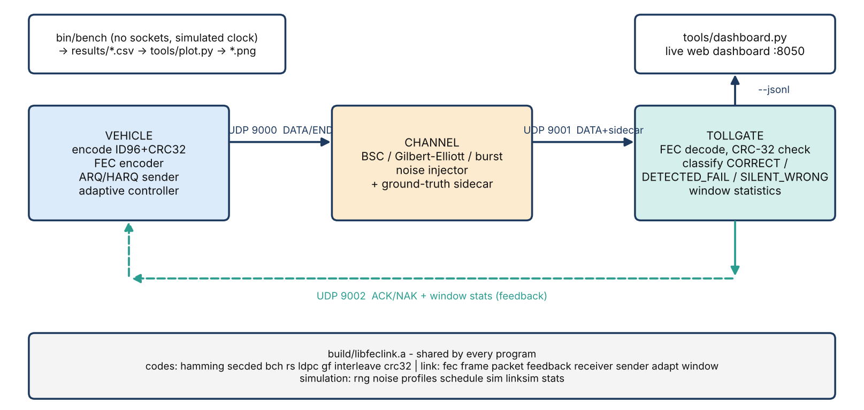
Figure 1. Final system architecture.
The vehicle talks to the channel on UDP 9000, and the channel passes frames to the tollgate on UDP 9001 along with a ground-truth field that is used only for scoring. The tollgate answers the vehicle on UDP 9002 with ACK/NAK and window statistics. All programs link the same library, build/libfeclink.a, so the benchmark and the real UDP programs share one set of code.
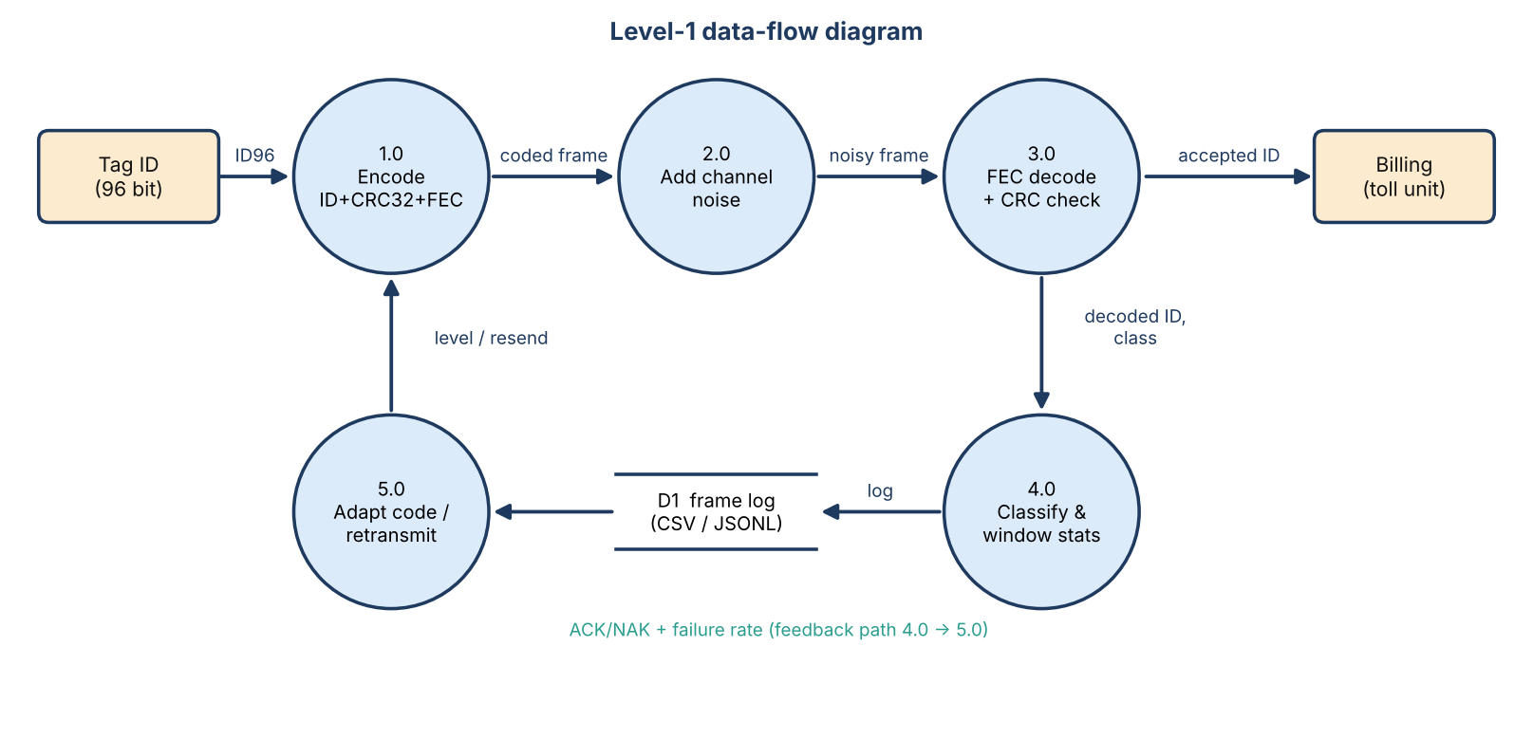
Figure 2. Level-1 data-flow diagram.
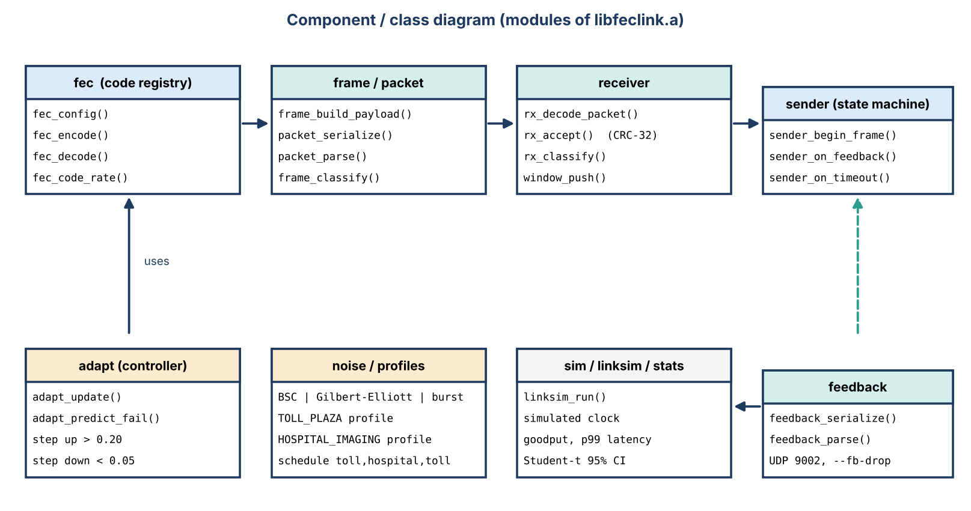
Figure 3. Component/class diagram.
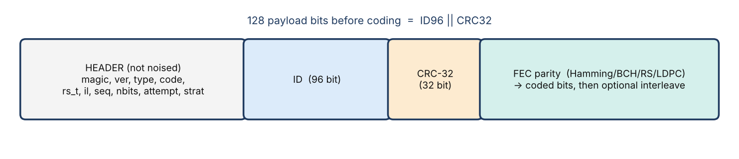
Figure 4. Frame layout.
The header is version 2 and 16 bytes long (magic, version, type, code, rs_t, interleave, seq, nbits, attempt, strategy). By default the channel does not touch it (DD-01), but we did test what happens when it is corrupted, and section 6.4 reports that.

4. Complete Implementation

4.1 Modules
Table 3. 28 library modules (src/*.c) grouped by role
Module(s) | Responsibility
bits, crc32, rng, gf | bit utilities, CRC-32 (IEEE 802.3), seeded RNG, GF(2^m) arithmetic
hamming, secded, bch, rs, ldpc, interleave | the error-correcting codes and the bit block interleaver
fec | single registry: choose a code, encode, decode, rate, description
frame, packet | payload ID96 || CRC32; wire header (v2, 16 bytes), parsing and validation
noise, profiles, schedule | BSC / Gilbert-Elliott / burst, the two profiles, toll->hospital->toll schedule
receiver | decode, CRC check, classification (never reads ground truth)
sender, adapt, window, feedback | ARQ/HARQ state machine, adaptive ladder controller, sliding-window statistics, ACK/NAK wire format
sim, linksim, stats | in-process link simulator on a simulated clock, goodput/latency, Student-t 95% CIs
apps/vehicle, channel, tollgate | the three UDP processes
tools/bench, plot.py, dashboard.py | benchmark, plots, live dashboard

The code base is roughly 4,455 lines of C (including headers) plus 3,096 lines of tests. It uses only C11 and POSIX, with no external libraries.

4.2 Codes
Table 4. Codes
Code | Rate | Corrects | Notes
uncoded | 1.0000 | - | baseline
Hamming(7,4) | 0.571 | 1 | cheap fallback; syndrome = error position
Hamming(15,11) | 0.711 | 1 | higher rate
SECDED(8,4) | 0.500 | 1 (+2 detected) | extended Hamming
BCH(15,7) | 0.449 | 2 | GF(16), Berlekamp-Massey + Chien
BCH(31,16) | 0.516 | 3 | best on random errors (original codes)
Reed-Solomon RS(16+2t,16) | 0.889 .. 0.333 | t bytes (default 4) | GF(256), shortened, Forney; bursts
LDPC(256,128) | 0.500 | (bit flipping) | v0.4 stretch; sparse (3,6)-regular H

4.3 Algorithms
- CRC-32: it detects errors but cannot correct them. Every 1-, 2- and 3-bit error in a 128-bit message is caught, and a random wrong word slips through with probability of about 2^-32. While checking our work we found one exception: because the payload is sent most-significant bit first, a few particular bursts of 30 to 32 bits do pass the CRC. We wrote this up in docs/ALGORITHMS.md [7].
- Hamming / SECDED: the syndrome is the position of the error, and SECDED can tell a single error from a double one.
- BCH: syndromes, then Berlekamp-Massey, then a Chien search, working over GF(16) and GF(32).
- Reed-Solomon: works over GF(256) with the polynomial x^8+x^4+x^3+x^2+1. It uses syndromes, Berlekamp-Massey, Chien search and Forney, and corrects t byte errors, so a burst of up to 8t bits damages only a few symbols.
- LDPC(256,128): a (3,6)-regular parity-check matrix built with a PEG-style rule (girth 6), a systematic encoder obtained by Gaussian elimination, and Gallager's hard-decision bit flipping for decoding (at most 50 iterations).
- Interleaver: it helps bit-level codes against bursts (BCH(31,16) with depth 8 reaches 1.0000 at L=16) but hurts Reed-Solomon, where RS t=4 on the hospital profile falls from 83.4% to 59.8%.

4.4 Noise models and profiles
Table 5. Profiles (modelling assumptions, not measurements)
Profile | BSC | Gilbert-Elliott | Burst
TOLL_PLAZA (primary) | p = 0.01 | p_gb 0.002, p_bg 0.5, e_good 0.005, e_bad 0.5 | L = 4 bits in 20% of frames
HOSPITAL_IMAGING (secondary) | p = 0.02 | p_gb 0.005, p_bg 0.08 (mean burst 12.5 bits), e_good 0.002, e_bad 0.5 | L = 16 bits in 50% of frames

4.5 Link strategies and adaptive controller
Table 6. Strategies
Strategy | Behaviour
fec | one shot, no retransmission
arq | Stop-and-Wait, uncoded + CRC, retransmit on timeout/NAK (the strawman)
harq | HARQ type I: FEC first, retransmit only when CRC fails (no soft combining)
adaptive | vehicle changes the code level from receiver window statistics (W = 32 frames)

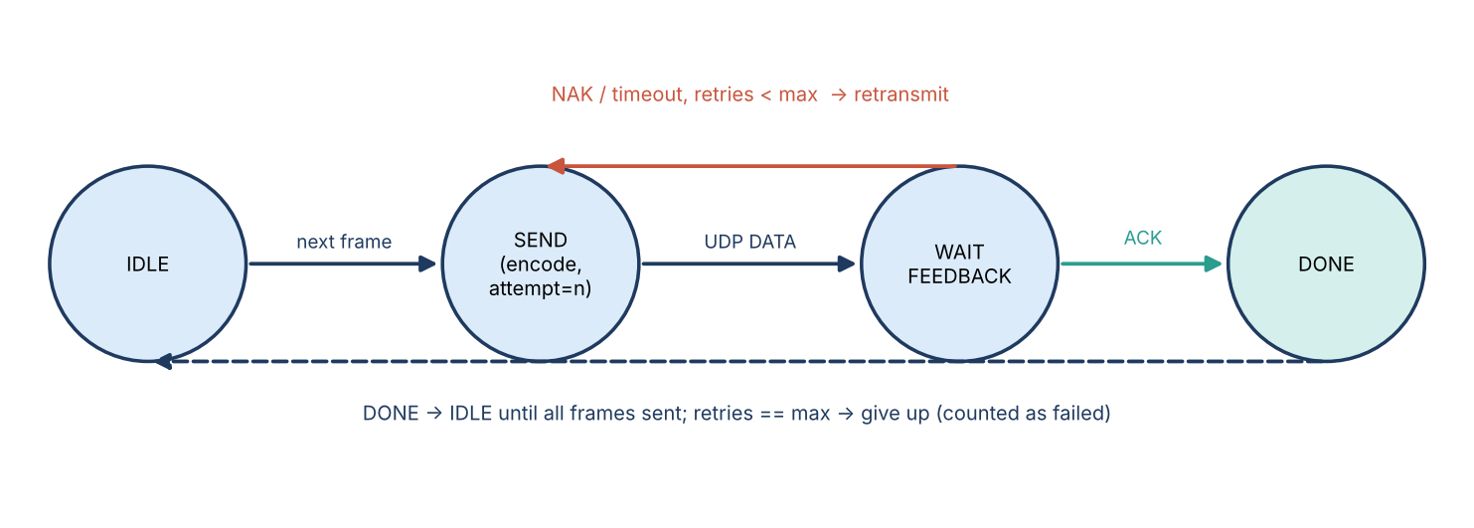
Figure 5. Sender state machine.
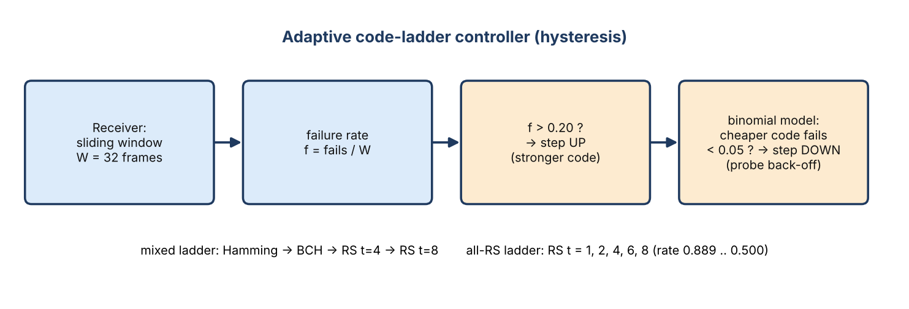
Figure 6. Adaptive controller.
The controller makes one decision per window of 32 frames. It steps up if the failure rate is above 0.20, and steps down only if the binomial model predicts the cheaper code would fail less than 5% of the time, with a probe back-off on top. We tried two ladders: a mixed one (Hamming, BCH, RS) and an all-RS one (t = 1, 2, 4, 6, 8, with rates from 0.889 down to 0.500).

5. Live Demonstration
The demonstration is scripted, so it goes the same way every time. docs/DEMO.md also has a two-minute talking script.
Table 7. Demonstration script
Step | Command | What the audience sees
1 | make && make test | build, 26 unit-test binaries, integration and failure-injection tests all green
2 | make demo | three processes; coloured bit map; 20/20 CORRECT on the toll profile
3 | make demo-hospital | bursty channel: errors in clusters; stronger code needed
4 | make demo-adaptive | controller steps the code up in the hospital segment and back down in toll
5 | make compare | same noise, different codes side by side
6 | make dashboard | live web dashboard on http://127.0.0.1:8050
7 | Wireshark proof (DEMO.md) | real UDP packets on loopback: 9000, 9001, 9002

When we ran it, a 20-frame toll-profile demo with Hamming(7,4) gave 20 CORRECT and no DETECTED_FAIL or SILENT_WRONG. The channel flipped 48 of 4,480 bits (a measured BER of 0.01071 against the model's 0.01000) and all 48 were corrected. A demo this short cannot show real rates, so for rates we rely on the benchmark.

6. Test Results

6.1 Test suite
Table 8. Test layers
Layer | What it checks | Result
26 unit-test binaries (171 test cases) | bits, CRC-32, RNG, GF, Hamming, SECDED, BCH, RS, LDPC, interleaver, noise, FEC, frame, packet, feedback, receiver, schedule, adapt, stats, sim, linksim, CLI, version | pass
Fuzz test | 450,000 seeded fuzzed parser inputs | pass
Integration (3 real UDP processes) | reproducibility by seed, both profiles, BCH, RS, interleaver, ARQ, HARQ with 30% feedback loss, adaptive schedule, JSON-lines + dashboard, bench/plot smoke tests | pass
Failure injection | malformed / truncated / duplicate packets, header corruption, port in use, lost END, 100% feedback loss, garbage on the feedback port | pass
Dashboard test | state computed from logs, empty / missing logs | pass
Sanitizers (make sanitize) | every unit and integration test under ASan + UBSan | no findings
CI (GitHub Actions) | build + test on Ubuntu and macOS; sanitizers on Ubuntu | green

We re-ran `make test` while writing this document, and the unit, integration, failure-injection and dashboard tests all passed.

6.2 Code comparison (E1, seed 42, 5,000 frames per point)
Table 9. Frame success rate by code and channel
code | rate | toll BSC p=0.01 | toll GE | hospital GE | burst L=16
uncoded | 1.0000 | 0.2700 | 0.3328 | 0.3952 | 0.0000
Hamming(7,4) | 0.5714 | 0.9354 | 0.7752 | 0.4170 | 0.0014
Hamming(7,4) + il8 | 0.5714 | 0.9360 | 0.9394 | 0.6106 | 0.0956
Hamming(15,11) | 0.7111 | 0.8956 | 0.7822 | 0.4720 | 0.0004
SECDED(8,4) | 0.5000 | 0.9174 | 0.7406 | 0.3654 | 0.0008
BCH(15,7) | 0.4491 | 0.9932 | 0.8978 | 0.3912 | 0.0044
BCH(31,16) | 0.5161 | 0.9986 | 0.9596 | 0.4936 | 0.0126
BCH(31,16) + il8 | 0.5161 | 0.9980 | 0.9978 | 0.8374 | 1.0000
RS t=4 | 0.6667 | 0.9634 | 0.9756 | 0.8336 | 1.0000
LDPC(256,128) | 0.5000 | 0.9994 | 0.9988 | 0.7902 | 0.9690
RS t=8 | 0.5000 | 0.9996 | 0.9996 | 0.9532 | 1.0000

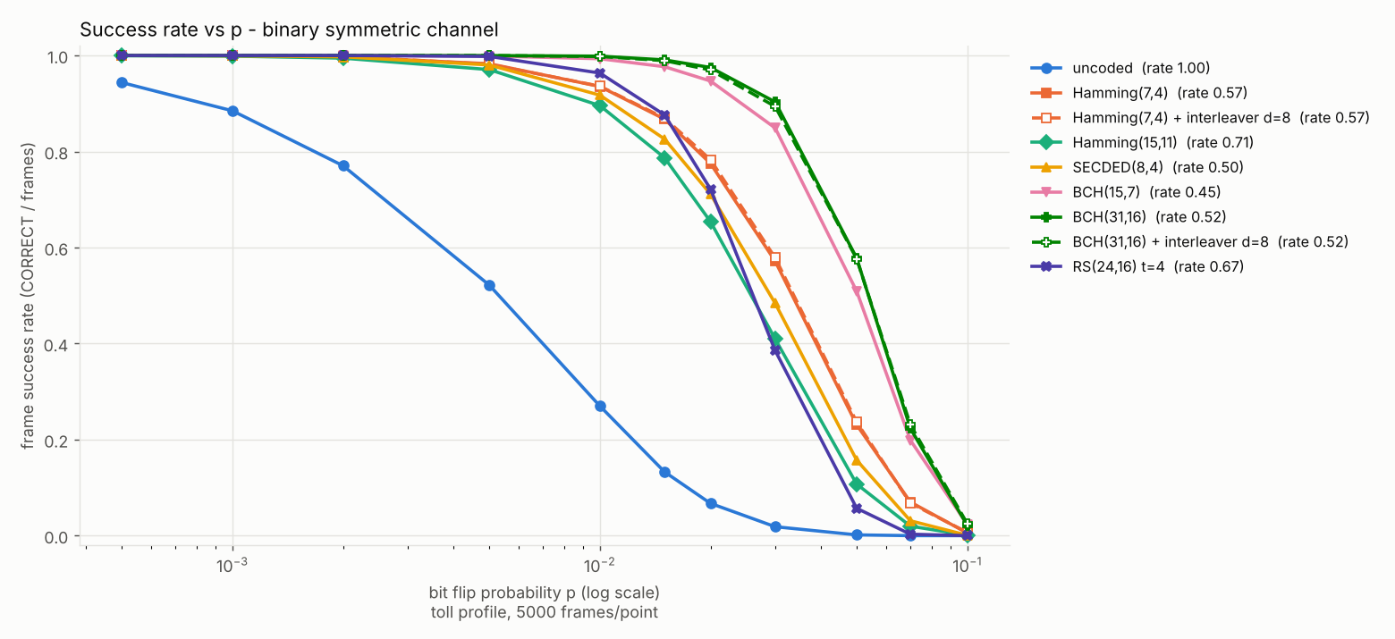
Figure 7. Success vs BSC probability.
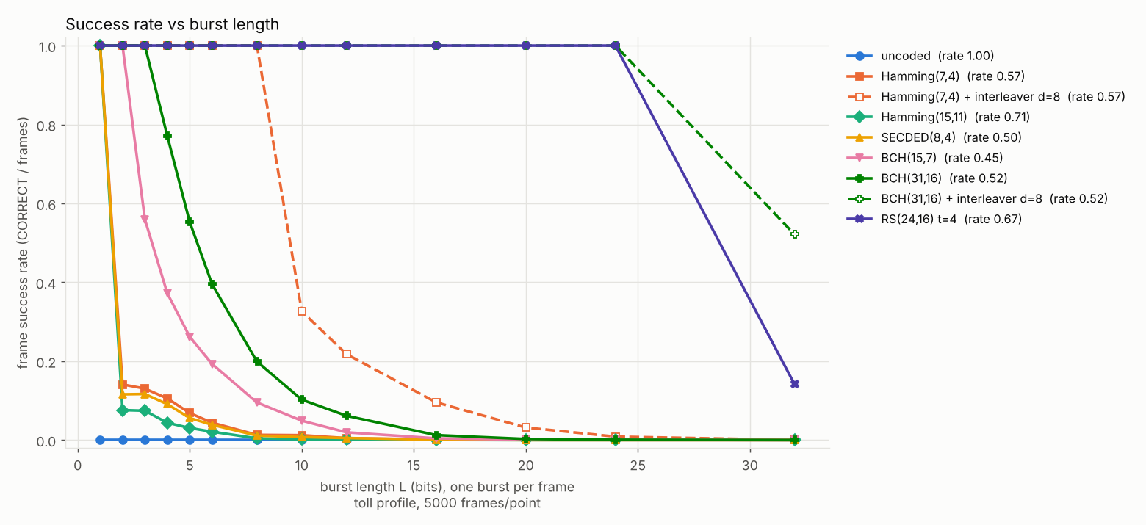
Figure 8. Success vs burst length.
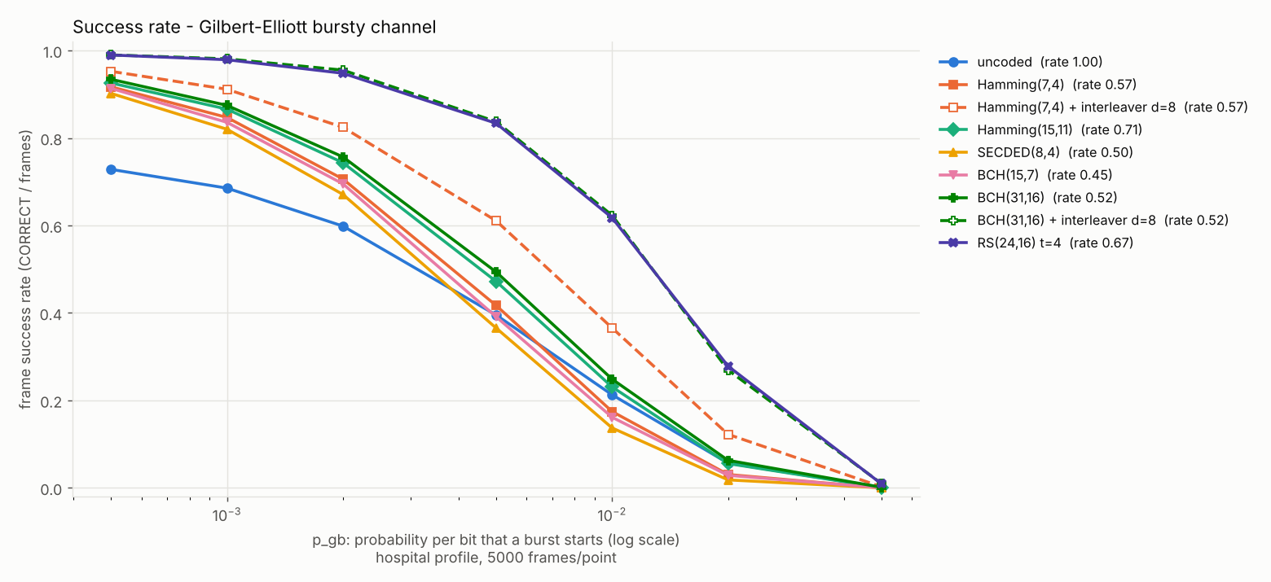
Figure 9. Success vs Gilbert-Elliott p_gb on the hospital profile.

6.3 Strategy comparison (E4, 20 seeds, mean +- 95% CI)
Table 10. Toll -> hospital -> toll channel, 5,000 frames, RTT 20 ms
strategy | success | goodput | retx / frame | p99 latency (ms)
FEC RS t=8 | 0.9817 +- 0.0010 | 0.4909 +- 0.0005 | 0 | 11.6
Stop-and-Wait ARQ (uncoded) | 0.8244 +- 0.0028 | 0.2960 +- 0.0019 | 1.785 +- 0.009 | 94.0
HARQ BCH(31,16) | 0.9932 +- 0.0006 | 0.4285 +- 0.0009 | 0.196 +- 0.002 | 76.2
HARQ RS t=8 | 1.0000 | 0.4910 +- 0.0005 | 0.018 +- 0.001 | 33.2
HARQ RS t=4 | 0.99998 +- 0.00003 | 0.6126 +- 0.0012 | 0.088 +- 0.002 | 42.0 +- 5.1 (bimodal)
Adaptive (mixed ladder) | 0.9995 +- 0.0001 | 0.5043 +- 0.0025 | 0.069 +- 0.002 | 33.2
Adaptive (all-RS ladder) | 0.99999 +- 0.00002 | 0.5841 +- 0.0040 | 0.0554 +- 0.0025 | 33.0 +- 0.1

Table 11. Paired differences, adaptive (mixed) minus baseline, same 20 seeds
metric | vs HARQ RS t=8 | vs HARQ RS t=4
success | -0.00051 +- 0.00009 | -0.00049 +- 0.00009
goodput | +0.0133 +- 0.0024 | -0.1083 +- 0.0030
retx / frame | +0.0506 +- 0.0023 | -0.0194 +- 0.0025
p99 latency (ms) | +0.0022 +- 0.0009 | -8.74 +- 5.06

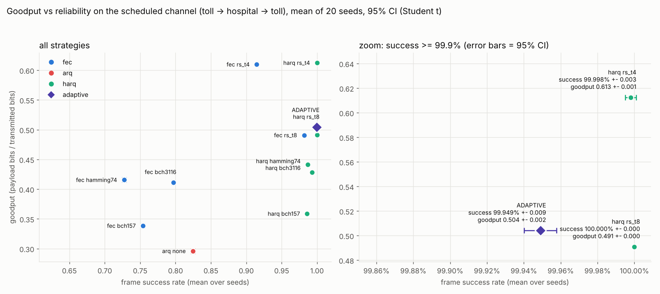
Figure 10. Goodput vs success with 20-seed confidence intervals.
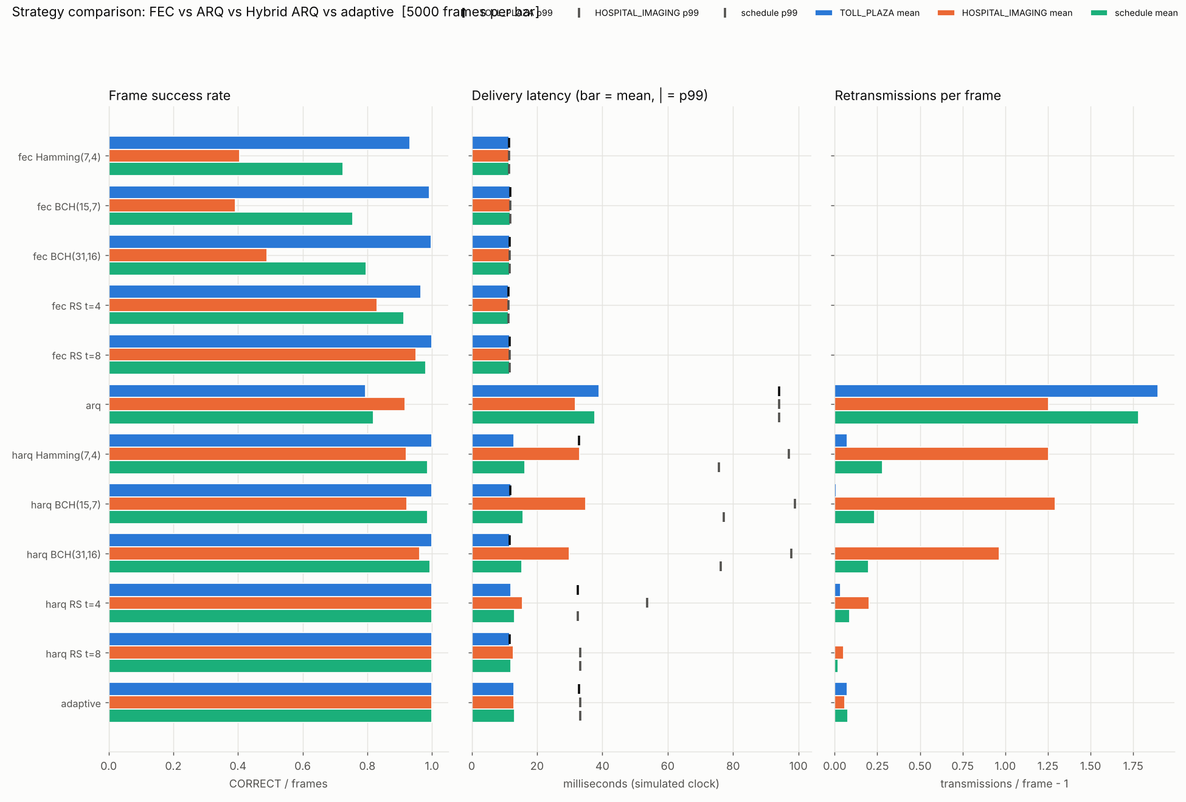
Figure 11. Strategy comparison.
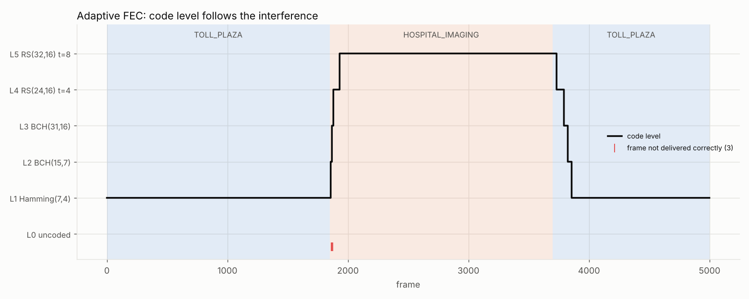
Figure 12. Adaptive level over time on the toll -> hospital -> toll schedule.

6.4 Failure injection and header corruption
Deliberately feeding the system bad input, and running it under the sanitizers, turned up four real bugs that all our normal tests had missed. An empty datagram stopped the tollgate and the channel; an invalid packet could take over a sequence number; SO_REUSEADDR let two processes bind the same UDP port; and the RS decoder returned uninitialised data when it failed. We fixed all four. Later we went through every module again, reading for memory-safety and input-validation problems and fuzzing each decoder under ASan and UBSan. That turned up more, and each one now has a regression test. A UDP datagram bigger than the receive buffer was cut off silently and could pass as a valid packet. Oversized sizes overran a stack buffer in the FEC encoder and decoder. A Galois-field polynomial with one bit too many made a table lookup read outside its array. The random-number helper divided by zero when asked for a value from an empty range. The 8-bit attempt counter wrapped around when the retry limit was set very high, and feedback and packet fields were not range-checked. A few low-severity items are still open and written down as follow-ups: a limit on the window size and a check on allocations for very large frame counts. Bursts much longer than any code can handle (L = 4096) give 100% DETECTED_FAIL and no SILENT_WRONG, and if all feedback is lost the vehicle simply gives up after the maximum number of retries.
Table 12. Header corruption (toll, RS t=4, seed 42, 2,000 frames)
strategy | P(corrupt header) | delivered | failed | misrouted | lost
fec | 0 | 1929 | 71 | 0 | 0
fec | 0.05 | 1835 | 69 | 13 | 83
fec | 0.2 | 1558 | 62 | 51 | 329
harq | 0 | 2000 | 0 | 0 | 0
harq | 0.05 | 1988 | 2 | 9 | 1
harq | 0.2 | 1960 | 2 | 28 | 10

This table shows a real weakness. At P = 0.2 with HARQ the tollgate reports 2003 CORRECT frames although only 2000 were sent, because a flipped sequence number creates a phantom frame. We have not fixed it. The fix we propose is a CRC-16 over the header, which needs a change to the wire format.

7. Performance Analysis

7.1 Goodput, reliability and latency
- Reliability: every strategy that combines FEC with feedback reaches a success rate of at least 0.9932, while uncoded Stop-and-Wait ARQ manages only 0.8244 within 4 retries on this channel.
- Goodput, meaning correct payload bits per coded bit sent, is mostly set by the code rate. Fixed HARQ with RS t=4 (rate 0.667) reaches 0.6126 and RS t=8 (rate 0.500) reaches 0.491. ARQ gets only 0.296 because of all its retransmissions.
- Latency: at an RTT of 20 ms the p99 latency is 33.2 ms for the adaptive scheme and for HARQ RS t=8, against 94.0 ms for ARQ.

7.2 RTT sensitivity (E3)
Table 13. p99 latency in ms (seed 42)
strategy | RTT 5 ms | RTT 20 ms | RTT 50 ms
Stop-and-Wait ARQ | 26.509 | 94.009 | 229.009
HARQ RS t=4 | 9.911 | 32.426 | 77.407
HARQ RS t=8 | 10.711 | 33.211 | 78.211
Adaptive (mixed) | 10.712 | 33.212 | 78.212

The ranking stays the same at every RTT. The longer the round trip, the more FEC gains over plain retransmission.
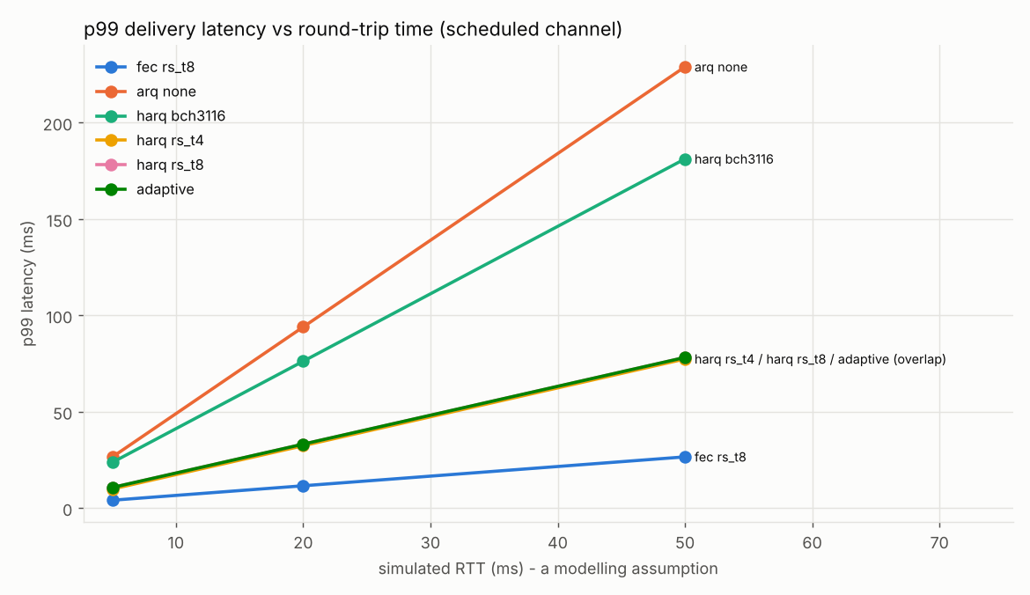
Figure 13. RTT sensitivity.

7.3 LDPC vs BCH and Reed-Solomon (E7, same rate 0.5)
Table 14. LDPC comparison (seed 42, 5,000 frames per point)
code | rate | BSC 0.01 | BSC 0.02 | BSC 0.03 | toll GE | hospital GE | burst L=16 | burst L=24 | mean decode
BCH(31,16) | 0.516 | 0.9986 | 0.9750 | 0.9032 | 0.9596 | 0.4936 | 0.0126 | 0.0008 | 6.9 us
RS t=4 | 0.667 | 0.9634 | 0.7218 | 0.3854 | 0.9756 | 0.8336 | 1.0000 | 1.0000 | 3.3 us
RS t=8 | 0.500 | 0.9996 | 0.9608 | 0.7568 | 0.9996 | 0.9532 | 1.0000 | 1.0000 | 5.6 us
LDPC(256,128) | 0.500 | 0.9994 | 0.9874 | 0.9152 | 0.9988 | 0.7902 | 0.9690 | 0.6916 | 10.5 us

With hard-decision decoding, LDPC is the best code on random errors between p = 0.015 and 0.03. On the bursty hospital channel and on bursts of 16 bits or more it is worse than both RS codes. It also has the longest average decode time, since frames it cannot decode still run all 50 iterations. There were no SILENT_WRONG frames in 155,000 per profile.
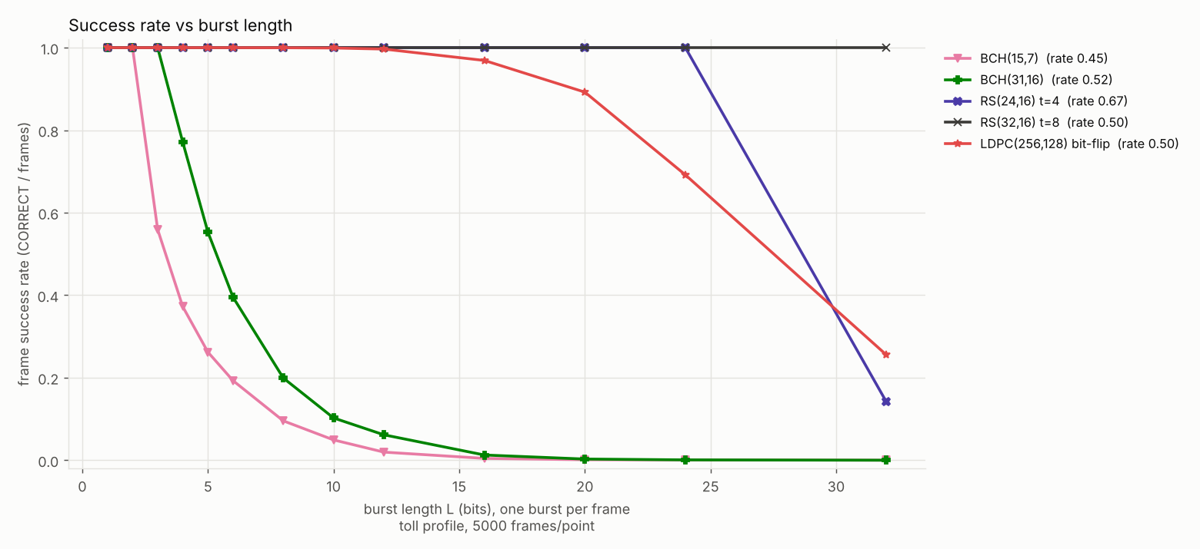
Figure 14. LDPC vs BCH/RS on bursts.

7.4 All-RS ladder experiment (E5, pre-registered)
We wrote down our hypothesis before running anything: an adaptive ladder of RS t = 1, 2, 4, 6, 8 should match the reliability of HARQ RS t=8 while giving clearly higher goodput than the mixed ladder. We did not tune anything afterwards. The hypothesis held, with goodput of 0.5841 +- 0.0040 against 0.5043 for the mixed ladder (paired difference +0.0799 +- 0.0050). It still did not beat fixed HARQ RS t=4 (paired -0.0284 +- 0.0038), and on the toll channel alone the two are tied (0.6434 against 0.6441, with the confidence interval including 0).
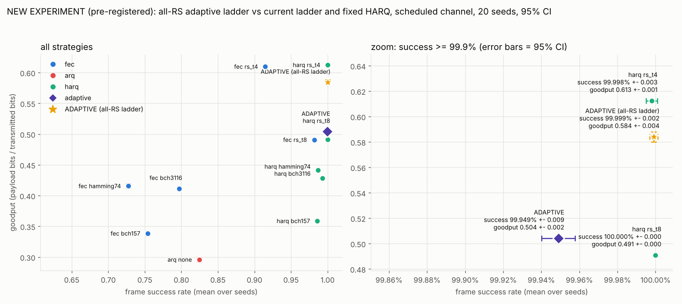
Figure 15. All-RS ladder experiment.

8. Comparison with Existing System
For a moving vehicle, the usual approach is either retransmission, i.e. Stop-and-Wait ARQ on an uncoded frame with a CRC, or one fixed FEC with no feedback. We treat these two as the existing system, implemented both, and measured them on the same channel and the same seeds as our proposal.
Table 15. Comparison on the toll -> hospital -> toll channel
Criterion | Existing: uncoded Stop-and-Wait ARQ | Existing: fixed FEC (RS t=8, no feedback) | Proposed: HARQ + FEC / adaptive
Success (20 seeds) | 0.8244 | 0.9817 | 0.9995 - 1.0000
Goodput | 0.296 | 0.491 | 0.504 - 0.613
Retransmissions / frame | 1.785 | 0 | 0.018 - 0.088
p99 latency (RTT 20 ms) | 94.0 ms | 11.6 ms | 33.0 - 42.0 ms
Silent wrong IDs | 0 (CRC) | 0 (CRC) | 0 of 1,395,000 frames
Adapts to channel | no | no | yes (adaptive)

In short, plain retransmission is the worst on every measure. A fixed strong FEC is fast, but it loses 1.8% of frames during the bursty segment. HARQ with FEC fixes that for the price of a few retransmissions. One caveat is that always using HARQ with RS t=4 beats our adaptive controller on goodput on this channel.

9. Achievement of Objectives
Table 16. Objectives
Objective | Status | Evidence
Implement multi-error codes from scratch | Achieved | Hamming, SECDED, BCH, RS, LDPC, CRC-32, interleaver; 171 unit tests
Model realistic noise (BSC, Gilbert-Elliott, burst), two profiles | Achieved | section 4.4; statistical tests of flip rates
Real UDP pipeline with feedback | Achieved | vehicle / channel / tollgate; integration tests; Wireshark proof
Compare FEC, ARQ, HARQ, adaptive | Achieved | 20 seeds, CIs, paired differences (section 6.3)
Reproducible measurements | Achieved | seeded RNG; 20 seeds 42..61; make bench
Adaptive FEC beats every fixed strategy | Not achieved | HARQ RS t=4 higher goodput; adaptive wins on retransmissions and p99

10. Innovation and Real-World Application
- What is new: one library where five code families, three noise models and four link strategies can be compared fairly. A ground-truth field lets us count the dangerous SILENT_WRONG frames without the decoder seeing the answer. The adaptive ladder works on windows of evidence and uses a binomial model to decide when to step down. We also pre-registered one experiment and used 20-seed paired statistics rather than a single run.
- Toll booths: read tag IDs at speed without waiting for a round trip.
- Hospitals and MRI rooms: imaging and electrosurgical equipment produce sudden bursts of interference, which Reed-Solomon coding handles well.
- Teaching and research: a small, readable reference that shows how FEC, ARQ and HARQ trade goodput, reliability and latency against each other.

11. Limitations
- Everything is a software simulation. We have no hardware and no over-the-air measurements, and the noise parameters, the 20 ms RTT, the 160 kbit/s bit rate and the burst model are our own assumptions.
- On this channel the adaptive controller does not beat fixed HARQ with RS t=4 on goodput. Our results suggest the choice of ladder matters more than the control logic.
- The header has no protection, so header corruption can cause misrouting. HARQ is type I without soft combining, and LDPC uses hard-decision decoding only.
- Decode times were measured on our simulation host. macOS is only checked by CI, and WSL by a single manual run.

12. Future Enhancement
- Add a CRC-16 to the header and make the sequence number robust to corruption, which would remove the misrouting problem.
- Move to Type II HARQ with soft combining, and to soft-decision (sum-product) LDPC decoding with longer codes.
- Let the controller pick a fixed code such as RS t=4 when that is the best choice, for example with a bandit algorithm, and tune the ladder on a channel it was not evaluated on.
- Use real channel traces and a real RTT, try it on an actual RFID or software-defined-radio link, and add macOS and WSL to CI.

13. Outcome (Conference / Patent / Journal / Book Chapter)
Nothing has been published or filed yet. The table lists realistic targets, and the team should replace 'Planned' with the real status before uploading.
Table 17. Outcome
Type | Proposed title / angle | Status
Conference paper | Adaptive FEC code ladders for bursty toll and hospital channels: why a fixed strong HARQ baseline is hard to beat | Planned [fill venue and date]
Journal article | Reproducible comparison of Hamming, BCH, Reed-Solomon and LDPC with ARQ/HARQ under Gilbert-Elliott noise | Planned [fill]
Patent | not pursued: all techniques are standard and the contribution is evaluative | Not planned
Book chapter | Case study chapter on link-layer error control for intelligent transport | Not planned [adjust]

14. Individual Contribution and References
Table 18. Individual contributions
Member | Reg. No. | Contribution (complete project)
[Your Name] | [Reg. No.] | All coding and implementation: architecture; CRC-32, RNG and GF arithmetic; Hamming, SECDED, BCH, Reed-Solomon and LDPC codes and the interleaver; noise models and profiles; the vehicle, channel and tollgate UDP programs; ARQ, HARQ and the adaptive controller (mixed and all-RS ladders); the benchmark, 20-seed statistics and plots; the dashboard; unit, integration, fuzz and failure-injection tests, sanitizer builds and CI.
[Teammate Name] | [Reg. No.] | Documentation and demo preparation: the Review 2 and Review 3 reports, architecture/DFD/UML diagrams, presentation slides, results tables and their checking against the data, demo script and rehearsal, test-case documentation.

References
[1] S. Lin and D. J. Costello, Error Control Coding, 2nd ed. Upper Saddle River, NJ: Pearson Prentice Hall, 2004.
[2] R. E. Blahut, Algebraic Codes for Data Transmission. Cambridge, UK: Cambridge University Press, 2003.
[3] R. G. Gallager, "Low-density parity-check codes," IRE Trans. Inf. Theory, vol. 8, no. 1, pp. 21-28, Jan. 1962.
[4] E. N. Gilbert, "Capacity of a burst-noise channel," Bell Syst. Tech. J., vol. 39, no. 5, pp. 1253-1265, Sept. 1960.
[5] E. O. Elliott, "Estimates of error rates for codes on burst-noise channels," Bell Syst. Tech. J., vol. 42, no. 5, pp. 1977-1997, Sept. 1963.
[6] IEEE Std 802.3, IEEE Standard for Ethernet (CRC-32 frame check sequence).
[7] Project repository and design records: docs/REPORT.md, docs/ALGORITHMS.md, docs/DESIGN_DECISIONS.md, docs/ARCHITECTURE_HISTORY.md.

