LexFront
A Compiler-Style Lexer Used as a Pre-Tokenizer for Noisy English Text Classification
Compiler Design Project, Review 2 Report

Abstract
Text from social media is full of hashtags, mentions, links, emoticons and stretched-out words, and the tokenizers that most classifiers rely on were not designed with this in mind. In this project we ask whether a lexical analyzer built the way a compiler builds one can do a better job. We built LexFront, a lexer with eleven token classes, longest-match scanning, error recovery, a symbol table and six switchable normalization rules. We also wrote our own engine that turns regular expressions into an NFA, then a DFA, then a minimized DFA. The experiments run on a PLY-based lexer, and our engine is checked against it, because it reproduces the same tokens on four of the token classes. LexFront was compared against whitespace splitting, NLTK and TweetTokenizer, and against BPE, WordPiece and Unigram subword tokenizers, with the classifier kept the same each time. The tests used three datasets (tweet_topic, go_emotions and ag_news) with Naive Bayes and Logistic Regression.
The results are mixed, and we report them that way. With the tokenizer as the only change, LexFront matches NLTK on go_emotions and ag_news and is 1.59 accuracy points lower on tweet_topic. Most of the apparent gain over the existing Naive Bayes setup comes from switching to Logistic Regression and not from the tokenizer. LexFront does give the lowest out-of-vocabulary rate and the smallest vocabulary among the word-level tokenizers, and its lowercase rule turns out to be the one that matters when case is kept. The subword variants did not beat the NLTK baseline in accuracy.
Keywords: lexical analysis, DFA, tokenization, noisy text, text classification, subword tokenization.

1. Introduction
A lot of the text we want to classify today comes from social media, and it is messy. People write hashtags, @-mentions, links and emoticons in the middle of sentences, they stretch words out ("soooo good"), and they use slang that no dictionary has. A tokenizer that was built for clean newspaper text can split these things in awkward ways, and since a classifier only sees the tokens, a bad split can cost accuracy. This problem has been known for a while, and early work on tweets already treated tokenization and normalization as problems of their own [2], [3].
Compilers face a very similar problem in their first phase. A lexical analyzer reads a stream of characters and groups them into tokens, using regular expressions, a longest-match rule, a symbol table and some way of recovering from characters it cannot match [1]. That is close to what a tweet tokenizer has to do, so we wanted to see how far the compiler approach carries over. Our idea was to build a lexer in the compiler-design style, use it as a pre-tokenizer for text classification, and compare it with existing tokenizers while keeping everything else in the pipeline fixed. The question we try to answer is whether a compiler-style lexer classifies noisy text better than the tokenizers people already use.
The work in this report makes three contributions. First, we built LexFront, a lexer with a priority-ordered token specification, a normalizer and a symbol table, together with our own regex-to-DFA engine that implements Thompson construction, subset construction and Moore minimization. Second, we set up a controlled comparison in which the tokenizer is the only thing that changes, with confidence intervals and significance tests so that small differences are not over-read. Third, we ran ablations that switch each normalization rule off separately, and a subword extension that combines LexFront with BPE and compares it with WordPiece and Unigram [4]. The report follows the structure asked for in Review 2. Section 2 reviews the literature, Section 3 describes the proposed system and its four modules, Section 4 gives the implementation and results, Section 5 compares performance, and Section 6 concludes.

2. Literature Survey
We grouped the related work into five areas: compiler front ends and automata, tokenization of noisy text, subword tokenization, text classification baselines, and evaluation methodology. Each subsection ends with a short note on how it connects to our work.

2.1 Compiler front ends and finite automata
The standard reference for the first phase of a compiler is the textbook by Aho, Lam, Sethi and Ullman [1], which describes how a lexical analyzer turns regular expressions into a recognizer and how a symbol table and error recovery fit around it. The construction we implement goes back to Thompson [5], who showed how to build a nondeterministic automaton from a regular expression piece by piece. The subset construction that converts it to a deterministic automaton, and the closure properties that make this possible, are covered in the automata theory text by Hopcroft, Motwani and Ullman [6]. For minimization we followed the partition-refinement idea that goes back to Moore [7].
On the practical side, Lex [8] generated scanners from regular expressions and was designed to work together with the parser generator Yacc [9]. PLY [10] brings the same style to Python, and the tokenizer used in our experiments is built on it. All of these tools take a list of patterns in priority order and apply longest match, with ties going to the earlier rule, which is the behaviour we copied. What we take from this area is the whole design vocabulary of LexFront: token classes, longest match, priority, semantic actions on tokens and panic-mode error recovery.

2.2 Tokenization and normalization of noisy text
Gimpel et al. [2] built a part-of-speech tagger specifically for Twitter and had to deal with hashtags, mentions, URLs and emoticons as tokens in their own right, and Owoputi et al. [11] improved it further with word clusters. Han and Baldwin [3] looked at the other side of the problem and studied how to normalize the ill-formed words in short text messages into their standard forms. Later, the shared tasks at the Workshop on Noisy User-generated Text made lexical normalization a regular benchmark [12]. These papers show that for noisy text the choice of what counts as a token, and what is done to it afterwards, is an open design decision and not a solved detail.
Most practical systems use general toolkits. NLTK [13] ships a standard word tokenizer and a TweetTokenizer that handles emoticons, handles and elongation, and these are the two existing tokenizers we compare against. Textbooks on information retrieval also treat tokenization as a step with real consequences for what ends up in the index [14]. Large language models for tweets follow a similar pattern. BERTweet [15], which was pre-trained on English tweets, normalizes user mentions and links before tokenization, which is close in spirit to the placeholders in our normalizer.

2.3 Subword tokenization
Subword methods avoid the unknown-word problem by splitting rare words into smaller pieces. Sennrich et al. [4] adapted byte pair encoding (BPE) for neural machine translation, and the WordPiece model, first described for Japanese and Korean voice search [16], was used in Google's translation system [17]. Kudo [18] proposed a unigram language model for subword segmentation and the SentencePiece toolkit [19] packaged BPE and unigram tokenization in a language-independent way. BERT [20] uses a WordPiece vocabulary and RoBERTa [21] uses byte-level BPE, so these methods sit under most modern language models.
Several papers question whether these tokenizers are optimal. Bostrom and Durrett [22] argue that BPE is suboptimal for language model pretraining and that a unigram-based tokenizer can do better. Rust et al. [23] show that the quality of the tokenizer affects how well multilingual models perform on single languages, and Toraman et al. [24] study how tokenization choices affect language models for Turkish. Mielke et al. [25] give a broad survey of tokenization and open-vocabulary modeling. Bojanowski et al. [26] used character n-gram subwords to enrich word vectors, which is another way of handling rare and misspelled words. Almost all of this work targets neural models trained at large scale. Our setting is smaller and uses a linear classifier, so we do not expect the same conclusions, and we treat the subword results as a separate question.

2.4 Text classification baselines and representations
Multinomial Naive Bayes is a classic text classifier and has been compared closely with other event models by McCallum and Nigam [27]. Wang and Manning [28] showed that simple Naive Bayes-style models with bigrams are strong baselines for sentiment and topic classification, and Joulin et al. [29] made a similar point with fastText, which is a fast linear classifier. Features for such classifiers are usually built with TF-IDF, which combines the idea of inverse document frequency [30] with term weighting schemes studied by Salton and Buckley [31]. Dense representations such as word2vec [32] and GloVe [33], and later the Transformer [34], moved the field toward neural models, but linear models on TF-IDF features remain a common and transparent baseline. We use scikit-learn [35] for TF-IDF, Naive Bayes and Logistic Regression.
We deliberately kept to this baseline setting. A linear model on TF-IDF features is sensitive to exactly the thing we want to study, which is how the text is split into tokens, and it is cheap enough to run the whole grid of tokenizers on full datasets.

2.5 Evaluation and statistical testing
Many papers report a difference of a few tenths of a point without saying whether it is bigger than the noise. The bootstrap [36] gives a way to put confidence intervals on a metric by resampling the test set, and McNemar's test [37] compares two classifiers on the same test examples, which is the paired case we have. Dietterich [38] discussed which tests are appropriate for comparing classifiers, and Dror et al. [39] wrote a guide to significance testing for NLP. We follow these ideas: paired bootstrap intervals and McNemar's test for every tokenizer difference, and a note on what the intervals do and do not cover.

2.6 Gap addressed by this work
From the survey we see plenty of work on tokenizers for neural models and on normalization for tweets, and a long tradition of lexer construction in compilers. What we did not find is a controlled comparison that takes a lexer built with standard compiler machinery and puts it next to existing tokenizers with the classifier held fixed. LexFront and the experiments in this report try to fill that gap on a small scale, and we try to be careful about what the results do and do not show.

3. Proposed System

3.1 Overview
The system is a text classification pipeline in which the tokenizer is the part we swap. Raw text goes into one of the tokenizers, the tokens are turned into TF-IDF features, and a classifier (Naive Bayes or Logistic Regression) predicts the label. Because everything after the tokenizer is identical, any difference in the results can be put down to the tokenizer and not to the rest of the pipeline. Around that pipeline we have an evaluation layer that computes accuracy, macro-F1, confidence intervals, significance tests and a few intrinsic measures such as out-of-vocabulary rate and vocabulary size.
We organised the work into four modules. Module 1 is the existing methodology that serves as the baseline. Module 2 is the LexFront lexer and our DFA engine. Module 3 is the normalizer and symbol table together with the ablation of its rules. Module 4 is the subword stage, which includes the LexFront + BPE hybrid and the comparison with WordPiece and Unigram. Modules 2, 3 and 4 are the new contribution, and we give pseudocode for each of them.

3.2 Architecture diagram
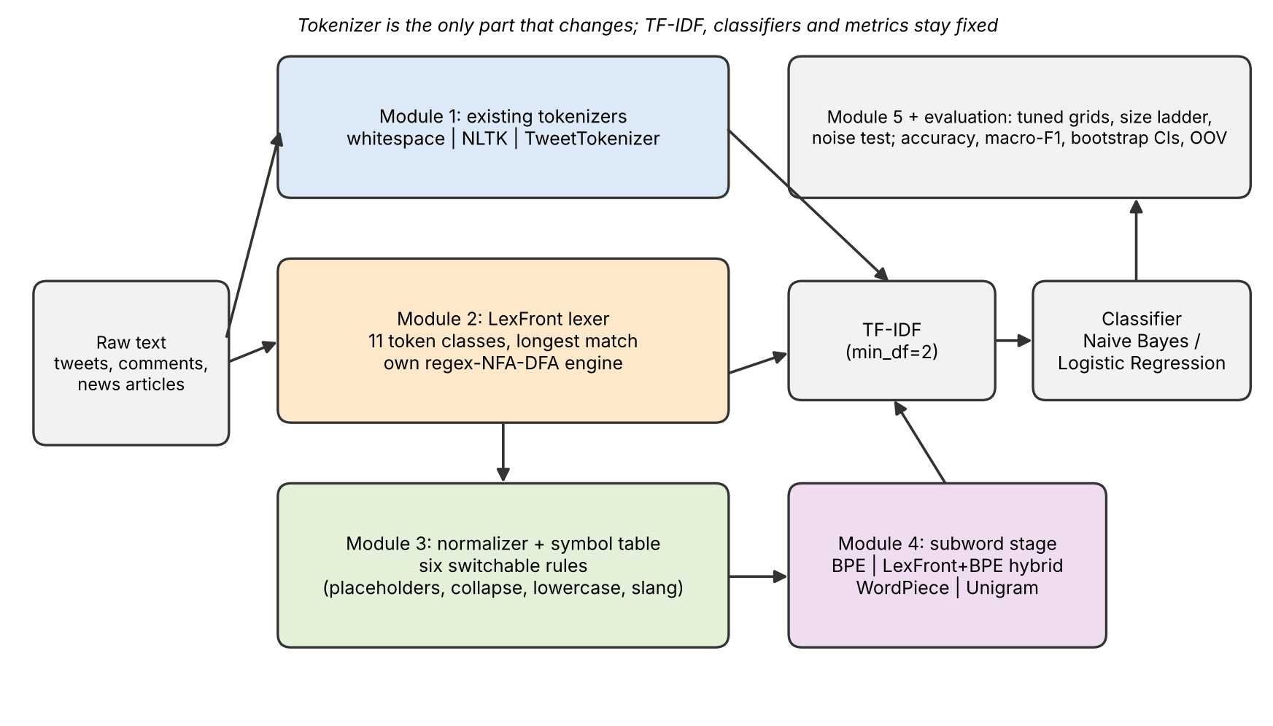
Figure 1. Architecture of the proposed system and its four modules

3.3 Module 1: Existing methodology (baseline)
Module 1 holds the setup that LexFront is compared against. It has three existing tokenizers, which are whitespace splitting, the NLTK word tokenizer and NLTK's TweetTokenizer [13]. Their tokens go into TF-IDF with min_df=2, and the features go into a majority-class baseline, Multinomial Naive Bayes (the existing method) and Logistic Regression with max_iter=1000 and seed 0. All fits run on a single thread, because we saw that the BLAS thread count changed some Logistic Regression metrics in the last digits. Every run writes a JSON file with its configuration, a fingerprint and the metrics, and stores its test predictions so that the confidence intervals can be computed without refitting.
The evaluation loop shared by all modules is short, and we give it as pseudocode below.
for dataset in [tweet_topic, go_emotions, ag_news]:
train, test <- load(dataset)
for tokenizer in tokenizer_list:
X_train <- TfidfVectorizer(tokenizer, min_df=2).fit_transform(train)
X_test <- vectorizer.transform(test)
for clf in [majority, naive_bayes, logistic_regression]:
clf.fit(X_train, y_train)
record <- {config, accuracy, macro_f1, timings, versions}
save record (with config + code fingerprint) and test predictions
tables, figures and statistics are built only from the saved files

3.4 Module 2: LexFront lexer and DFA engine
This is the main new module. LexFront defines eleven token classes in priority order (in lexer/token_spec.py): URL, MENTION, HASHTAG, EMOTICON, EMOJI, NUMBER, CONTRACTION, ELONGATED, WORD, PUNCT, and UNKNOWN as the fallback. A PLY-based scanner takes the longest match at each position, ties go to the earlier class, and a character that matches nothing becomes an UNKNOWN token so scanning continues, which is panic-mode recovery.
Besides the PLY lexer we wrote our own engine in lexer/dfa/. A recursive-descent parser turns each regular expression into an AST, Thompson construction [5] gives an NFA, subset construction [6] gives a DFA over an alphabet that is split into atoms, and Moore's partition refinement [7] minimizes it. The engine covers four classes (EMOTICON, HASHTAG, MENTION and WORD). The tokenizer used in the experiments is the PLY-based one, and our engine is a separate implementation that a test checks against it: it produces the same tokens on those four classes. ELONGATED is not part of the engine because its usual regex, (.)\1{2,}, needs a back-reference, which regular expressions cannot express.
The pseudocode below covers the two parts of this module: building the automaton, and scanning with it.
(a) regex -> NFA -> DFA -> minimized DFA
input : rules = [(name_0, regex_0), ..., (name_k, regex_k)]
# list order = priority
asts <- [parse(regex_i) for each rule]
atoms <- split the code-point line at every range boundary used in asts
NFA <- new start state
for i, ast in asts:
(s, t) <- thompson(ast)
add epsilon edge NFA.start -> s ; accepting[t] <- i
start_set <- eps_closure({NFA.start}); DFA.states <- {start_set}
while worklist not empty:
S <- pop(worklist)
for each atom a:
T <- eps_closure(move(S, a))
if T is non-empty: add T if new, set DFA.trans[S][a] <- T
for each DFA state S:
S.accepts <- min{accepting[q] : q in S} # priority
# Moore minimization
block[S] <- id of S.accepts
repeat: signature[S] <- (block[S], sorted (a, block[trans[S][a]]))
block[S] <- id of signature[S]
until the number of blocks stops growing
merge states with equal block

(b) longest-match scanner with error recovery
pos <- 0
while pos < len(text):
if text[pos] is whitespace: pos++ ; continue
state <- start ; last <- none ; i <- pos
while i < len(text):
state <- table[state][atom_of(text[i])]
if state == DEAD: break
i++
if accepts[state] is not none: last <- (i, accepts[state])
if last is none: # error recovery
emit (UNKNOWN, text[pos]) ; pos++
else:
emit (class[rule], text[pos:end]) ; pos <- end

3.5 Module 3: Normalizer, symbol table and rule ablation
After a token has been scanned, a semantic action maps it to its canonical form, much like the action block attached to a Lex rule. LexFront has six such rules in lexer/normalize.py, and each one can be switched on or off by itself. URLs become <URL>, mentions become <USER> and numbers become <NUM>. Runs of three or more identical letters are shortened to two ("sooooo" becomes "soo"). Word-like tokens are lowercased, and a lookup in a slang table of 30 entries expands things like "u" into "you". The symbol table stores an id, a frequency and a class for each token.
Because every rule has its own switch, we can run an ablation in which one rule is removed at a time, and a case-sensitivity check in which TF-IDF's own lowercasing is turned off. That is how we find out which rules actually help. Pseudocode for the normalizer follows.
normalize_token(cls, lexeme, config):
if cls == URL and config.url: return ["<URL>"]
if cls == MENTION and config.mention: return ["<USER>"]
if cls == NUMBER and config.number: return ["<NUM>"]
if cls not in {WORD, CONTRACTION, ELONGATED}: return [lexeme]
if cls == ELONGATED and config.elongated:
lexeme <- shorten every run of 3+ identical letters to 2
if config.lowercase: lexeme <- lowercase(lexeme)
if config.slang and lexeme in slang_table:
return split(slang_table[lexeme]) # may be several words
return [lexeme]

tokenize(text):
for (cls, lexeme) in scan(text):
for form in normalize_token(cls, lexeme, config):
symbol_table.update(form, cls) # id, frequency, class
emit form

ablation: for rule in [url, mention, number, elongated,
lowercase, slang, all]:
run the full pipeline with that rule switched off

3.6 Module 4: Subword stage and the LexFront + BPE hybrid
Module 4 adds learned vocabularies on top of, and next to, the word-level tokenizers. We trained BPE, WordPiece and Unigram models with the Hugging Face tokenizers library on the training split only, lowercased, with a vocabulary of 8000 pieces (BPE was also run at 32000). Pieces that continue a word carry the ## marker in BPE and WordPiece. We also built a two-stage hybrid that follows the compiler idea of passing different token types to different handlers. LexFront decides the class of each token first. Structural tokens such as placeholders, hashtags, emoticons, emoji, punctuation and error tokens are passed through whole, and only the word-like tokens are handed to a BPE model that was trained on the word-like tokens of the training texts.
Making the training deterministic took some care. The trainer assigns ids to the ## alphabet in hash-map order, so two trainings on the same text could merge in a different order. We fixed this by passing a sorted alphabet as special tokens and removing them from the added-token list afterwards. We also checked that texts from the test split do not leak into the trained vocabularies. The hybrid is described in the pseudocode below.
train_hybrid(train_texts):
words <- []
for text in train_texts:
for (cls, lexeme, forms) in LexFront.analyze(lowercase(text)):
if cls in {WORD, CONTRACTION, ELONGATED}: words.extend(forms)
BPE <- train_bpe(join(words), vocab_size, sorted_alphabet)

tokenize_hybrid(text):
out <- []
for (cls, lexeme, forms) in LexFront.analyze(text):
for form in forms:
if cls in {WORD, CONTRACTION, ELONGATED}:
out.extend(BPE.encode(form))
else:
out.append(form) # structural: pass through
return out

4. Results and Implementation
The system is written in Python and every number below was read from the JSON result files in the repository, which are written by the scripts we ran. All results are on full data with no subsampling, one training run per cell. The 95% confidence intervals are paired percentile bootstraps over the test examples, with McNemar's test for accuracy. They cover the draw of the test set, not training randomness, since each cell is a single run.

4.1 Dataset description
We used three English datasets that differ in style and size. tweet_topic [40] has tweets labelled with six topics. go_emotions [41] has Reddit comments labelled with 28 emotion classes, and we kept only the single-label examples. ag_news [42] has news articles in four categories. The first two are noisy and informal, while ag_news is relatively clean, which gives us a useful contrast. The last column of Table 1 is the share of the largest class in the test set, which is also the accuracy of the majority baseline.
Table 1. Datasets used (results/datasets.json)
Dataset | Source | Train docs | Test docs | Labels | Largest test class %
tweet_topic | cardiffnlp/tweet_topic_single | 3,598 | 3,399 | 6 | 40.01
go_emotions | go_emotions (simplified) | 36,308 | 4,590 | 28 | 34.99
ag_news | fancyzhx/ag_news | 120,000 | 7,600 | 4 | 25.00

4.2 Module 1: existing tokenizers
Table 2 gives accuracy and macro-F1 for the three existing tokenizers with each classifier. The first thing we notice is how little the tokenizer matters compared with the classifier. On go_emotions, switching from Naive Bayes to Logistic Regression is worth around 17 points for every tokenizer, while the spread between tokenizers under Logistic Regression is about 2 points. NLTK and TweetTokenizer are slightly ahead of plain whitespace splitting in nearly every row. Naive Bayes on go_emotions is close to the majority baseline in accuracy, and its macro-F1 is very low, which means it mostly predicts the large classes.
Table 2. Accuracy / macro-F1 (%), existing tokenizers (results/module1/)
Dataset | Tokenizer | Majority | Naive Bayes | Logistic Reg.
tweet_topic | whitespace | 40.01 / 9.53 | 70.26 / 28.83 | 70.49 / 35.76
tweet_topic | nltk | 40.01 / 9.53 | 70.99 / 28.56 | 72.32 / 36.95
tweet_topic | tweet | 40.01 / 9.53 | 70.79 / 28.31 | 72.02 / 36.70
go_emotions | whitespace | 34.99 / 1.85 | 37.73 / 4.93 | 53.51 / 31.40
go_emotions | nltk | 34.99 / 1.85 | 37.78 / 4.88 | 55.27 / 33.86
go_emotions | tweet | 34.99 / 1.85 | 37.80 / 4.86 | 55.47 / 34.02
ag_news | whitespace | 25.00 / 10.00 | 90.14 / 90.12 | 91.43 / 91.42
ag_news | nltk | 25.00 / 10.00 | 90.38 / 90.35 | 91.88 / 91.87
ag_news | tweet | 25.00 / 10.00 | 90.22 / 90.20 | 91.84 / 91.83

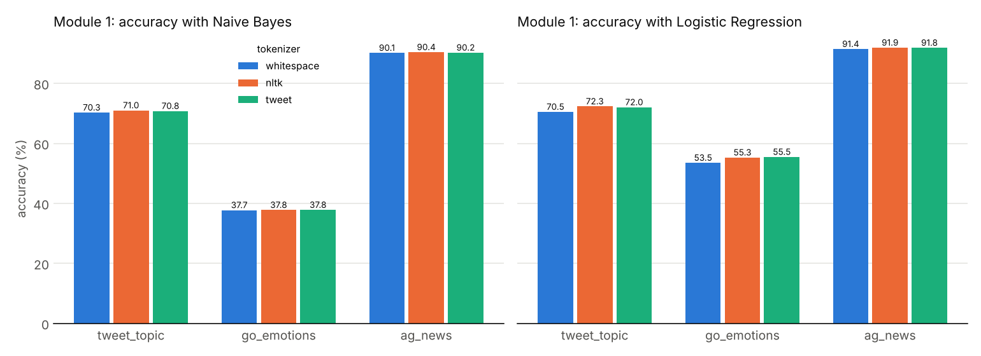
Figure 2. Accuracy of the existing tokenizers (results/figures/module1_accuracy.png)

4.3 Module 2: LexFront lexer and DFA engine
Automaton sizes
Table 3 shows how big each automaton is. The four classes are small. The combined automaton goes from 43 NFA states to 12 DFA states, and minimization brings it down to 10. WORD shrinks from 3 DFA states to 2 and EMOTICON from 6 to 5, so minimization does remove real redundancy. We also compiled ELONGATED by spelling it out as 26 separate branches, only to see what happens. It is not part of LexFront, but it shows how fast the construction can grow, from 221 NFA states to 157 DFA states and 54 after minimization.
Table 3. Automaton sizes (results/module2/dfa_states.json)
Automaton | Alphabet atoms | NFA states | DFA states | Minimized DFA states
MENTION | 5 | 9 | 3 | 3
HASHTAG | 8 | 9 | 3 | 3
EMOTICON | 17 | 19 | 6 | 5
WORD | 6 | 9 | 3 | 2
Combined (4 classes) | 31 | 43 | 12 | 10
ELONGATED, 26 branches (extra) | 26 | 221 | 157 | 54

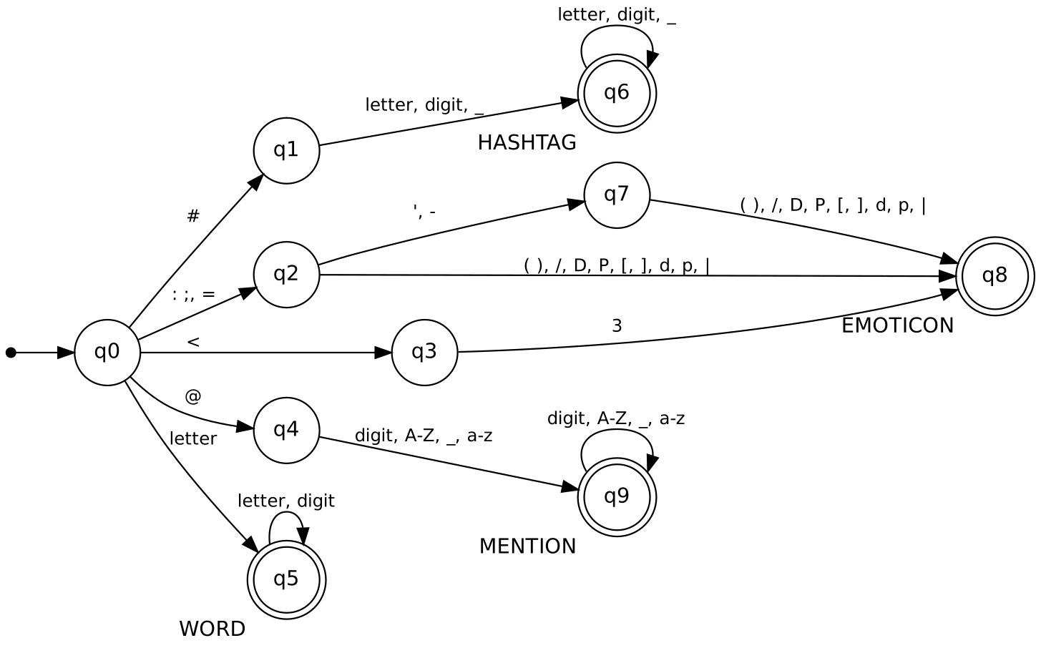
Figure 3. The minimized combined DFA (results/module2/dfa_min.png)
Intrinsic metrics
Table 4 compares the word-level tokenizers on three intrinsic measures. LexFront has the lowest out-of-vocabulary rate and the smallest vocabulary on all three datasets. On ag_news, for example, its OOV rate is 0.48% against 0.96% for NLTK, and its vocabulary has 65,337 types against 98,994. We need to be careful with this result. Part of it is built in, because placeholders and collapsed letters shrink the vocabulary by design, so it is not evidence of better classification by itself. The accuracy results are the real check, and we look at them next.
Table 4. Intrinsic metrics of the word-level tokenizers (results/module2/intrinsic__*.json)
Dataset | Tokenizer | OOV rate % (tokens) | Fertility | Vocabulary size
tweet_topic | whitespace | 18.45 | 1.000 | 21,653
tweet_topic | nltk | 8.74 | 1.431 | 15,712
tweet_topic | tweet | 9.86 | 1.376 | 16,524
tweet_topic | lexfront | 8.25 | 1.391 | 14,483
go_emotions | whitespace | 6.04 | 1.000 | 44,476
go_emotions | nltk | 2.57 | 1.220 | 26,410
go_emotions | tweet | 2.56 | 1.195 | 25,907
go_emotions | lexfront | 2.45 | 1.195 | 24,459
ag_news | whitespace | 1.90 | 1.000 | 158,733
ag_news | nltk | 0.96 | 1.158 | 98,994
ag_news | tweet | 0.75 | 1.154 | 86,096
ag_news | lexfront | 0.48 | 1.207 | 65,337

Classification with LexFront
Table 5 gives the main comparison. We call LexFront with Logistic Regression our proposed setup and NLTK with Naive Bayes the existing one. The proposed setup is 17.58 points higher on go_emotions and 1.50 higher on ag_news, and 0.26 lower on tweet_topic, so on the surface it looks good. The last two columns separate the effects. NLTK with Logistic Regression scores about the same as LexFront with Logistic Regression on go_emotions and ag_news, which tells us that nearly all of the gain is the classifier and not the tokenizer. This is why we report the tokenizer-only comparison in Section 5 as the fair one.
Table 5. Proposed (LexFront+LR) versus existing (NLTK+NB), accuracy / macro-F1 (%)
Dataset | NLTK+NB | LexFront+LR | Delta acc (pts) | LexFront+NB | NLTK+LR
tweet_topic | 70.99 / 28.56 | 70.73 / 36.18 | -0.26 | 70.43 / 27.84 | 72.32 / 36.95
go_emotions | 37.78 / 4.88 | 55.36 / 33.97 | +17.58 | 37.78 / 4.81 | 55.27 / 33.86
ag_news | 90.38 / 90.35 | 91.88 / 91.86 | +1.50 | 90.08 / 90.05 | 91.88 / 91.87

4.4 Module 3: Normalizer and rule ablation
Table 6 shows the effect of removing one rule at a time in the main setting, where TF-IDF still lowercases the text. In this setting no single-rule removal gives an accuracy interval that excludes 0, so none of the individual rules shows a clear effect on its own. One more thing explains part of this. The URL rule never fires on tweet_topic and go_emotions, and the mention rule never fires on ag_news, because those datasets already mask URLs and handles. For those cases the removal is not a real test of the rule. The one setting that does stand out is removing every rule on tweet_topic, which raises accuracy by 1.09 points [+0.50, +1.71]. In other words, on that dataset the normalization as a whole does not help.
Table 6. Per-rule ablation, accuracy change versus full LexFront+LR (points, 95% CI), main setting (results/ablation)
Variant removed | tweet_topic | go_emotions | ag_news
url | +0.00 [+0.00, +0.00] | +0.00 [+0.00, +0.00] | +0.01 [-0.07, +0.09]
mention | +0.41 [-0.03, +0.82] | -0.02 [-0.13, +0.07] | +0.00 [+0.00, +0.00]
number | +0.50 [-0.03, +1.00] | -0.11 [-0.26, +0.04] | +0.07 [-0.07, +0.20]
elongated | +0.09 [-0.09, +0.26] | +0.00 [-0.11, +0.13] | +0.04 [-0.04, +0.12]
slang | -0.06 [-0.35, +0.24] | -0.04 [-0.24, +0.15] | +0.03 [-0.03, +0.09]
all rules off | +1.09 [+0.50, +1.71] | -0.17 [-0.41, +0.07] | +0.11 [-0.04, +0.25]

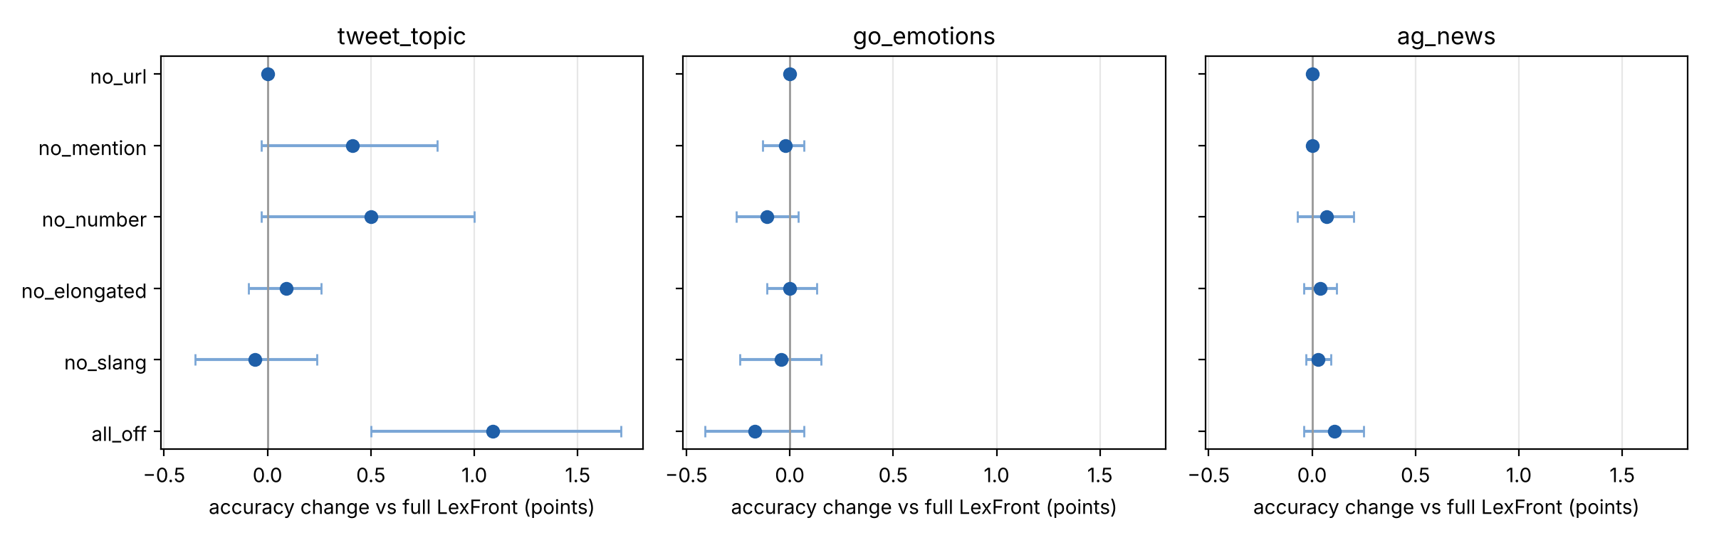
Figure 4. Rule ablation: accuracy change with 95% intervals (main setting)
The case-sensitivity check tells a clearer story. When TF-IDF's own lowercasing is switched off, the lowercase rule inside LexFront becomes the one that matters. Removing it lowers accuracy by 0.91 points on tweet_topic [-1.71, -0.09] and by 1.07 on go_emotions [-1.72, -0.44], while ag_news does not change in a clear way (+0.14 [-0.17, +0.46]). The same check explains a result we noticed earlier. With case kept, LexFront barely moves, with Logistic Regression accuracy changing by only -0.03, -0.02 and +0.04 points on the three datasets, while the baseline tokenizers lose between 0.6 and 1.3 points on tweet_topic and go_emotions, because they leave capitalised words alone. With case kept, LexFront beats NLTK on go_emotions by 1.15 points [+0.46, +1.85]. Our reading is that this advantage comes from the lowercase rule alone, and since TF-IDF lowercases by default, it disappears in the main setting.
Table 7. Case kept (TF-IDF lowercase=False): LexFront+LR minus NLTK+LR, accuracy points [95% CI] (results/sensitivity_case)
Dataset | Case kept | Main setting
tweet_topic | -0.91 [-1.88, +0.09] | -1.59 [-2.38, -0.82]
go_emotions | +1.15 [+0.46, +1.85] | +0.09 [-0.35, +0.54]
ag_news | -0.18 [-0.55, +0.20] | +0.00 [-0.32, +0.33]

4.5 Module 4: Subword stage
Table 8 lists the subword runs next to the two word-level references. BPE with a vocabulary of 8,000 shows no accuracy gain over NLTK with Logistic Regression. The intervals include 0 on tweet_topic (-0.41 [-1.27, +0.44]) and go_emotions (-0.04 [-0.68, +0.59]), and on ag_news it is 0.75 points lower [-1.13, -0.37]. The LexFront + BPE hybrid is below LexFront alone on all three datasets, by 0.82, 0.72 and 0.86 points, and 17 of the 24 intervals in the hybrid comparison at vocabulary 8,000 exclude 0, all pointing down. A bigger vocabulary (32,000) reduced this, since 8 of 24 intervals exclude 0 there. Our guess, which we have not tested, is that the hybrid splits up words that the word-level scanner already handled well, so it adds noise. For WordPiece and Unigram, none is above NLTK with Logistic Regression in accuracy with an interval that excludes 0, and on ag_news both are below it (-0.41 and -0.91). The one interval that is above NLTK is Unigram's macro-F1 on go_emotions (+1.26 [+0.10, +2.39]), which is 1 of 30 comparisons and could easily be chance.
Table 8. Subword runs, Logistic Regression, accuracy / macro-F1 (%), vocabulary 8000 (results/bpe, results/subword2)
Dataset | NLTK+LR | LexFront+LR | BPE+LR | LexFront+BPE+LR | WordPiece+LR | Unigram+LR
tweet_topic | 72.32 / 36.95 | 70.73 / 36.18 | 71.90 / 35.09 | 69.90 / 33.56 | 71.61 / 34.88 | 73.05 / 36.49
go_emotions | 55.27 / 33.86 | 55.36 / 33.97 | 55.23 / 33.29 | 54.64 / 32.59 | 55.12 / 33.12 | 55.71 / 35.12
ag_news | 91.88 / 91.87 | 91.88 / 91.86 | 91.13 / 91.12 | 91.03 / 91.01 | 91.47 / 91.46 | 90.97 / 90.96

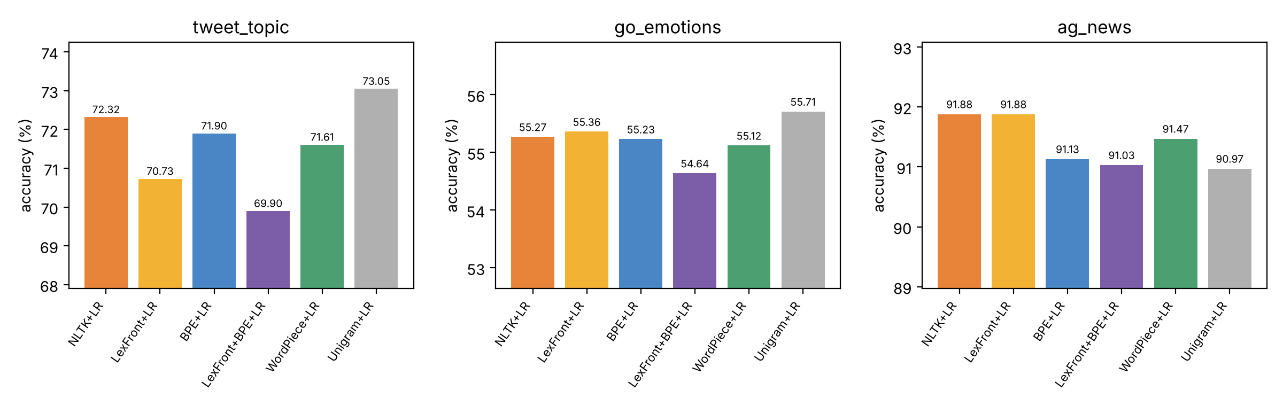
Figure 5. Accuracy of the subword tokenizers with Logistic Regression
The OOV rate of the subword tokenizers is close to zero, for example 0.44% for BPE and 0.31% for WordPiece on tweet_topic, because rare words are split into pieces instead of being left unknown. That number is not comparable with the word-level OOV rates in Table 4, and the price is more tokens per word (fertility goes up to between 1.3 and 1.8).

5. Performance and Metrics
This section pulls the comparison together. We use two metrics, accuracy and macro-F1. Macro-F1 matters on tweet_topic and go_emotions, where the classes are unbalanced, because a model can have decent accuracy by favouring the large classes. We also report paired 95% bootstrap intervals and McNemar's test, so that each difference comes with a statement of how large the test-set noise is.

5.1 Accuracy: existing versus proposed
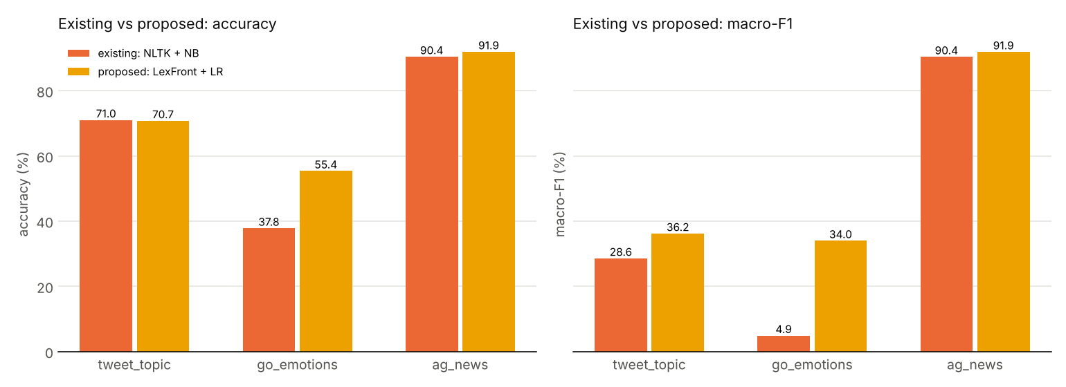
Figure 6. Existing (NLTK+NB) versus proposed (LexFront+LR), accuracy and macro-F1
Figure 6 shows the headline comparison, which is the same one as in Table 5. The proposed setup is higher on go_emotions and ag_news and about level on tweet_topic in accuracy. In macro-F1 it is higher on all three, by 7.62 points on tweet_topic and 29.09 on go_emotions. The tokenizer-only comparison in Table 9 shows where that comes from.

5.2 Separating the tokenizer from the classifier
Table 9. Paired differences, accuracy points [95% CI] (results/stats/bootstrap.json)
Dataset | Comparison | Accuracy pts [95% CI] | Macro-F1 pts [95% CI] | McNemar p
tweet_topic | LexFront+LR minus NLTK+LR (tokenizer only) | -1.59 [-2.38, -0.82] | -0.77 [-1.81, +0.32] | < 0.001
tweet_topic | LexFront+LR minus NLTK+NB (proposed minus existing) | -0.26 [-1.47, +0.91] | +7.62 [+5.93, +9.31] | -
go_emotions | LexFront+LR minus NLTK+LR (tokenizer only) | +0.09 [-0.35, +0.54] | +0.11 [-0.51, +0.77] | 0.773
go_emotions | LexFront+LR minus NLTK+NB (proposed minus existing) | +17.58 [+16.21, +18.95] | +29.09 [+27.32, +31.07] | -
ag_news | LexFront+LR minus NLTK+LR (tokenizer only) | +0.00 [-0.32, +0.33] | -0.01 [-0.33, +0.33] | 1.000
ag_news | LexFront+LR minus NLTK+NB (proposed minus existing) | +1.50 [+1.00, +1.99] | +1.51 [+1.01, +2.01] | -

Reading Table 9 row by row, the tokenizer-only differences are the fair test of LexFront. On go_emotions and ag_news the intervals include 0, so LexFront and NLTK are indistinguishable there. On tweet_topic LexFront is 1.59 points lower and that difference is significant (McNemar p < 0.001). The proposed-minus-existing rows are large on go_emotions and ag_news, but almost all of that is the move from Naive Bayes to Logistic Regression: with NLTK held fixed, the classifier change alone is worth +17.49 on go_emotions and +1.50 on ag_news. So we do not claim that LexFront is better. What the data support is that it does about as well as NLTK on two of the datasets and somewhat worse on one, and that it gives a smaller vocabulary and a lower OOV rate.

5.3 Intrinsic and subword comparison
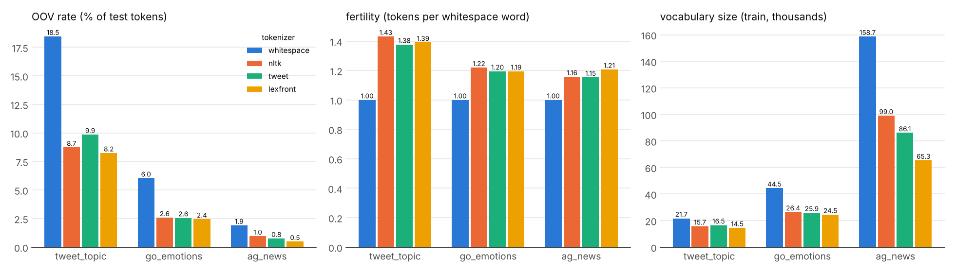
Figure 7. OOV rate, fertility and vocabulary size by tokenizer (results/figures/intrinsic_metrics.png)
On the intrinsic side, LexFront has the best OOV rate and vocabulary size among the word-level tokenizers, with fertility close to the others. Throughput is in the same range as NLTK's, from about 0.84 times NLTK's speed on ag_news to 1.48 times on go_emotions on our machine, so the lexer is not a bottleneck. On the subword side (Figure 5 and Table 8) no learned tokenizer is clearly better than NLTK in accuracy. Taken together, the dataset and classifier matter much more than the choice of tokenizer in this setting.

5.4 Limits of these measurements
A few cautions apply to all of the numbers. There is one training run per cell, so training randomness is not covered by the intervals. We ran many comparisons and did not correct for multiple testing, which is why we mention that 6 of 42 interval comparisons in the rule ablation exclude 0 when about 2 would be expected by chance. There are only three datasets and one family of classifiers, so we cannot say anything about neural models, other languages or code-mixed text. All reasons we give for why a difference appears are hypotheses, not tested conclusions.

6. Conclusion
We built LexFront, a compiler-style lexer for noisy English text, with our own regex-to-DFA engine, a normalizer with six switchable rules, a symbol table and error recovery, and compared it with existing and subword tokenizers under a fixed classifier. The engine works as intended: the combined automaton goes from 43 NFA states to 12 DFA states and 10 minimized states, and it agrees with the PLY lexer on the four classes it covers. The classification experiments themselves run on the PLY-based lexer.
On the question we started with, the answer so far is that a compiler-style lexer is competitive but not better. With the tokenizer as the only change, LexFront matches NLTK on go_emotions and ag_news and is 1.59 points lower on tweet_topic. It does produce a smaller vocabulary and a lower out-of-vocabulary rate, and its lowercase rule is what gives it an edge when case is kept. Most of the gain over the existing Naive Bayes setup comes from the classifier. The hybrid with BPE and the WordPiece and Unigram runs did not improve on the word-level baseline.
There is still work to do before the final review. We want to test LexFront at a larger scale and with wider classifier settings, and to finish the report and the demo. Those results will tell us whether the picture above holds up, and we will report them in the same careful way, including the cases where LexFront does not win.

References
[1] A. V. Aho, M. S. Lam, R. Sethi, and J. D. Ullman, Compilers: Principles, Techniques, and Tools, 2nd ed. Boston, MA, USA: Addison-Wesley, 2006.
[2] K. Gimpel et al., "Part-of-speech tagging for Twitter: Annotation, features, and experiments," in Proc. 49th Annu. Meeting Assoc. Comput. Linguistics (ACL-HLT), Portland, OR, USA, 2011, pp. 42-47.
[3] B. Han and T. Baldwin, "Lexical normalisation of short text messages: Makn sens a #twitter," in Proc. 49th Annu. Meeting Assoc. Comput. Linguistics (ACL-HLT), Portland, OR, USA, 2011, pp. 368-378.
[4] R. Sennrich, B. Haddow, and A. Birch, "Neural machine translation of rare words with subword units," in Proc. 54th Annu. Meeting Assoc. Comput. Linguistics (ACL), Berlin, Germany, 2016, pp. 1715-1725.
[5] K. Thompson, "Programming techniques: Regular expression search algorithm," Commun. ACM, vol. 11, no. 6, pp. 419-422, Jun. 1968.
[6] J. E. Hopcroft, R. Motwani, and J. D. Ullman, Introduction to Automata Theory, Languages, and Computation, 3rd ed. Boston, MA, USA: Pearson, 2006.
[7] E. F. Moore, "Gedanken-experiments on sequential machines," in Automata Studies, C. E. Shannon and J. McCarthy, Eds. Princeton, NJ, USA: Princeton Univ. Press, 1956, pp. 129-153.
[8] M. E. Lesk and E. Schmidt, "Lex: A lexical analyzer generator," Bell Laboratories, Murray Hill, NJ, USA, Comput. Sci. Tech. Rep. 39, 1975.
[9] S. C. Johnson, "Yacc: Yet another compiler-compiler," Bell Laboratories, Murray Hill, NJ, USA, Comput. Sci. Tech. Rep. 32, 1975.
[10] D. Beazley, "PLY (Python Lex-Yacc)," software documentation. [Online]. Available: https://www.dabeaz.com/ply/
[11] O. Owoputi, B. O'Connor, C. Dyer, K. Gimpel, N. Schneider, and N. A. Smith, "Improved part-of-speech tagging for online conversational text with word clusters," in Proc. Conf. North Amer. Chapter Assoc. Comput. Linguistics: Human Lang. Technol. (NAACL-HLT), Atlanta, GA, USA, 2013, pp. 380-390.
[12] T. Baldwin, M.-C. de Marneffe, B. Han, Y.-B. Kim, A. Ritter, and W. Xu, "Shared tasks of the 2015 workshop on noisy user-generated text: Twitter lexical normalization and named entity recognition," in Proc. Workshop Noisy User-generated Text (W-NUT), Beijing, China, 2015, pp. 126-135.
[13] S. Bird, E. Klein, and E. Loper, Natural Language Processing with Python. Sebastopol, CA, USA: O'Reilly Media, 2009.
[14] C. D. Manning, P. Raghavan, and H. Schutze, Introduction to Information Retrieval. Cambridge, U.K.: Cambridge Univ. Press, 2008.
[15] D. Q. Nguyen, T. Vu, and A. T. Nguyen, "BERTweet: A pre-trained language model for English tweets," in Proc. Conf. Empirical Methods Natural Lang. Process.: Syst. Demonstrations (EMNLP), 2020, pp. 9-14.
[16] M. Schuster and K. Nakajima, "Japanese and Korean voice search," in Proc. IEEE Int. Conf. Acoust., Speech, Signal Process. (ICASSP), Kyoto, Japan, 2012, pp. 5149-5152.
[17] Y. Wu et al., "Google's neural machine translation system: Bridging the gap between human and machine translation," arXiv:1609.08144, 2016.
[18] T. Kudo, "Subword regularization: Improving neural network translation models with multiple subword candidates," in Proc. 56th Annu. Meeting Assoc. Comput. Linguistics (ACL), Melbourne, Australia, 2018, pp. 66-75.
[19] T. Kudo and J. Richardson, "SentencePiece: A simple and language independent subword tokenizer and detokenizer for neural text processing," in Proc. Conf. Empirical Methods Natural Lang. Process.: Syst. Demonstrations (EMNLP), Brussels, Belgium, 2018, pp. 66-71.
[20] J. Devlin, M.-W. Chang, K. Lee, and K. Toutanova, "BERT: Pre-training of deep bidirectional transformers for language understanding," in Proc. Conf. North Amer. Chapter Assoc. Comput. Linguistics: Human Lang. Technol. (NAACL-HLT), Minneapolis, MN, USA, 2019, pp. 4171-4186.
[21] Y. Liu et al., "RoBERTa: A robustly optimized BERT pretraining approach," arXiv:1907.11692, 2019.
[22] K. Bostrom and G. Durrett, "Byte pair encoding is suboptimal for language model pretraining," in Findings Assoc. Comput. Linguistics: EMNLP 2020, 2020, pp. 4617-4624.
[23] P. Rust, J. Pfeiffer, I. Vulic, S. Ruder, and I. Gurevych, "How good is your tokenizer? On the monolingual performance of multilingual language models," in Proc. 59th Annu. Meeting Assoc. Comput. Linguistics and 11th Int. Joint Conf. Natural Lang. Process. (ACL-IJCNLP), 2021, pp. 3118-3135.
[24] C. Toraman, E. H. Yilmaz, F. Sahinuc, and O. Ozcelik, "Impact of tokenization on language models: An analysis for Turkish," ACM Trans. Asian Low-Resour. Lang. Inf. Process., vol. 22, no. 4, 2023.
[25] S. J. Mielke et al., "Between words and characters: A brief history of open-vocabulary modeling and tokenization in NLP," arXiv:2112.10508, 2021.
[26] P. Bojanowski, E. Grave, A. Joulin, and T. Mikolov, "Enriching word vectors with subword information," Trans. Assoc. Comput. Linguistics, vol. 5, pp. 135-146, 2017.
[27] A. McCallum and K. Nigam, "A comparison of event models for naive Bayes text classification," in Proc. AAAI-98 Workshop Learning Text Categorization, Madison, WI, USA, 1998, pp. 41-48.
[28] S. Wang and C. D. Manning, "Baselines and bigrams: Simple, good sentiment and topic classification," in Proc. 50th Annu. Meeting Assoc. Comput. Linguistics (ACL), Short Papers, Jeju Island, Korea, 2012, pp. 90-94.
[29] A. Joulin, E. Grave, P. Bojanowski, and T. Mikolov, "Bag of tricks for efficient text classification," in Proc. 15th Conf. Eur. Chapter Assoc. Comput. Linguistics (EACL), Short Papers, Valencia, Spain, 2017, pp. 427-431.
[30] K. Sparck Jones, "A statistical interpretation of term specificity and its application in retrieval," J. Documentation, vol. 28, no. 1, pp. 11-21, 1972.
[31] G. Salton and C. Buckley, "Term-weighting approaches in automatic text retrieval," Inf. Process. Manage., vol. 24, no. 5, pp. 513-523, 1988.
[32] T. Mikolov, K. Chen, G. Corrado, and J. Dean, "Efficient estimation of word representations in vector space," arXiv:1301.3781, 2013.
[33] J. Pennington, R. Socher, and C. D. Manning, "GloVe: Global vectors for word representation," in Proc. Conf. Empirical Methods Natural Lang. Process. (EMNLP), Doha, Qatar, 2014, pp. 1532-1543.
[34] A. Vaswani et al., "Attention is all you need," in Adv. Neural Inf. Process. Syst. (NIPS), vol. 30, Long Beach, CA, USA, 2017, pp. 5998-6008.
[35] F. Pedregosa et al., "Scikit-learn: Machine learning in Python," J. Mach. Learn. Res., vol. 12, pp. 2825-2830, 2011.
[36] B. Efron, "Bootstrap methods: Another look at the jackknife," Ann. Statist., vol. 7, no. 1, pp. 1-26, 1979.
[37] Q. McNemar, "Note on the sampling error of the difference between correlated proportions or percentages," Psychometrika, vol. 12, no. 2, pp. 153-157, 1947.
[38] T. G. Dietterich, "Approximate statistical tests for comparing supervised classification learning algorithms," Neural Comput., vol. 10, no. 7, pp. 1895-1923, 1998.
[39] R. Dror, G. Baumer, S. Shlomov, and R. Reichart, "The hitchhiker's guide to testing statistical significance in natural language processing," in Proc. 56th Annu. Meeting Assoc. Comput. Linguistics (ACL), Melbourne, Australia, 2018, pp. 1383-1392.
[40] D. Antypas et al., "Twitter topic classification," in Proc. 29th Int. Conf. Comput. Linguistics (COLING), Gyeongju, South Korea, 2022, pp. 3386-3400.
[41] D. Demszky, D. Movshovitz-Attias, J. Ko, A. Cowen, G. Nemade, and S. Ravi, "GoEmotions: A dataset of fine-grained emotions," in Proc. 58th Annu. Meeting Assoc. Comput. Linguistics (ACL), 2020, pp. 4040-4054.
[42] X. Zhang, J. Zhao, and Y. LeCun, "Character-level convolutional networks for text classification," in Adv. Neural Inf. Process. Syst. (NIPS), vol. 28, Montreal, QC, Canada, 2015, pp. 649-657.

