1. Implement the following using SASS  
   -Use the HTML code from homework.html  
   -Create the SASS easy to change (backgrounds, fonts)  
   -Use mixins for clears, gradients)  
   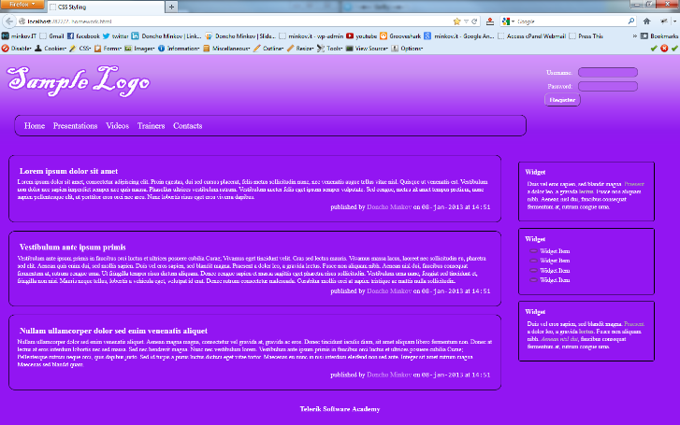
2. Create a web gallery  
   -Use only HTML, SASS and CSS  
   -List images  
   -When an image is selected, show it zoomed  
   