Protokoll

1. Design and Architecture
We have created an application based on the GUI frameworks C# (WPF). Our TourPlanner is structured in more layers: BussinessLayer, DataAccessLayer and UILayer.
- BussinessLayer
In the Bussiness layer, we implemented two classes: BussinessFactory and BussinessLogic.
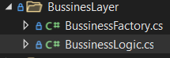
In the BussinessFactory we are reading all information from the config file (Resources\Settings.xml) with XMLReader class, which we implemented in Util folder in our Solution. In the BussinessFactory we are putting all information in the objects, we implemented in DTO folder, so it will be easier for use to use it, later in the project. We also created an Instance for the BussinessFactory, so we can easily use the data, so we used Singleton pattern.

Credentials for the Database connection and HttpRequests are located in the Settings.xml and in BussinessFactory used and stored in DatabaseDTO and in HttpDTO. We also implemented the Crypto class in the Util folder and used it to hash all credentials.
All Sql Commands we also implemented in Settings.xml and stored them in SqlDTO. And we used Settings file to define all paths we are going to use in the application.
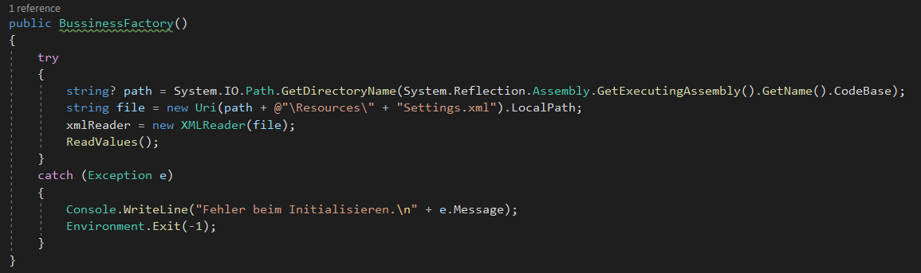

In the BussinessLogic we implemented all the functions, we will need for this application to work. We are getting the objects from the BussinessFactory and we are using them in the BussinessLogic.

We are in almost every function using just string routeId as parameter. And most of the functions, have a Boolean as return type, so we can use this in the UI for the interaction with the user.
Also, we implemented some functions in the Documents folder, which we are using for the report creation and import and export.
For the import and export function, we used .xml format.

For the unique feature, we implemented the function to make the route favorite. User should click on the button and in database the column for the favorite route will be updated.
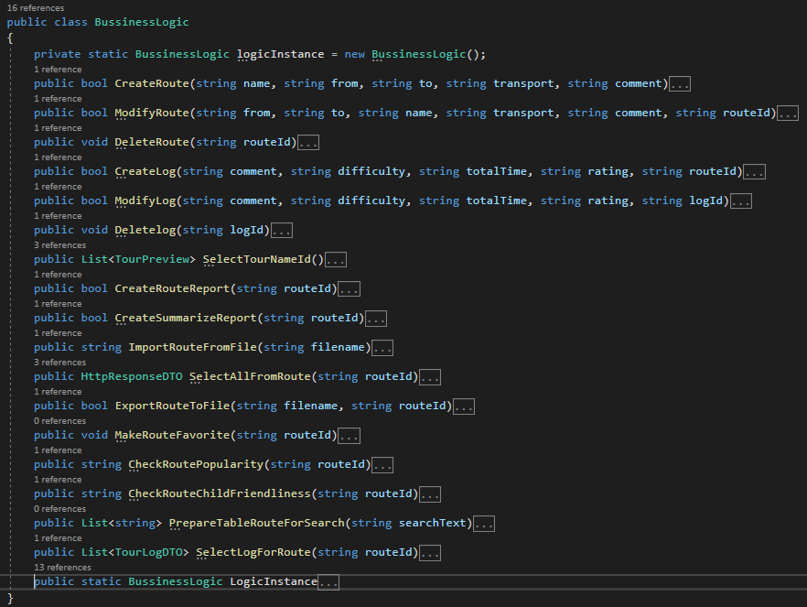

- DataAccessLayer
In the DataAccessLayer we implemented two classes: HttpRequest and DatabaseConnection.
We also used Singleton pattern here, so that will be easier to use it later on.
In the HttpRequest class we created two functions for the requests. To the first one, we are sending just the HttpDTO and we are receiving a new object with the response from the API.
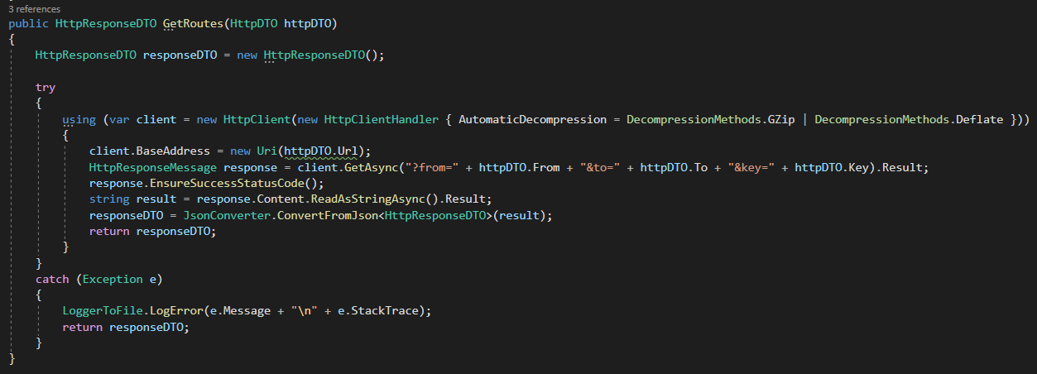

To the second function we are sending the object we already filled with the response from API, to get the image. We are saving the image on the local disc and its path to the database.

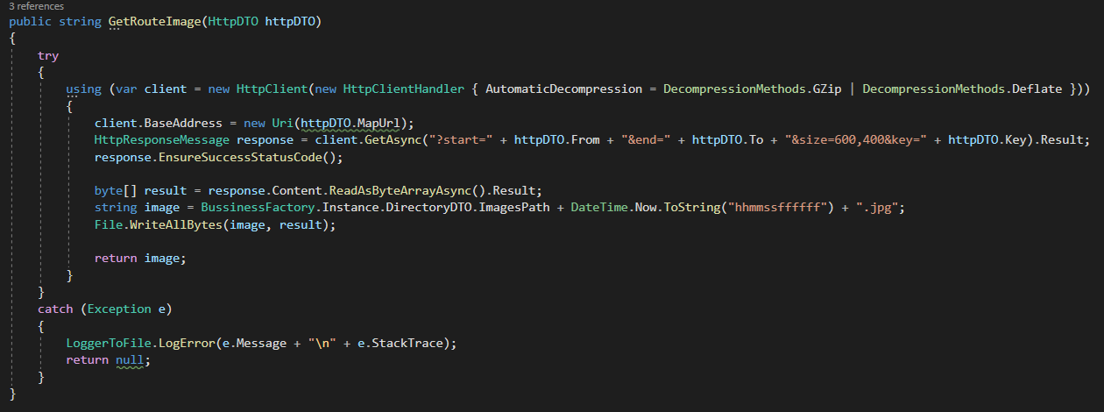

In the DatabaseConnection class we implemented all the functions we are using for the communication with database and also the connection to database.
Here we used Singleton pattern as well.
We also created LoggerToFile class in the Util folder and we used it to not allow SQL injections. LoggerToFile we used in every function to write the exception to the log file.

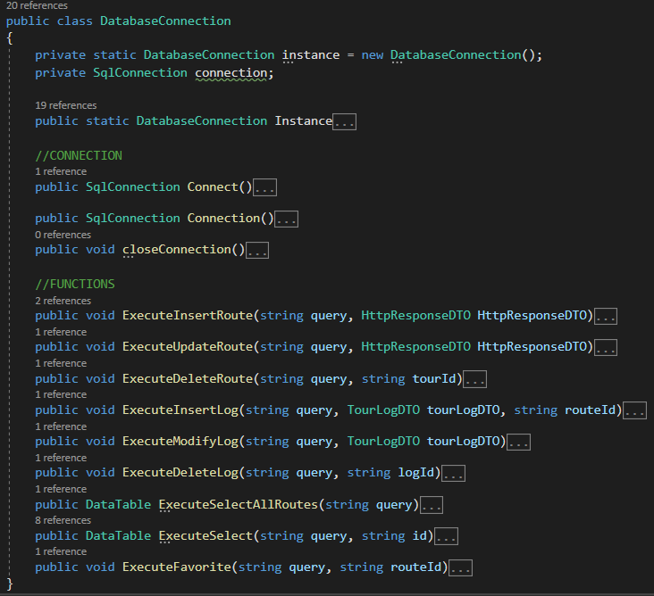

- UILayer
This is the top-most layer of the application where the user performs their activity. Let's take the example of any application where the user needs to fill up a form. This form is nothing but the Presentation Layer. In Windows applications Windows Forms are the Presentation Layer and in web applications the web form belongs to the Presentation Layer. Basically, the user's input validation and rule processing is done in this layer.
This is the top-most layer where the user interacts with the system. We will create simple windows as in the following:
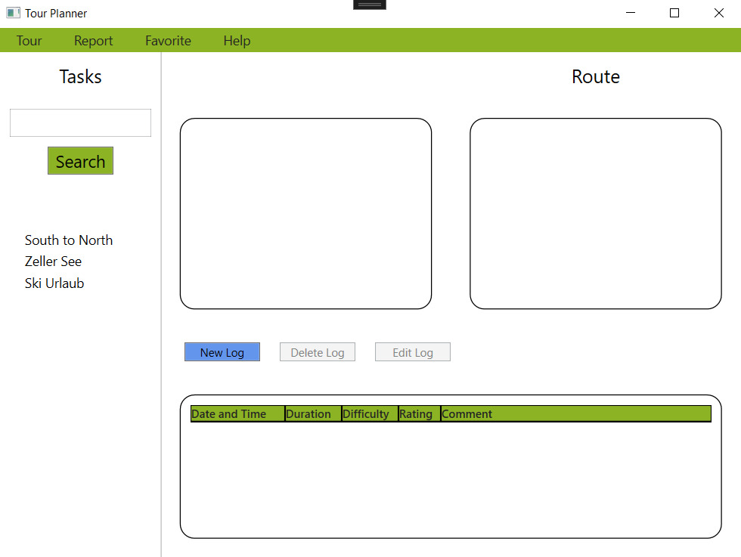
The form contains one Menu with several Menu Items, Borders, Labels, Buttons, one List and two DataGrids. We also used Style Definitions for most of the Elements. In the load event of the form, we will pull all data and it will show in the DataGrid. There is another operation, where can the user fetch a specific tour by providing a text in the search box.

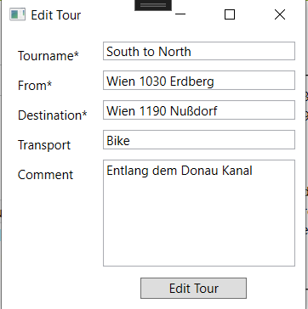
New and Edit Tour Windows
There are also four other windows that the user can call up. NewTourWindow.xaml and EditTourWindow are two of them and are quite similar but have a separate structure and look like this (see right).
The form consists of a grid containing labels, text boxes and a button. When editing a tour, the data from the ViewModel is inserted into the window to be able to edit existing data easily and not have to rewrite it. However, the NewTourWindow must remain empty when opened.

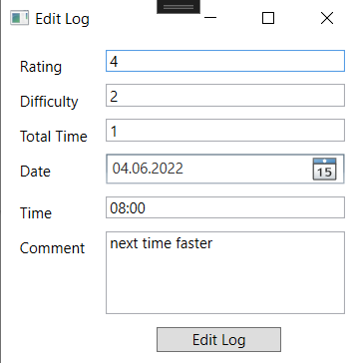
New and Edit Log Windows
The two remaining windows are CreateLogWindow.xaml and EditLogWindow.xaml, which are also quite similar.
The form consists of a grid containing labels, text boxes, a datepicker and a button. Here, too, the data is loaded from the ViewModel and inserted into the Edit Window.

2. NUnit tests
We created 20 NUnit tests.
17 of them are used to Test BusinessLogic and the functions we created there. Almost all of them are using a database Connection and all of them are returning values, so it was perfect designed to implement the tests.
We also created one test for the HttpRequest and two tests for DocumentCreation.

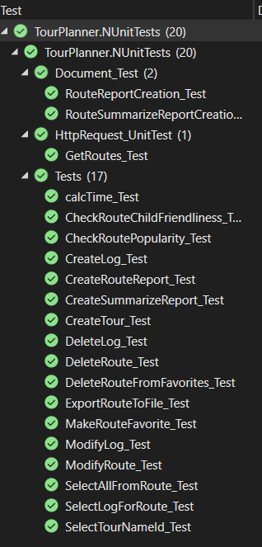
3. Lessons learned
We learned to work in the team on the same project and to implement the solution together. Git was very helpful for the teamwork.
We also learned to structure the code in the layers and to use the config file. Using the config file was very easy to make some changes, for example for paths. We needed just to change it in config file and not in the logic itself.
MVVM is the maybe the most important thing we learned to use. Also, we learned to use the WPF.
We learned to create the HttpRequest in C# and to serialize and deserialize json in the objects.
We learned to use the report-generation library.
We learned that the logging in the file is very useful, because it is much easier to find an error there.

4. Time spent and link to the git
We spent together 112 hours to finish this project.
Link to our git repository: https://github.com/PavleTomanovic/TourPlanner.

