**Код:**

**HTML**(*оставите наслов HTML*)

<!doctype html>

<head>

<meta charset="UTF-8">

<meta name="viewport" content="width=device-width, initial-scale=1.0">

<link rel="stylesheet" type="text/css" href="css/main.css">

<link rel="stylesheet" type="text/css" href="https://fonts.googleapis.com/css?family=Montserrat">

<link media and="screen and (shape:round)" rel="stylesheet" href="round.css">

</head>

<body>

<title>Centar Novih Tehnologija</title>

<center>

<nav class="nav">

<ul>

<li><a href="index.html">NASLOVNA</a></li>

<li><a href="service.html">SERVIS</a> </li>

<li><a href="fiscal.html">FISKALNI PROGRAM</a></li>

<li><a href="hosting.html">HOSTING</a></li>

<li><a href="contact.html">KONTAKT </a></li>

</ul>

</nav>

<div class="header">

<h1>CENTAR NOVIH TEHNOLOGIJA </h1>

<h3>IT AND WEB SOLUTIONS </h3>

</div>

</center>

<div class="containerpr">

<div class="leftp">

<h1> Centar Novih Tehnologija</h1><br>

<p> "Centar Novih Tehnologija" d.o.o. je IKT firma osnovana 2004.

godine sa ciljem da kompanijama i pojedincima iz okruženja pruži adekvatnu podršku za usvajanje novih tehnologija. <br><br>

Tokom dosadašnjeg postojanja kompanija se usmerila na dva glavna sektora rada, a to su održavanje računara i računarskih sistema i razvoj namenskog softvera i "outsourcing" svojih usluga.

Tim koji čini firmu trenutno broji 9 zaposlenih koji svojim radom i zalaganjem čine da se IKT tehnologije iskoriste na najbolji mogući način u cilju poboljšanja poslovanja naših klijenata. </p>

</div> <div><img src="Pics/img3.jpg" class="img3"></div>

</div>

<div class="containerpl">

<div><img src="Pics/servis.jpg" class="img4"></div>

<div class="rightp">

<h1>SERVIS</h1><br>

<p>Održavanje računara i računarskih sistema, prodaja računarske opreme i servisiranje računarske opreme,

prodaja i servis računara, tehnička podrška, montiranje i

održavanje sistema za video nadzor, montiranje i održavanje alarmnih sistema.</p>

</div>

</div>

<div class="containerpr">

<div class="leftp">

<h1> FISKALNE KASE</h1><br>

<p>KOMPLETNO HARDVERSKO-SOFTVERSKO REŠENJE ZA VAŠE POSLOVANJE <br> <br> Rešenje za fiskalne kase,

namenjeno lancu prodavnica, sa centralizovanim magacinskim poslovanjem,

centralizovanim izveštajima i analitikom poslovanja. </p>

</div> <div><img src="Pics/kasa.jpg" class="img5"></div>

</div>

<div class="containerpl">

<div><img src="Pics/server.jpg" class="img4"></div>

<div class="rightp">

<h1>HOSTING</h1><br>

<p>"CNT u svojoj bogatoj ponudi usluga nudi veliki broj hosting paketa.

Ukoliko želite kvalitetan hosting servis sa pouzdanim hardverom i stabilnom vezom ka Internetu,

kontaktirajte nas na hosting@cnt.rs i mi ćemo Vam rado izaći u susret.

Među prvima u Srbiji smo ponudili hosting Java web aplikacija.

Pored toga, tu je i standardno hostovanje internet prezentacija izrađenih u PHP-u.

Svi paketi su pravljeni tako da po svojim cenama budu dostupni širokom krugu korisnika.

Korisnicima naših usluga omogućena je upotreba svih naših dodatnih servisa koji olakšavaju rad.</p>

</div>

</div>

<footer>

<section class="ft-main">

<div class="ft-main-item">

<h2 class="ft-title">O nama</h2>

<p>"Centar Novih Tehnologija" d.o.o. je IKT firma osnovana 2004.

godine sa ciljem da kompanijama i pojedincima iz okruženja pruži adekvatnu

podršku za usvajanje novih tehnologija.</p>

</div>

<div class="ft-main-item">

<h2 class="ft-title">Meni</h2>

<p><a href="index.html">Naslovna</a></p>

<p><a href="service.html">Servis</a></p>

<p><a href="fiscal.html">Fiskalni program</a></p>

<p><a href="hosting.html">Hosting</a></p>

<p><a href="contact.html">Kontakt</a></p>

</div>

<div class="ft-main-item">

<h2 class="ft-title">Kontakt</h2>

<p>Tel: +381 (0) 22 490 157</p>

<p>Fax: +381 (0) 22 495 159</p>

<p>JNA, 126, 22400 Ruma</p>

<p>E-mail: info@cnt.rs</p>

</div>

<div class="ft-main-item">

<h2 class="ft-title">Posetite nas</h2>

<iframe class="map-footer"src="https://www.google.com/maps/embed?pb=!1m14!1m8!1m3!1d5641.991086527586!2d19.8176622!3d45.0047124!3m2!1i1024!2i768!4f13.1!3m3!1m2!1s0x475babfa78b3c037%3A0xef799dc07de944d7!2sCentar%20Novih%20Technologija!5e0!3m2!1ssr!2srs!4v1583916317539!5m2!1ssr!2srs"

frameborder="0" style="border:0" allowfullscreen></iframe>

</div>

</section>

<center>

<section class="ft-legal">

<p>2020 Centar Novih Tehnologija - All rights reserved</p>

</section>

</footer>

</body>

</html>

**less**(*оставите наслов* ***css***)// цео фајл из спољашњег фолдера, избацити коментаре

@colback:#1e2022 ;

@colnav:#1e2022;

@colfooter:#1e2022;

@colhov:grey;

@colnavtxt:hsla(0,0%,100%,.6);

@imgdir:"../Pics/";

@smartphones:~"only screen and (max-width:479px)";

@tablets: ~"only screen and (min-width: 768px) and (max-width: 959px)";

@desktop:~"only screen and (min-width: 768px) and (max-width: 1200px)";

@smartwatch:~"only screen and (min-width:128px) and (max-width: 128px)";

*{

margin:0;

padding:0;

font-family: "Montserrat", open-sans;

color:white;

}

body{

background-color: @colback;

display: flex;

min-height: 100vh;

flex-direction: column;

}

ul {

list-style-type:none;

position: relative;

}

li { /

display:inline-block;

}

li a {

display:block;

min-width:140px;

text-align: center;

line-height: 47px;

font-family:Arial;

color:white; //white;

text-decoration: none;

color:white;

}

li:hover a {

border-bottom: solid 2px white;

}

.nav{

position:fixed;

margin-left:1010px;

background-color:transparent;

}

.header, .headercontact, .headerservice, .headerhosting, .headerfiscal{

padding-top:10%;

color:white;

background-image: url("@{imgdir}/img1.jpg");

height:200px;

background-attachment: scroll;

background-position: center;

background-repeat: no-repeat;

background-size: cover;

}

.headercontact{

background-image:url("@{imgdir}/imgcontact.jpg");

}

.headerservice{

background-image:url("@{imgdir}/soldering.jpg");

}

.headerhosting{

background-image:url("@{imgdir}/hosting.jpg");

}

.headerfiscal{

background-image:url("@{imgdir}/fiscal.jpg");

}

.section1{

margin:0;

padding:0;

background-image: url("@{imgdir}/img3.jpg");

background-position: center;

background-repeat: no-repeat;

height:200px;

width:800px;

float:right;

}

.containerp{

padding:10% 10% 0 10%;

text-align: justify;

}

.containerpr{

display:flex;

padding:10%;

align-items: center;

}

.containerpl{

background-color: #3b3f42;

.containerpr

}

.container{

display:flex;

align-items: center;

justify-content: center

}

.leftp, .rightp{

font-size: 16px;

text-align:justify;

margin-right:100px;

}

.rightp{

margin-right: 0;

margin-left:100px;

}

.img3,.img4, .img5{

height:600px;

width:800px;

margin-left:0;

border-radius: 10px;

}

footer {

background-color:#1e2022;

line-height: 1.5;

}

footer a {

text-decoration: none;

color: white;

}

.ft-title, .ft-title-n {

font-size: 1.375rem;

padding-bottom: 0.625rem;

}

/* Footer main */

.ft-main {

padding: 1.25rem 1.875rem;

display: flex;

justify-content: space-evenly;

}

.ft-main-item {

padding: 1.25rem;

min-width: 10%;

max-width: 15%;

text-align:justify;

}

/* Footer legal */

.ft-legal {

padding: 0.9375rem 1.875rem;

background-color:#1e2022;

text-align: center;

}

.ft-main-n {

justify-content: center;

display: flex;

}

.ft-main-item-n, .ft-main-item-c {

padding:7%;

min-width: 10%;

max-width: 30%;

text-align:center;

}

.ft-main-h {

justify-content: center;

display: flex;

}

.ft-main-item-h {

padding:6%;

margin:5%;

min-width: 10%;

max-width: 20%;

text-align:center;

line-height: 45px;;

border:solid 1px white;

border-radius: 10px;

background-color: @colback;

}

.imghost{

height:150px;

width:150px;

margin-bottom: 50px;

}

.imgfiscal{

height:200px;

width:200px;

}

.map{

height:400px;

width:100%;

}

.map-footer{

height:160px;

}

.feedback-input {

color:white;

font-weight:500;

font-size: 18px;

border-radius: 5px;

line-height: 22px;

background-color: transparent;

border:1px solid black;

transition: all 0.3s;

padding: 13px;

margin-bottom: 15px;

width:100%;

box-sizing: border-box;

outline:0;

}

.feedback-input:focus { border:2px solid #CC4949; }

textarea {

height: 150px;

line-height: 150%;

resize:vertical;

}

[type="submit"] {

width: 20%;

background:#CC6666;

border-radius:5px;

border:0;

cursor:pointer;

color:white;

font-size:24px;

padding-top:10px;

padding-bottom:10px;

transition: all 0.3s;

margin-top:-4px;

font-weight:700;

margin-left:40%;

}

[type="submit"]:hover { background:#CC4949; }

.location{

padding-top:50px;

}

.contact{

padding:150px 0 150px 0;

}

p{

font-size: 16px;

}

.material-icons{

font-size: 80px !important;

}

@media @tablets {

.ft-main {

justify-content: space-evenly;

}

.nav{

margin-left:0;

}

.img3, .img4, .img5{

width:100%;

}

.containerpr, .containerpl{

display:block;

padding:5%;

}

.containerp{

padding:5%;

}

.ft-main-item-h{

margin:2%;

}

.rightp, .leftp{

margin:5% 0 5% 0;

}

.ft-main-item-n{

padding:7% 2% 7% 0%;

}

.map-footer{

width:100%;

}

}

@media @smartphones{

.ft-main {

justify-content: space-evenly;

padding:4%;

}

.nav{

margin-left: 0;

display:none;

}

li a{

width:80px;

}

.img3, .img4, .img5{

width:100%;

height:300px;

}

.map-footer{

width:100%;

}

.containerpr, .containerpl{

display:block;

padding: 10% 4% 10% 4%;

}

.containerp{

padding: 10% 4% ;

}

.rightp, .leftp{

margin:5% 0 5% 0;

}

.ft-main{

flex-wrap: wrap;

align-items: stretch;

}

.ft-main-item{

padding:10% 3% 10% 3%;

max-width:40%;

}

.imgfiscal{

width:80px;

height:80px;

}

.ft-main-item-n, .ft-main-item-c{

padding:7% 2%;

}

.imghost{

width:80px;

height:80px;

}

.ft-title-n, .ft-title{

font-size: 15px;

}

.ft-main-item-h{

max-width: 100%;

}

.ft-main-h{

display:block;

}

h1{

font-size: 24px;

}

h2{

font-size: 20px;

}

}

@media @smartwatch{

.ft-main {

justify-content: space-evenly;

padding:0%;

}

.nav{

margin-left: 0;

display:none;

}

li a{

width:80px;

}

.img3, .img4, .img5{

width:100%;

height:80px;

}

.map-footer{

width:100%;

}

.containerpr, .containerpl{

display:block;

padding: 4% 1%;

}

.containerp{

padding: 10% 4% ;

}

.rightp, .leftp{

margin:5% 0 5% 0;

}

.ft-main, .ft-main-n{

display:block;

}

.ft-main-item{

padding:4% 1%;

max-width:100%;

}

.imgfiscal{

width:80px;

height:80px;

}

.ft-main-item-n, .ft-main-item-c{

padding:4% 2%;

text-align: center;

max-width: 100%;

}

.map, .location{

margin:0;

padding: 0;

}

.imghost{

width:80px;

height:80px;

}

.ft-title-n, .ft-title{

font-size: 12px;

}

.ft-main-item-h{

max-width: 100%;

}

.ft-main-h{

display:block;

}

h1{

font-size: 12px;

}

h2{

font-size: 8px;

}

h3{

font-size: 10px;

}

p{

font-size: 10px;

}

li{

font-size: 9px;

}

[type="submit"]{

width:100%;

padding:0;

margin: 0;

}

.feedback-input{

font-size: 10px;

}

.material-icons{

font-size: 40px !important;

}

}

**css**(*оставите наслов* ***css***)// цео фајл из спољашњег фолдера, избацити коментаре

*{margin:0;padding:0;font-family:"Montserrat",open-sans;color:white}body{background-color:#1e2022;display:flex;min-height:100vh;flex-direction:column}ul{list-style-type:none;position:relative}li{display:inline-block}li a{display:block;min-width:140px;text-align:center;line-height:47px;font-family:Arial;text-decoration:none;color:white}li:hover a{border-bottom:solid 2px white}.nav{position:fixed;margin-left:1010px;background-color:transparent}.header,.headercontact,.headerservice,.headerhosting,.headerfiscal{padding-top:10%;color:white;background-image:url("../Pics//img1.jpg");height:200px;background-attachment:scroll;background-position:center;background-repeat:no-repeat;background-size:cover}.headercontact{background-image:url("../Pics//imgcontact.jpg")}.headerservice{background-image:url("../Pics//soldering.jpg")}.headerhosting{background-image:url("../Pics//hosting.jpg")}.headerfiscal{background-image:url("../Pics//fiscal.jpg")}.section1{margin:0;padding:0;background-image:url("../Pics//img3.jpg");background-position:center;background-repeat:no-repeat;height:200px;width:800px;float:right}.containerp{padding:10% 10% 0 10%;text-align:justify}.containerpr{display:flex;padding:10%;align-items:center}.containerpl{background-color:#3b3f42;display:flex;padding:10%;align-items:center}.container{diplay:flex;align-items:center;justify-content:center}.leftp,.rightp{font-size:16px;text-align:justify;margin-right:100px}.rightp{margin-right:0;margin-left:100px}.img3,.img4,.img5{height:600px;width:800px;margin-left:0;border-radius:10px}footer{background-color:#1e2022;line-height:1.5}footer a{text-decoration:none;color:white}.ft-title,.ft-title-n{font-size:1.375rem;padding-bottom:.625rem}.ft-main{padding:1.25rem 1.875rem;display:flex;justify-content:space-evenly}.ft-main-item{padding:1.25rem;min-width:10%;max-width:15%;text-align:justify}.ft-legal{padding:.9375rem 1.875rem;background-color:#1e2022;text-align:center}.ft-main-n{justify-content:center;display:flex}.ft-main-item-n,.ft-main-item-c{padding:7%;min-width:10%;max-width:30%;text-align:center}.ft-main-h{justify-content:center;display:flex}.ft-main-item-h{padding:6%;margin:5%;min-width:10%;max-width:20%;text-align:center;line-height:45px;border:solid 1px white;border-radius:10px;background-color:#1e2022}.imghost{height:150px;width:150px;margin-bottom:50px}.imgfiscal{height:200px;width:200px}.map{height:400px;width:100%}.map-footer{height:160px}.feedback-input{color:white;font-weight:500;font-size:18px;border-radius:5px;line-height:22px;background-color:transparent;border:1px solid black;transition:all .3s;padding:13px;margin-bottom:15px;width:100%;box-sizing:border-box;outline:0}.feedback-input:focus{border:2px solid #CC4949}textarea{height:150px;line-height:150%;resize:vertical}[type="submit"]{width:20%;background:#CC6666;border-radius:5px;border:0;cursor:pointer;color:white;font-size:24px;padding-top:10px;padding-bottom:10px;transition:all .3s;margin-top:-4px;font-weight:700;margin-left:40%}[type="submit"]:hover{background:#CC4949}.location{padding-top:50px}.contact{padding:150px 0 150px 0}p{font-size:16px}.material-icons{font-size:80px !important}@media only screen and (min-width: 768px) and (max-width: 959px){.ft-main{justify-content:space-evenly}.nav{margin-left:0}.img3,.img4,.img5{width:100%}.containerpr,.containerpl{display:block;padding:5%}.containerp{padding:5%}.ft-main-item-h{margin:2%}.rightp,.leftp{margin:5% 0 5% 0}.ft-main-item-n{padding:7% 2% 7% 0%}.map-footer{width:100%}}@media only screen and (max-width:479px){.ft-main{justify-content:space-evenly;padding:4%}.nav{margin-left:0;display:none}li a{width:80px}.img3,.img4,.img5{width:100%;height:300px}.map-footer{width:100%}.containerpr,.containerpl{display:block;padding:10% 4% 10% 4%}.containerp{padding:10% 4% }.rightp,.leftp{margin:5% 0 5% 0}.ft-main{flex-wrap:wrap;align-items:stretch}.ft-main-item{padding:10% 3% 10% 3%;max-width:40%}.imgfiscal{width:80px;height:80px}.ft-main-item-n,.ft-main-item-c{padding:7% 2%}.imghost{width:80px;height:80px}.ft-title-n,.ft-title{font-size:15px}.ft-main-item-h{max-width:100%}.ft-main-h{display:block}h1{font-size:24px}h2{font-size:20px}}@media only screen and (min-width:128px) and (max-width: 128px){.ft-main{justify-content:space-evenly;padding:0%}.nav{margin-left:0;display:none}li a{width:80px}.img3,.img4,.img5{width:100%;height:80px}.map-footer{width:100%}.containerpr,.containerpl{display:block;padding:4% 1%}.containerp{padding:10% 4% }.rightp,.leftp{margin:5% 0 5% 0}.ft-main,.ft-main-n{display:block}.ft-main-item{padding:4% 1%;max-width:100%}.imgfiscal{width:80px;height:80px}.ft-main-item-n,.ft-main-item-c{padding:4% 2%;text-align:center;max-width:100%}.map,.location{margin:0;padding:0}.imghost{width:80px;height:80px}.ft-title-n,.ft-title{font-size:12px}.ft-main-item-h{max-width:100%}.ft-main-h{display:block}h1{font-size:12px}h2{font-size:8px}h3{font-size:10px}p{font-size:10px}li{font-size:9px}[type="submit"]{width:100%;padding:0;margin:0}.feedback-input{font-size:10px}.material-icons{font-size:40px !important}}

**Слика са GitHub-a (ако има)**

<https://github.com/PavleVuk/Less-projekat>

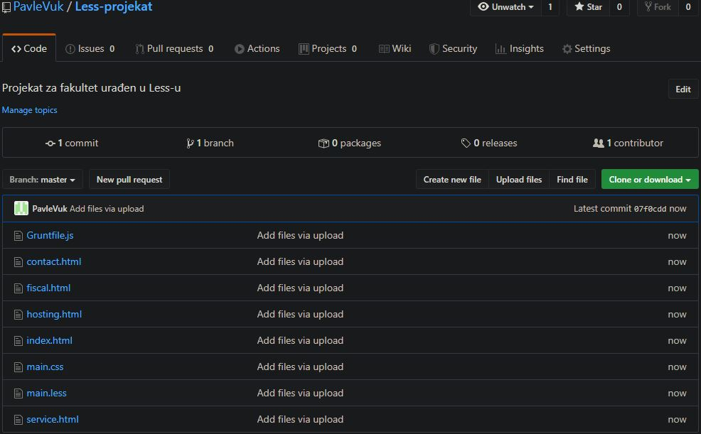

Фотографија 11: Доказ да се пројекат налази на GitHub-u

**Слика која приказује начин конвертовања LESS-a у CSS.**

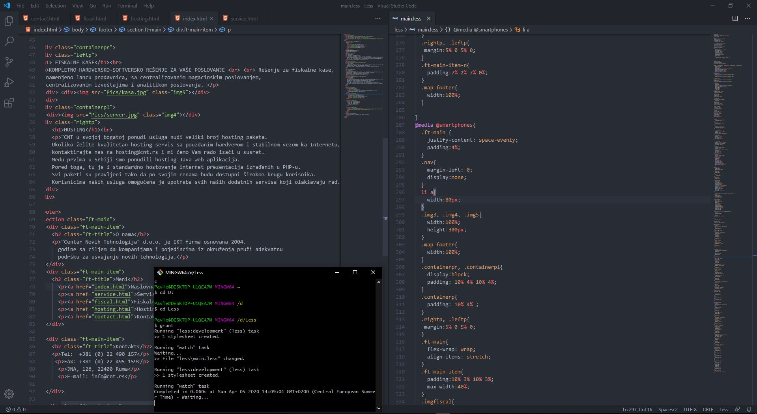

Фотографија 12: Доказ конвертовања Less-a u CSS