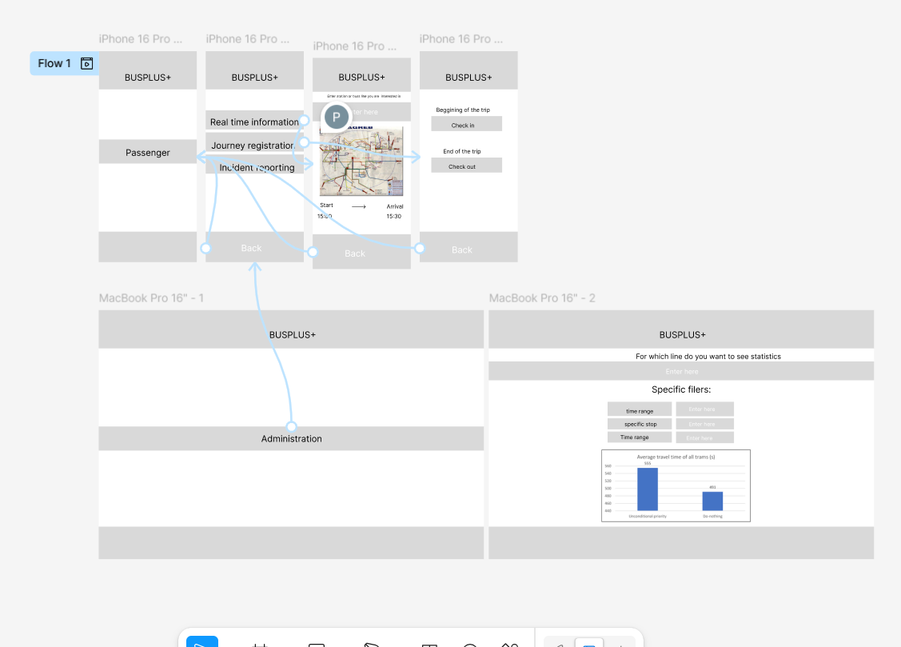

https://www.figma.com/proto/F6udxyClLq7PyjCMUD6fKU/Public-Transport?node-id=0-1&t=9w3ppbY4lSwOqG7o-1

