# Linux Multimedia Studio – 2 (LMMS) Milestone-4

Pavleen Kaur Batra - 9754733

Sardar Maninder Singh - 6555519

# Implemented refactoring

Refactoring that is suggested

1. Long Method (**code smell**) from Song.cpp Class

**Pull Request**: <https://github.com/Pavleen30/SOEN6471/pull/1>

1. **Change (0/0) : Decompose a Long method into under stable and easily modifiable methods**

We identified a **code smell : long method** in that ProcessNextBuffer() method in song.cpp as a long method that contains different types of buffers(Next Song, Next Track, NextBB, NextPattern) and also some other functionalities, depicting that it too much responsibity, thus, it is a Long Method code smell and it also lacks clarity which is replaced using **compose Method** refactoring .

Given that ProcessNextBuffer() has been identified as a Long Method, we decomposed this method into several understandable methods, namely; LoopinBuffer(), GetMaxTact(), processNextBufferSong(), processNextBufferTrack(), processNextBufferBB(), processNextBufferPattern() and we make sure we update the references to these methods.

The implication of this refactoring is that it makes the code easier to modify and understand .

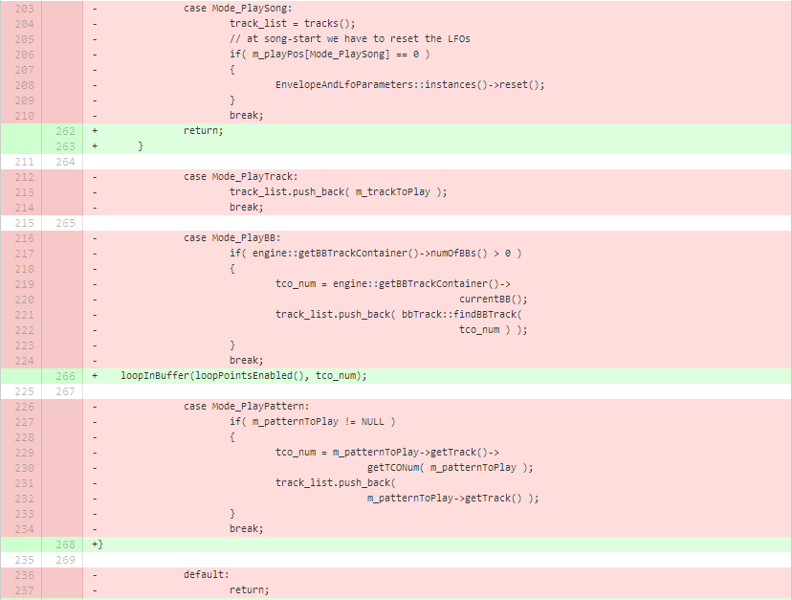

The image shows part of the processBuffer() method we removed. As it has been said above; it is a long method with nested if statements , we deleted some independent section .After deleting these sections , we created the new methods as an individual methods , and then start the calling the methods in the switch statements, as per shown as follow:

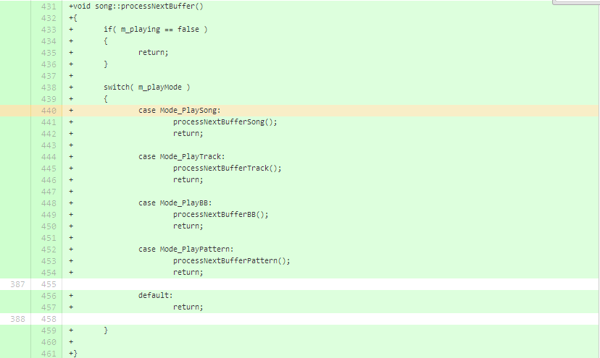

Systems that have a majority of small methods tend to be easier to extend and maintain because they’re easier to understand and contain less duplication.

**TOOL USED:** QtCreator for Linux to edit the code on linux which supports the Qt Core Library of the source code and also user friendly tool for c++ source code Editing and also supports the Qt4 ,Git ,Cmake dependencies for the project to build and compile on Linux os.

**References :**

[1]. http://sourcemaking.com/refactoring/composing-methods

[2].http://readwrite.com/2013/10/02/github-for-beginners-part-2#awesm=~oACCEVFE7tU6ku

[3]. https://qt-project.org/