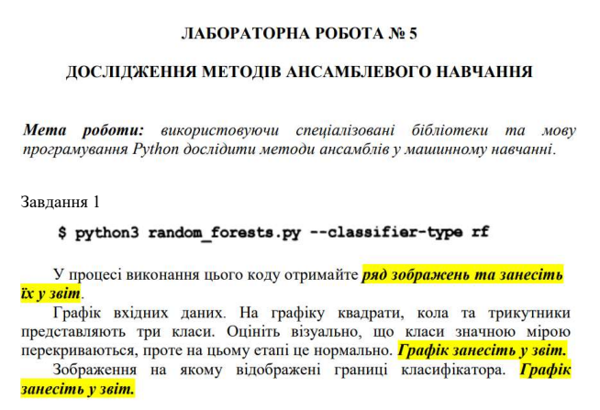

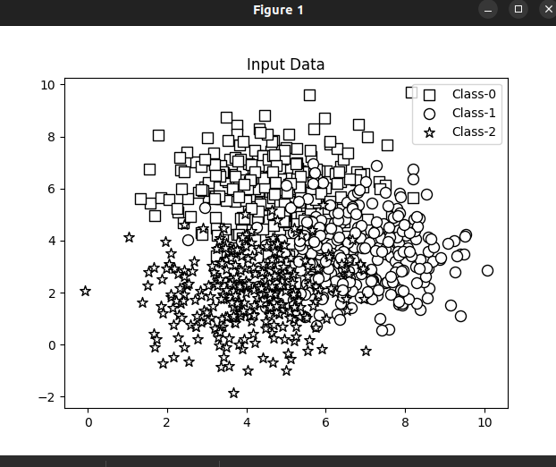

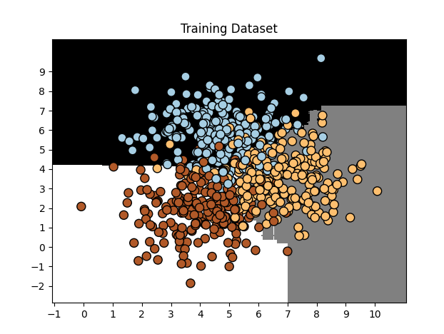

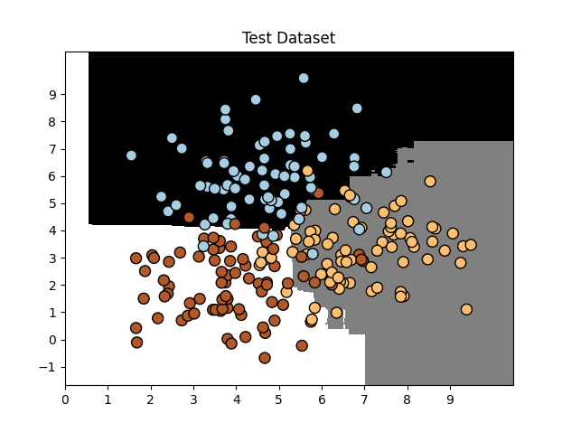

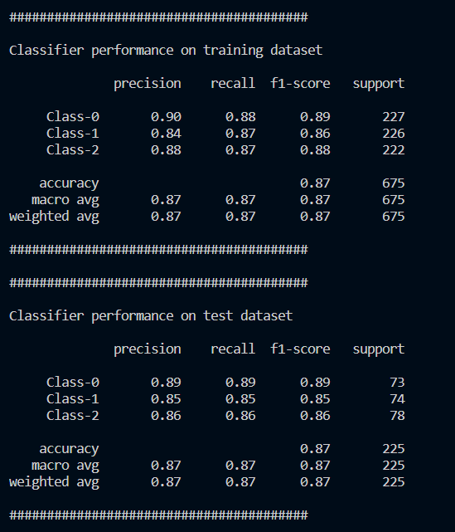

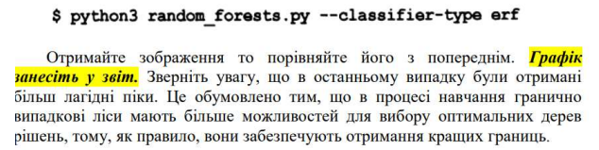

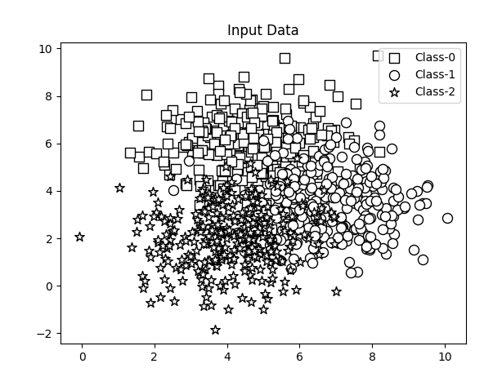

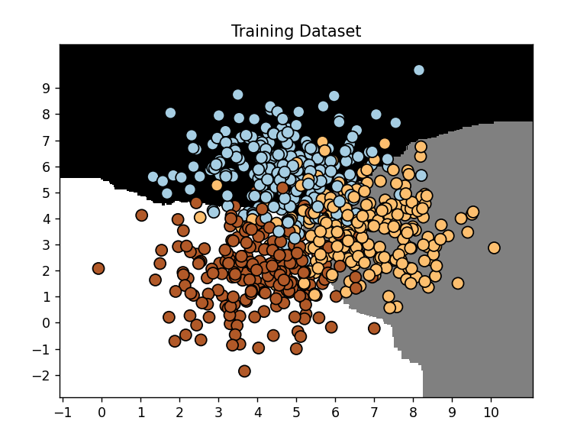

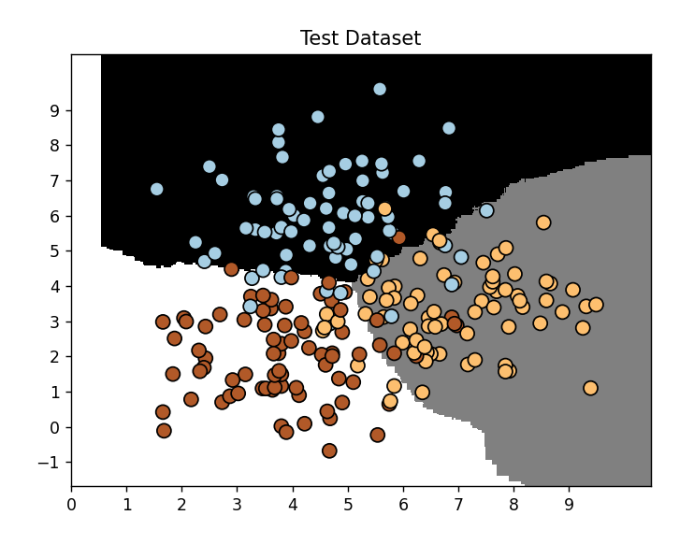

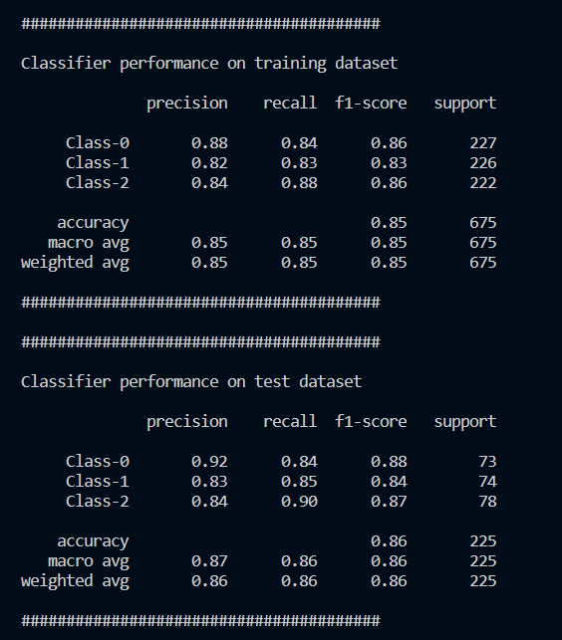

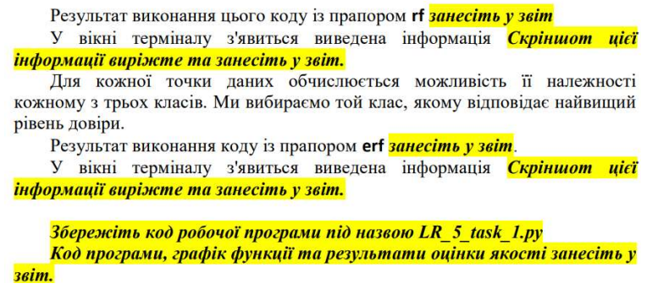

RF:

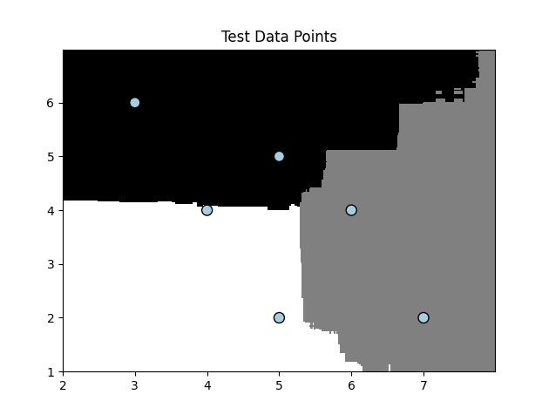

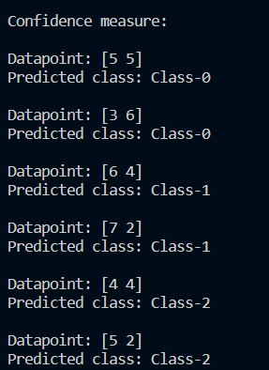

ERF:

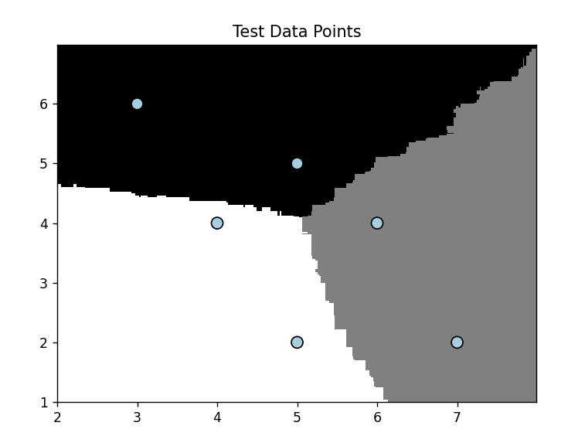

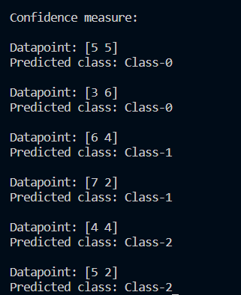

Лістинг:

import argparse

import numpy as np

import matplotlib.pyplot as plt

from sklearn.metrics import classification_report

from sklearn.model_selection import train_test_split

from sklearn.ensemble import RandomForestClassifier, ExtraTreesClassifier

from utilities import visualize_classifier

*def* build_arg_parser():

parser = argparse.ArgumentParser(*description*='Classify data using ensemble learning techniques')

parser.add_argument('--classifier-type', *dest*='classifier_type', *required*=True, *choices*=['rf', 'erf'],

*help*="Type of classifier to use: 'rf' (Random Forest) or 'erf' (Extra Random Forest)")

return parser

*def* load_data(*input_file*):

data = np.loadtxt(*input_file*, *delimiter*=',')

X, y = data[:, :-1], data[:, -1]

return X, y

*def* main():

# Parsing arguments

args = build_arg_parser().parse_args()

classifier_type = args.classifier_type

# Load dataset

input_file = 'data_random_forests.txt'

X, y = load_data(input_file)

# Input data visualization

plt.figure()

markers = ['s', 'o', '*']

for i, label in enumerate(np.unique(y)):

class_data = X[y == label]

plt.scatter(class_data[:, 0], class_data[:, 1], *s*=75, *facecolors*='white',

*edgecolors*='black', *linewidth*=1, *marker*=markers[i], *label*=*f*'Class-{int(label)}')

plt.title('Input Data')

plt.legend()

plt.show()

# Splitting the dataset

X_train, X_test, y_train, y_test = train_test_split(X, y, *test_size*=0.25, *random_state*=2)

# Classifier initialization

params = {'n_estimators': 100, 'max_depth': 4, 'random_state': 0}

if classifier_type == 'rf':

classifier = RandomForestClassifier(**params)

elif classifier_type == 'erf':

classifier = ExtraTreesClassifier(**params)

# Training the classifier

classifier.fit(X_train, y_train)

# Training dataset visualization

visualize_classifier(classifier, X_train, y_train, 'Training Dataset')

# Test dataset visualization

visualize_classifier(classifier, X_test, y_test, 'Test Dataset')

# Training performance

print("\n" + "#" * 40)

print("\nClassifier performance on training dataset\n")

print(classification_report(y_train, classifier.predict(X_train), *target_names*=['Class-0', 'Class-1', 'Class-2']))

print("#" * 40 + "\n")

# Test performance

print("#" * 40)

print("\nClassifier performance on test dataset\n")

print(classification_report(y_test, classifier.predict(X_test), *target_names*=['Class-0', 'Class-1', 'Class-2']))

print("#" * 40 + "\n")

# Test data points visualization

test_datapoints = np.array([[5, 5], [3, 6], [6, 4], [7, 2], [4, 4], [5, 2]])

print("\nConfidence measure:")

for datapoint in test_datapoints:

probabilities = classifier.predict_proba([datapoint])[0]

predicted_class = *f*"Class-{np.argmax(probabilities)}"

print(*f*"\nDatapoint: {datapoint}")

print(*f*"Predicted class: {predicted_class}")

visualize_classifier(classifier, test_datapoints, [0] * len(test_datapoints), 'Test Data Points')

plt.show()

if __name__ == '__main__':

main()

Завдання 2.2. Обробка дисбалансу класів

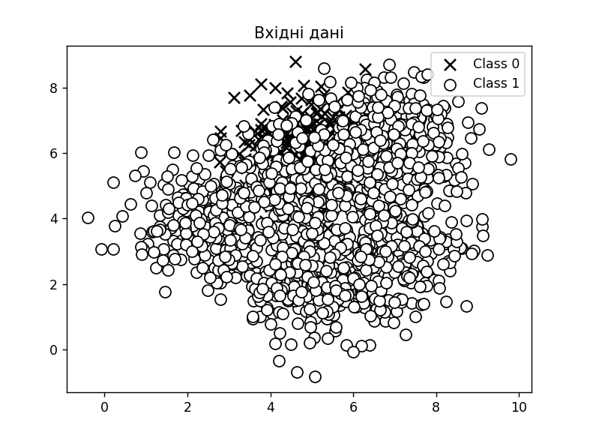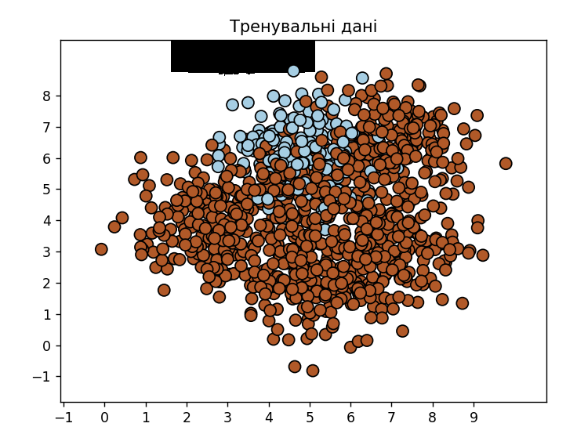

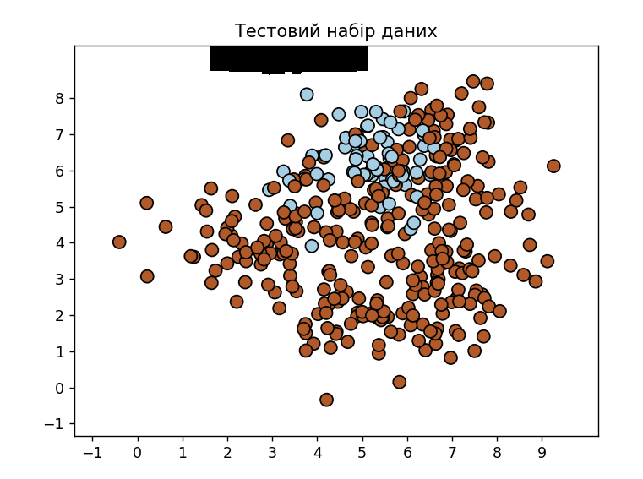

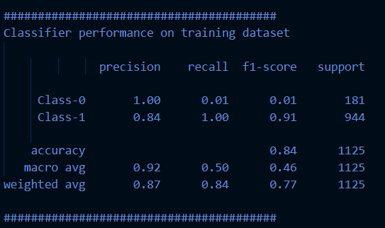

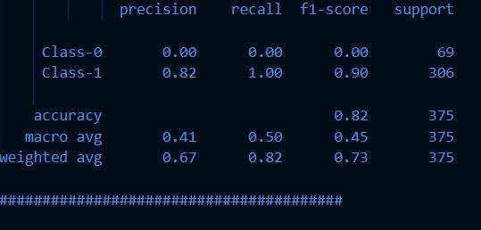

python3 –W ignore class_imbalence.py:

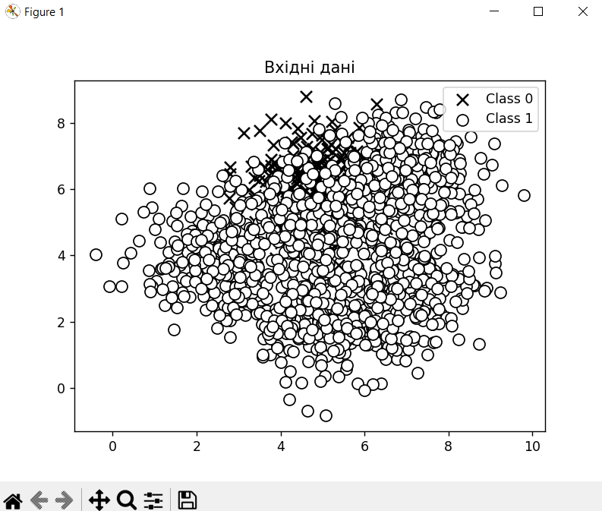

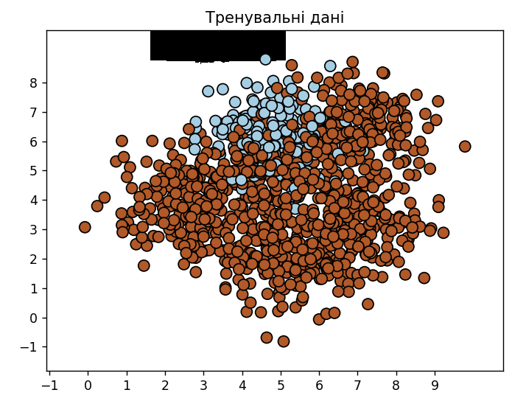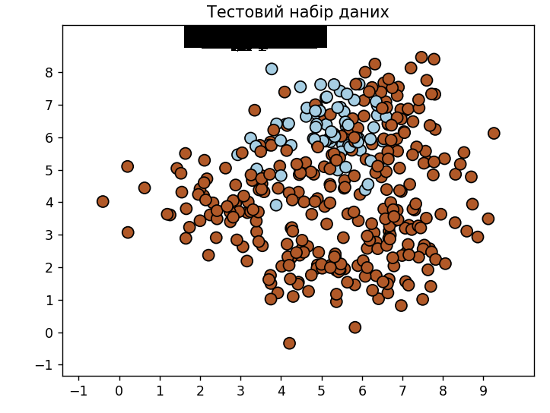

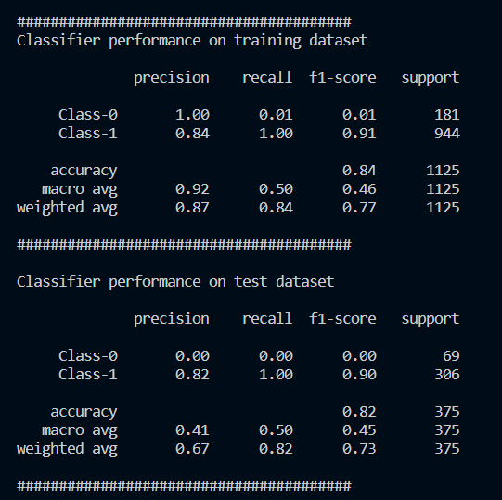

python3 class_imbalence.py balance:

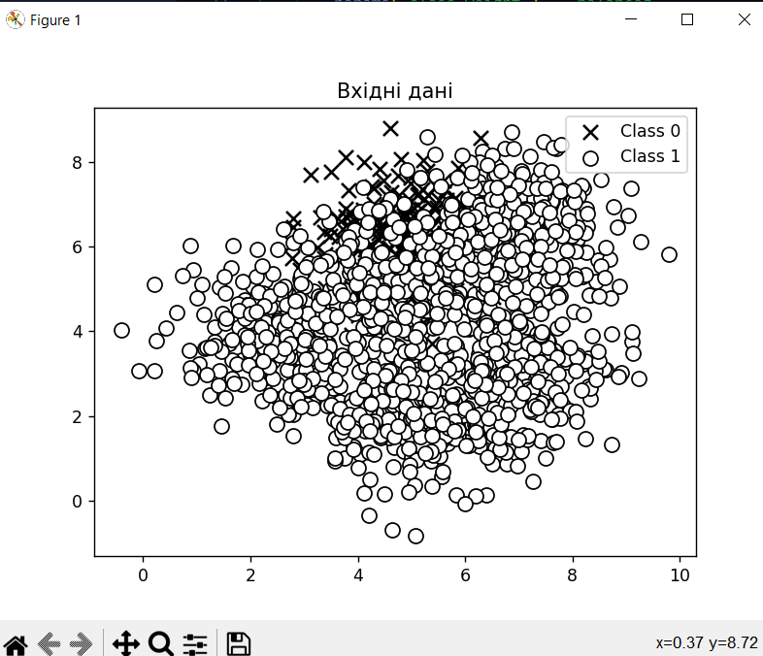

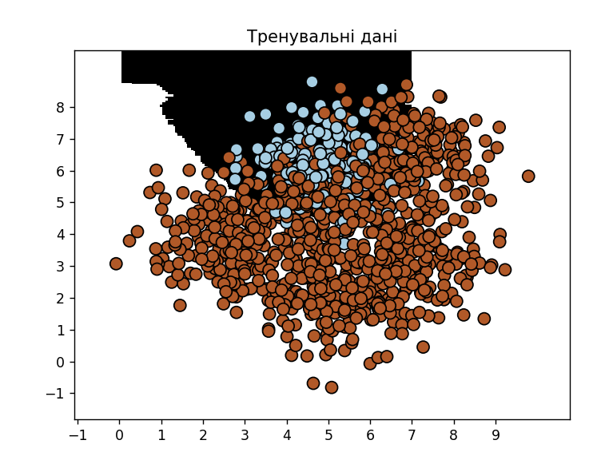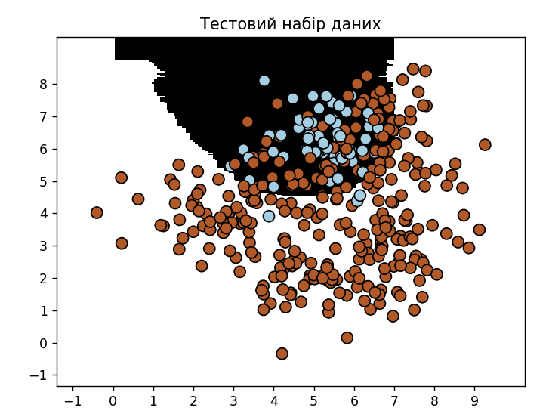

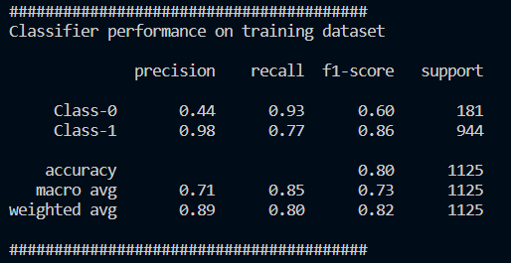

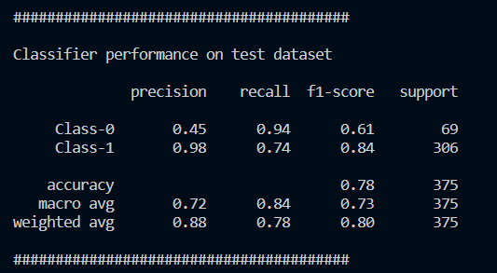

Лістинг:

import sys

import numpy as np

import matplotlib.pyplot as plt

from sklearn.ensemble import ExtraTreesClassifier

from sklearn.model_selection import train_test_split

from sklearn.metrics import classification_report

from utilities import visualize_classifier

*def* load_data(*input_file*):

data = np.loadtxt(*input_file*, *delimiter*=',')

X, y = data[:, :-1], data[:, -1]

return X, y

*def* plot_data(*X*, *y*):

class_0 = *X*[*y* == 0]

class_1 = *X*[*y* == 1]

plt.figure()

plt.scatter(class_0[:, 0], class_0[:, 1], *s*=75, *c*='black', *marker*='x', *label*='Class 0')

plt.scatter(class_1[:, 0], class_1[:, 1], *s*=75, *c*='white', *edgecolors*='black', *marker*='o', *label*='Class 1')

plt.title("Вхідні дані")

plt.legend()

plt.show()

*def* train_and_evaluate(*X*, *y*, *balance*=False):

# Split the data into training and testing sets

X_train, X_test, y_train, y_test = train_test_split(*X*, *y*, *test_size*=0.25, *random_state*=5)

# Define classifier parameters

params = {'n_estimators': 100, 'max_depth': 4, 'random_state': 0}

if *balance*:

params['class_weight'] = 'balanced'

# Train the classifier

classifier = ExtraTreesClassifier(**params)

classifier.fit(X_train, y_train)

# Visualize the training and testing results

visualize_classifier(classifier, X_train, y_train, 'Тренувальні дані')

visualize_classifier(classifier, X_test, y_test, 'Тестовий набір даних')

# Evaluate classifier performance

class_names = ['Class-0', 'Class-1']

print("\n" + "#" * 40)

print("Classifier performance on training dataset\n")

print(classification_report(y_train, classifier.predict(X_train), *target_names*=class_names))

print("#" * 40 + "\n")

print("Classifier performance on test dataset\n")

print(classification_report(y_test, classifier.predict(X_test), *target_names*=class_names))

print("#" * 40 + "\n")

*def* main():

input_file = 'data_imbalance.txt'

X, y = load_data(input_file)

# Plot the input data

plot_data(X, y)

# Check for optional argument

balance = len(sys.argv) > 1 and sys.argv[1] == 'balance'

# Train and evaluate the classifier

train_and_evaluate(X, y, *balance*=balance)

if __name__ == "__main__":

main()

Завдання 2.3. Знаходження оптимальних навчальних параметрів за допомогою сіткового пошуку.

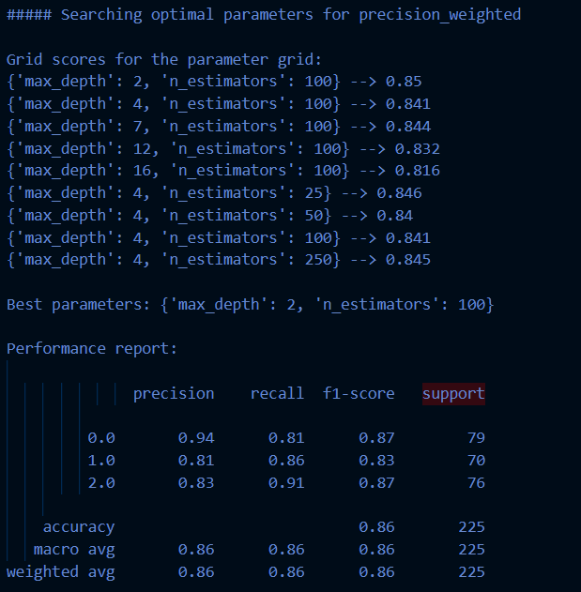

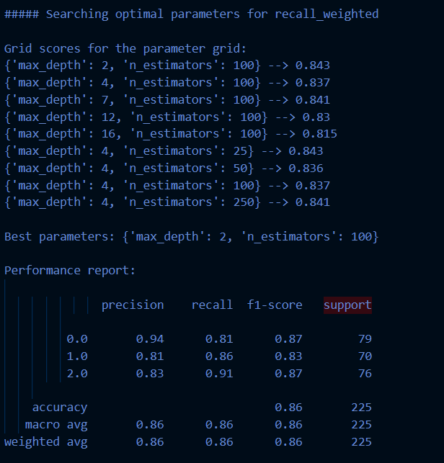

Лістинг:

import numpy as np

import matplotlib.pyplot as plt

from sklearn.metrics import classification_report

from sklearn.model_selection import train_test_split, GridSearchCV

from sklearn.ensemble import ExtraTreesClassifier

from utilities import visualize_classifier

input_file = 'data_random_forests.txt'

data = np.loadtxt(input_file, *delimiter*=',')

X, y = data[:, :-1], data[:, -1]

class_0 = np.array(X[y == 0])

class_1 = np.array(X[y == 1])

class_2 = np.array(X[y == 2])

X_train, X_test, y_train, y_test = train_test_split(X, y, *test_size*=0.25, *random_state*=5)

parameter_grid = [

{'n_estimators': [100], 'max_depth': [2, 4, 7, 12, 16]},

{'max_depth': [4], 'n_estimators': [25, 50, 100, 250]}

]

metrics = ['precision_weighted', 'recall_weighted']

for metric in metrics:

print("\n##### Searching optimal parameters for", metric)

classifier = GridSearchCV(ExtraTreesClassifier(*random_state*=0), parameter_grid, *cv*=5, *scoring*=metric)

classifier.fit(X_train, y_train)

print("\nGrid scores for the parameter grid:")

for params, avg_score in zip(classifier.cv_results_['params'], classifier.cv_results_['mean_test_score']):

print(params, '-->', round(avg_score, 3))

print("\nBest parameters:", classifier.best_params_)

y_pred = classifier.predict(X_test)

print("\nPerformance report: \n")

print(classification_report(y_test, y_pred))

Завдання 2.4. Обчислення відносної важливості ознак.

load_boston було видалено з нових версій scikit-learn, тому було викорстано: from sklearn.datasets import fetch_california_housing

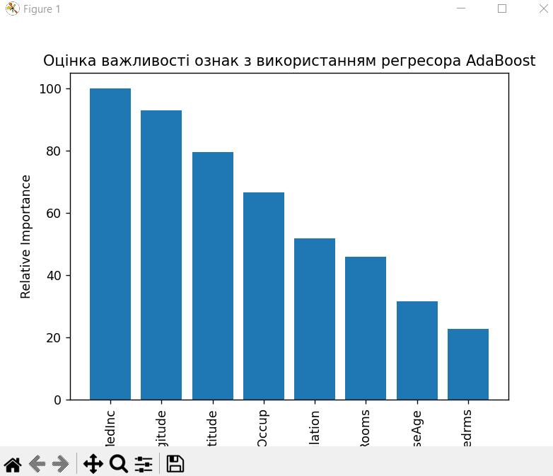

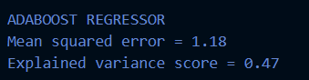

Лістинг:

import numpy as np

import matplotlib.pyplot as plt

from sklearn.tree import DecisionTreeRegressor

from sklearn.ensemble import AdaBoostRegressor

from sklearn.datasets import fetch_california_housing

from sklearn.metrics import mean_squared_error, explained_variance_score

from sklearn.model_selection import train_test_split

from sklearn.utils import shuffle

housing_data = fetch_california_housing()

X, y = shuffle(housing_data.data, housing_data.target, *random_state*=7)

X_train, X_test, y_train, y_test = train_test_split(X, y, *test_size*=0.2, *random_state*=7)

regressor = AdaBoostRegressor(DecisionTreeRegressor(*max_depth*=4), *n_estimators*=400, *random_state*=7)

regressor.fit(X_train, y_train)

y_pred = regressor.predict(X_test)

mse = mean_squared_error(y_test, y_pred)

evs = explained_variance_score(y_test, y_pred)

print("\nADABOOST REGRESSOR")

print("Mean squared error =", round(mse, 2))

print("Explained variance score =", round(evs, 2))

feature_importances = regressor.feature_importances_

feature_names = housing_data.feature_names

feature_importances = 100.0 * (feature_importances / max(feature_importances))

index_sorted = np.flipud(np.argsort(feature_importances))

pos = np.arange(index_sorted.shape[0]) + 0.5

plt.figure()

plt.bar(pos, feature_importances[index_sorted], *align*='center')

plt.xticks(pos, np.array(feature_names)[index_sorted], *rotation*=90)

plt.ylabel("Relative Importance")

plt.title("Оцінка важливості ознак з використанням регресора AdaBoost")

plt.show()

Завдання 2.5. Прогнозування інтенсивності дорожнього руху за допомогою класифікатора на основі гранично випадкових лісів.



Лістинг:

import numpy as np

import matplotlib.pyplot as plt

from sklearn.metrics import classification_report, mean_absolute_error

from sklearn.model_selection import train_test_split

from sklearn import preprocessing

from sklearn.ensemble import ExtraTreesRegressor

input_file = 'traffic_data.txt'

data = []

with open(input_file, 'r') as f:

for line in f:

items = line.strip().split(',')

data.append(items)

data = np.array(data)

label_encoders = []

X_encoded = np.empty_like(data, *dtype*=float)

for i, value in enumerate(data[0]):

if value.isdigit():

X_encoded[:, i] = data[:, i]

else:

encoder = preprocessing.LabelEncoder()

X_encoded[:, i] = encoder.fit_transform(data[:, i])

label_encoders.append(encoder)

X = X_encoded[:, :-1].astype(int)

y = X_encoded[:, -1].astype(int)

X_train, X_test, y_train, y_test = train_test_split(X, y, *test_size*=0.25, *random_state*=5)

params = {'n_estimators': 100, 'max_depth': 4, 'random_state': 0}

regressor = ExtraTreesRegressor(**params)

regressor.fit(X_train, y_train)

y_pred = regressor.predict(X_test)

mae = mean_absolute_error(y_test, y_pred)

print(*f*"Mean absolute error: {mae*:.2f*}")

test_datapoint = ['Saturday', '10:20', 'Atlanta', 'no']

test_datapoint_encoded = []

for i, value in enumerate(test_datapoint):

if value.isdigit():

test_datapoint_encoded.append(int(value))

else:

encoder = label_encoders.pop(0)

test_datapoint_encoded.append(encoder.transform([value])[0])

test_datapoint_encoded = np.array(test_datapoint_encoded)

predicted_traffic = regressor.predict([test_datapoint_encoded])[0]

print(*f*"Predicted traffic: {int(predicted_traffic)}")

Git: <https://github.com/PavlenkoOks/AI>