Commit & push your materials to remote repository
(It is supposed that you already -have account on GitHub.com)

~ ~ ~ ~ ~ ~ ~ ~ ~ ~ ~ ~ ~ ~ ~ ~ In GitHub.com https://GitHub.com ~ ~ ~ ~ ~ ~ ~ ~ ~ ~ ~ ~ ~ ~ ~ ~
1. “Sign in” in your account on GitHub. and create a new repository in GitHub – for example DemoPrj1.
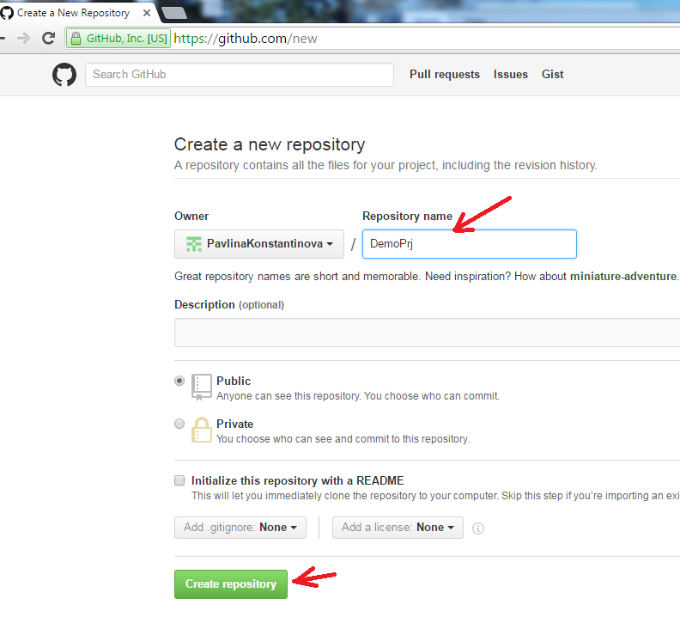
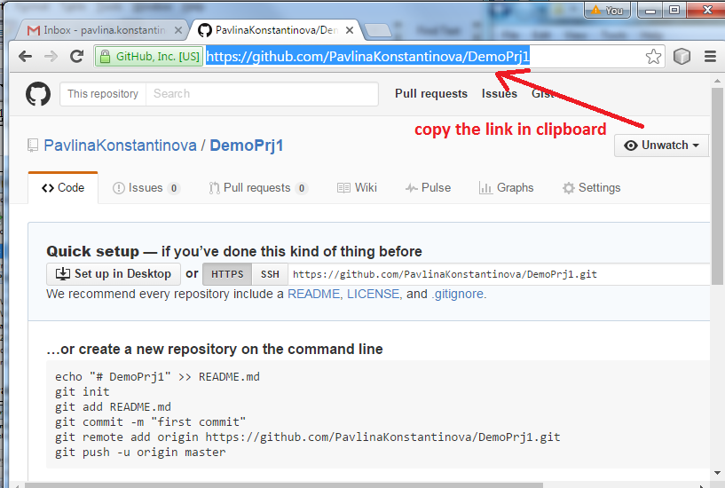
2. Copy the link into the Clipboard. By copying the link you help SmartGit to fill needed info in the next operations.

~ ~ ~ ~ ~ ~ ~ ~ ~ ~ ~ Using SmartGit ~ ~ ~ ~ ~ ~ ~ ~ ~ ~ ~ ~ ~ ~ ~ ~
3. Start SmartGit and choose Repository/ Clone
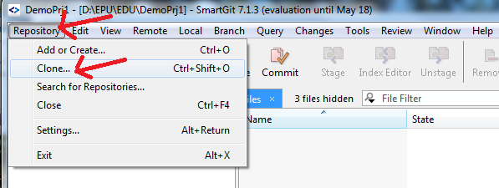
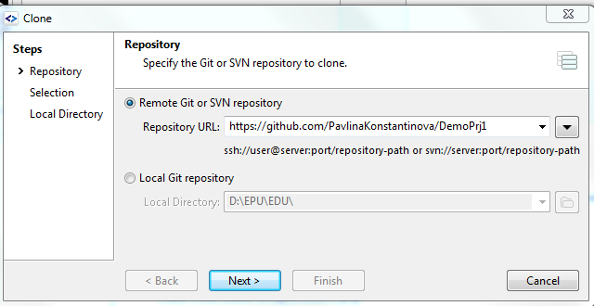
In the step “Repository” in RadioButton “Remote Git ..” the link to remote repository is already ready (Thanks to the fact- you copy the link in the clipboard.) Press button ”Next”.

Step “Selection” is accepted by default ..(all files are checked) Press button ”Next”.
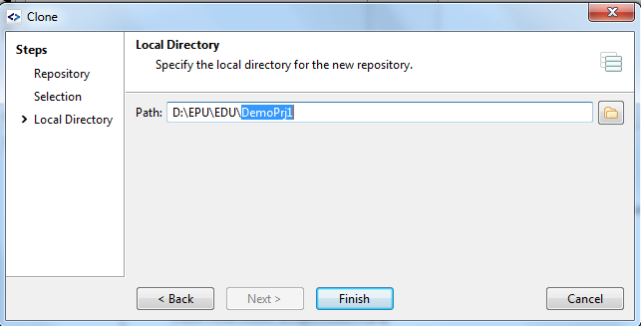
In the step Local directory you may define the root directory or path (this is the directory, where SmartGit will make subdirectory with the name of the newly created Remote Repository in GitHub.com). The path finishes with “\”. In this case the path is d:\EPU\EDU\ . You can see the SmartGit suggestion- namely DemoPrj1.
When you press FINISH SmartGit makes folder with the name of the newly created Remote Repository.
4. Using Windows Explorer copy files from your working directory in the newly created local repository - directory DemoPrj1. The copied files appear in the newly created clone DemoPrj1.
(If in SmartGit the Repositories and/or Files are not seen choose Windows/Repositories or Windows/ Files )
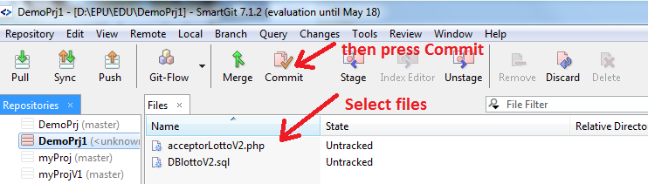
5. Select files and press Commit
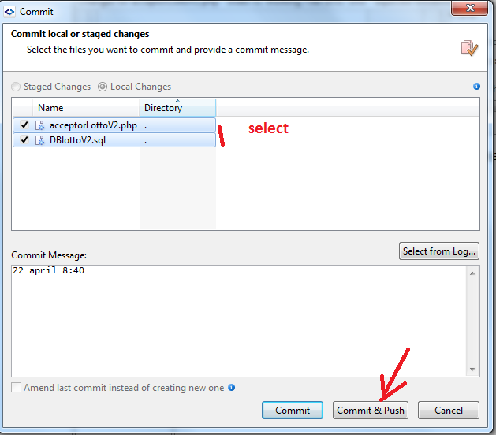
6. Select files again and press Commit&Push

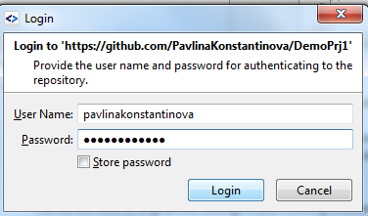
7. Enter user-name and password
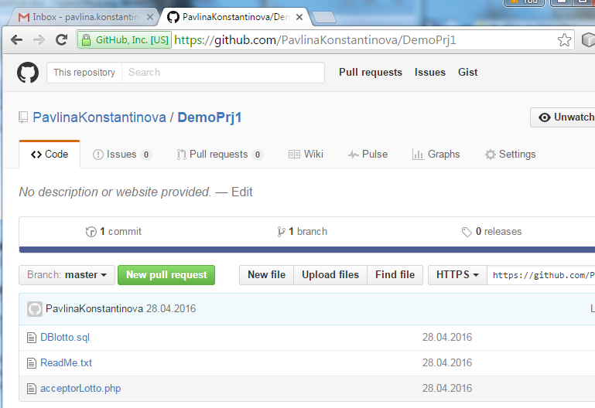
The commit is finished and you may see files and send the link

Deleting remote repository:
-open the repository(that you want to delete)
Choose “Setting”
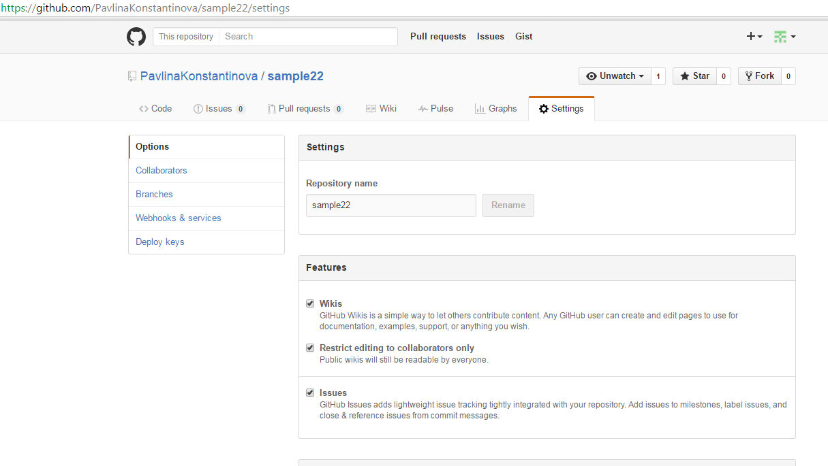
Slide down ...
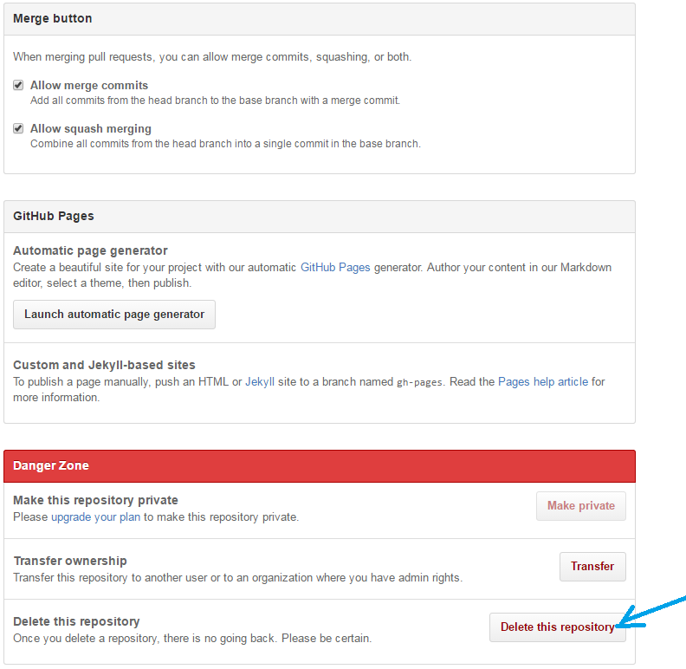
You have to confirm writing the name...

