### Multidimensional ANALYSIS

The first 3 dimensions have got eigenvalues above 0.05 and are selected for interpretation. The principal component analysis gives 47.72 % of variance explanation (Sup. Table 1).

Figure 1a, 1b and 1c show variables in correlation circles. Each circle highlights two dimensions and the variables that are correlated to them. Variable names are displayed when their covariance is greater than 0.4.

|  |
| --- |
|  |
| *Figure 1a: Principal component analysis: correlation circle with dimension 1 and 2* |
|  |
| *Figure 1b: Principal component analysis: correlation circle with dimension 1 and 3* |
|  |
| *Figure 1c: Principal component analysis: correlation circle with dimension 2 and 3* |

A good correlation is observed between “TIR” and “AGE” and a anticorrelation is observed between “AGE” and “HBA1C” (Figure 1a).

Variables “HEIGHT”, “WEIGHT” and “WAISTC” exhibit similar variability (Figure 1b). DDS scores, “PHQ-9”, “EPICES” and “WHO5” are linked (Figure 1b):

* Of all subscales of DDS, the “DDSemotionalBurden” is the most revealing to the final DDS score (Figure 1a).
* The “PHQ-9” score and the difficulty in completing the PHQ-9 questionnaire “PHQ-9difficulty” are highly correlated (Figure 1a).
* Patient responses to “WHO5” and “EPICES” are linked to the “DDSinterpersonalDistress” score.
* Dialyzed patients (“DIALYSIS”) have a high “DDSphysicianRelatedDistress” score.

The number of comorbidities (“NBCOMORB”) increases with the patient's age (Figure 1c). The time in range (“TIR”) is anticorrelated with “RFTEGFR”. Figure 1c shows that patients treated with oral antidiabetics tend to have a larger waist circumference than the others.

*Hierarchical clustering.* The classification algorithm proposes a division of individuals into 3 groups of patients. The choice of this number of clusters constitutes a compromise between the gain of information (or gain of inertia) and the ease of interpretation.

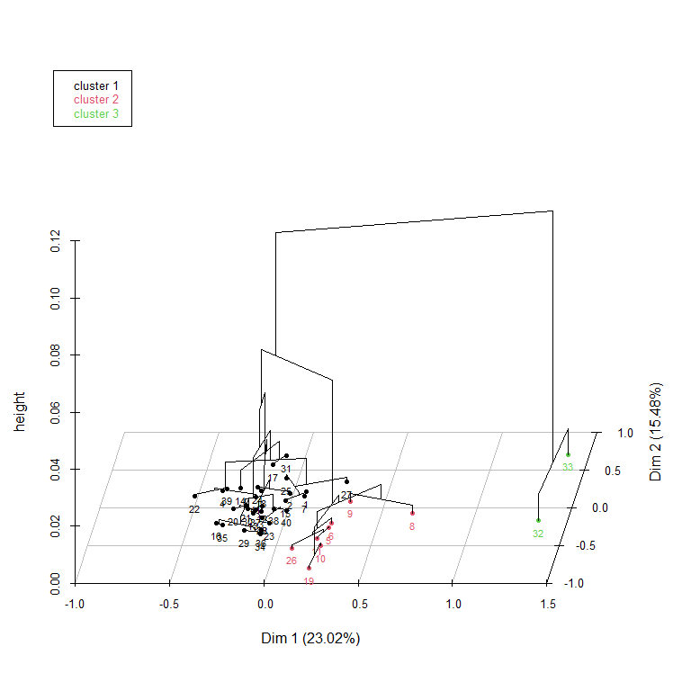

*Figure 2: Hierarchical clustering on the principal components: cluster dendrogram in the factorial plan with dimension 1 and 2. Vertical axis represents the quantification of the inertia gain. Individuals are colored according to their cluster.*

The distribution of patients within the clusters is represented by the cluster dendrogram (Figure 2). Three distinguished groups are perceived: one large group consisting of 32 patients (76.2 %) and two little groups of 8 (19.0 %) and 2 (4.8 %) patients respectively.

Figure 2 also gave a perspective of the individuals hierarchical clustering. It indicated more singularity in the responses of cluster 3 patients compared to the other patient clusters.

Table 5 shows the variables that characterize each cluster. The greater the absolute value of the V.test, the more the variable is representative of the group of individuals.

|  |  |  |  |  |  |  |
| --- | --- | --- | --- | --- | --- | --- |
| **Variable** | **Cluster 1 V.test** |  | **Cluster 2 V.test** |  | **Cluster 3 V.test** |  |
| AGE | 2.69 | ** | -2.74 | ** | -0.31 |  |
| BENZOTHERA | -0.88 |  | -0.70 |  | 3.04 | ** |
| DDSemotionalBurden | -4.31 | *** | 2.60 | ** | 3.83 | *** |
| DDSinterpersonalDistress | -3.46 | *** | 1.04 |  | 4.99 | *** |
| DDSphysicianRelatedDistress | -1.92 |  | -0.46 |  | 4.70 | *** |
| DDSregimenRelatedDistress | -5.17 | *** | 3.97 | *** | 3.00 | ** |
| DDStotal | -4.74 | *** | 2.54 | * | 4.80 | *** |
| DIALYSIS | -1.79 |  | -0.49 |  | 4.47 | *** |
| EPICES | -2.71 | ** | 1.09 |  | 3.42 | *** |
| FRIED | -2.13 | * | 1.20 |  | 2.04 | * |
| GIRERD | -2.39 | * | 0.70 |  | 3.50 | *** |
| HBA1C | -3.22 | ** | 3.19 | ** | 0.56 |  |
| PERINEUCLI | -1.61 |  | -0.16 |  | 3.51 | *** |
| PHQ9 | -4.02 | *** | 1.73 |  | 4.86 | *** |
| PHQ9difficulty | -3.54 | *** | 1.16 |  | 4.94 | *** |
| RFTEGFR | -1.21 |  | 2.76 | ** | -2.67 | ** |
| SMOK | -2.01 | * | 1.67 |  | 0.94 |  |
| TELECONSULT | -1.91 |  | 2.45 | * | -0.70 |  |
| TIR | 3.41 | *** | -3.69 | *** | -0.02 |  |
| WAISTC | 1.86 |  | -2.15 | * | 0.24 |  |
| WHO5 | 2.96 | ** | -1.38 |  | -3.37 | *** |

*Table 5: Description of cluster 1, 2 and 3 by the variables linked to the classification. * p < 0.05; ** p < 0.01; *** p < 0.001.*