Construction of subsystems

1)Organize MVC Structure

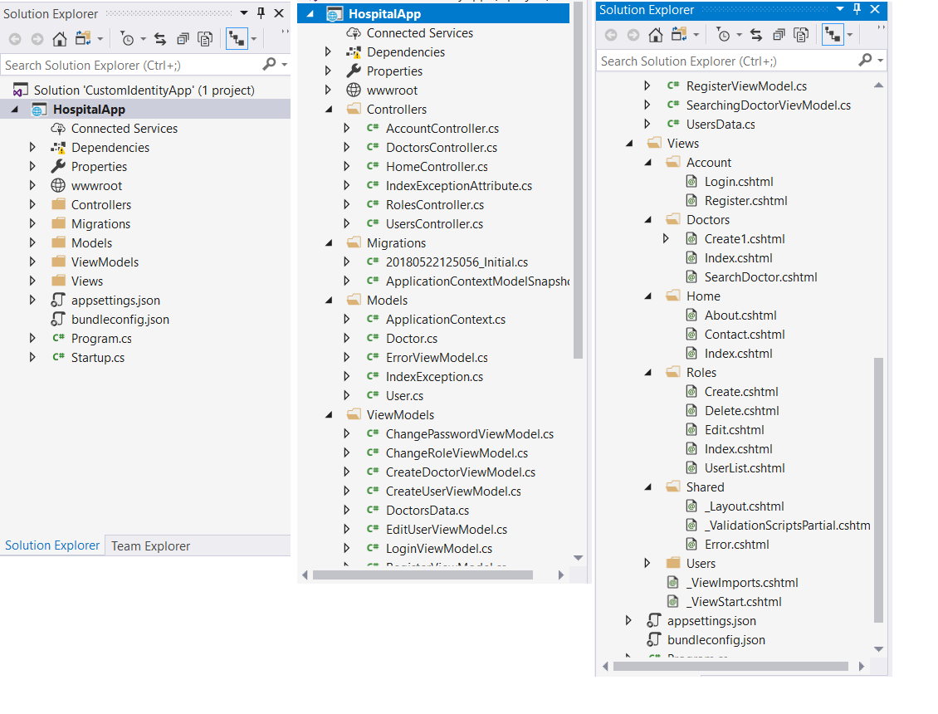

2)Add Domain Models

Added some models.

3)Prepare DataBase (add migrations)

Was created class Context where is described DataBase. Connection String are located in appsettings.json. Also was created DbInitializer in order to check if Connection String is right, to create and fill DB by some data.

4)Add Controllers & Views

Added DoctorsController, which contains operations over the all doctors in hospital. Also was added same controller for users roles and account.

Authorization I did by Microsoft software (AspNetCore.Identity).